Paul Lazaros

System Requirements

1. Only authorized users have access to the configuration and uninstall

* 1. Functional: Alert sent to parent if unauthorized user tries to configure or uninstall
  2. Functional: Uninstall and configure requires one-time passcode sent via email, even on authorized user
  3. Functional: Parent must manually add each authorized user
  4. Functional: Authorized users can disable E-guard for account under configuration
  5. Functional: Parent manually remove authorized user
  6. Functional: If computer goes into sleep mode while on authorized user, automatically enable E-guard
  7. Functional: Add or remove blocked websites in configuration
  8. Functional: Option for authorized users to temporarily turn on e-guard for account
  9. Functional: Unauthorized accounts automatically enable e-guard on login
  10. Functional: Current settings saved to cloud on uninstall
  11. Functional: If E-Guard servers go down, parent sent failsafe alert
  12. Functional: Alert sent to parent if child clears search history
  13. Functional: Search history automatically saved to E-guard as well
  14. Functional: Under configure, restrict screen-time
  15. Functional: Goes over screen-time allowed, locked pc

**Use Cases:**

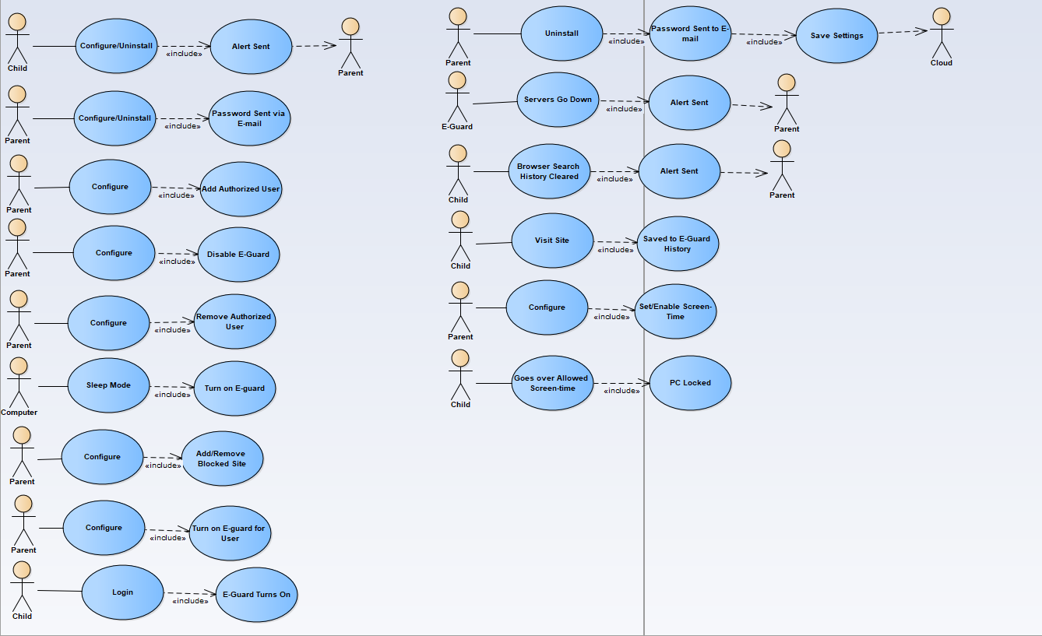

**Configure Class Diagram:**

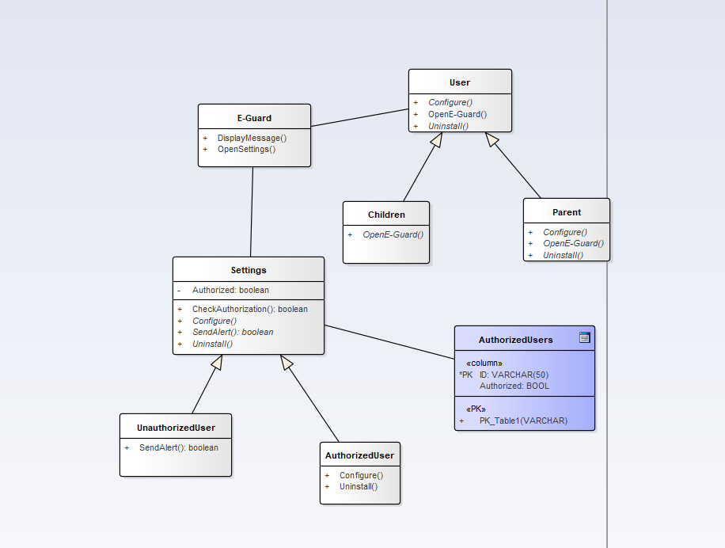

Class Diagram for E-Guard sending alert to parents if an unauthorized user attempts to access the configure or install options.

**History Class Diagram:**

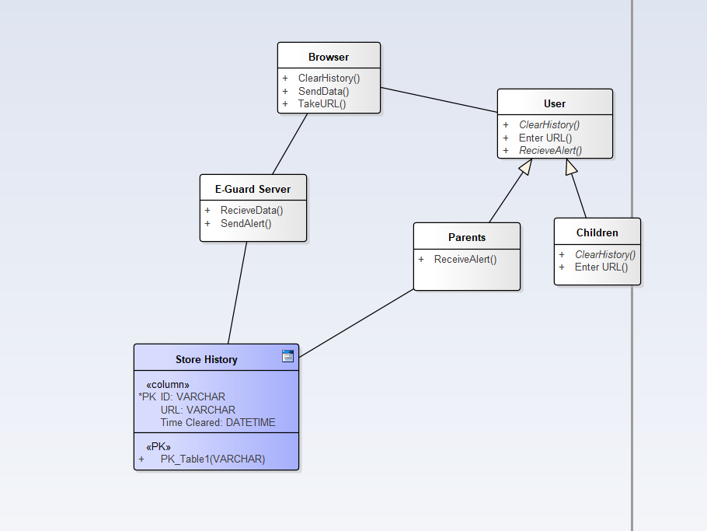

Class Diagram for search history being sent and stored in E-Guard as well as sending an alert to the parent if an unauthorized user clears their search browser history.

**Configure Sequence Diagram:**

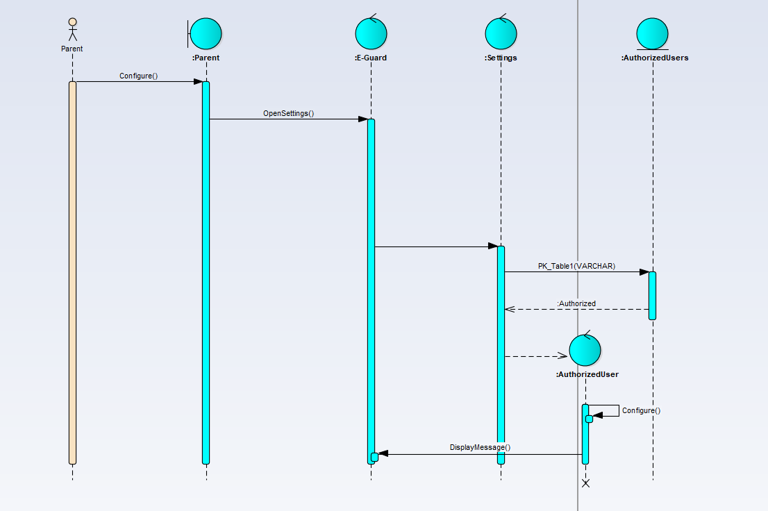

Sequence Diagram for a parent accessing the configure setting for E-Guard, and E-Guard verifying that they are an authorized user.

**History Sequence Diagram:**

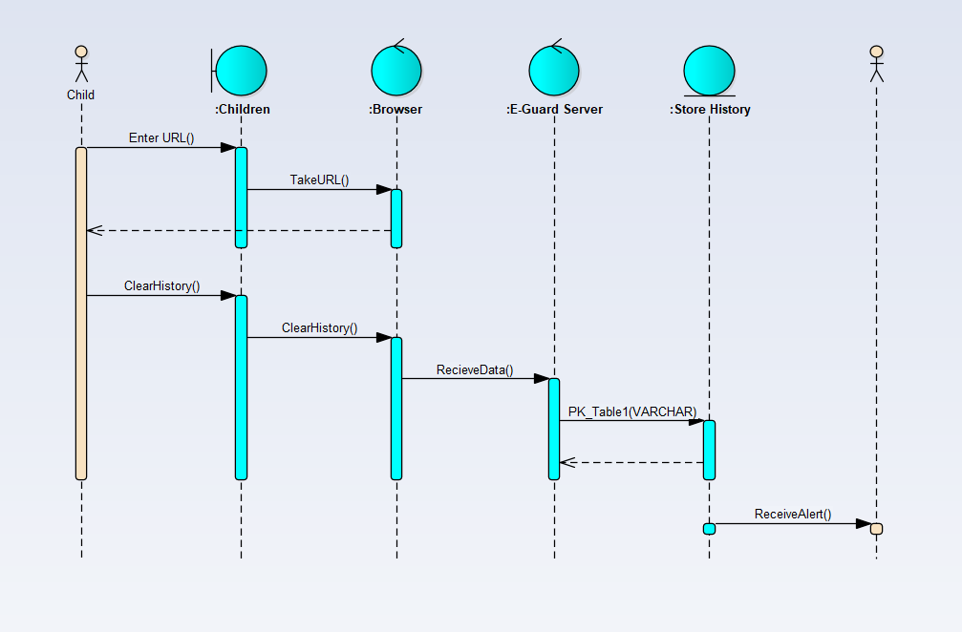

Sequence Diagram for a child visiting a website and then clearing their search history, with the history being saved by E-Guard and an alert being sent to parents.

**E-Guard State Diagram:**

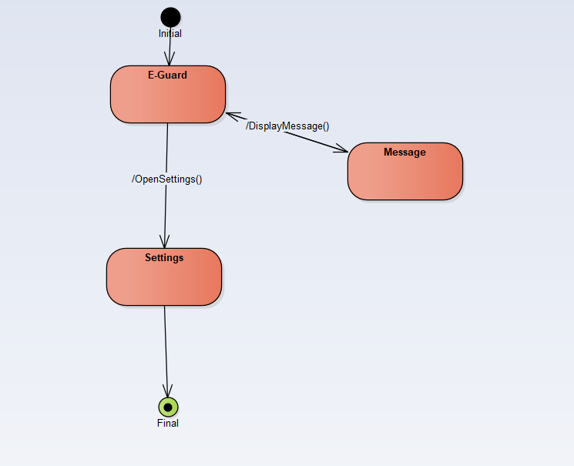

State Diagram for the E-Guard class of the Configure Class Diagram

**Settings State Diagram:**

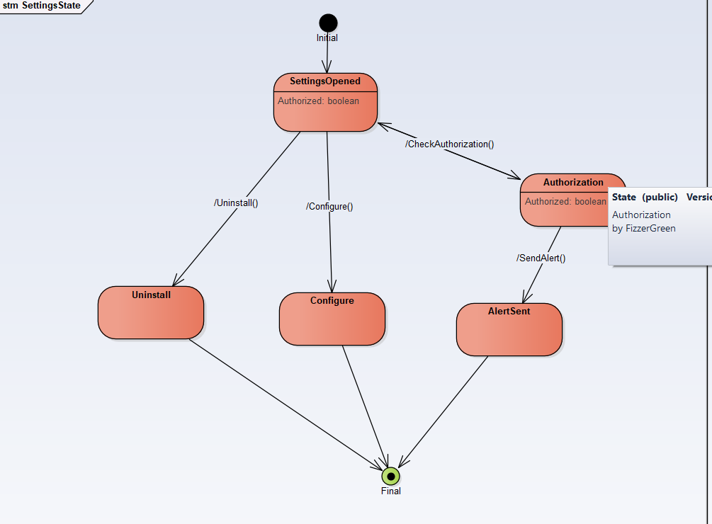

State Diagram for the Settings class of the Configure Class Diagram

**User State Diagram:**

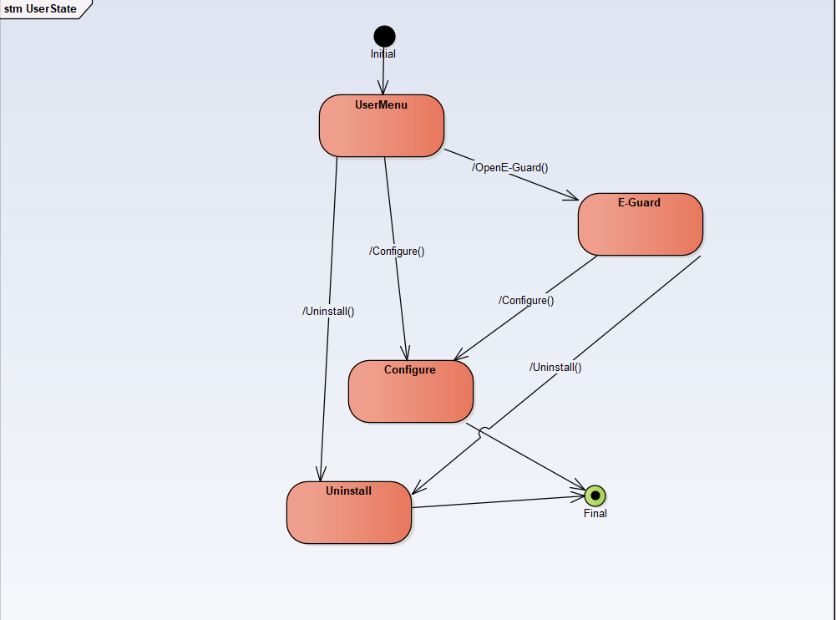

State Diagram for the User class of the Configure Class Diagram

**Adding/Removing Authorized Users Activity Diagram:**

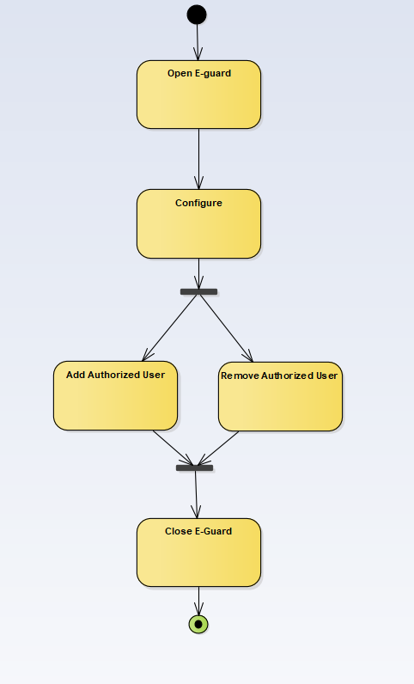

Activity Diagram for a parent either adding or removing an authorized user

**Blocking Site Activity Diagram:**

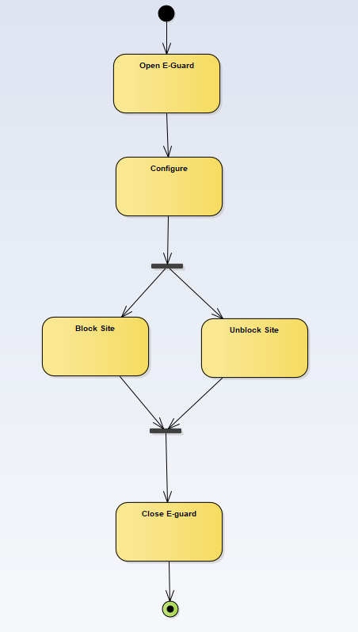

Activity Diagram for a parent either blocking or unblocking a site

**Configure Activity Diagram:**

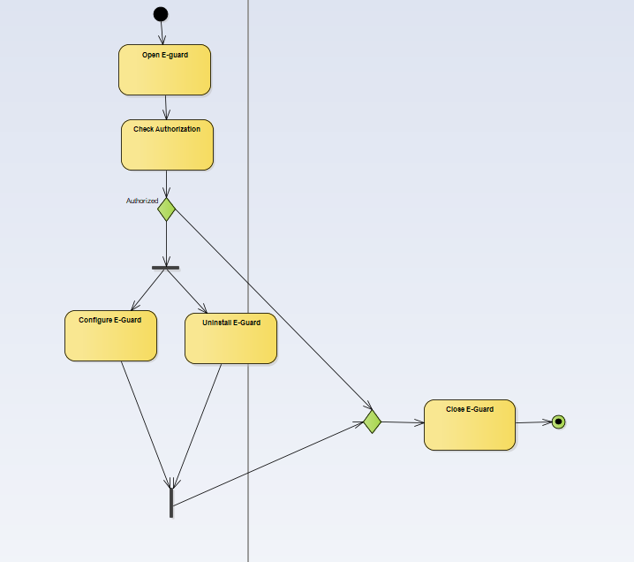

Activity Diagram for either allowing a user to configure or uninstall, or sending an alert to parents depending on their authorization status

**Requirements Model:**

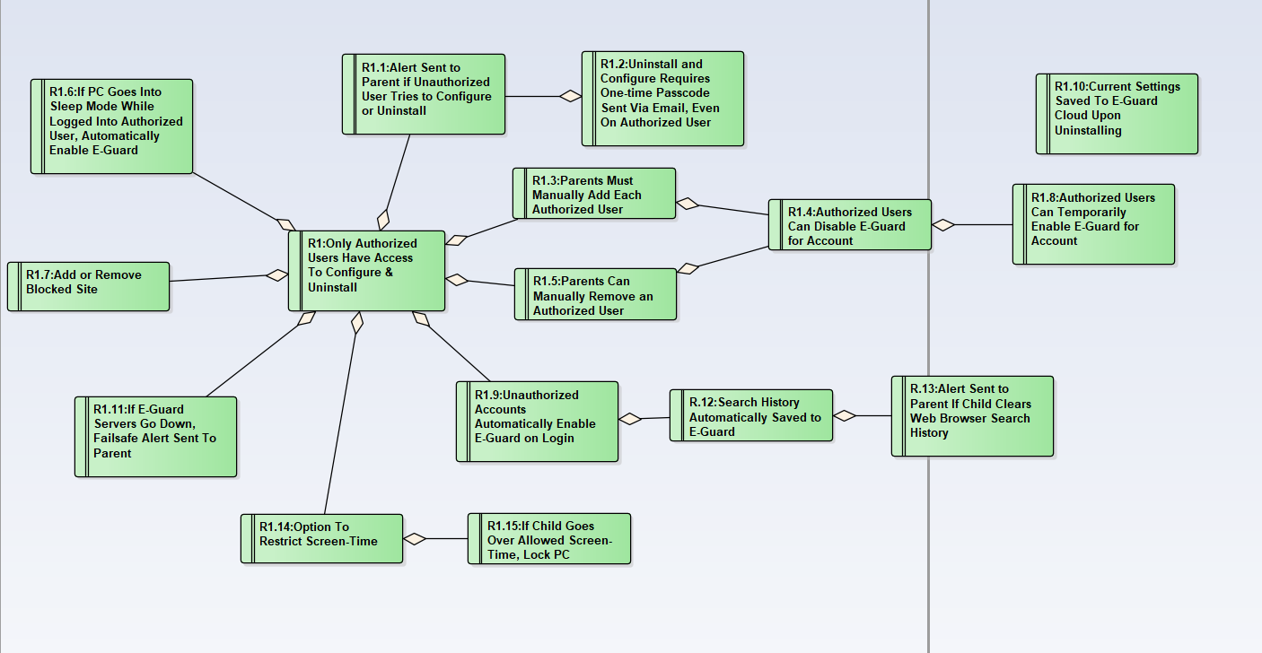

Requirements model for every use case, every requirement is functional