Project plan

Infrastructure Inventory and Monitoring Automation

CARNET
Split

Date : 16.09.2026
Version : v1.2
Status : Done
Author : Marko Šestanović

Version

Version | Date | Author(s) | Amendments | Status
1.0 | 15.9.2026 | Marko Šestanović |  | In-progress
1.1 | 16.9.2026 | Marko Šestanović |  | In-progress
1.2 | 22.09.2026 | Marko Šestanović |  | Done

Communication

Version | Date | To

Table of contents

1. Project Assignment 5
1.1 Context 5
1.2 Goal of the project 5
1.3 The assignment 5
1.4 Scope 5
1.5 Conditions 6
1.6 Finished products 6
1.7 Research questions 7
2. Approach and Planning 8
2.1 Approach 8
2.2 Research methods 8
2.3 Learning outcomes 9
2.4 Breakdown of the project 10
2.5 Time plan 12
3. Project Organization 13
3.1 Team members 13
3.2 Communication 13
3.3 Test environment 13
3.4 Configuration management 14
4. Finance and Risks 15
4.1 Risks and fall-back activities 15
5. Other 16
5.1 Disclaimer 16

Project Assignment

Context
The Croatian Academic and Research Network (CARNET) is the national research and education network of Croatia. CARNET provides ICT infrastructure, cloud services, network connectivity, cybersecurity services, and various digital platforms that support educational institutions, research organizations, students, and teachers throughout Croatia. Within CARNET, the Department of Computing Infrastructure and Services is responsible for design, implementation, operation, and maintenance of critical ICT infrastructure and services. These activities include management of server and storage platforms, virtualization environments, backup and recovery systems, monitoring systems and other operational IT services that ensure reliable and secure service delivery.

Goal of the project
The core objective of the project is to research, design and implement a proof-of-concept automation solution within the current IT environment. Currently, employees must perform repetitive, manual tasks to keep the infrastructure inventory (source of truth) and monitoring systems aligned. This manual overhead creates bottlenecks within the company and introduces the risk of human error during the configuration. The goal of the project is to eliminate these inefficiencies by bridging the two systems.
The desired situation is a streamlined, integrated workflow where the infrastructure source-of-truth communicates directly with the monitoring system. In this environment, whenever a new piece of infrastructure is deployed, modified or decommissioned in inventory, the monitoring system automatically reflects these changes.
The key benefit of the project is the drastic reduction of the required resources to deploy and monitor new infrastructure components while also freeing up employee time by eliminating the repetitive manual administrative tasks.

The assignment
The assignment is to design and deliver a working proof-of-concept that automates the deployment and monitoring of newly provisioned infrastructure components.

Scope
The project includes: | The project does not include:
- Researching, comparing and selecting the appropriate technology stack | - The final deliverable is explicitly a working prototype designed for development environment
- Designing the architecture and setting up a laboratory environment with the chosen tools | - Actively managing, maintaining, or troubleshooting the company’s live production infrastructure
- Developing a prototype that connects inventory and monitoring systems via an API | - Implementing advanced functionalities such as dry-run preview, or fully automated tests
- Implement synchronization logic that automatically creates and updates the objects based on the source of truth
- Integrating basic safety mechanics, including API handling, data validation, secure credential logging and basic logging
- Delivering final technical documentation, which covers the architecture, installation, and configuration

Conditions
Currently the company has not enforced any strict technological preconditions or specific software stack. While this provides flexibility, it requires me to objectively evaluate, compare and justify the selection of all tools to ensure they meet the project’s needs before designing the final architecture. Since this assignment’s scope is a proof-of-concept, the primary objective is to validate automatic logic within a safe, isolated development environment.

Finished products
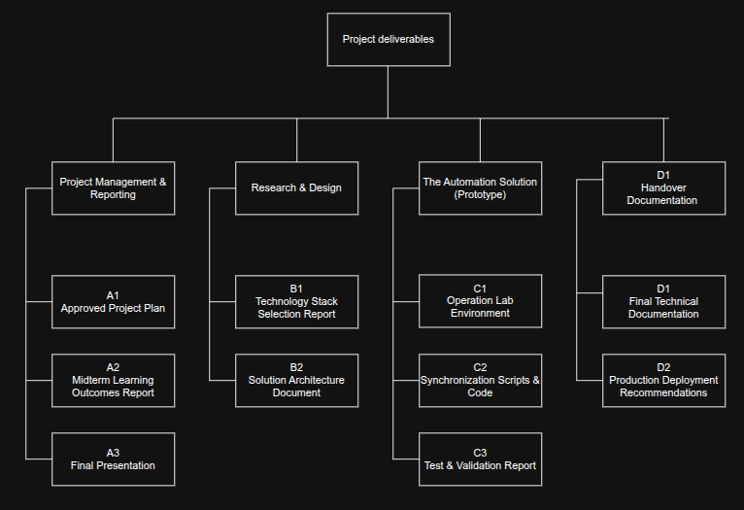
Image shows the PBS diagram
A: Project Management & Reporting
- A1: Approved Project Plan: The document defining the project objective, scope, planned phases, and expected timeline for the internship
- A2: Midterm Learning Outcome Report: A progress summary detailing the initial research, selected technologies and the end-to-end prototype
- A3: Final Presentation: The presentation and materials to present the complete, working automation workflow and final findings to the client and stakeholders
B: Research & Design
- B1: Technology Stack Selection Report: Analysis and justification of the chosen inventory solutions (e.g., Netbox), monitoring platform, and automation approaches
- B2: Solution Architecture Document: Document defining which system acts as the source of truth, how the components map to each other, and how the APIs will interact.

C: The Automation Solution (Prototype)
- C1: Operational Lab Environment: The working development setup (e.g., Docker/Podman) where the isolated inventory and monitoring systems are hosted and tested
- C2: Synchronization Scripts & Code: The actual code/automation mechanisms (e.g., Python or Ansible) that extract API data from the inventory and dynamically create, update, or ignore objects in the monitoring system
- C3: Test & Validation Report: Documentation proving the reliability of the prototype, including test of typical change scenarios, API error handling, and data validation
D: Handover Documentation
- D1: Final Technological Documentation: The complete operational guide detailing the final architecture, implementation details, installation steps, and how the synchronization process functions
- D2: Production Deployment Recommendations: A summary describing known limitations and the specific improvements or security measures required before this prototype can be safely deployed into the live production

Research questions
How can a centralized source of truth be designed and implemented to create an automated and reliable infrastructure monitoring workflow?
Q1: How can infrastructure inventory, monitoring and automation tools be evaluated and selected for automated infrastructure monitoring workflow?
Q2: How should infrastructure resources and operational relationships be modeled within a centralized source of truth to support automated monitoring?
Q3: How can an automated and reliable reconciliation mechanism be implemented between the source of truth and the monitoring platform?
Q4: What are the technical feasibility, benefits, and operational limitations of the implemented proof of concept?

Approach and Planning

Approach
For the execution of this proof of concept, an Agile methodology will be employed, specifically utilizing a modified Scrum framework, adapted for individual assignment. This approach is ideal for infrastructure project, as it allows for continuous feedback, and flexibility during the research phase.
The project begins with a problem definition phase, which functions as “Spring 0”. During this period the focus is strictly on defining the project scope and translating client’s requirements. This phase concludes with the approval of this project plan, setting the stage for research.
To maintain the rhythm and transparency, the Scrum elements will be structured as follows:
- The project timeline is divided into strict two-week sprints, to give me enough time to meet the milestones while keeping the feedback loops short.
- Because this is an individual project, I will be documenting my progress in a daily report, which will consist of technical logs recording what was built, what is planned for the next day, and any technical blockers encountered
- At the end of every sprint, a demonstration of the progress will be presented to the internship supervisor.
- A periodic review of the development process will be documented in weekly summary notes. This review will evaluate what went well technically, and what tools or processes caused issues.

Test approach
Testing will follow an iterative, scenario-based approach. Because the end goal is a stable proof-of-concept, the testing must show how the system handles discrepancies. The sandbox approach is specifically chosen because it allows for rapid destruction and recreation of the infrastructure states. It provides a safe space to simulate API failures, network timeouts, and repeated synchronization cycles.
Testing will be broken down in two main phases:
- Component validation: Testing individual elements in isolation, such as verifying that API calls can successfully authenticate
- Scenario-Based Testing: Executing predefined scenarios during the development. These scenarios include adding a new device, modifying existing tags, and intentionally breaking the API connection to test error handling

Research methods
Q1: How can infrastructure inventory, monitoring and automation tools be evaluated and selected for automated infrastructure monitoring workflow?
- Library (Literature study): I will conduct desk research by reading the official technical documentation, API references, and community forums for candidate tools. The purpose is to gather data on their technical capabilities, system requirements and integration methods
- Showroom (Benchmark): I will compare the candidate tools against the predefined functional and non-functional requirements. The purpose is to objectively prove the final choice and document why certain tools were discarded
Q2: How should infrastructure resources and operational relationships be modeled within a centralized source of truth for automated monitoring?
- Workshop (IT architecture sketching): I will create architecture diagrams and data mapping schemas. The purpose is to visually design how the data models in the source of truth will translate into objects in the monitoring system.

Q3: How can an automated, reliable synchronization mechanism be implemented between the source of truth and the monitoring platform?
- Workshop (Prototyping): I will iteratively build and refine the automation logic withing the isolated environment. The purpose is to discover technical limitations early and transfer the theoretical architecture into a functional integration.
Q4: What is the technical feasibility, benefits, and operational limitations of the implemented proof of concept?
- Lab (System testing): I will execute predefined test cases within the isolated lab environment. By simulating typical operational scenarios, I will validate the reliability, performance, and error-handling capabilities of the synchronization logic.
- Showroom (Expert review): At the end of the project, I will demonstrate the working prototype to my internship supervisor and relevant IT engineers. The purpose is to gather expert feedback on the design choices and identify missing steps required before the product can be deployed in a production environment.

Research questions | Research methods
Question 1 | Library (Literature study) | Showroom (Benchmark)
Question 2 | Workshop (IT architecture sketching)
Question 3 | Workshop (Prototyping)
Question 4 | Lab (System testing) | Showroom (Expert review)

Learning outcomes
1. Professional duties
To prove this learning outcome I will use the following documents/resources:
- Technology stack selection report: Report justifying the chosen inventory solution, monitoring platform, and automation approach
- Solution architecture document: Document which defines which system acts as the source of truth, how the components map to each other and how the APIs interact.
- Operational lab environment: The working development setup where different systems are hosted and tested
- Test & validation report: Document proving the reliability of the prototype, including tests, API error handling and data validation
- Final technical documentation: Document which consists of the complete operational guide detailing the final architecture, implementation details, and installation steps
2. Situation-orientation
To prove this learning outcome I will use the following documents/resources:
- Agile workflow with standard two-week sprints and bi-weekly reviews
- Daily and weekly logs which will include what was built, what were the struggles and what is the task for the next day
- Final technical documentation and Technology stack selection report are used as a proof of the project relevance, since they will provide the blueprint company needs to eventually deploy this solution into production
- Bi-weekly sprint reviews will be used as feedback which will influence my design choices

3. Professional standard
I am proving this learning outcome by aligning my way of working with the company’s. This includes the Agile/scrum workflows and daily progress reports. I also prove the learning outcome by applying DOT research methods in different periods of the project, ensuring my solutions are well informed and effective.
4. Personal leadership
I will prove this learning outcome by delivering all of the previously mentioned documents. This will prove my communication, planning, documentation and independence skills. I will also reflect on my skills and the skills I am missing as an ICT-professional

Breakdown of the project
Sprint 0 – Initial project planning
- Define the project problem and expected outcome
- Define the main development phases and expected deliverables
Deliverables: Project plan

Sprint 1 – Research & technology selection
- Research the appropriate tools which will be used
- Research what data model will be modeled by the source of truth
- How can automated synchronization mechanism be implemented between inventory and monitoring system
- What are technical feasibility, benefits, and operational limitations of the project
Deliverables: Select and justify the technologies which will be used for the remainder of the project

Sprint 2 – Architecture & development environment
- Define the architecture of the selected solution
- Define the basic mapping between inventory objects and monitoring objects
- Build a laboratory/development environment with the selected tools
Deliverables: Working development environment in which the inventory and monitoring systems can be tested

Sprint 3 – First automation prototype
- Connect to the inventory system trough it’s API
- Retrieve the basic device information
- Connect to the monitoring system trough it’s API
- Automatically create monitoring objects based on inventory data
Expected result: Basic end-to-end prototype: inventory change –> automation –> monitoring system

Sprint 4 – Synchronization & midterm portfolio report
- Extend the prototype so it can detect existing monitoring objects
- Implement basic synchronization:
  - create missing objects
  - update changed objects
  - detect unchanged objects
- Test several typical change scenarios
- Document work completed during the first half of the project
Deliverable: Working synchronization mechanism connecting inventory and monitoring systems and midterm portfolio report

Sprint 5 – Reliability and production-oriented improvements
- Validation of inventory data
- Safe handling of devices removed from monitoring
- Error handling for API failures
- External configuration and secure credential handling
- Basic logging and synchronization reporting
Deliverables: Initial project becomes more reliable solution capable of handling common operational and error scenarios

Sprint 6 – Final testing & project documentation
- Test the complete workflow
- Fix identified problems
- Document the final architecture and implementation
- Document installation and configuration
- Document the synchronization process
- Describe known limitations and possible future improvements
- Prepare the final project demonstration
Deliverables: Demonstration of the complete workflow and deliver the final documents:
Inventory object –> synchronization –> monitoring object –> modification –> synchronization update
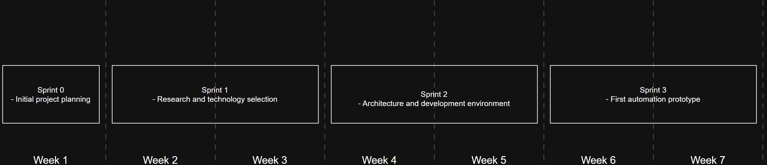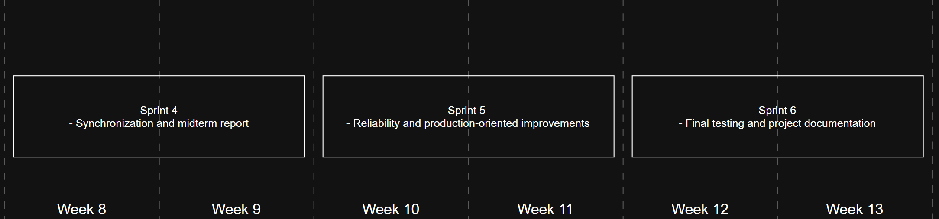
Images visually show the project sprints

Time plan

Phasing | Start | Ready
Sprint 0 – Project planing | 14.09 | 20.09
Sprint 1 – Research & technology selection | 21.09 | 04.10
Sprint 2 – Architecture & development environment | 05.10 | 18.10
Sprint 3 – First automation prototype | 19.10 | 01.11
Sprint 4 – Synchronization & midterm portfolio report | 02.11 | 15.11
Sprint 5 – Reliability & production improvements | 16.11 | 29.11
Sprint 6 – Final testing & documentation | 30.11 | 15.12

Project Organization

Team members
Name + Phone + e-mail | Abbr. | Role/tasks | Availability
Ljubomir Hrboka  +385 16661757  ljubomir.hrboka@carnet.hr |  | Product Owner | 5 days a week
Krešimir Šodan  +385 976463683  ksodan@carnet.hr |  | Secondary Supervisor | Once a week
Marko Šestanović  +385 996432052  558991@student.fontys.nl |  | Intern | 5 days a week
Mehrzad Verdizadegan  +31 885086811  m.verdizadegan@fontys.nl |  | 1st assessor | 5 days a week
Gleb Popov  +31 885084465  g.popov@fontys.nl |  | 2nd assessor | None

Communication
- Daily notes, a brief, written summary of technical progress, daily goals, and any blockers
- Weekly 30 minutes meetings to discuss the general progress and plan the focus for the upcoming week
- Bi-weekly meetings at the start of the sprint as a formal demonstration of the working prototype and gather feedback

Test environment
The test environment for this assignment will be an isolated, local sandbox designed to simulate a scaled-down version of a production infrastructure. To ensure consistency and avoid modifying any live company assets, the environment will be entirely containerized in Docker. The laboratory setup will consist of newly deployed project products and necessary external components:
- Source of truth: Containerized instance of selected inventory system populated with dummy data
- Monitoring platform: Containerized instance of the selected monitoring system
- Automation mechanism: Selected automation tool responsible for reading the inventory and writing to the monitoring system
- Host hardware: Dedicated development workstation provided by the company serving as the Docker host for the containers.

Configuration management
All project resources, including automation code, development environment configurations, and technical documentation will be archived and version-controlled using the central Git repository. To maintain a clean and logical separation, the repository will follow a standardized directory structure:
- “/docs” : Contains all of project’s documentation, including architecture diagrams, test reports, daily logs and sprint logs
- “/env”: Holds the configuration files required to build the local laboratory environment
- “/scripts”: Contains core automation logic, such as custom scripts or tool specific scripts

Finance and Risks

Risks and fall-back activities
Risk | Prevention activities included in plan | Fall-back Activities
- Company supervisor is unavailable for extended period | Agile workflow ensures the progress is not hindered, and the Git repository ensures the project is accessible and transparent to the company | A secondary stakeholder will step-in to review the sprint demos and help with technical issues
- The API lacks necessary endpoints or has undocumented bugs | The project timeline prevents this since the first end-to-end API connection is scheduled early in sprint 3 | Because the research phase includes evaluating alternatives, the project can pivot to a backup tool
- The local development host crashes and potentially wipes weeks of configuration work | The entire lab environment is defined as code and all resources are version controlled | Since the environment is containerized and version controlled, the setup can be rebuilt on a new host machine

Other

Disclaimer
Parts of this document were written by an AI tool. I have used the tool to re-format my words, so they sound more professional and up to standard. The AI tool was used simply to enhance/enrich the sentences and nothing more. None of the text was written purely by AI tool.

