Codesys OPC UA setup with UA Expert No security.

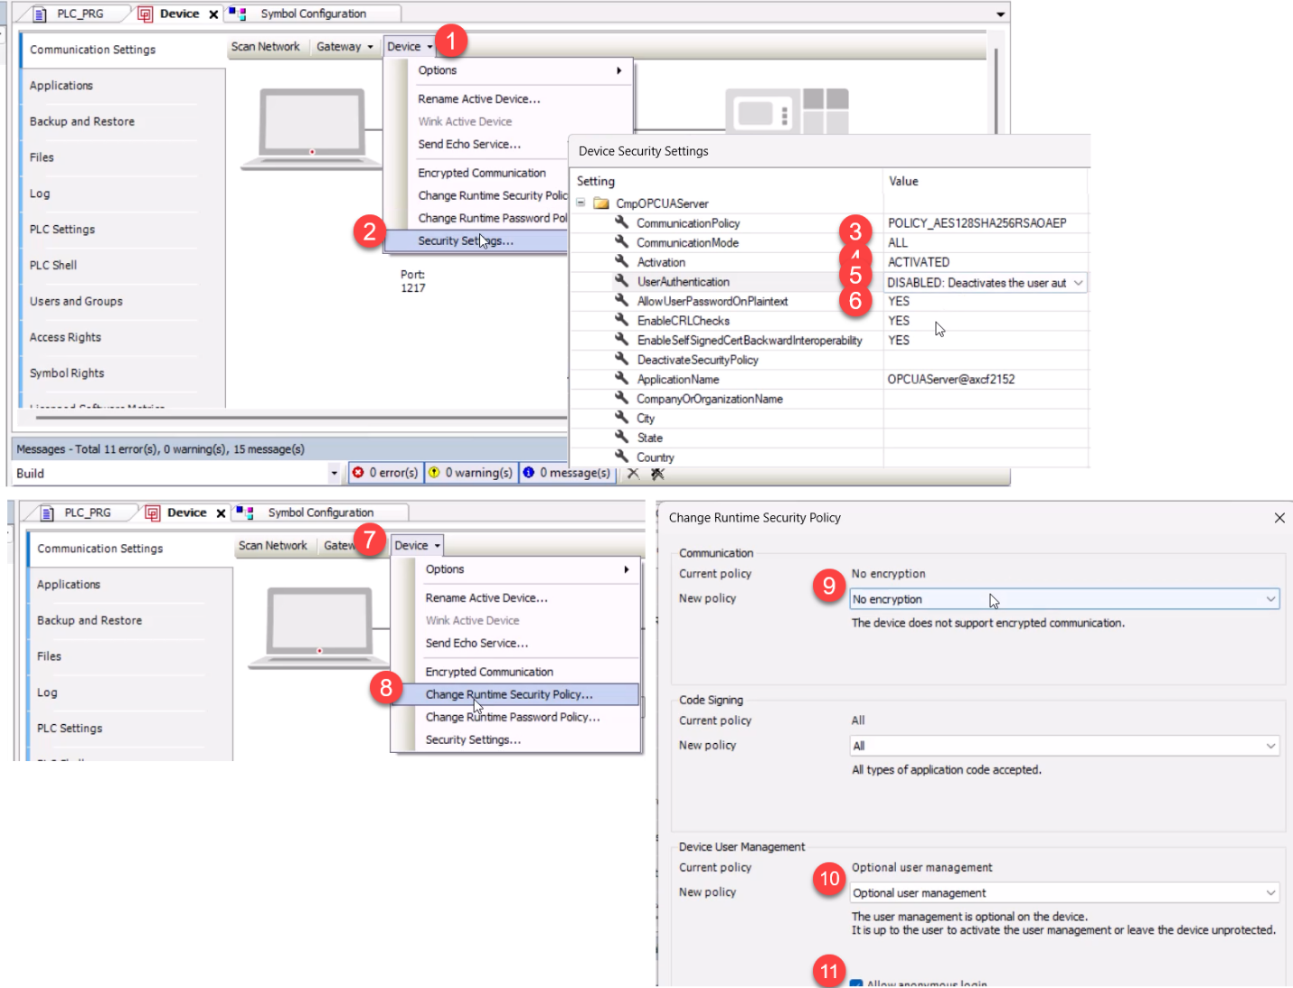

1. Go to Device
2. Go to security settings
3. Set communication mode to ALL
4. Set Activation to ACTIVATED
5. Set User Authentication top DISABLED
6. Set AllowUserPasswordOnPlaintext to YES
7. Go to device
8. Go to change runtime security policy
9. Set communication to No Encryption
10. Optional: Set device user management to optional
11. Check the box for allow anonymous login

Once complete, you should be able to connect to UA expert.   
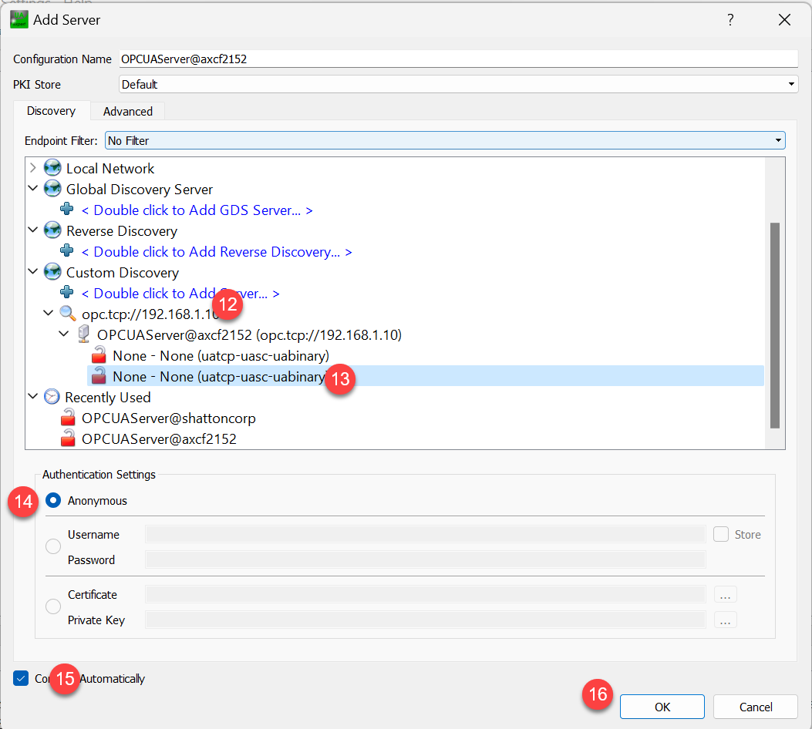

12. Add the OPC-UA server to discovery

13. Choose the second option

14. Make sure anonymous is checked

15. Check connect automatically

16. Click ok.

Then, you'll need to add some variables to symbol configuration in the Codesys IDE.   
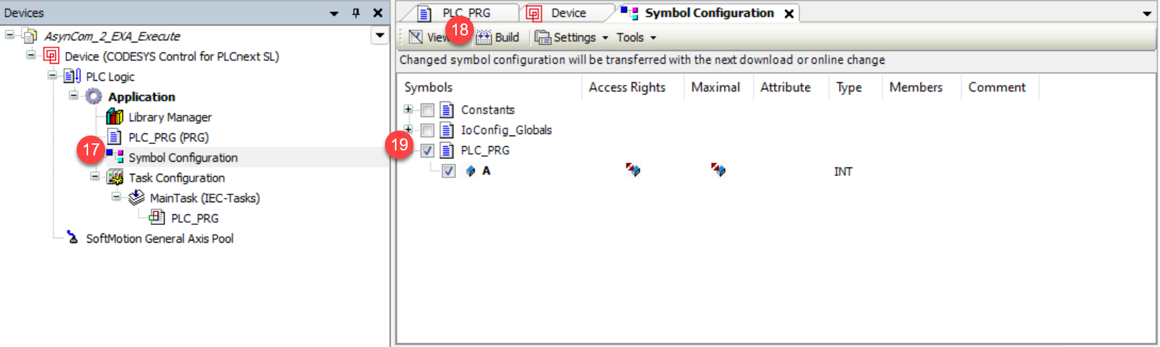

17. Add a symbol configuration object to the tree

18. Build the application

19. Check the variables that you want to view in UA expert

Now, when you go back to UA expert it should look like this:

