StreamFlow — Subscription Analytics Report
Funnel, revenue, cohort retention and unit economics of a subscription language-learning app
Pavlo Renhach · October 2026 · SQL (MySQL, DBeaver) · Power BI (Power Query, DAX)
Contents
Executive summary 1
Data and method 2
Revenue 4
Acquisition funnel 5
Cohort retention 6
Unit economics 7
Deep dives 8
Refunds and campaigns 9
Recommendations 10
Limitations 10

The report opens with the conclusions and the way the numbers were produced. The next six sections follow the Power BI pages: each one starts with the main finding, then shows the dashboard page, the details and the SQL query that checks the numbers. It ends with recommendations and the limits of the data.

Executive summary
Acquisition pays back. Each StreamFlow user has brought $68.71 of net revenue so far, against $18.36 of direct marketing spend (3.7x) or $36.91 once shared overhead is included (1.86x). Monthly net revenue reached $34.3K in August 2025.
The analysis covers 5,000 users and 23,020 transactions from February 2024 to August 2025, across 6 countries and 7 acquisition channels.
- Revenue: renewals bring 61.9% of the $343.6K net revenue, so keeping payers matters more than first payments.
- Funnel: 76.6% of signups start a trial and 64.0% of trials convert to paid. Mexico (52.7%) and Brazil (55.9%) convert 16–19 points below the US (71.8%).
- Retention: 49% of a cohort still pays one month after signup and about 35% by months 8–11. Annual renewals lift month 12 to 42.9%.
- Black Friday 2024: the discount moved half of the November cohort to cheap Annual plans. That cohort has the lowest LTV of its neighbours ($56.64 vs $64–83).
- Facebook Ads: CAC per new user rose 49% from Feb–Apr to May–Jul 2024 ($36.7 → $54.7).
- Brazil: users pay the least for the Monthly plan ($10.79 vs a $14.99 list price), but they are so cheap to acquire that Brazil has the best LTV/CAC (7.2x direct).
The three most valuable next steps are fixing trial conversion in Mexico and Brazil, limiting deep Annual discounts, and alerting on paid-channel CAC spikes (see Recommendations).

Data and method
The dashboard figures are DAX measures in Power BI, and the headline figures were rebuilt independently in SQL. All 26 match.
- Source: a MySQL database with 4 tables and 28,432 rows (users 5,000, transactions 23,020, marketing spend 407, plans 5). Profiling in DBeaver found no duplicate keys and no orphan rows.
- Extract: four SQL queries in DBeaver, one per table, saved as CSV. They select explicit columns and contain no business logic.
- Model: a Power BI star schema with two fact tables (transactions, marketing spend) and shared dimensions for date, country and channel, plus users and plans. Signup date has its own inactive relationship to the date table for new-user measures.
- Metrics: 65 DAX measures in six folders: base, funnel, revenue, retention, unit economics, advanced.
- Validation: six SQL queries rebuild the dashboard figures and compare them with Power BI.
Before the analysis, the data was checked on seven quality dimensions. None of the checks found errors, so no rows were removed or corrected.
Dimension | Check | Result
Completeness | Missing values in every column | Only two columns have gaps, both by design: campaign is empty for the 19,794 transactions without a campaign, and duration_days is empty for the Lifetime plan.
Uniqueness | Duplicate keys in all four tables | None. Every key is unique.
Validity | Category values, amounts and their signs | All values match the data description: 6 countries, 3 platforms, 7 channels, 5 age groups, 5 transaction types. Trials are $0, refunds are negative, payments are positive.
Consistency | Links between tables | Every transaction has a matching user and plan. No orphan rows.
Accuracy | Business rules | No violations: no transaction before signup, no renewal without a first payment, no renewal of the Lifetime plan.
Timeliness | Date range of each table | Users, transactions and marketing spend all cover February 2024 to August 2025 (19 months).
Relevance | Fields needed for each question | Marketing rows with country 'Global' (SMM + Content, $92,750) belong to no country, so they are kept apart as shared overhead.
All 23,020 transactions and 5,000 users are used as they are. Refunds stay in as negative amounts, so net revenue is a plain sum. Two fields are missing for a fuller analysis: a cancellation date, so a subscriber counts as active only in months with a payment, and campaign costs, so the return on campaigns cannot be measured.
The main metrics are defined as follows:
Metric | Definition
LTV per user | Net revenue paid so far ÷ users. Historical, not a forecast.
CAC direct | Marketing spend of the country or channel ÷ users it acquired
CAC loaded | Direct spend + shared Global overhead (SMM + Content, $92,750), split by each country's share of users
Retention, month N | Share of a signup cohort with a paying transaction N calendar months after signup
Trial → Paid | Users with a trial and a later first payment ÷ users with a trial
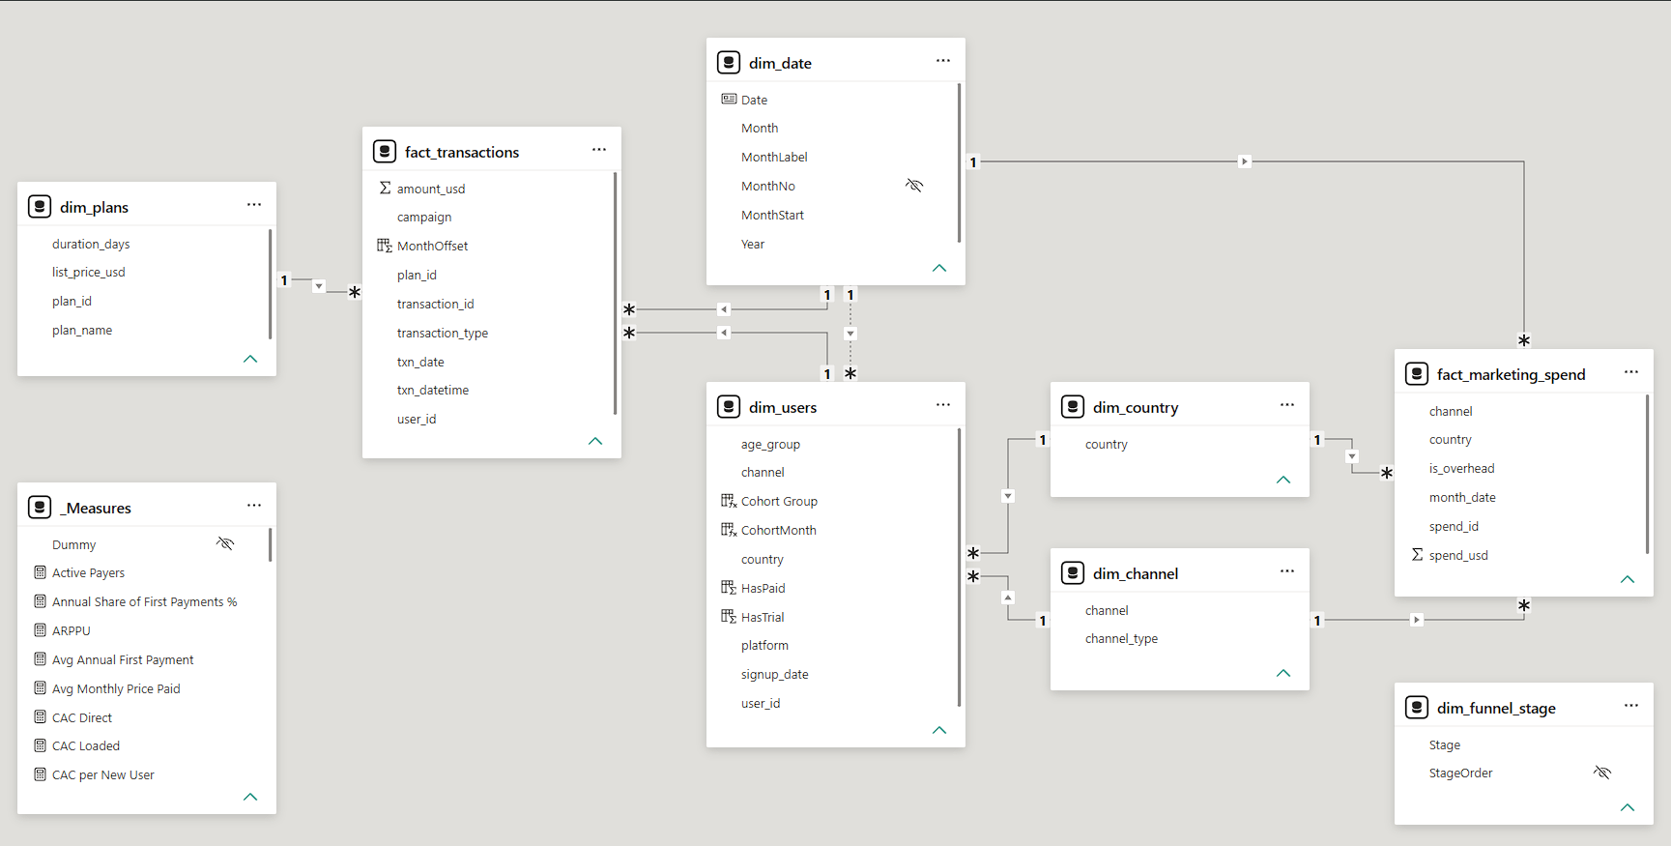
Figure 1. Power BI data model (star schema)
SQL check in DBeaver: every headline number is recomputed from the raw tables and compared with the value shown in Power BI (abridged from sql/validation/01_reconcile_headline_kpis.sql).
WITH sql_values AS (
SELECT 'Total Users' AS metric, COUNT(*) AS sql_value FROM users
UNION ALL SELECT 'Net Revenue, $', ROUND(SUM(amount_usd), 2) FROM transactions
UNION ALL SELECT 'Refunds, $', ROUND(-SUM(amount_usd), 2)
FROM transactions WHERE transaction_type = 'refund'
-- ... 23 more metrics in the full query
),
power_bi_values AS (
SELECT 'Total Users' AS metric, 5000 AS power_bi_value
UNION ALL SELECT 'Net Revenue, $', 343563.00
UNION ALL SELECT 'Refunds, $', 1777.03
)
SELECT s.metric, s.sql_value, p.power_bi_value,
CASE WHEN s.sql_value = p.power_bi_value THEN 'OK' ELSE 'CHECK' END AS status
FROM sql_values s
JOIN power_bi_values p ON p.metric = s.metric;
Result: all 26 metrics return OK.

Revenue
Net revenue grew from $1.3K in February 2024 to $34.3K in August 2025, and renewals now carry it. Over the whole period they brought 61.9% of the $343.6K total, and $24.0K of August's $34.3K.
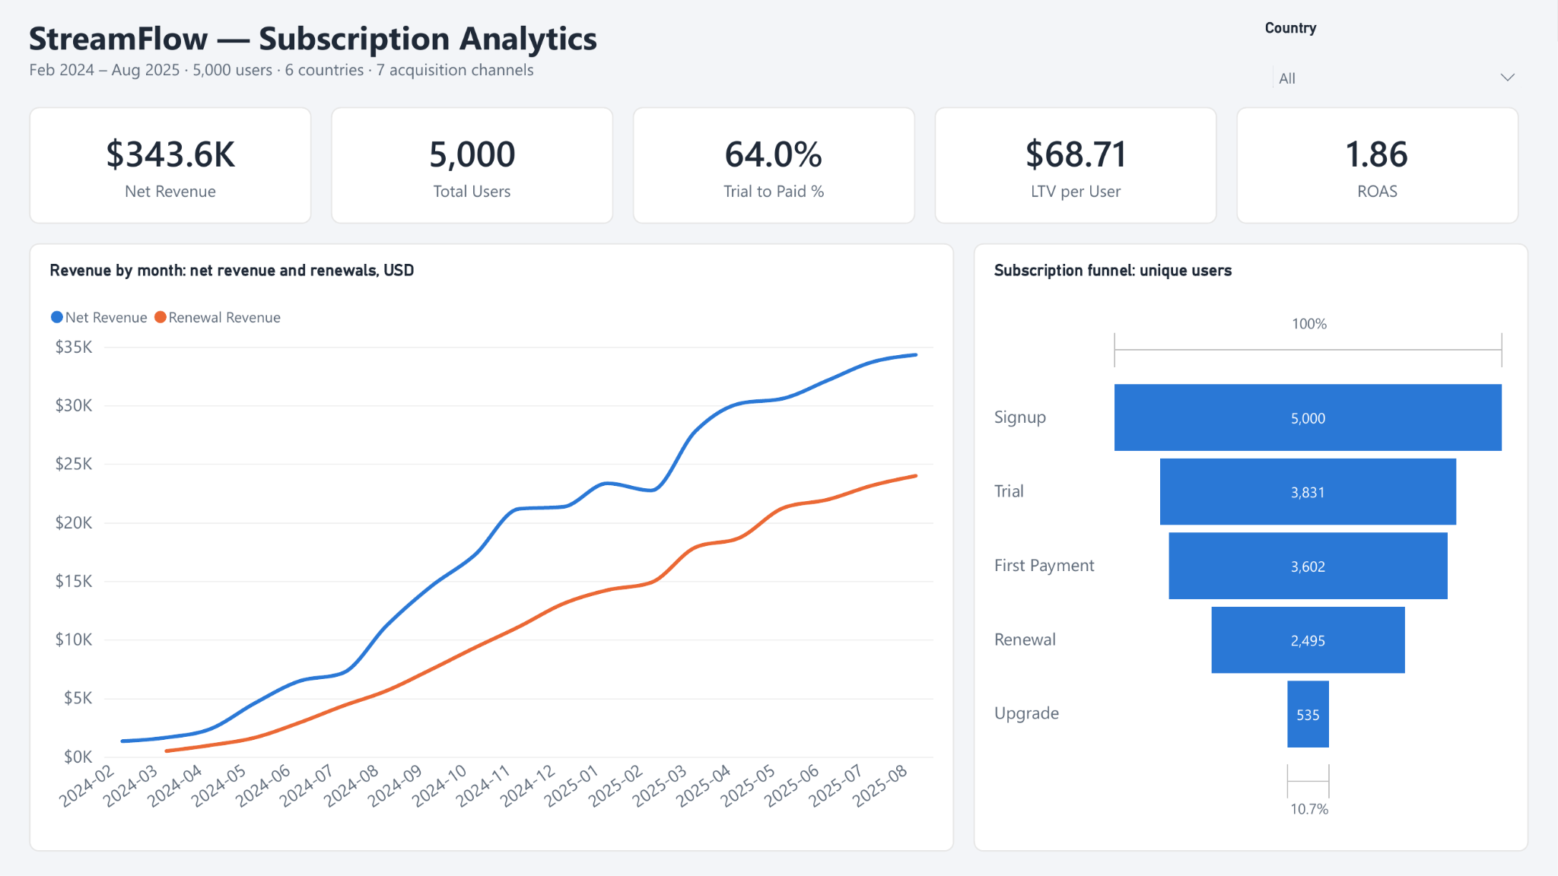
Figure 2. Overview page: KPIs, monthly revenue and the subscription funnel
Revenue type | Net revenue, $ | Share
Renewals | 212,742 | 61.9%
First payments | 94,178 | 27.4%
Upgrades | 38,420 | 11.2%
Refunds | −1,777 | −0.5%
Growth has slowed. Revenue was flat from November 2024 to February 2025 ($21.2K–$23.3K) and has grown only 2–5% a month since April 2025. The Monthly plan brings 67.5% of gross revenue, Annual 18.5%, Lifetime 8.9% and Quarterly 5.0%.
SQL: revenue by transaction type and its share of the total.
SELECT transaction_type,
ROUND(SUM(amount_usd)) AS net_revenue,
ROUND(100 * SUM(amount_usd) / SUM(SUM(amount_usd)) OVER (), 1) AS share_pct
FROM transactions
WHERE transaction_type <> 'trial_start'
GROUP BY transaction_type
ORDER BY net_revenue DESC;
Result: the same split as in the table above.

Acquisition funnel
Two in three trial users become payers (64.0%), but the rate depends on the country far more than on the channel. Of 5,000 signups, 3,831 (76.6%) started a trial and 3,602 (72.0%) made a first payment. 2,495 (49.9%) renewed at least once and 535 (10.7%) upgraded.
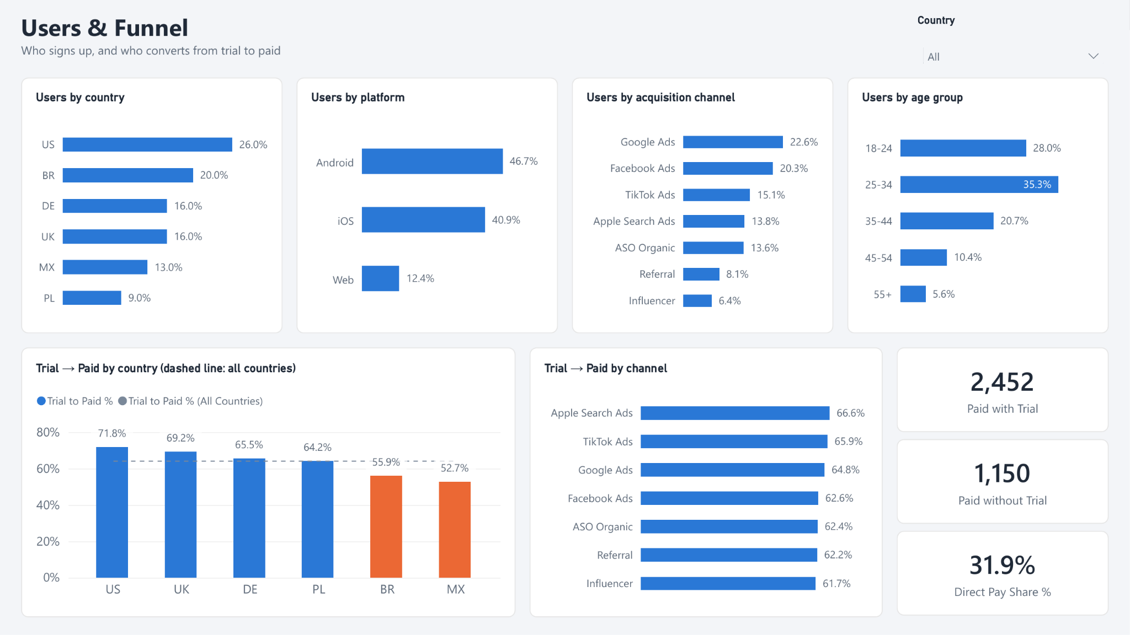
Figure 3. Users & Funnel page
- Countries: Trial → Paid ranges from 71.8% in the US to 55.9% in Brazil and 52.7% in Mexico. Bringing Brazil and Mexico up to the 64.0% average would add about 120 paying users.
- Channels: the spread is narrow, from 61.7% (Influencer) to 66.6% (Apple Search Ads). Channel choice does not explain weak conversion.
- Trial is optional: 1,150 payers (31.9%) paid without a trial, so the trial is not the only way in.
SQL: the funnel from raw transactions, with the share of signups and step-to-step conversion from window functions (abridged from sql/validation/02_funnel.sql).
WITH stage_users AS (
SELECT 1 AS stage_order, 'Signup' AS stage, COUNT(*) AS users FROM users
UNION ALL SELECT 2, 'Trial', COUNT(DISTINCT user_id)
FROM transactions WHERE transaction_type = 'trial_start'
UNION ALL SELECT 3, 'First Payment', COUNT(DISTINCT user_id)
FROM transactions WHERE transaction_type = 'first_payment'
UNION ALL SELECT 4, 'Renewal', COUNT(DISTINCT user_id)
FROM transactions WHERE transaction_type = 'renewal'
)
SELECT stage, users,
ROUND(100 * users / FIRST_VALUE(users) OVER (ORDER BY stage_order), 1)
AS pct_of_signup,
ROUND(100 * users / LAG(users) OVER (ORDER BY stage_order), 1) AS step_pct
FROM stage_users;
Result: 5,000 → 3,831 (76.6%) → 3,602 (72.0%) → 2,495 (49.9%), the same as in Power BI.

Cohort retention
About half of a cohort still pays one month after signup (49.1%), and about a third is still paying after 8–11 months (34–35%). The curve weights each month by cohort size and only counts cohorts old enough to have reached that month.
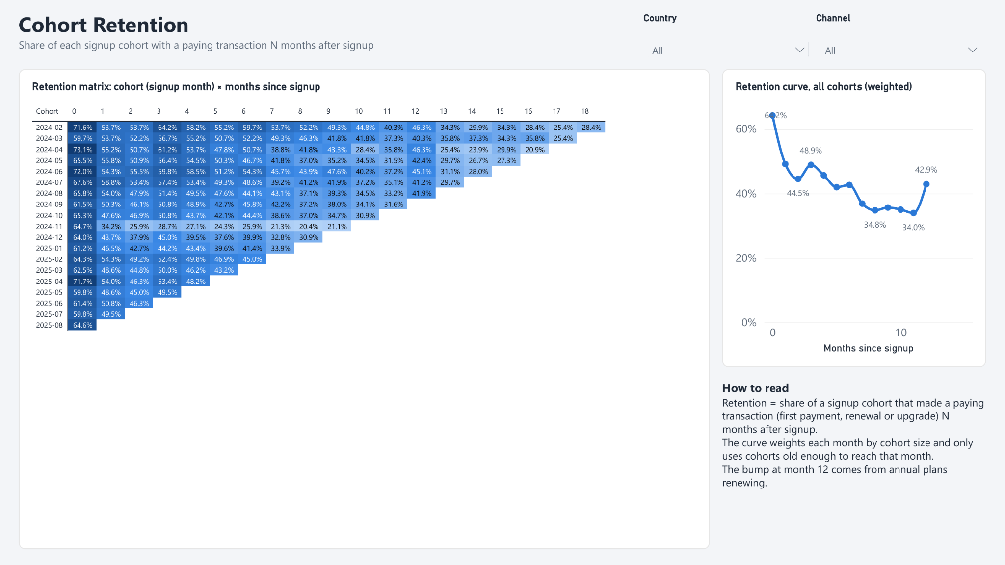
Figure 4. Retention page: cohort matrix and weighted retention curve
- Biggest drop: from 64.2% in the signup month to 49.1% one month later. The first renewal is where most payers are lost.
- Plan renewals lift the curve: month 3 rises to 48.9% because 151 Quarterly payers renew then. Month 12 rises to 42.9% because Annual renewals jump from 34 users in month 11 to 93.
- Weakest cohort: November 2024 keeps only 34.2% in month 1, against 44–48% for its neighbours. Half of it bought Annual plans, which pay once a year and so do not show as paying in months 1–11 (see Deep dives).
SQL: the weighted retention curve (simplified from sql/validation/03_cohort_retention.sql).
WITH payments AS (
SELECT DISTINCT t.user_id,
PERIOD_DIFF(DATE_FORMAT(t.date, '%Y%m'),
DATE_FORMAT(u.signup_date, '%Y%m')) AS month_offset
FROM transactions t
JOIN users u ON u.user_id = t.user_id
WHERE t.transaction_type IN ('first_payment', 'renewal', 'upgrade')
),
cohorts AS (
SELECT DATE_FORMAT(signup_date, '%Y%m') AS cohort, COUNT(*) AS cohort_size
FROM users
GROUP BY cohort
)
SELECT p.month_offset,
ROUND(100 * COUNT(*) / (
SELECT SUM(c.cohort_size) FROM cohorts c -- only cohorts old enough
WHERE PERIOD_DIFF('202508', c.cohort) >= p.month_offset -- (data ends Aug 2025)
), 1) AS retention_pct
FROM payments p
GROUP BY p.month_offset
ORDER BY p.month_offset;
Result: 64.2% in month 0, 49.1% in month 1 and 42.9% in month 12, as on the Retention page.

Unit economics
Acquisition pays back in every country, but the ranking flips once shared overhead is counted. On direct spend Brazil leads with 7.2x LTV/CAC. With the Global overhead ($92,750, more than direct spend) split by users, the US leads with 2.13x and Poland is last with 1.58x.
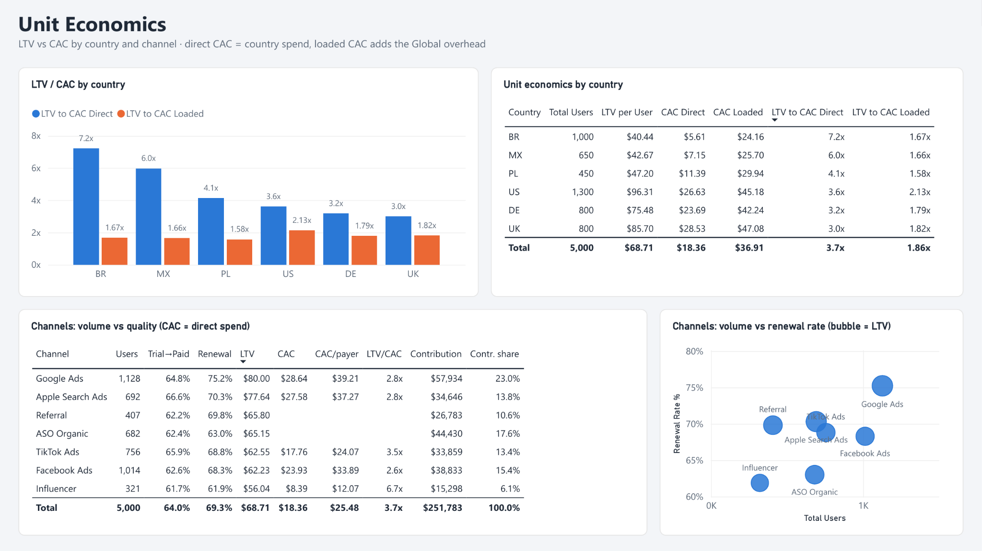
Figure 5. Unit Economics page: LTV vs CAC by country and channel
- Cheap vs valuable users: a US user brings $96.31 and a Brazilian user $40.44. A Brazilian user costs only $5.61 in direct spend against $26.63 in the US.
- Overhead matters: loaded CAC ($36.91) is twice direct CAC ($18.36). Total LTV/CAC falls from 3.7x to 1.86x, so overhead decides whether growth is profitable.
- Channels: Google Ads brings the most after its own spend ($57,934, 23.0% of the total contribution) and the best renewal rate (75.2%). Influencer is the cheapest paid channel ($8.39 per user, 6.7x) but has the lowest LTV ($56.04) and renewal rate (61.9%).
- Organic: ASO Organic and Referral bring 1,089 users (22%) with no direct spend and $71,213 of net revenue.
SQL: LTV and CAC by country, with the Global overhead split by each country's share of users (simplified from sql/validation/04_unit_economics.sql).
WITH users_c AS (SELECT country, COUNT(*) AS users FROM users GROUP BY country),
revenue AS (SELECT u.country, SUM(t.amount_usd) AS net_revenue
FROM transactions t JOIN users u ON u.user_id = t.user_id
GROUP BY u.country),
spend AS (SELECT country, SUM(spend_usd) AS direct_spend
FROM marketing_spend WHERE country <> 'Global' GROUP BY country),
overhead AS (SELECT SUM(spend_usd) AS global_spend
FROM marketing_spend WHERE country = 'Global')
SELECT c.country,
ROUND(r.net_revenue / c.users, 2) AS ltv,
ROUND(s.direct_spend / c.users, 2) AS cac_direct,
ROUND(r.net_revenue / s.direct_spend, 1) AS ltv_cac_direct,
ROUND(r.net_revenue / (s.direct_spend
+ o.global_spend * c.users / SUM(c.users) OVER ()), 2) AS ltv_cac_loaded
FROM users_c c
JOIN revenue r USING (country)
JOIN spend s USING (country)
CROSS JOIN overhead o
ORDER BY ltv_cac_direct DESC;
Result: Brazil 7.2x direct and 1.67x loaded, the US 3.6x and 2.13x, as in Power BI.

Deep dives
Three anomalies have clear causes: a deep Black Friday discount, a short Facebook Ads cost spike and low local prices in Brazil.
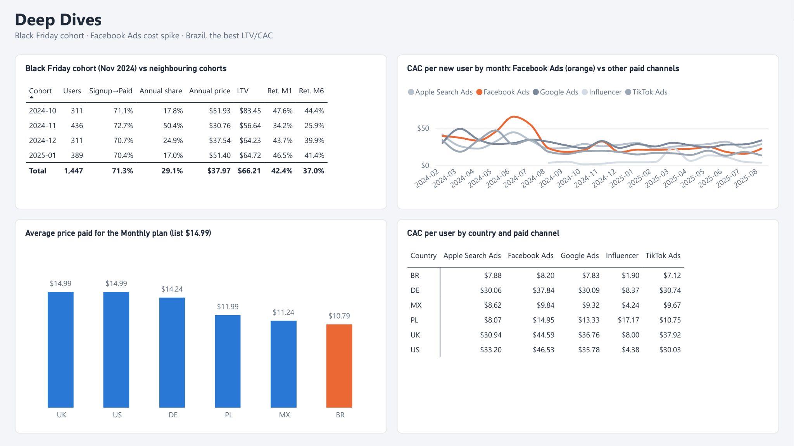
Figure 6. Deep Dives page: Black Friday cohort, Facebook Ads CAC, Monthly price by country
Black Friday cohort (November 2024). The month brought 436 signups, 40% more than October or December (311 each). These users converted as well as others (72.7% signup → paid), but 50.4% chose Annual, against 17–25% in neighbouring cohorts. They paid $30.76 on average for a plan listed at $59.99, while October payers paid $51.93. As a result the cohort's LTV is $56.64, against $83.45 for October and $64–65 for December and January. Its M6 retention (25.9% vs 40–44%) is low partly by definition: Annual subscribers pay once a year, so they do not show as paying in months 1–11.
Facebook Ads cost spike. CAC per new user rose from $36.7 in February–April 2024 to $54.7 in May–July, peaking at $65.55 in June. Other paid channels stayed flat. From August 2024 Facebook Ads cost $15–25 per new user most months, in line with the rest. The spike rests on small volumes (32 and 64 new users), so it shows up in the trend more than in totals.
Brazil. Brazilian users pay $10.79 on average for the Monthly plan, 28% below the $14.99 list price that US and UK users pay. Mexico ($11.24) and Poland ($11.99) also pay less. Brazil still has the best direct LTV/CAC (7.2x), because a user there costs only $5.61 to acquire.
SQL: Annual share and average Annual price of first payments for the cohorts around Black Friday (simplified from sql/validation/06_deep_dives.sql).
SELECT DATE_FORMAT(u.signup_date, '%Y-%m') AS cohort,
ROUND(100 * AVG(p.plan_name = 'Annual'), 1) AS annual_share_pct,
ROUND(AVG(CASE WHEN p.plan_name = 'Annual' THEN t.amount_usd END), 2)
AS avg_annual_price
FROM transactions t
JOIN users u ON u.user_id = t.user_id
JOIN subscription_plans p ON p.plan_id = t.plan_id
WHERE t.transaction_type = 'first_payment'
AND u.signup_date >= '2024-10-01' AND u.signup_date < '2025-02-01'
GROUP BY cohort
ORDER BY cohort;
Result: November 2024 has 50.4% Annual at $30.76; the other cohorts have 17.0–24.9% at $37.54–51.93.

Refunds and campaigns
Refunds are too small to act on (0.51% of gross revenue). Campaigns matter far more for upgrades than for renewals.
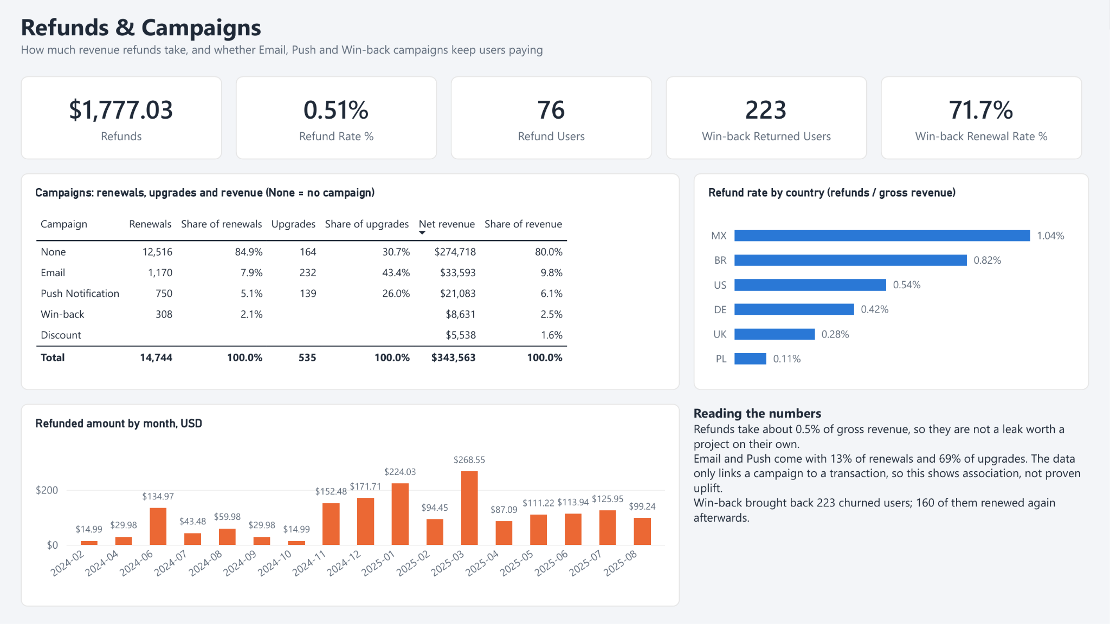
Figure 7. Refunds & Campaigns page
- Refunds: 77 refunds from 76 users, $1,777 in total. The rate is highest in Mexico (1.04%) and Brazil (0.82%) and lowest in Poland (0.11%).
- Email and Push: they come with 1,920 renewals (13.0%) but 371 upgrades (69.3%), so nearly every upgrade follows a campaign message. The data links a campaign to a transaction but has no control group, so this is an association, not proven uplift.
- Win-back: the campaign brought back 223 churned users and $8,631 of net revenue. 160 of them (71.7%) renewed again afterwards, slightly above the overall renewal rate (69.3%).
- Discount: the Black Friday campaign ran from 15 November to 11 December 2024 and brought $5,538 (1.6% of revenue) in first payments.
SQL: users who came back through Win-back and renewed afterwards (sql/validation/05_campaigns_refunds.sql).
WITH returned AS (
SELECT user_id, MIN(date) AS return_date
FROM transactions
WHERE campaign = 'Win-back' AND transaction_type = 'first_payment'
GROUP BY user_id
)
SELECT COUNT(DISTINCT r.user_id) AS returned_users,
COUNT(DISTINCT t.user_id) AS renewed_after,
ROUND(100 * COUNT(DISTINCT t.user_id) / COUNT(DISTINCT r.user_id), 1)
AS renewal_rate_pct
FROM returned r
LEFT JOIN transactions t
ON t.user_id = r.user_id
AND t.transaction_type = 'renewal'
AND t.date > r.return_date; -- renewed after coming back
Result: 223 returned, 160 of them renewed again (71.7%).

Recommendations
- Lift trial conversion in Mexico and Brazil (52.7% and 55.9% vs 64.0% overall). Test local payment methods and a local price at the end of the trial. Reaching the average adds about 120 payers.
- Protect the first renewal, where retention falls from 64.2% to 49.1%. Send a reminder before the first charge and offer a cheaper plan instead of cancellation.
- Keep Black Friday discounts shallow, or limit them to the Monthly plan. Annual at $30.76 cut the November 2024 cohort's LTV to $56.64, against $64–83 around it.
- Put a CAC alert on paid channels, for example when a month's CAC is 1.5× the previous three-month average. It would have flagged Facebook Ads in May–July 2024.
- Review the shared overhead. SMM + Content ($92,750) costs more than all direct spend and halves LTV/CAC (3.7x → 1.86x), so it needs measurable goals.
- Test Email and Push with a holdout group before scaling them. They come with 69% of upgrades, but the data cannot show they cause them.

Limitations
- LTV is the revenue paid so far, not a forecast, so recent cohorts look less valuable than they will be.
- Retention counts paying transactions. Annual, Quarterly and Lifetime subscribers do not show as active between payments.
- Campaign results are associations: there is no control group.
- Loaded CAC splits overhead by each country's share of users. A split by revenue would turn the ranking around: Brazil first (2.45x), the US fifth (1.83x).
- The data is a training dataset from a Data Loves Academy course project.

