KDM – Lab3 by SG19 (Polisetty, Lakshmana Dheeraj,

James, Dowling)

Assignment:

To create an android app that contains a web view.

Step1:

Opened a new application from Android Studio and created a Application named Lab3.

Step2:

Create a Design Layout consisting of a button and web view from the activity_main.xml.The id and text are given manually for each of them.

Step3:

In the main java the button are redirected to the links by the below code.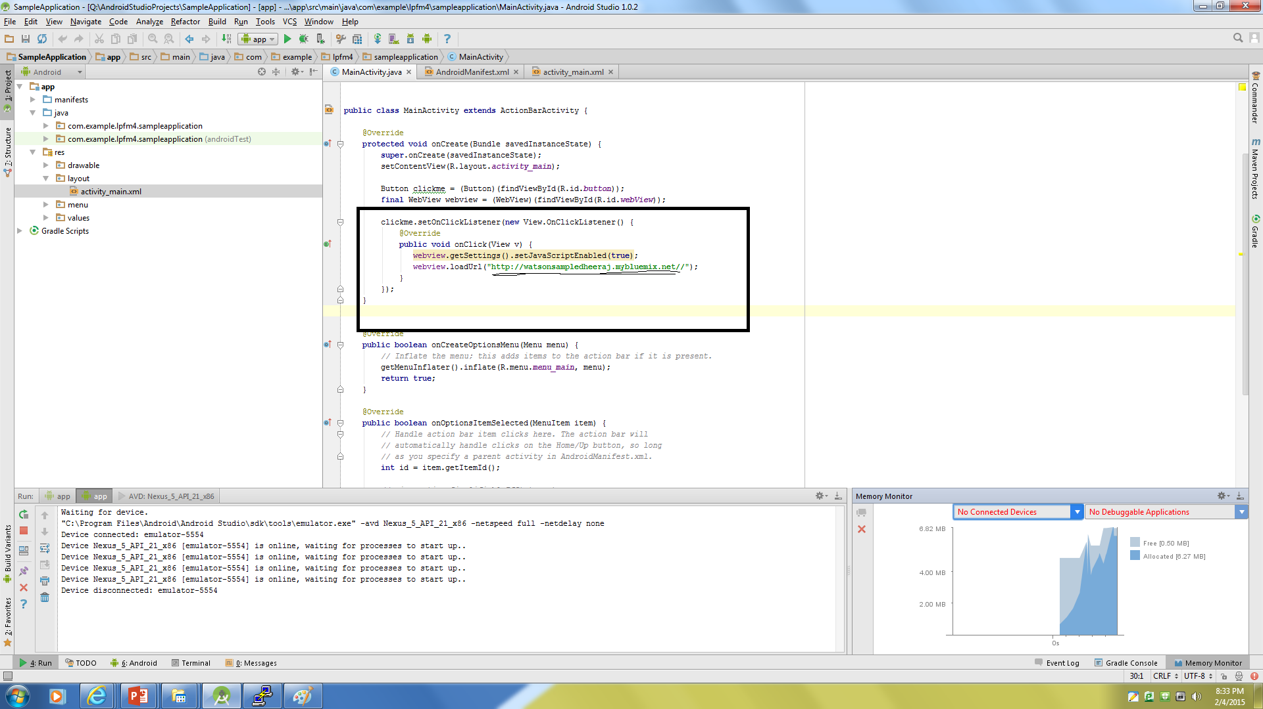

Step 4:

Then the using the ADT we create a screen and by clicking the webview it will redirect to the Watson page <http://watsonsampledheeraj.mybluemix.net/>

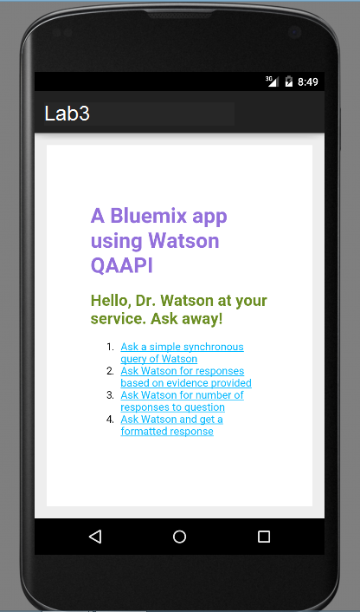

Pi