Support and Command Center (SCC) for TAPAT

**Team Members**

Dolot, Patrick Vonn L.

Rivera, Mark Jerome P.

Cayaban, Francis Paolo E.

**Main Objective**

To develop a logging system that will document and note all of the incident reports and calls made from the support center. It will also provide additional legal documents that will be useful for the investigation of transmission issues and fraud. It will serve as an evidence for BEIs and BOCs that they have complied to the transmission process. It will also be a way to communicate with the Technical Assistance Team (Manufacturer’s technician) in case of technical issues for hardware, software, and network issue.

**Problem Statement**

The current system, used in the last two elections (2010 and 2013), had issues with transmission logs. The PCOS machine had doubtful logs containing inaccurate and unsynchronized time stamp making a subject for suspicion. The previous system also does not have logs or reports for transmission issues that will validate why manual transmission was needed. In an automated system, transmission is a very important module as it is vulnerable for hacks and aerial interception that can lead to election manipulation. Having a support center that will log all issues experienced with the system will help us minimize and lower the volume of suspected anomaly, pin point suspicious transmission, and at the same time protect the BEI from being suspects for election manipulation.

**Project Overview**

The SCC (Support and Command Center) is a web-based application that aims to provide a logging system for the support center processes namely, registration of all BEI and BOC, document and note technical support calls, and transmission confirmation for election returns to the Board of Canvassers. This will serve as additional evidence for investigations of transmission anomaly after the election if there will be a protest against the result of the election returns.

**Scope and Limitations**

This project will cover the processes:

* Administrator
* Human Resource Manager
* Registrar
* Team Leader
* Agent – Call center agent
* Provincial Election Supervisor

**System Recommendation**

**System Features and Functions**

**System Diagrams**

Site Map

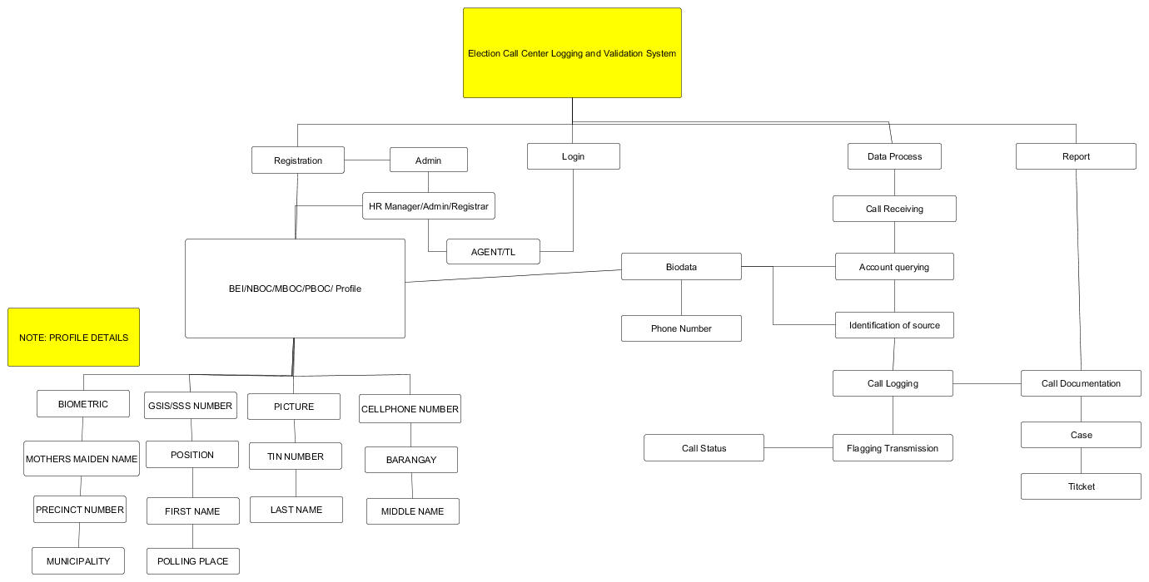

Context Level Diagram

Data Flow Diagram

Entity Relationship Diagram

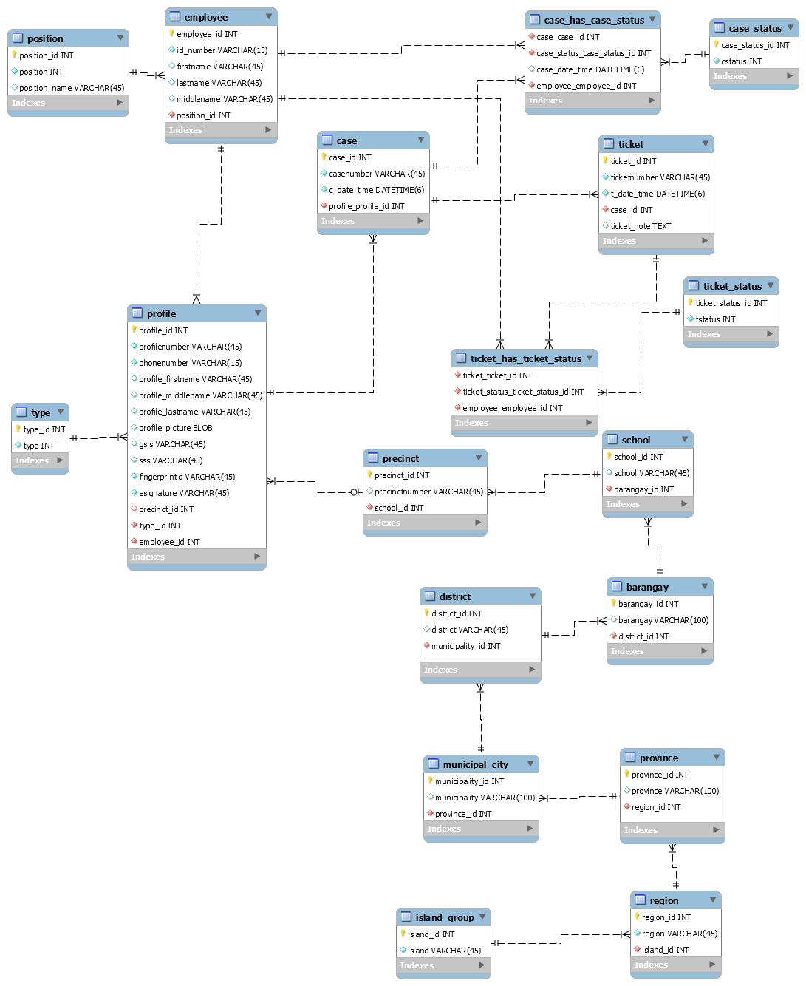

Data Dictionary

Screenshots

**References**

Republic Act 9369

Comelec Resolution 8879

Comelec Resolution 8900