Wildfire Challenge – Team PSR

# Description of the Solution

The H2O.ai Wildfire challenge focuses on a solution to be directly applied into numerous organizations that are working towards preventing and reducing the occurrences of wildfires (a.k.a. bushfires). The solution which is presented here can be used for predicting the severity of a wildfire on a specific geo-location based on the weather data of the relevant day.

Severity of a wildfire is ranging from values **0 to 5000+**. The higher the severity it represents a more critical wildfire. According to the severity, wildfire size can be categorized into following classes.

Table - Wildfire Size Categorization [1]

|  |  |  |
| --- | --- | --- |
| Severity Value | Class | Class Description |
| 0 | None | No fire hazard |
| 0.1 – 0.2499 | Class A | one-fourth acre or less |
| 0.25 – 9.99 | Class B | more than one-fourth acre, but less than 10 acres |
| 10 – 99.99 | Class C | 10 acres or more, but less than 100 acres |
| 100 – 299.99 | Class D | 100 acres or more, but less than 300 acres |
| 300 – 999.00 | Class E | 300 acres or more, but less than 1,000 acres |
| 1000 - 4999 | Class F | 1,000 acres or more, but less than 5,000 acres |
| 5000 and above | Class G | 5,000 acres or more |

## Inputs to the model

The prediction system accepts several inputs if the user needs to get predictions for a wildfire. Following image shows the user interface for inputting data which is required for the system (Model) to predict the severity parameter for the given geo-location.

Geo-Location can be viewed using the “**Show Map**” button and selecting the desired point using the graphical map of the region. After the point is selected, coordination data can be input to the system manually using Latitude & Longitude.

The system needs user to pick a date which the user wants the system to predict the wildfire on the desired geo-location. Ideally the above application can be modified to fetch the current date and time from the Internet thus the user doesn’t get to input the date. Main reason the application has designed in this way manner is due to complexity in updating weather data automatically. After the user interface provide necessary values to fetch the weather data from a pre-saved dataset which is not being automatically updated.

Table 2 - Input Parameters for the Application by User

|  |  |  |
| --- | --- | --- |
| Parameter | Description | Input Range |
| Latitude | Latitude of the geo-location | 17.9397 to 70.3306 |
| Longitude | Longitude of the geo-location | -178.8026 to  -65.2569 |
| Date | Date to fetch the weather data from pre-saved dataset | 07/01/2021 to 01/12/2021 |

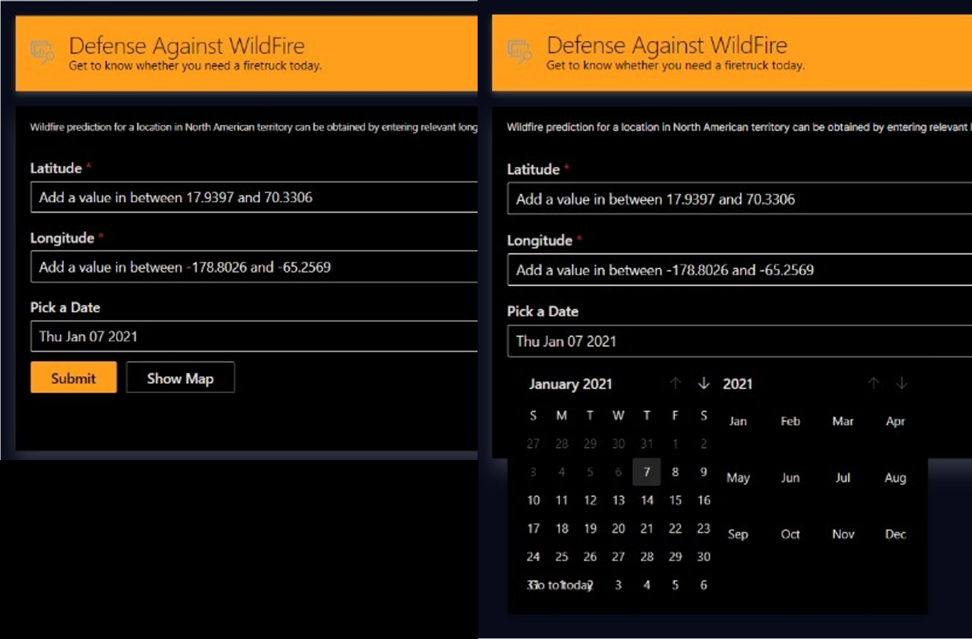

Figure - User Interface of the Application

## Prediction from the System

As the user provides necessary values to the application, model which has been trained in the application fetches the relevant weather data. The application requires weather data for past 7 days from the user picked date. Application is defined to collect all the weather data into one row and then provide them into the model.

The model out is produced as the severity value which starting from zero and zero represents that there is no risk of a wildfire event considering the geo-location and weather data for past 7 days from the user picked date. If there is a severity value presented it can be further understood by referring above table (Table 1 - Wildfire Size Categorization [1].

Figure - Output from the Application (Severity)

# References

|  |  |
| --- | --- |
| [1] | National Wildfire Coordinating Group, “Size Class of Fire,” [Online]. Available: https://www.nwcg.gov/term/glossary/size-class-of-fire. |