

Date: April 30, 2002
To: Avnet
CC:
From: Kenn Gordon
Re: MAC address programming of EEPROMS for the DJ35 and Sahara Projects

Manufacturer/model/package of EEPROM to program

INDEX | REF DES | QTY | DESCRIPTION | Fullplay P/N | Manufacturer | Manufacturer  P/N
47 | U20 | 150 | IC Serial EEPROM 64 x 16 | 300-0001-03 | Atmel | AT93C46A-10SI-2.7

Programming
Each chip must be programmed with a unique MAC address. Eight words are required to be programmed on to each chip. The table below illustrates what is to be programmed. Boldfaced items will be the data changed from chip to chip.

0h | 1h | 2h | 3h | 4h | 5h | 6h | 7h | 8h | 9h | 10h | 11h | 12h | 13h | 14h | 15h
0E | A1 | 58 | 21 | 00 | 06 | D4 | FF | F8 | 53 | 20 | 00 | 00 | 03 | 00 | 91
0EA1 |  | 5821 |  | 0006 |  | D4FF |  | F853 |  | 2000 |  | 0003 |  | 0091
Word 0 |  | Word 1 |  | Word 2 |  | Word 3 |  | Word 4 |  | Word 5 |  | Word 6 |  | Word 7

Words 2, 3, 4 collectively make up the MAC address. Word 7 is a checksum. Words 4 and 7 will be different for each chip. Words 2 and 3 will stay the same. Words 0, 1, 5 and 6 must not change.

The last octet of word 7 is the checksum; the first octet of Word7 must be 00. Refer below for instructions for calculating the checksum.

Address Range
A single block of 100 addresses has been reserved for this project. No addresses should be reused. The range of addresses available for the DJ35 and Sahara units is:

00:06:D4:FF:F8:53 to 00:06:D4:FF:F8:E8

Recommendations
- Retape and rereel EEPROMS
- put a red dot on each EEPROM to indicate it has been programmed
- Send first articles to the following address:
  - Contact Fullplay Media Systems, Inc.
12600 SE 38th St, Suit 150
Bellevue, WA 98006
Attn: Kenn Gordon
425.289.0302
kenn@fullplaymedia.com

- Ship EEPROMs to the following address:
  - Fullplay Media Systems, Inc.
12600 SE 38th St, Suit 150
Bellevue, WA 98006
Attn: Kenn Gordon
425.289.0302
kenn@fullplaymedia.com

How to compute checksum

Example Compute checksum for the following MAC address: 00:06:D4:FF:F8:53

Here are the words associated with this MAC address:

0EA1 | 5821 | 0006 | D4FF | F853 | 2000 | 0003 | Checksum  0091
Word 0 | Word 1 | Word 2 | Word 3 | Word 4 | Word 5 | Word 6 | Word 7

We need to compute the last byte of word 7.

Step One Open calculator in windows (i.e. type “calc” in Start→Run option on Windows Start Menu)

Step Two Select Hex and Byte options in calculator (see screen shot below)

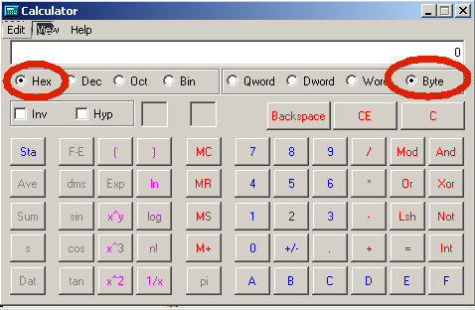

Step Three Add up each octect by typing the following keystrokes into the calc application (no need to type leading zeros):

Octet | Value
0h | 0E
1h | A1
2h | 58
3h | 21
4h | 00
5h | 06
6h | D4
7h | FF
8h | F8
9h | 53
10h | 20
11h | 00
12h | 00
13h | 03

After adding the above bytes you should get a total of 6F.

Step Four Hit CE and C button in calc.

Step Five Subtract 6F from zero and you should get 91, the checksum to put in the last byte of word 7.

