

Date: October 4, 2001
To: Rebecca Rostetter
CC:
From: Kenn Gordon
Re: MAC address programming of EEPROMS for the iObjects Dharma Hardware Reference Platform

Manufacturer/model/package of EEPROM to program

INDEX | REF DES | QTY | DESCRIPTION | SUPPLIER PART NUMBER | SUPPLIER | CLIENT PART NUMBER | PACKAGE
19 | U401 | 1 | IC Serial EEPROM 64 x 16 | 93LC46B/SN | Microchip | 93LC46B/SN-ND | SOIC8-150

Programming
Each chip must be programmed with a unique MAC address. Eight words are required to be programmed on to each chip. The table below illustrates what is to be programmed. Boldfaced items will be the data changed from chip to chip.

0h | 1h | 2h | 3h | 4h | 5h | 6h | 7h | 8h | 9h | 10h | 11h | 12h | 13h | 14h | 15h
0E | A1 | 58 | 21 | 00 | 06 | D4 | 00 | A1 | 20 | 20 | 00 | 00 | 03 | 00 | 1A
0EA1 |  | 5821 |  | 0006 |  | D407 |  | A120 |  | 2000 |  | 0003 |  | 001A
Word 0 |  | Word 1 |  | Word 2 |  | Word 3 |  | Word 4 |  | Word 5 |  | Word 6 |  | Word 7

Words 2, 3, 4 collectively make up the MAC address. Word 7 is a checksum. Words 4 and 7 will be different for each chip. Words 2 and 3 will stay the same. Words 0, 1, 5 and 6 must not change.

The last octet of word 7 is the checksum; the first octet of Word7 must be 00. Refer below for instructions for calculating the checksum.

Address Range
A single block of 5000 addresses has been reserved for this product. No addresses should be reused. The range of addresses available for the Dharma Platform is:

00:06:D4:07:A1:20 to 00:06:D4:07:B4:A7

Recommendations
- Retape and rereel EEPROMS
- Label EEPROMs with iObjects part number 300-0005-01
- put a red dot on each EEPROM to indicate it has been programmed
- Send first articles to the following address:
  - Contact IObjects, Inc.
12600 SE 38th St, Suit 150
Bellevue, WA 98006
Attn: Kenn Gordon
425.653.5505

- Ship EEPROMs to the following address:
Cirrus should fill this area in.
- IObjects recommends Pioneer-Standard Electronics, Inc to supply the programmed parts:
  - Contact Doug Vickers
8201 164th Ave NE, Suite 310
Redmond, WA 98052
425.869.3308
vickersd@pios.com

How to compute checksum

Example Compute checksum for the following MAC address: 00:06:D4:07:A1:20

Here are the words associated with this MAC address:

0EA1 | 5821 | 0006 | D407 | A120 | 2000 | 0003 | checksum
Word 0 | Word 1 | Word 2 | Word 3 | Word 4 | Word 5 | Word 6 | Word 7

We need to compute the last byte of word 7.

Step One Open calculator in windows (i.e. type “calc” in Start→Run option on Windows Start Menu)

Step Two Select Hex and Byte options in calculator (see screen shot below)

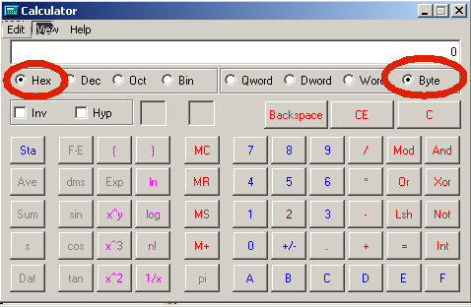

Step Three Add up each octect by typing the following keystrokes into the calc application (no need to type leading zeros):

Octet | Value
0h | 0E
1h | A1
2h | 58
3h | 21
4h | 00
5h | 06
6h | D4
7h | 00
8h | A1
9h | 20
10h | 20
11h | 00
12h | 00
13h | 03

After adding the above bytes you should get a total of E6.

Step Four Hit CE and C button in calc.

Step Five Subtract 27 from zero and you should get D9, the checksum to put in the last byte of word 1A.

