

Date: July 23rd 2001
To: Gary Nuut
CC: Erin Rolfe, Doug Vickers, Mike Cusson, various iObjects personnel
From: David Dancause
Re: Info for programming EEPROMS for iObjects – Revised after approving first articles on Monday 7/23

Manufacturer/model/package of EEPROM to program

Microchip 93LC46B-/fm

208 mil s08 package

Total Quantity of chips we want programmed

512 - Includes the first 3 you provided as first articles

Description of what we want programmed
We want to program each of the chips with a unique MAC address. We only need 7 words programmed on to each chip. Refer to the table below for an example of what we want programmed. Boldfaced items will be the data you change from chip to chip.

0h | 1h | 2h | 3h | 4h | 5h | 6h | 7h | 8h | 9h | 10h | 11h | 12h | 13h | 14h | 15h
0E | A1 | 58 | 21 | 00 | 06 | D4 | 00 | 00 | 0A | 20 | 00 | 00 | 03 | 00 | D1
0EA1 |  | 5821 |  | 0006 |  | D400 |  | 000A |  | 2000 |  | 0003 |  | 00D1
Word 0 |  | Word 1 |  | Word 2 |  | Word 3 |  | Word 4 |  | Word 5 |  | Word 6 |  | Word 7

Words 2, 3, 4 collectively make up the MAC address. Word 7 is a checksum. So, when you program chips for us, words 4 and 7 will be different for each chip. Words 2 and 3 will stay the same because you will only need to change word 4 to program unique MAC addresses for the chips we are buying from you.

The last octet of word 7 is the checksum, the first octet of Word7 must be 00. Refer to page 3 of this document for instructions for calculating the checksum.

To change word 4 increment the MAC address. Please begin with the following MAC:

00:06:D4:00:01:04

After producing the chips for us, incrementing the MAC as you go, the last EEPROM you program should have this MAC address:

00:06:D4:00:03:00

Additional requirements on page 2 and 3

Additional requirements
- Retape and rereel EEPROMS
- Label EEPROMs with iObjects part number 300-0001-01
- put a red dot on each EEPROM to indicate it has been programmed
- Send first articles to the following address:

InDesign
Attn: Scott Early
5640 Caito Drive
Indianapolis, IN 46226

- Ship EEPROMs to the following address:

Diversified Systems
Dock 7 CS-00766
3939 W 56th Street
Indianapolis, IN 4625

How to compute checksum

Example Compute checksum for the following MAC address: 00:06:D4:00:01:01

Here are the words associated with this MAC address:

0EA1 | 5821 | 0006 | D400 | 0101 | 2000 | 0003 | checksum
Word 0 | Word 1 | Word 2 | Word 3 | Word 4 | Word 5 | Word 6 | Word 7

We need to compute the last byte of word 7.

Step One Open calculator in windows (i.e. type “calc” in Start→Run option on Windows Start Menu)

Step Two Select Hex and Byte options in calculator (see screen shot below)

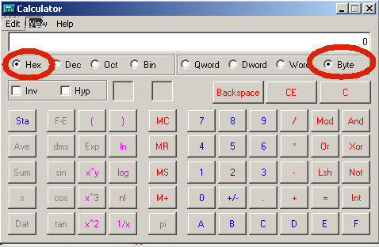

Step Three Add up the bytes, typing the following keystrokes into the calc application (no need to type leading zeros):

E
+
A1
+
58
+
21
+
6
+
D4
+
1
+
1
+
20
+
3

After adding the above bytes you should get a total of 27.

Step Four Hit CE and C button in calc.

Step Five Subtract 27 from zero and you should get D9, the checksum to put in the last byte of word 7.

