DJ-C40 Remote Control Requirements

August 2, 2002
Revision 9

Document Number 300-0067-01

This document contains proprietary information on a product under development by Fullplay Media Systems, Inc. The information contained herein is not to be used by or disclosed to third parties without the express written permission of Fullplay Media Systems, Inc. Fullplay Media Systems, Inc. reserves the right to make changes to this specification and the products described herein at any time without notice. The purchase or use of the product from Fullplay Media Systems, Inc. does not convey a license under any patent rights, copyrights, trademarks or any other intellectual property rights of Fullplay Media Systems, Inc.

Copyright © 2002, by Fullplay Media Systems, Inc. All rights reserved.

Introduction
The purpose of this document is to briefly describe Fullplay Media’s Digital Audio Jukebox, the DJ-C40 and it’s requirements for an infra-red remote control. This specification is not intended to be exhaustive but rather to provide general guide-lines to the manufacturer of remote controls to meet Fullplay’s requirements.

Fullplay prefers to use an existing tooled remote control to reduce costs. Fullplay will consider tooling for a unique design when quantities permit or if a licensing customer requests a unique design.

A full color graphic image is included in this document to provide a visual example of Fullplay’s preferred remote control design.

DJ-C40 Digital Audio Jukebox
The DJ-C40 is a networked, streaming digital audio jukebox and recorder with CD-ROM and HDD. The DJ-C40 plays MP3, WMA, AAC and Ogg Vorbis music files from its 40GB (upgradeable) hard drive and CD drive. The DJ can encode standard audio from tapes, albums and compact disks to MP3 and copy and store this music on its hard drive (700 cd’s on the 40GB drive). The DJ uses ethernet to connect to a pc allowing content management from a personal computer, music streaming from the pc to the DJ, internet radio streaming and other networking features.

The DJ-C40 is intended for the consumer electronics market as a stereo or entertainment systems component product, replacing mass storage compact disk players as well as adding many new features to the consumers experience.

The DJ-C40 Remote Control

Fit
The remote control design should be both comfortable in the hand and pleasing to the eye. All buttons should be in easy reach of the thumb of a right handed person. The preferred color is black. Fullplay will evaluate all remote controls to meet these needs.

Universal Remote
The remote control need not support universal remote features but will be considered. Universal remotes must include a programming and set-up guide document shipped with each remote in.

Please note the key functionality table below does not list buttons for volume. Volume buttons will be required of universal remote controls only.

Features
The remote control should include an LED indicator that will be placed somewhere near the top of the remote and will be lighted whenever a button is pressed.

The remote should use Alkaline batteries, in either AA or AAA format.

The remote must use a 38 kHz emitter.

Button layout
The approximate number of buttons will be 50. There are 4 main sections: alpha-numeric entry; menu controls, player controls and pre-programmed feature buttons.

The power button should be near the top of the remote and should be a unique color with our power icon printed directly on the button.

- A full alpha-numeric pad as found on phones should be included: 0 – 9, a –z. It is acceptable to have the numbers printed on the buttons and the letters printed on the remote.

- Menu controls will include separate controls for up, down, right, left, enter/select, add and menu. An up/down, right/left and select navigation feature similar to the one pictured below is preferred.

- Player controls will include play, pause, stop, next/seek forward, previous/seek back, source and play mode.

- Pre-programmed buttons include Genre, Artist, Album, Playlist, Radio, Info, Zoom, Edit, Save, Delete, and Clear.

Key Functionality Table
Fullplay Media Systems Remote Control Key Specifications
ID | Title | Navigation Keys | Description | Status | Priority | Location
1 | Up | IR_KEY_UP | Navigates Up in the menu lists | Required | 1 | We prefer this to occur with the up/down/next/previous buttons in a single fixture around the select button, flanked by the add and menu buttons
2 | Down | IR_KEY_DOWN | Navigates Down in the menu lists | Required | 1
3 | Next | IR_KEY_NEXT | Navigates Right in the menus | Required | 1
4 | Previous | IR_KEY_PREV | Navigates Left in the menus | Required | 1
5 | Select | IR_KEY_SELECT | Selects | Required | 1
6 | Add | IR_KEY_ADD | Adds to current playlist | Required | 1
7 | Menu | IR_KEY_MENU | Jumps to Menu | Required | 1
ID | Title | Alphanumeric Keys | Description | Status | Priority | Location
8 | 1 | IR_KEY_1_misc | Alphanumeric Key | Required | 1 | These buttons must be grouped together. Silkscreen for each button will include it's corresponding number and 3 letters typical with phones.
9 | 2/ABC | IR_KEY_2_abc | Alphanumeric Key | Required | 1
10 | 3/DEF | IR_KEY_3_def | Alphanumeric Key | Required | 1
11 | 4/GHI | IR_KEY_4_ghi | Alphanumeric Key | Required | 1
12 | 5/JKL | IR_KEY_5_jkl | Alphanumeric Key | Required | 1
13 | 6/MNO | IR_KEY_6_mno | Alphanumeric Key | Required | 1
14 | 7/PQR | IR_KEY_7_pqrs | Alphanumeric Key | Required | 1
15 | 8/STU | IR_KEY_8_tuv | Alphanumeric Key | Required | 1
16 | 9/WXYZ | IR_KEY_9_wxyz | Alphanumeric Key | Required | 1
17 | 0 | IR_KEY_0_space | Alphanumeric Key | Required | 1
ID | Title | Play Control Keys | Description | Status | Priority | Location
18 | Rewind | IR_KEY_REW | Previous track, hold to REW | Required | 1 | These buttons must be grouped together.
19 | Play | IR_KEY_PLAY | Play | Required | 1 | These buttons must be grouped together.
20 | Next | IR_KEY_FWD | Next track, hold to FWD | Required | 1 | These buttons must be grouped together.
21 | Record | IR_KEY_RECORD | Record | Required | 1 | These buttons must be grouped together.
22 | Stop | IR_KEY_STOP | Stop | Required | 1 | These buttons must be grouped together.
ID | Title | Function Keys | Description | Status | Priority | Location
23 | Standby / Power | IR_KEY_POWER | Toggles On/Standby mode on the DJ | Required | 1 | Upper Right Corner
24 | Info | IR_KEY_INFO | Jump to Info | Required | 1 | Group with Functional keys
25 | Zoom | IR_KEY_ZOOM | Toggle Zoom | Required | 1 | Group with Functional keys
26 | Delete | IR_KEY_DELETE | Delete item | Required | 1 | Group with Functional keys
27 | Save | IR_KEY_SAVE | Save the current entry | Required | 1 | Group with Functional keys
28 | Edit | IR_KEY_EDIT | Edit item | Required | 1 | Group with Functional keys
29 | Artist | IR_KEY_ARTIST | Jump to the Artist screen | Optional | 2 | Group with Functional keys
30 | Album | IR_KEY_ALBUM | Jump to the Album screen | Optional | 2 | Group with Functional keys
31 | Playlist | IR_KEY_PLAYLIST | Jump to the Playlist screen | Optional | 2 | Group with Functional keys
32 | Genre | IR_KEY_GENRE | Jump to the Genre screen | Optional | 2 | Group with Functional keys
33 | Radio | IR_KEY_RADIO | Jump to the Radio screen | Optional | 2 | Group with Functional keys
34 | Play Modes | IR_KEY_PLAY_MODE | Cycle through Play Modes | Optional | 2 | Group near Alphanumeric keys
35 | Clear | IR_KEY_CLEAR | Clear the playlist or text string | Optional | 3 | Group with Functional keys
36 | Exit | IR_KEY_EXIT | Exit to main screen | Optional | 3 | Group near Navigation keys
37 | Pause | IR_KEY_PAUSE | Pause | Optional | 3 | Group with Play control keys
38 | Mute | IR_KEY_MUTE | Mute | Optional | 3 | Group with Play control keys
39 | Source | IR_KEY_INPUT | Jump to the Source Screen | Optional | 3 | Group with Functional keys
40 | Page (Up) | IR_KEY_JUMP_10_UP | Jump 10 Up in the menu lists | Optional | 4 | Group with Alphanumeric keys
41 | Page (Down) | IR_KEY_JUMP_10_DOWN | Jump 10 Down in the menu lists | Optional | 4 | Group with Alphanumeric keys
42 | A…(Z) | IR_KEY_JUMP_ALPHA_UP | Jump to the previous letter in the menu lists | Optional | 4 | Group with Alphanumeric keys
43 | (A)…Z | IR_KEY_JUMP_ALPHA_DOWN | Jump to the next letter in the menu lists | Optional | 4 | Group with Alphanumeric keys

Example Layout
The Drawings below are examples of different layouts and silkscreens that are consistent with these requirements.

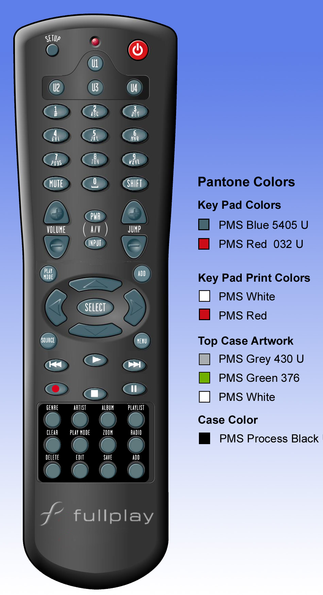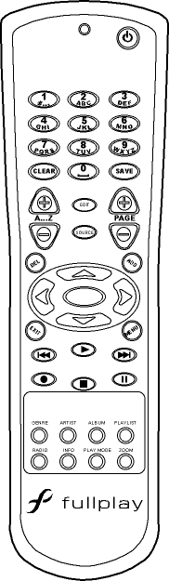

Quantities
Fullplay expects quantities for the Darwin Jukebox to be modest in 2002, reaching approximately 5000 units by the end of the year. Quantities will reach up to 50,000 units in 2003.

Quote Format Requirements
Your quote should include:
- Pricing for 5000, 10,000 and 50,000 pieces per year.
- Detail costs for additional colors or silkscreen changes to you remote control.
- Detail costs for Unique Key Code registration (only as required, e.g. For universal remotes).
  - Please provide information about the registering agency
- Detail costs for programming
- Detail leads from delivery of valid purchase order and art work.
- Detail required format of art work for silkscreen and colors.
- Detail your terms and conditions for payment and returns.

Technical Specifications
In addition to the quote please provide the following information

- The type of IR emitter is used in your remote.
- The IR remote control protocol (NEC, RC5, etc.). If not a standard, registered protocol please submit timing diagrams for your protocol.
- Please supply any unique identification codes (e.g. Mfg ID) for the remote.
- Please supply a key map of buttons to actual command words for every button or function of the remote. Use the format provide above in the key functionality table.
- Does your remote support hold events? If so, please provide specifications for it’s implementation.
- Basic Dimensions (height, width, length).
- Weight
- Any regulatory approvals.
- Please provide drawings in a .bmp format and/or a color .jpg photo of the remote being quoted.

Agency Certifications
The remote control should be certified for sale in the United States, Canada, Europe and Asia. But Fullplay will consider remote controls with more limited registrations.

Samples
Please provide 5 samples of each remote you are submitting for consideration as well as any available data sheets. Ship samples to the following address:

Fullplay Media Systems, Inc.
12600 SE 39th St., Suite 150
Bellevue, WA 98006
Attn: Kenn Gordon

Contact Information
Please contact Kenneth Gordon regarding this project.

Kenneth Gordon
Program Manager
Fullplay Media Systems, Inc.

425.289.0302 office
425.653.5777 fax
kenn@fullplaymedia.com

