让步论证法
- 常见表达方式
A. 运用词汇（词组）
尽管：in spite of this, despite this
但是：however, nonetheless, nevertheless
B.句型
1. As is granted, … However,
convincing arguments have been made that
2.Opponents would argue that… However, …
3. Although/ In spite of the fact that …,
people tend to believe that …
4. It is undeniable that …
Example:
Your school has enough money to purchase either computers for students or books for the library. Which should your school choose to buy — computers or books?
让步反驳段：
（支持买电脑）
- 翻译练习
- 诚然书真的有超过电脑的优点。它们容易携带，单位价格低，而且更节约能源，鉴于电脑是电源驱动的；然而电脑作为高效、耐用、可管理的新世纪图书馆工具具有更多有价值的优点。

结尾段写作
1. The final paragraph should be short (two to three sentences) and forceful (restatements, summary or recommendation of the points).
个人观点强调+分论点总结
2. Commonly used phrases:
in short…, in a word…, in brief…, to sum up…
in conclusion…, on the whole…, altogether…, in all
3. Notice:
a. Do not repeat the ideas.
b. Do not provide new information except for making recommendations.
c. Do not write too long a paragraph.
提纲：
Introduction: People’s ideas about just anything are greatly influenced by today’s mass media such as television, radio and newspaper.
Main Body:
Mass media is a window through which people may acquire what has happened in and abroad rapidly.
Mass media is also a scale which tells people what is right and what is wrong hence influences their world view.
4. Three patterns for writing the final paragraph:
综合归纳式
In conclusion, media do exert a great influence on people's opinions given that it is the indispensable access to acquiring information for the public and it plays an authoritative role in judging right and wrong in our society. Therefore we have to recognize its significance in shaping people's viewpoints.
比较对照式
In conclusion, while any anxiety about going overseas for university study is certainly understandable, it is important to remember that the benefits offered by the experience make it well worthwhile considering it can both enlarge our knowledge and friends circle internationally. I totally approve of furthering study abroad.
高瞻远瞩式
Sample: In summary, I would agree that the mass media’s influence is certainly great given that it is the indispensible access to acquiring information for the public and it plays an authorative role in judging right and wrong in our society .Indeed, with technological advancements such as the internet bringing even more forms of electronic media to our homes and workplaces, it is likely that the media’s influence will grow even stronger.
雅思小作文
小作文基本信息
字数：150字
时间：17-20分钟为宜
分值比重：占了作文分数的1/3
类型： 图表类作文

小作文类型
线形图：line graph
柱状图：bar chart
饼图：pie chart
表格：table
流程图：flow chart
地图：map

主流图形
线形图：line graph
柱状图：bar chart
饼图：pie chart
表格：table
可分为动态图和静态图
1 动态趋势图：多时间， 上升下降，做纵向比较
2 静态数据图：单时间， 多和少 ， 做横向比较

小作文评分标准
1. Task Achievement (TA)
2. Coherence and Cohesion (CC)
3. Lexical Resource (LR)
4.Grammatical Range and Accuracy

小作文结构
总起段 | 首句 | 改写题目
主体段 | 1总体趋势  2具体趋势+ 数据
结尾段 | 重申总体趋势或者无结尾

开头段 改写题目
基本结构
Type of chart | Appropriate verbs | description | place | time
the illustration  the graph  the pie chart  the bar chart  the table | shows  illustrates  presents  represents  compares  reveals  describes | the number of  the proportion of  the information on  data on  the percentage of | in +place | from...to...  between...and...

题目改写
同义词替换
题目一The table below shows the proportion of different categories of families living in poverty in Australia in 1999.
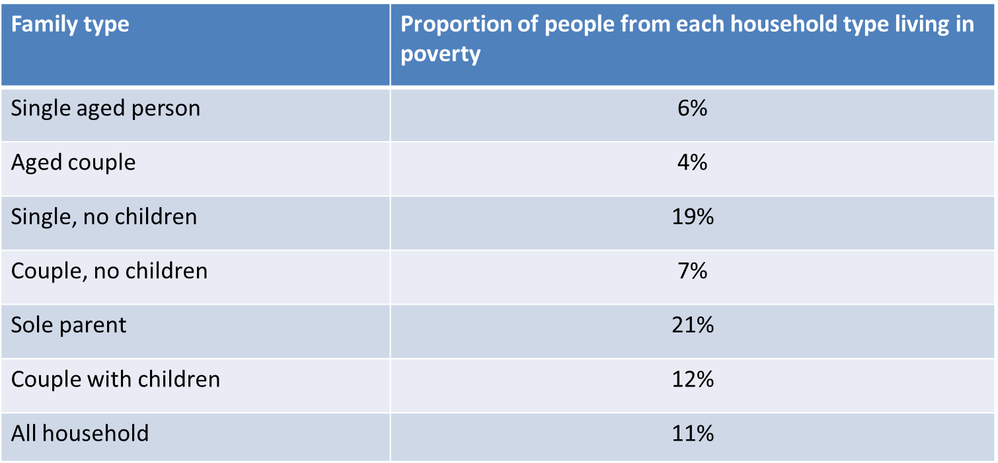

改写：The following chart describes the percentage of diverse types （同义词替换）of poor families （改变关键词的位置和词性）in Australia in 1999.

动态图必备词汇和句型
◎ 上升（v）increase，rise，go up，grow，jump，climb
◎ 下降（v）decrease，decline，go down，fall，drop
◎ 修饰上升下降（v）的变化幅度词（adv）
◎ 轻微地 slowly，slightly，marginally
◎ 平缓地 steadily，smoothly，gradually，moderately
◎ 剧烈地 significantly，sharply，dramatically，drastically，steeply，
Surprisingly，strikingly，hugely
电脑的销量急剧/平稳/轻微上升/下降。
The sales of computers rise /decrease sharply/rapidly/dramatically.
moderately/steadily/gradually.
slightly/slowly/minimally.
◎ 上升(n)
Increase，rise，growth
◎ 下降（n）
Decrease，decline，fall，drop
◎ 修饰上升下降(n)的变化幅度词（adj）
把刚才变化幅度词（adv）去掉ly，就成了形容词，除了下面三个词：
dramatically-dramatic
drastically- drastic
steadily-steady
◎ 用名词短语来表达上升下降
There is a sharp/dramatic/rapid rise/decrease.
There is a moderate/steady/gradual rise/decrease.
There is a slight/slow/minimal increase /drop.
◎ 波动震荡
fluctuate
……fluctuate dramatically/minimally between xx% and xx% during …period.
五年间汽车产量在5%至15%之间剧烈波动。
The production of cars fluctuated dramatically between 5% and 15% during the five-year period.
◎ 波动性下降
sth have/show a downward trend
sth decrease with (minor) fluctuations
◎ 波动性上升
sth have/show an upward trend
sth increase with (minor) fluctuations
◎ 到达顶点
reach the peak
peak (v)
climax
culminate
注：达到底点 reach the bottom
◎ 保持不变
keep/remain unchanged/ stable/ steady/constant
stabilize
level off

◎ 带数据的介词
- 从…到… from…to…
电脑销量略微增长，从500台增加到700台。
The sales of the computers increased slightly from 500 to 700.
- 表示“了” by
电脑销量轻微地上升了200台。
The sales of computers increased slightly by 200.
- 表示某个时间点稳定的数据 at
reach the peak/bottom/level off at +数据
电脑的销量在2005年的时候以2100台的水平达到了顶点。
The sales of the computers reached the peak at 2100 in 2005.
1999年电脑的销售额维持500台。
The sales of computers kept stable at 500 in 1999.

◎ 动态图中必用的三大句型
1 主题+变化（v）+ 变化幅度（adv）+数据+时间
2 There be + a + 变化幅度（adj）+ 变化（n）+ in +主题+数据+时间
3 时间+see/experience/witness/undergo+ a +变化幅度（adj）+变化（n）+in +主题+数据
注：第三种句型也可以用主题做主语
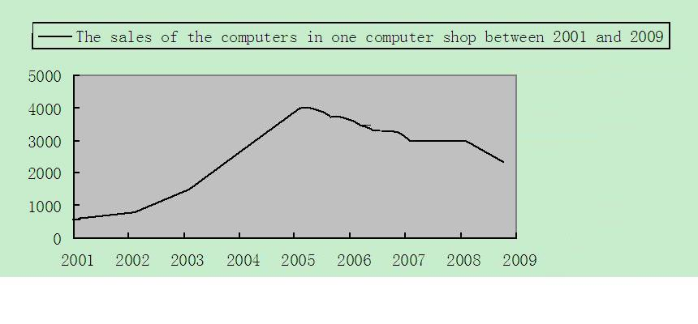
- 电脑的销售量缓慢增长，在2001年至2002年间从600台增加到900台。
The sales of the computers increased slowly from about 600 to 900 between 2001 and 2002.
There was a marginal growth in the sales of the computers from 600 in 2001 to 900 in 2002.
The period between 2001 and 2002 saw a slow increase in the sales of computers from 600 to 900.
The sales of computers witnessed a slow increase from 600 in 2001 to 900 in 2002.

作业
1.翻译下面句子
- 第二年电脑的销售量稳步增长500台。

- 自从2003年电脑的销售量急剧增长，在2005年达到顶峰4000台。

- 电脑的销量呈现下降趋势，在2007年下降到3000台。

- 在2008年电脑的销售量保持稳定在3000台。

- 在2009年电脑的销量急剧下降到1800台。

2.完成大作文一篇
Children should begin learning a foreign language as soon as they start school. Do you agree or disagree with the following statement?

3. 让步反驳段作业：
（支持买电脑）
- 翻译练习
- 诚然书真的有超过电脑的优点。它们容易携带，单位价格低，而且更节约能源，鉴于电脑是电源驱动的；然而电脑作为高效、耐用、可管理的新世纪图书馆工具具有更多有价值的优点。

