上节课作业参考
让步反驳段
让步段：
Admittedly, books do have certain advantages over computers.They are easier to carry , lower in unit price, and more energy-efficient given that computers are driven by electrical power. However, computers have more valuable merits as an efficient, durable, manageable means for libraries of the new century, so I strongly recommend the school library should be equipped with more computers that really bring more convenience for faculties and students with abundant virtues that books don't possess.

动态图翻译
- 电脑的销售量缓慢增长，在2001年至2002年间从600台增加到900台。
The sales of the computers increased slowly from about 600 to 900 between 2001 and 2002.
There was a marginal growth in the sales of the computers from 600 in 2001 to 900 in 2002.
The period between 2001 and 2002 saw a slow increase in the sales of computers from 600 to 900.
The sales of computers witnessed a slow increase from 600 in 2001 to 900 in 2002.
- 第二年电脑的销售量稳步增长500台。
The sales of the computers rose steadily by 500 in the following year .
- 第二年电脑的销售量稳步增长到1400台。
The following year saw/witnessed/experienced a steady increase to 1400.
- 自从2003年电脑的销售量急剧增长，在2005年达到顶峰4000台。
The sales of computers went up dramatically from 2003,reaching the peak at 4000 in 2005.
The sales of computers increased steeply to the peak at 4000 in 2005 from 2003.
◎ 写顶点的方法
第一种方法：用分词的方法
The sales of computers went up dramatically from 2003,reaching the peak at 4000 in 2005.
第二种方法：用and并列句
The sales of computers went up dramatically from 2003 and reached the peak at 4000 in 2005.
第三种方法：直接法
The sales of computers increased steeply to the peak at 4000 in 2005.
- 电脑的销量呈现下降趋势，在2007年下降到3000台。
The sales of computers showed a downward trend, decreasing to 3000 in 2007.
There was a downward trend in the sales of computers during the following two years, which decreased to 3000 in 2007.
用了show/have a downward trend这个句型后发现数据比较难带，可以采用以下的办法：
1.The sales of the computers showed a downward trend, decreasing from XX to XX.
2.There was a downward trend in XX during XX, which decreased to XX in +时间.
- 在2008年电脑的销售量保持稳定在3000台。
The sales of the computers remained steady at 3000 in 2008.
- 在2009年电脑的销量急剧下降到1800台。
The sales of computers declined dramatically to 1800 in 2009.
◎ 小作文主体段常用连接词和句型
According to the 图的类型
As shown in the 图的类型
As can be seen from the 图的类型
It is clear/apparent/manifest/obvious from the 图的类型 that ..
概括整体趋势句型
The overall / general trend indicates …
There was an overall + 趋势
From图的类型, it can be (safely) concluded that…

对比：however, conversely, compare to, in/by contrast, on the contrary, totally opposite, on the other hand, whereas, nevertheless
例句：
After 1960 the number of West Indian immigrants decreased rapidly whereas the number of Indian and Pakistani immigrants continued to increase.
The chart shows about a third of the male population was arrested in 1994, while only 0.9% of the female population was arrested.
By/in contrast, fruit sugar, which causes the mouth’s acidity to fall to just above ph4, poses a danger for a shorter period: tooth decay is unlikely 20 minutes after consumption.
On the other hand, an energy gap that continues to widen is forecast, beginning in the late 1990s.
However , Egypt’s infant mortality rate was slightly higher than Indonesia’s, at 97 deaths per 1000 compared to 87 in Indonesia.
Nevertheless, this percentage was less than the percentage of females arrested for the same reason, which was approximately 37%.
类比：similarly, likewise, follow the same/similar trend
例句：
Similarly, the number of West Indian immigrants increased more moderately between 1940 and 1960 to roughly 15000 people.
衔接：then, from this time onwards, from then on, afterwards, subsequently, also, besides, in addition, furthermore, meanwhile / at the same time
例句：
Furthermore, the percentage of women working as general laborers is very small, only 0.5%.
In addition, the forecast for water supply is to continue to increase in the next three years.
对于…来说/在…方面：as to, in terms of, as for, when it comes to/When coming to, in view of, in the case of, in respect of, regarding, turning to
It must be noted that …
It is worth mentioning that …
例句：
The map below presents country equivalents for every state in terms of GDP, GDP per person and population.

连句成段
As can be seen from the graph, there was a slight growth in the sales of computers from 600 to 900 between 2001 and 2002, and they increased gradually to 1400 in the following year. Then they rose dramatically to the peak at 4000 in 2005. After that there was a downward trend in the sales, which decreased to 3000 in 2007. Before they decreased sharply to 1800 in 2009, they remained constant .

◎ 结尾段（总结总体趋势或者不写）
不要主观描述
不要分析原因
不要寻找本质
◎ 总结段常用短语
in short, in brief, in conclusion, in sum, in summary, to conclude, to sum up, finally, overall, all in all
例如：
- In conclusion, it can be clearly seen from the chart that the main sales period was in the early part of the year, plummeting in the summer, except for a sudden increase in August.
- In conclusion, more teachers were in Chinese regular schools in the 1990 than 30 years before.

静态图表达逻辑
第一种
占比最大(A)+占比最小(B)
非重要数据罗列 例如：C D and E occupy %, % and % respectively.
加字数: 倍数关系，分数关系，相似关系等
如果有占比相同，必须要写

第二种
从大到小排序（模板）

静态图常用短语
◎“占”：account for, hold, make up, take up, constitute, comprise，represent, occupy, stand for
◎ 百分比：percentage，proportion, share ...
◎ 确切数字
(1) 分数与百分比的转化：one third, two fifths
(2) 常见表达：a quarter, a half ..
（3）倍数表达 twice as ...as
three times +比较级 than....
- 例题
- the popularity of different car colors
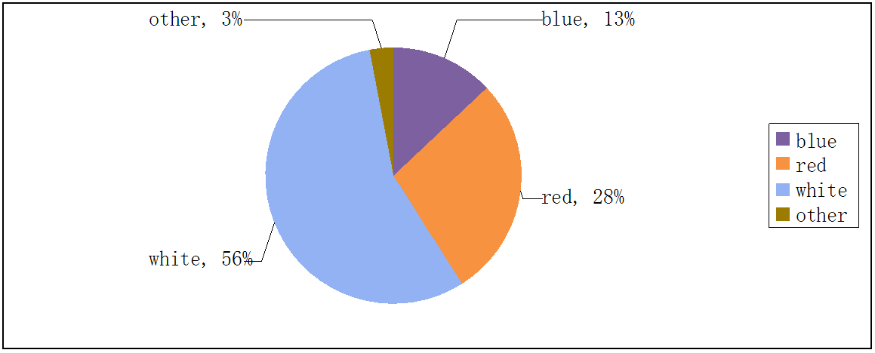
句型练习：
- 最受欢迎的汽车颜色是白色,占56%。
The most popular car color is white, which accounts for 56%
accounting for 56%
(56%)
在主系表结构中，还可以把主语和表语互换。
White is the most popular car color.
The highest/greatest/largest percentage/proportion of the popularity of car color is that of white.
White has the largest percentage of all car colors.
White has 56% of all the car colors.
A班的学生在社团中占有最大的比例，占比40%。

- 红色占据不同颜色汽车总数的几乎三分之一。
Red has almost a third of the total number of different car colors.
A学校有B学校几乎四分之一的学生。

- 白色的受欢迎度是红色的两倍。
White is about twice as popular as red.
A学校的学生人数是B学校人数的两倍。

◎ 有时候比较的数量比较多，可以将其排序
A has the largest proportion (in…), followed by B. C comes next. D ranks fourth. E takes the fifth position. F lies last.
例：美国占比最大，然后是日本，英国紧随其后。法国占第四，意大利占据第五，菲律宾位于最后。
The US has the largest proportion, followed by Japan. Britain comes next. France ranks fourth. Italy takes the fifth position. The Philippines lies last.
◎ 两个被比较对象如果数量相同，也值得描述
A和B都占10%。
1 A and B both have 10%.
2 A is exactly of the same popularity/size/number/percentage… as B.
3 A is the same in size/ popularity/number/percentage… as B.
A 班和B班人数一样多，都占20%。
◎ 两个比较数据数量接近
A学校和B学校几乎有同样多的学生。
1 School A has almost/ nearly as many students as school B.
2 School A has almost the same number of students as school B.
3 The number of students in school A is similar to that in school B.
4 School A comes close to school B in the number of students.
红色和白色的受欢迎程度差不多。

典型图例题
The graph below shows the different modes of transport used to travel to and from work in one European city in 1960, 1980 and 2000.
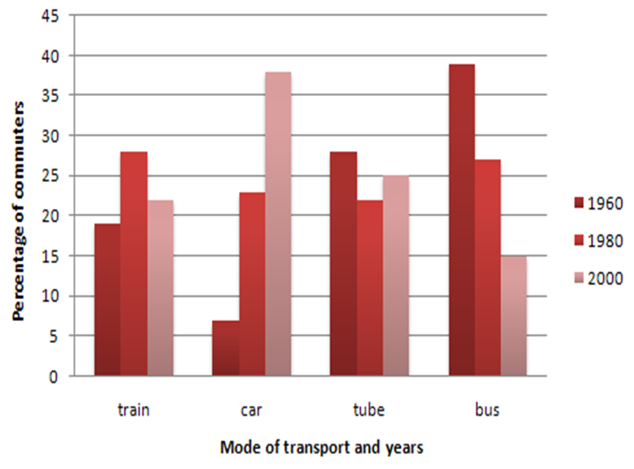
范文参考
The bar graph shows the changing patterns in commuting by train, car, tube or bus for commuters in one European city in the years 1960, 1980 and 2000.
As can be seen from the chart, the number of people using trains at first rose from just under 20% in 1960 to about 26% in 1980, but then fell back to about 23% in 2000. Use of the tube was relatively stable, falling from around 27% of commuters in 1960 to 22% in 1980, but climbing back to reach 25% by 2000.

On the other hand, the use of cars increased steadily from just over 5% in 1960 to 23% in 1980, reaching almost 40% by 2000, whereas the popularity of buses had declined since 1960, falling from just under 35% in 1960 to 27% in 1980 and only 15% in 2000.

In conclusion，the graph indicates the growing use of cars for commuting to work between 1960 and 2000, and the continued decline in the popularity of buses from being the most popular mode of transport in 1960 to the least popular in 2000.

作业：
1翻译句子（文档里黄色突出显示部分）
2完成下面第二个饼图的写作
例题
The following two pie charts illustrate the energy use in the U.S.A.
Write a report for a university lecturer describing the information given in the pie charts below.
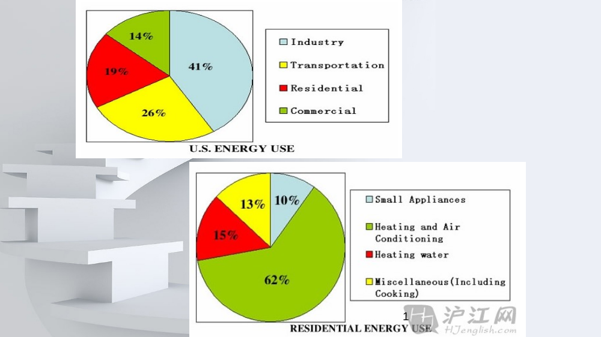范文参考：
The two graphs describe the data of the energy use and the residential energy use in detail in the United States.
第一个饼图范文
It can be seen from the first pie chart that the energy is used for four purposes. Specifically , industry accounts for the largest proportion (41%) of the used energy while demand of transportation makes up 26% of the total need of energy. Residential and commercial represent 19% and 14% respectively.

结尾范文
In conclusion, industry occupies the most part of the US energy use while heating and air conditioning takes dominance in residential energy use.

