静态图表达逻辑
第一种
占比最大(A)+占比最小(B)
非重要数据罗列 例如：C D and E occupy %, % and % respectively.
加字数: 倍数关系，分数关系，相似关系等
如果有占比相同，必须要写

第二种
从大到小排序（模板）

静态图常用短语
◎“占”：account for, hold, make up, take up, constitute, comprise，represent, occupy, stand for
◎ 百分比：percentage，proportion, share ...
◎ 确切数字
(1) 分数与百分比的转化：one third, two fifths
(2) 常见表达：a quarter, a half ..
（3）倍数表达 twice as ...as
three times +比较级 than....
- 例题
- the popularity of different car colors
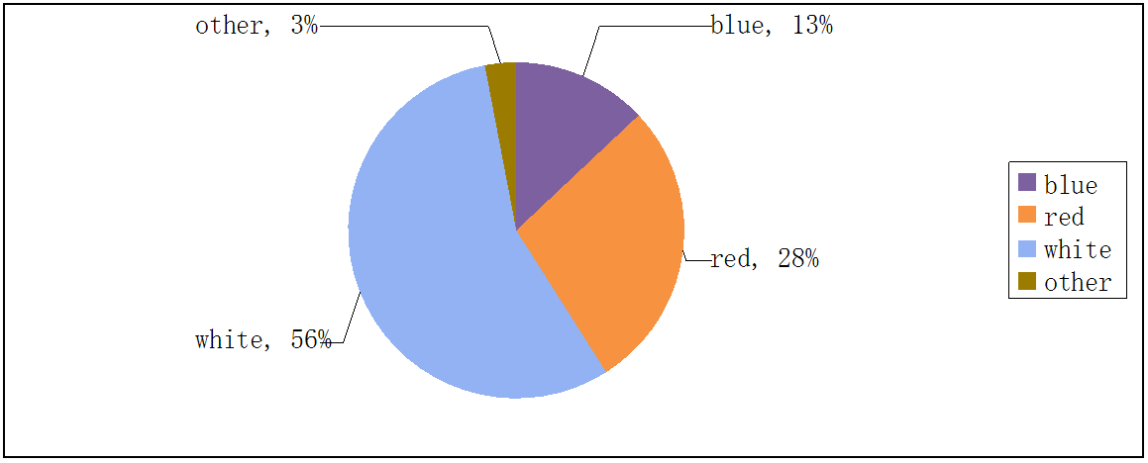
句型练习：
- 最受欢迎的汽车颜色是白色,占56%。
The most popular car color is white, which accounts for 56%
accounting for 56%
(56%)
在主系表结构中，还可以把主语和表语互换。
White is the most popular car color.
The highest/greatest/largest percentage/proportion of the popularity of car color is that of white.
White has the largest percentage of all car colors.
White has 56% of all the car colors.
A班的学生在社团中占有最大的比例，占比40%。
Class A has the largest proportion of the total number in the club, accounting for 40%.
The largest percentage of the students' number in the club is that of Class A(40%).
- 红色占据不同颜色汽车总数的几乎三分之一。
Red has almost a third of the total number of different car colors.
A学校有B学校几乎四分之一的学生。
School A has almost a quarter of students of school B.
- 白色的受欢迎度是红色的两倍。
White is about twice as popular as red.
A学校的学生人数是B学校人数的两倍。
The number of students in school A is twice as large as that in school B.
The students of School A are twice as many as those of School B.
◎ 有时候比较的数量比较多，可以将其排序
A has the largest proportion (in…), followed by B. C comes next. D ranks fourth. E takes the fifth position. F lies last.
例：美国占比最大，然后是日本，英国紧随其后。法国占第四，意大利占据第五，菲律宾位于最后。
The US has the largest proportion, followed by Japan. Britain comes next. France ranks fourth. Italy takes the fifth position. The Philippines lies last.
◎ 两个被比较对象如果数量相同，也值得描述
A和B都占10%。
1 A and B both have 10%.
2 A is exactly of the same popularity/size/number/percentage… as B.
3 A is the same in size/ popularity/number/percentage… as B.
A 班和B班人数一样多，都占20%。
Class A and Class B both have 20%.
Class A is exactly of the same number as Class B (20%).
Class A is the same in number as Class B.
◎ 两个比较数据数量接近
A学校和B学校几乎有同样多的学生。
1 School A has almost/ nearly as many students as school B.
2 School A has almost the same number of students as school B.
3 The number of students in school A is similar to that in school B.
4 School A comes close to school B in the number of students.
红色和白色的受欢迎程度差不多。
Red has almost/ nearly as much popularity as white.
Red has almost the same popularity of car colors as white.
The popularity of red is similar to that of white.
Red comes close to white in popularity of car colors.
作业：完成下面饼图
例题
The following two pie charts illustrate the energy use in the U.S.A.
Write a report for a university lecturer describing the information given in the pie charts below.
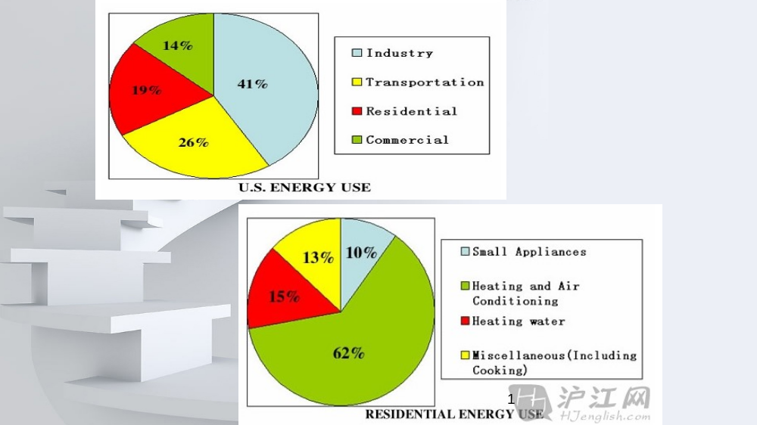范文参考：
The two graphs describe the data of the energy use and the residential energy use in detail in the United States.
It can be seen from the first pie chart that the energy is used for four purposes. Specifically , industry accounts for the largest proportion (41%) of the used energy while demand of transportation makes up 26% of the total need of energy. Residential and commercial represent 19% and 14% respectively.
According to the second pie chart, it clearly shows that heating and air conditioning account for the largest proportion (62%) in the residential energy use while the small appliances make up the least proportion (10%). The heating water and miscellaneous ( including cooking) constitute 15% and 13% respectively.

In conclusion, industry occupies the most part of the US energy use while heating and air conditioning takes dominance in residential energy use.
例题：
The graph below shows the different modes of transport used to travel to and from work in one European city in 1960, 1980 and 2000.
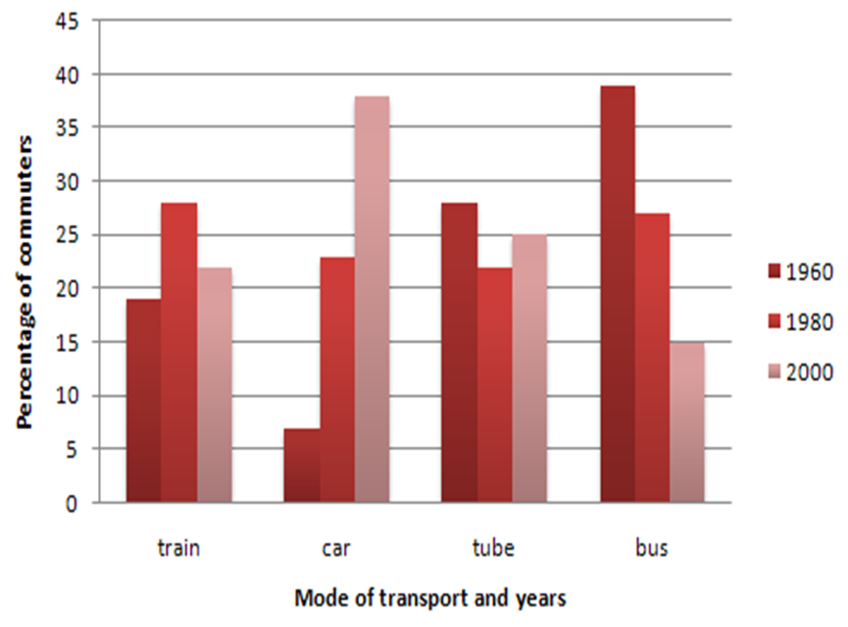
范文参考
The bar graph shows the changing patterns in commuting by train, car, tube or bus for commuters in one European city in the years 1960, 1980 and 2000.
As can be seen from the chart, the number of people using trains at first rose from just under 20% in 1960 to about 26% in 1980, but then fell back to about 23% in 2000. Use of the tube was relatively stable, falling from around 27% of commuters in 1960 to 22% in 1980, but climbing back to reach 25% by 2000.

On the other hand, the use of cars increased steadily from just over 5% in 1960 to 23% in 1980, reaching almost 40% by 2000, whereas the popularity of buses had declined since 1960, falling from just under 35% in 1960 to 27% in 1980 and only 15% in 2000.

In conclusion，the graph indicates the growing use of cars for commuting to work between 1960 and 2000, and the continued decline in the popularity of buses from being the most popular mode of transport in 1960 to the least popular in 2000.

例题：

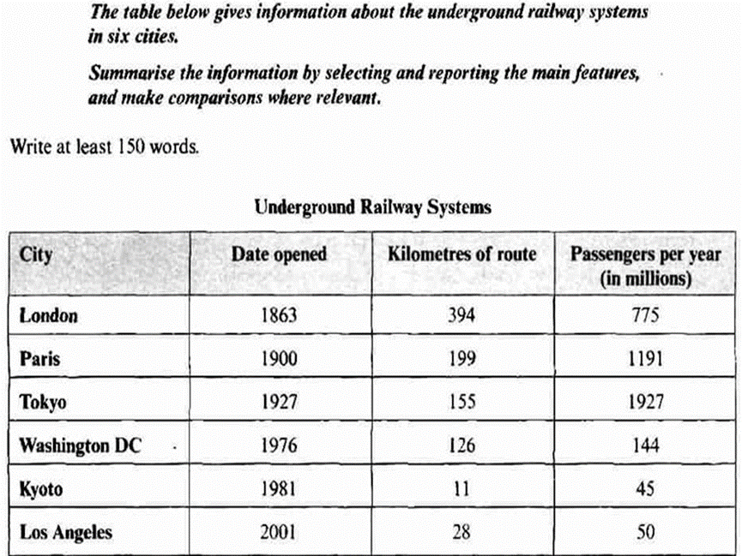
范文参考
The table demonstrates the data regarding the subway system in six cities, including date opened, kilometers of route and passengers per year (in millions) .

In terms of date opened, London has the most time-honored (in 1863) subway system among the six cities while subway system in Los Angeles is the newest one ， opened in 2001. （最老，最新）
The Systems in Paris and Tokyo were opened in 1900 and 1927, respectively. After that, the undergrounds in Washington DC and Kyoto were opened in 1976 and 1981 successively.

As for the size of the railway system, London still ranks the first, meaning it has the longest subway system (394 kilometers) among the six cities, which is roughly twice as large as the system in Paris(199 km). By contrast, subway system in Kyoto is shorter (11 kilometers) than the others even though it opened in relatively recent year. The kilometers of route in Tokyo, Washington DC and Los Angeles are 155, 126 and 28 respectively.

The third part is passengers per year in millions. More exactly, the top three are Tokyo (1927), Paris (1191) and London (775).
The underground railway system in Washington DC has 144 million passengers per year. The systems in Los Angeles and Kyoto carry fewer passengers per year (50 and 45, respectively).

In conclusion, it can be clearly seen from the table that London enjoys the earlies subway system and the longest route among the six cities while Tokyo underground carries the most passengers.

例题：
The table below gives information about changes in modes of travel in England between 1985 and 2000. 剑6 P52
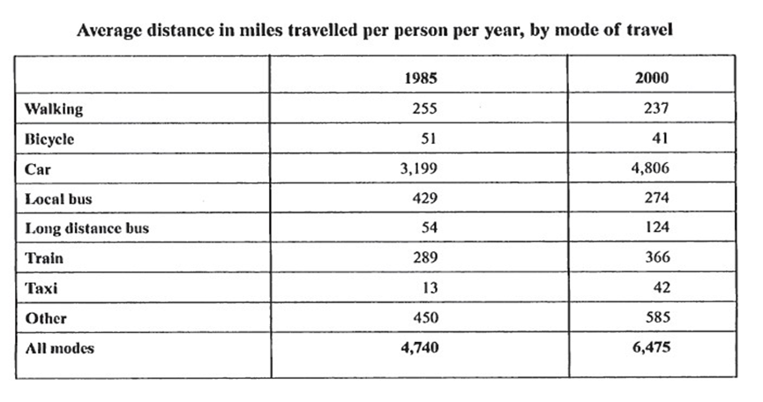
- 增加的 Car, Long distance bus, Train, Taxi
- 幅度大的 Car +1607
- 减少的 Walking, Bicycle, Local bus
- 幅度大的 Local bus -155
范文
The table demonstrates how different modes of travel changed in England in 15 years spanning from 1985 to 2000.

In general, the modes are classified into two kinds in terms of average miles travelled per person per year: one enjoyed rising popularity while the other decreasing.

The travel modes which gained popularity in the period include cars, long distance buses, trains, taxis and others. Cars remained top among the modes in the 15 years, with its average miles increasing considerably from 3,199 in 1985 to 4,806 in 2000. Long distance buses and taxis seemed to be warmly welcomed by travelers, so average miles travelled in the two modes almost tripled(from 54 to 124 and from 13 to 42 respectively). In addition, the use of train and others rose by 77 and 135 severally.

Travels by walking, bicycle and local bus lost travelers’ favor in the one and a half decade. Average travelling distance by local bus suffered the biggest decrease, dropping from 429 to 274, while the number of miles by walking and bike fell mildly from 255 to 237 and from 51 to 41 respectively.

Overall, the number of miles travelled by the average per person rose from 4,740 miles in 1985 to 6,475 miles in 2000, with the increase of cars accounting for almost all of that increase.

