The plan below shows the layout of Dale Hall Conference center when it was built in 2010 and as planned for 2025.
Summarise the information by selecting and reporting the main features, and make comparisons where relevant.
Write at least 150 words
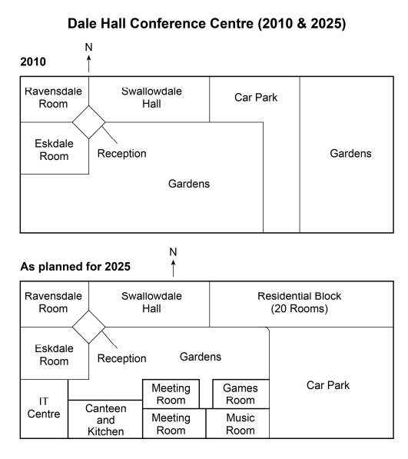

The two maps illustrated the distinction of structure of Dale Hall Conference Centre from 2010 and as planned for 2025.
Overall, a consideable number of changes have been taken place in the center, the most notable of which were the layout and division of areas.
In 2010, there was a Ravensdale Room located in the northwest corner, which was surrounded by Eskdale Room and Swallowdale Hall. As a bridge connecting them, reception was next to each of them and Gardens, which occupied the biggest areas. In the east of map, another Gardens connected with Car Park.
The map, as planned for 2025, showed that the Car Park and Gardens in the east of former map were replaced by Residential Block with 20 Rooms and car Park situated at southeast side. Additionaly, the region of central Garden reduced and this part of space was filled by IT centre, Canteen and kitchen, two Meeting Rooms, Games Room and Music Room from west to east.

