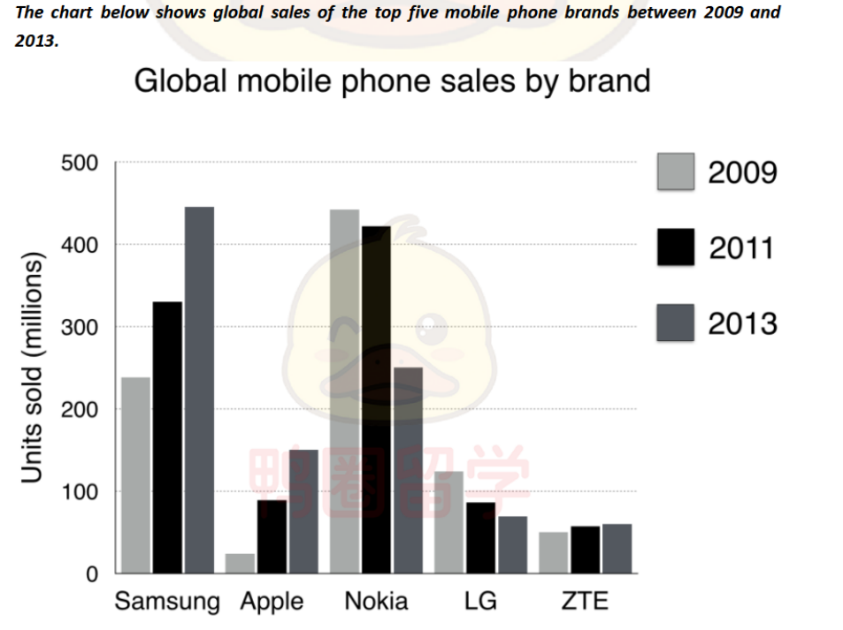
The bar graph illustrates the the number of mobile phone sold worldwide by the 5 most popular manufacturers in the years 2009, 20011 and 2013.
Overall, Nokia was the most successful brand in both 2009 and 2011, while samsung sold the most amount of mobil phone in 2013. Additionally, apple witnessed the biggest rise in sales over the period of 4 years.
It is clear that there was a dramaticly increase in sales by samsung from approximately 200 million in 2009 to about 450 million in 2013, which was became the most popular manufacturer. By contrast, the nokia had an opposite tendency that the figure of it rapidly fell by amostly 200 million.
On the other hand, during this 4-years period, apple saw a huge growth in sales and reached the peak at about 150 million, whereas the number of sales by LG slightly decrease from approximately 140 million to 80 million. In addition, ZTE remain stable over this period (50million) .

