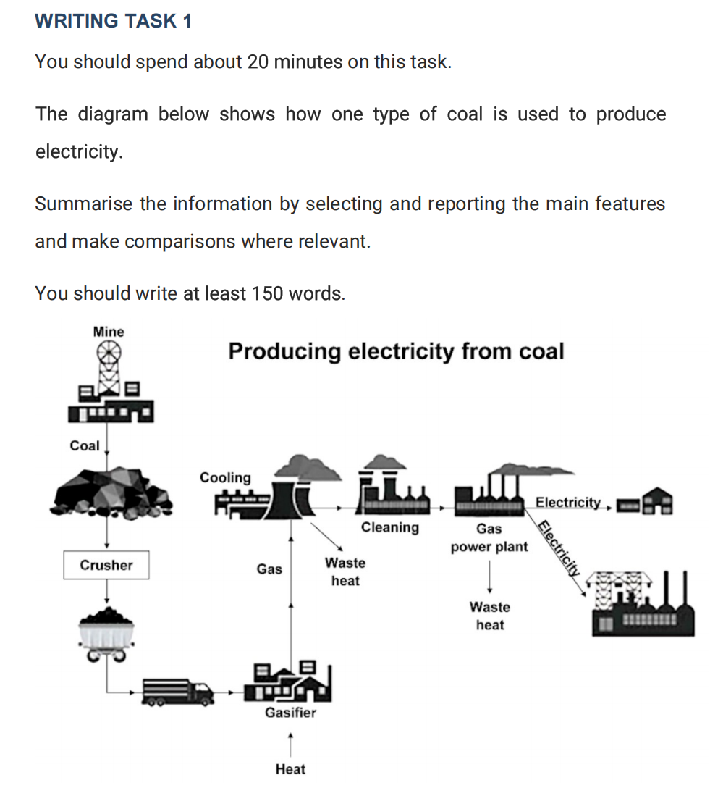
The diagram illustrates how to convert a category of coal into electricity.
Overall, The coals, a kind of raw material accquired from mine, undergo approximately seven stages before finally produceing sufficient electricity, providing to support operation of diverse fields.
In the first step of the whole procedure, coals are exploited in mine. Concurrently with the process of exploitation, materials are deliverd to gasifier by trucks and crushers which helps to load them into trucks. Upon completion of transportation, coals are transformed into gas under a heated environment in gasifier. After this phase, gas come to cooling, a facility to cool down temperature of gas, relieving waste heat.
Following these stages, the semi-finished products are transfered to cleaning and gas power plant in sequence. In the meantime, waste heat is emitted and electricity is created. In the last step, according to different demand of electricity, it inputs to manufactures or residence respectively.

