The graph below shows the value of clothing exported from Bangladesh between 1988 and 2012, and the pie chart shows the destination and value of exported clothing in 2012. Summarise the information by selecting and reporting the main features, and make comparisons where relevant. Write at least 150 words.
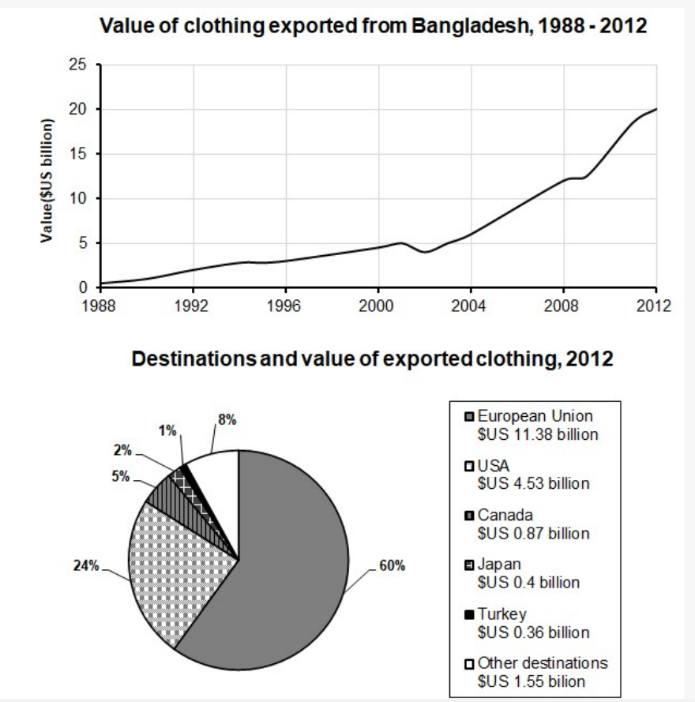
The line chart illustrated the information about the change of clothing sale scale exported from Bangladesh over the period of 24 years, while the pie graph indicated the percentages of exported clothings’ value from five different regions respectively.
Overall,it is clear that the value of clothing witnessed a soaring risk from 1988 to 2012. With regard of the distribution of value of exported chothing, European Union and USA were the two most profitable countries in the 2012.
On the one hand, there was a generally increase in cost of clothing exported from Bangladesh from approximately 0 billion in 1988 to 5 billion in 2001. Then the figure of it dramatically grew with fluctuation to the peak (20 billion dollars) in 2012.
On the other hand, European Union ,one of most popular areas to export clothing ,accounted for 60% of the total which had almostly as twice value as others (11.38 billion dollars). In the meantime, 24% of them attributed by USA (4.53 billion dollars) was mostly equal to the rest of regions

