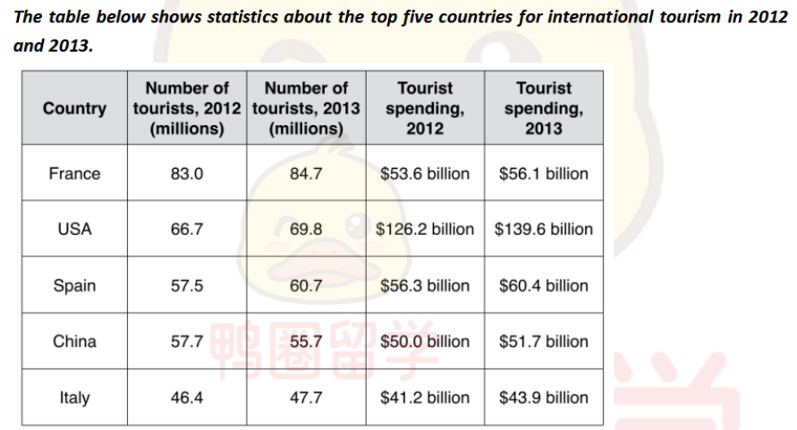
The table illustrates the information about numbers of tourists and the money they spent in the five most popular nations in the years 2012 and 2013.
Overall, during this period, the number of visiters slightly increased in all the regions except for China, while the tour expenditure from tourists show a same tendency in all the countries.
On the one hand, France became the most popular place which attracted roughly 83 million people to visit. By contrast, this twe years witness a largest rise in visitors’s amount in USA and Spain from 66.7 million to 69.8 million and from 57.5 million to 60.7 million. Additionally, China was the only place which saw a decrease over this two years.(from 57.7 million to 55.7 million).
With regard to cost spent by the tourists, there was a rapid growth in tour expense in USA which rose by amost 13 billion and made it became the most profitable place in the world, while italy earned the lowest revenue(approximately average 42 billion).

