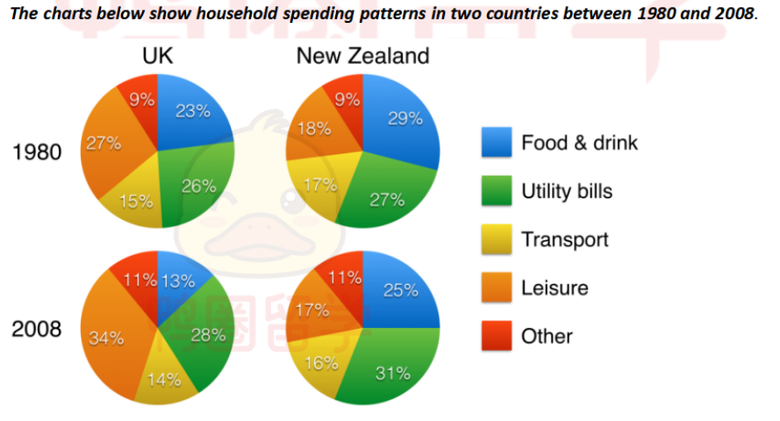
These pie graphs illustrate the five categories of houehold expenditure in UK and New Zealand in the years 1980 and 2008.
It is clear that the proportion of household expense on food and drink fell in both countries between 1980 and 2008, while utility bills had an opposite tendency. Additionally, the UK residents spent a larger percentage of household budgets on leisure than New Zealand counterparts.
There were an incresse in expenditure on utility bills both two countries over 28-year period from 26% to 28% in UK and from 27% to 31% in New Zealand, while those on food and drink show a reverse trend which fell by 10% and 4% respectively.
The percentage of budgets on leisure witness a dramatic rise from 27% in 1980 to 34% in 2008 in UK, which accounted for the largest part. By contrast, the counterparts in New Zealand slightly decreased from 18% to 17%. Additionly, in two regions ,transport cost and other cost occupied about 15% and 10% respectively.

