Data Science market analysis

**Maciej Pleban**  
Warsaw, Poland 2024

# Introduction

In the era of information abundance, data has emerged as the lifeblood of modern enterprises, driving decision-making processes, innovation, and competitive advantage across industries. As organizations seek to harness the power of data, the field of Data Science has risen to prominence, offering a multidisciplinary approach to extracting insights, predicting trends, and solving complex problems.

The Data Science market is witnessing unprecedented growth, propelled by advancements in technology, increasing digitization of processes, and a growing recognition of the transformative potential of data-driven decision-making. From healthcare to finance, retail to manufacturing, organizations are investing heavily in Data Science initiatives to gain a competitive edge, optimize operations, and unlock new revenue streams.

The aim of this study is to examine the dynamics of change in the Data Science market, in order to identify trends, insights and forecast what lies ahead for this field of science in the coming years.

# Dataset

The dataset used in the following research has been taken from [AI-Jobs](ai-jobs.net), a website with job offers for Data Science. This dataset relates to annual salary data for Data Science professions, broken down by experience, role, company size, work mode and contract type over the years. The data is collected anonymously from professionals and employers all over the world, however it consists of very few records for years 2020 and 2021, nevertheless this data was also taken into consideration. As we are at the beginning of 2024 the data will be limited from 2020 to 2023.

# Research

In case of the revenues instead of the simple average, the median has been used as it is an estimator much more resistant to outliers.

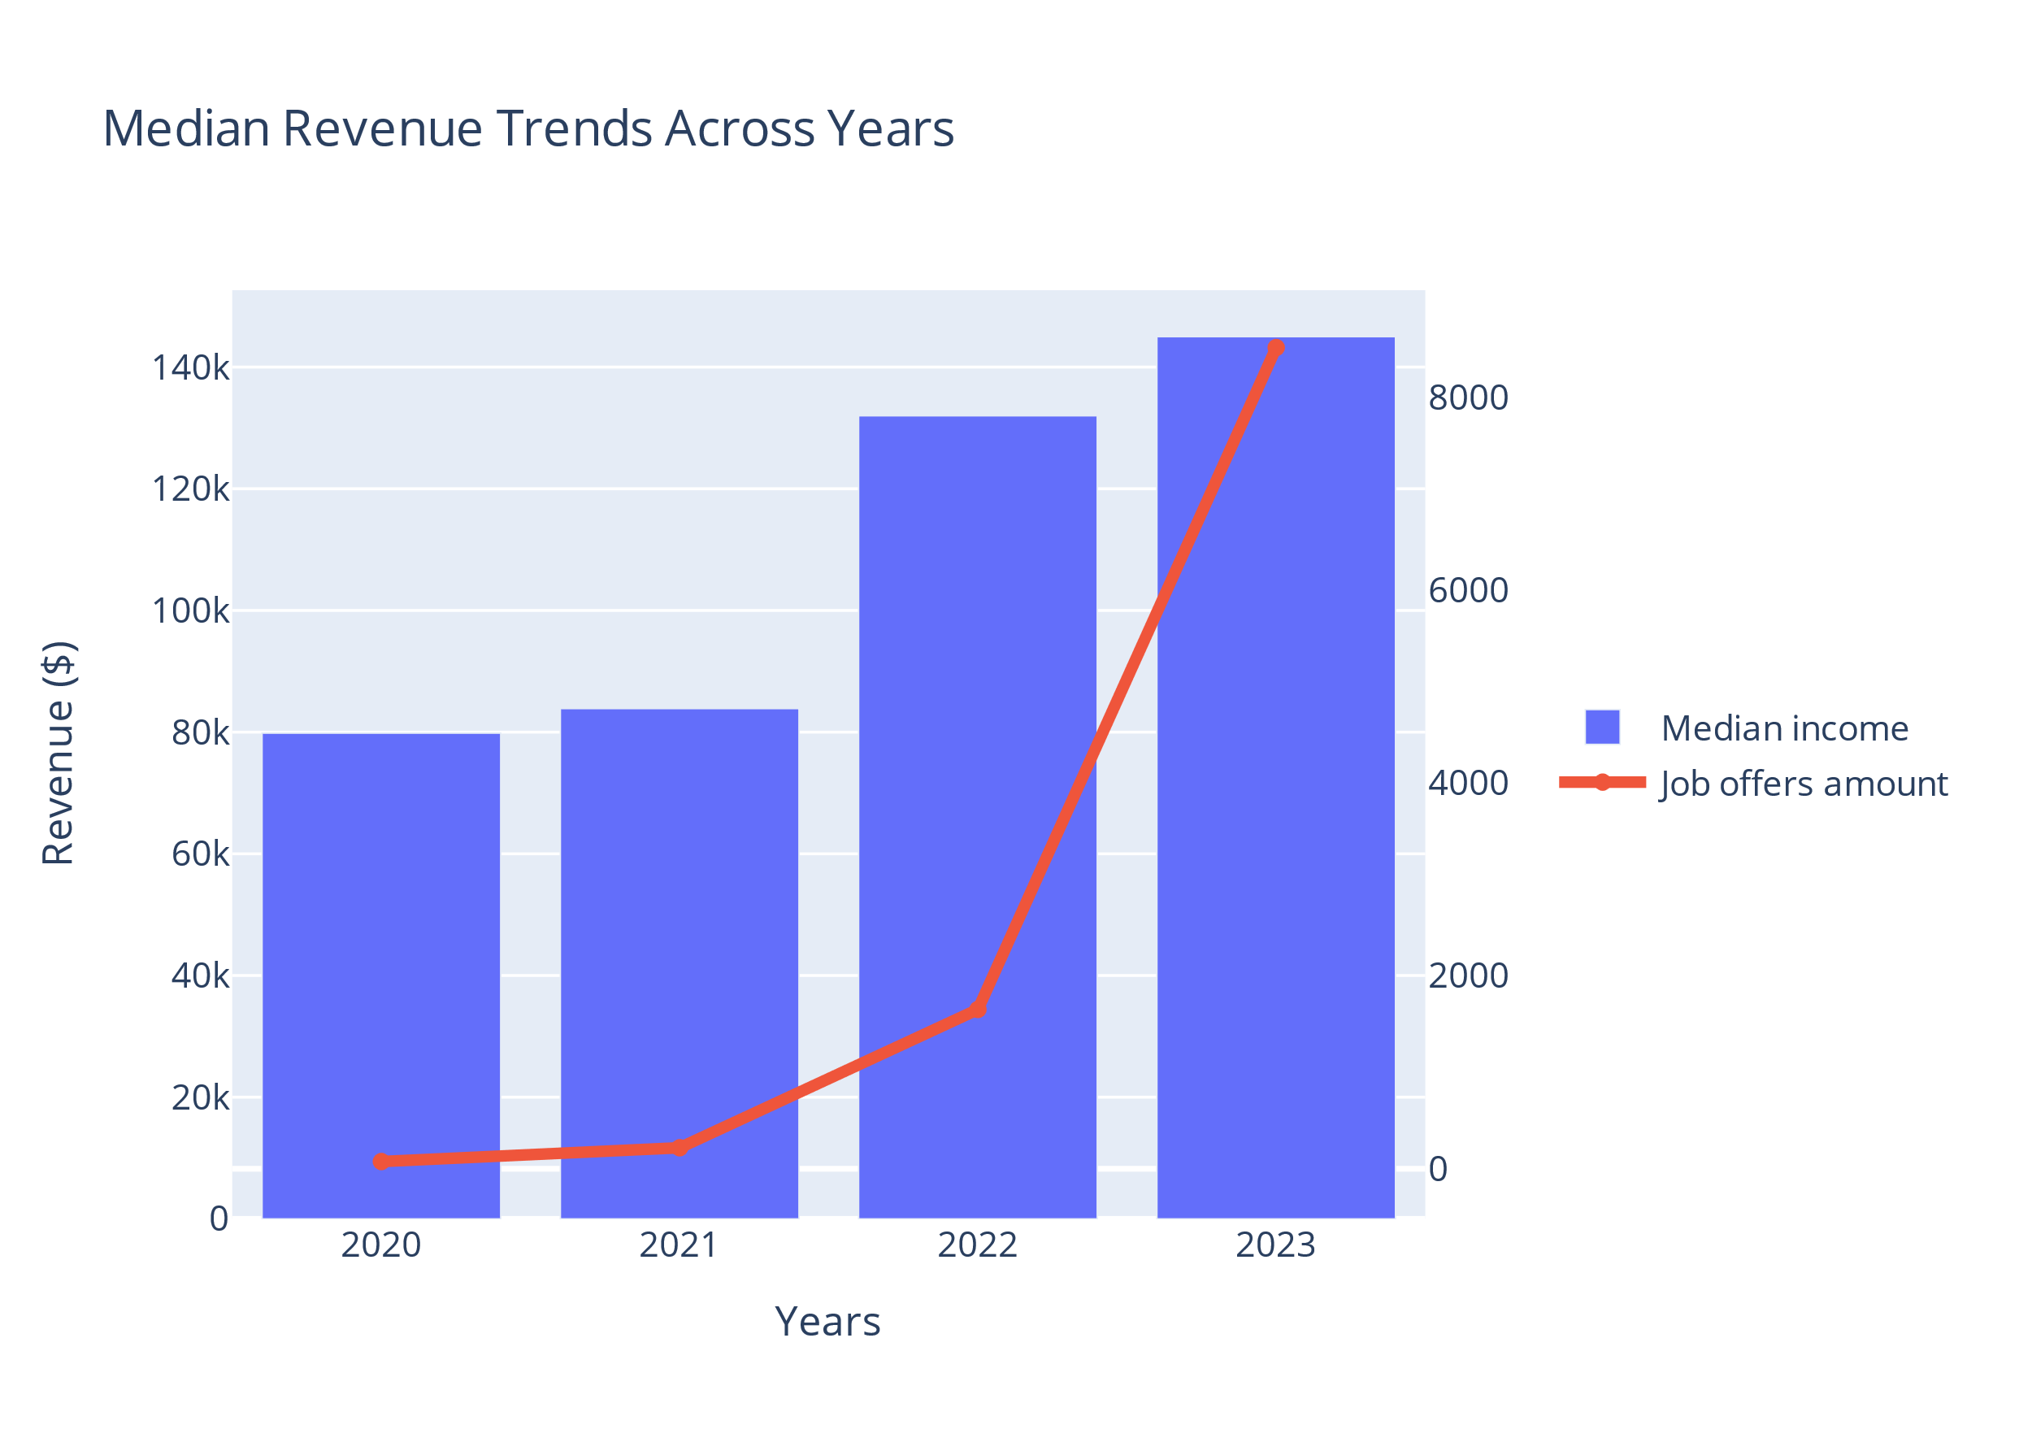

There is a clear upward trend in median annual revenues from 2020 to 2023, indicating robust growth and increasing demand for Data Science expertise. The significant jump in median annual revenues from 2021 to 2022, followed by a more moderate increase from 2022 to 2023, suggests a period of rapid growth followed by stabilization in the Data Science market. This stabilization phase may indicate a maturing market, characterized by more predictable growth patterns and established norms in terms of compensation and demand-supply dynamics.

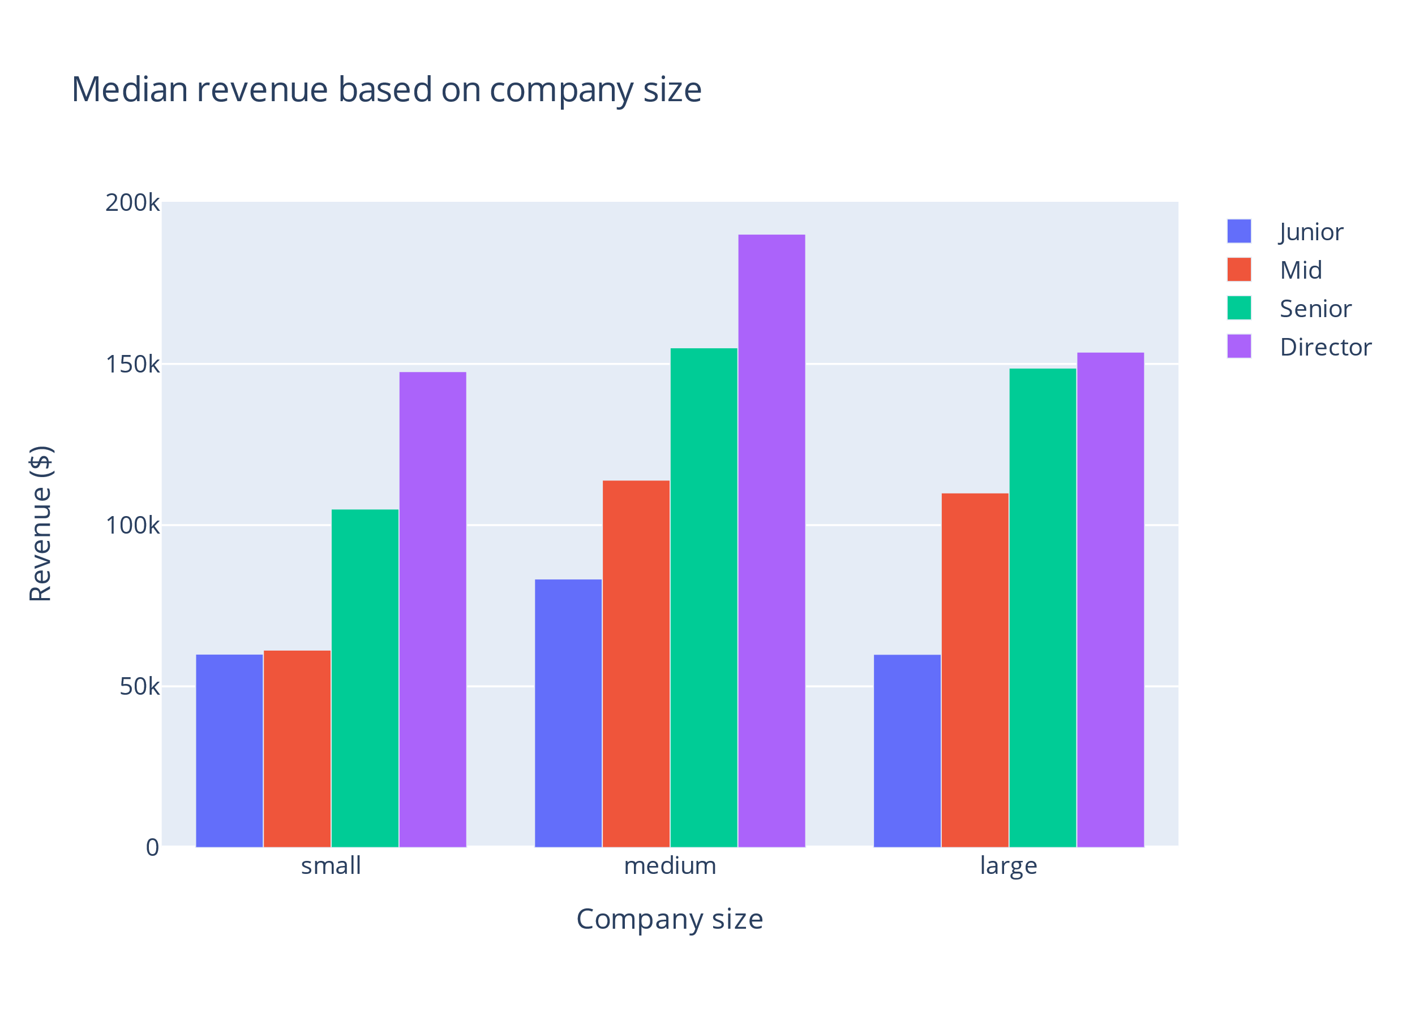

It's evident that there exists a significant disparity in compensation levels based on both company size and experience level. Across all company sizes, from small to large enterprises, there is a clear trend of compensation increasing with experience. This reaffirms the value placed on seasoned professionals within the Data Science domain, as their expertise and insights are instrumental in driving organizational success.

Moreover, the data highlights the influence of company size on compensation structures within the Data Science field. While smaller companies may offer competitive salaries for junior and mid-level roles, larger enterprises tend to provide higher remuneration, particularly for senior and director-level positions. The substantial increase in compensation from junior to mid-level positions suggests that career progression within the Data Science field can lead to significant financial rewards. This underscores the importance of continuous learning, skill development, and professional growth for individuals aspiring to advance their careers in Data Science.

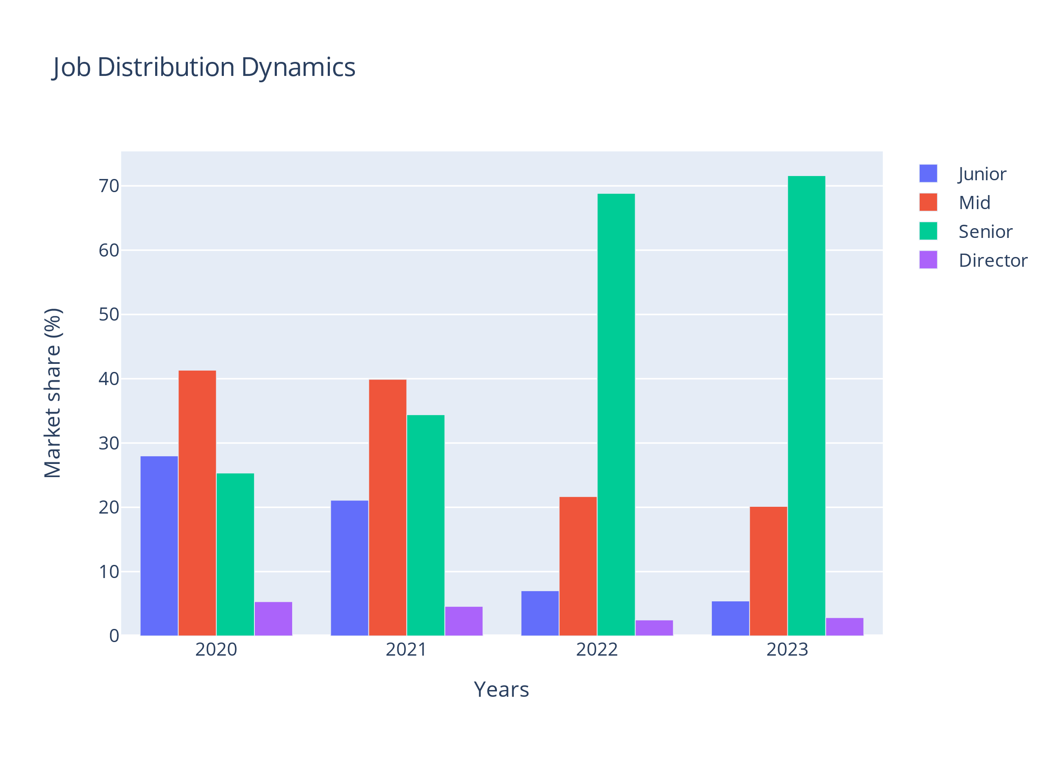

The data reveals a notable shift in the distribution of job roles over the years. Junior positions have seen a consistent decline, while there's a steady rise in the market share of Senior and Director roles. Mid-level positions have remained relatively stable throughout. this phenomenon may be due to an influx of people from outside the IT and Data Science community because they have been enticed by the high wages. Therefore it was much more difficult to find a valuable employee which is not geared to the desire to quickly make a lot of money at little cost. Another thing is that the funding for many projects has been cut so there was no need to employ so many people.

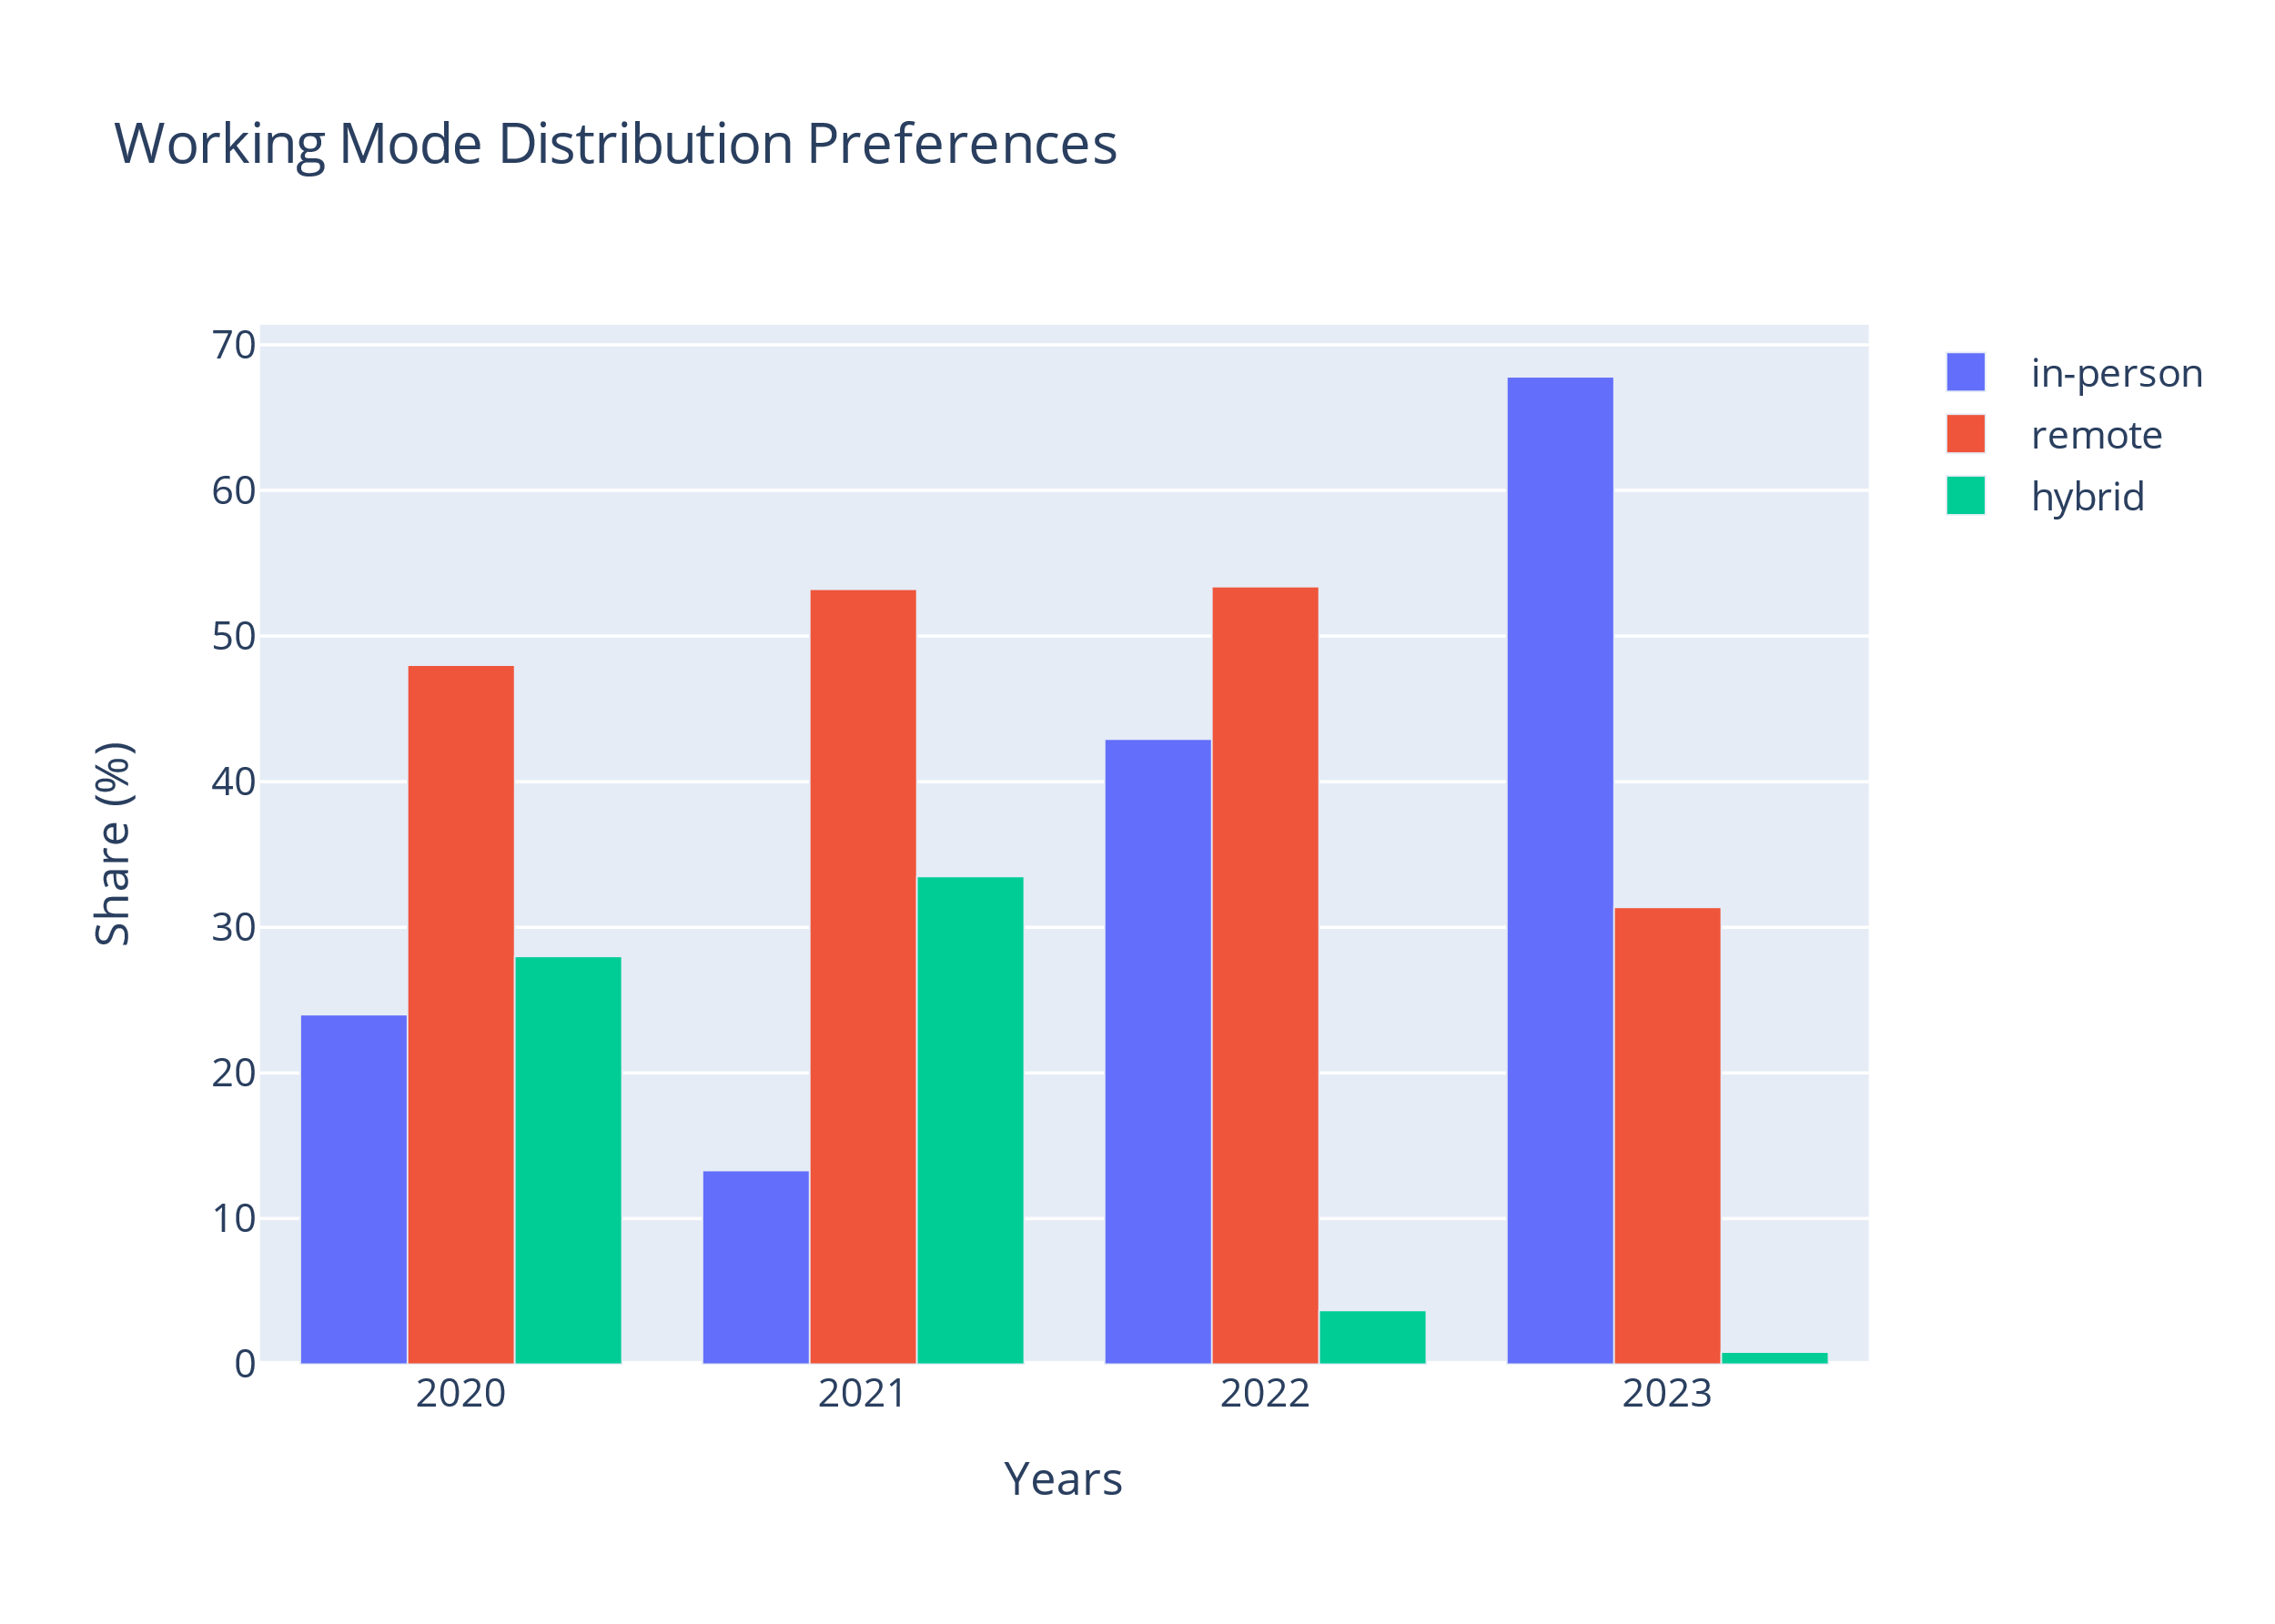

The high level of remote working as opposed to working in person is certainly due to the outbreak of the COVID-19 pandemic in 2019. The restrictions present in those years often prevented working in the office in order to limit the spread of the coronavirus to limit the spread of the coronavirus. Over time, this ratio has increased in favour of working from the office and there has been a slow return to the standard working mode, although there is still quite high part of employees who value remote working.