# Careful with QR codes

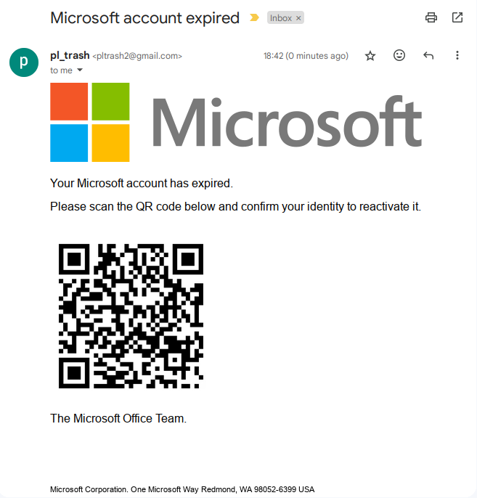Be careful with QR codes... Try this one.  
Use an app that allows you to preview the link before opening it. This will help you spot potential dangers.