# Reporting phishing websites to browser manufacturers

As noted in the previous article about reporting phishing to authorities, sharing the methods and means used by hackers is important to prevent others from becoming victims of criminal acts.

Fortunately, major browser manufacturers have recognized the importance of user safety and have provided mechanisms protecting the user.

* Google has created an initiative called Safe Browsing, used by Google Chrome, Mozilla Firefox and Apple Safari;
* Microsoft uses Microsoft Defender SmartScreen with Edge.

When these options are enabled, the browser sends the URLs you visit to Google or Microsoft, where they are compared with a blocklist of fraudulent sites. If they are in the list, the browser displays a warning page and prevents you from accessing the sites.

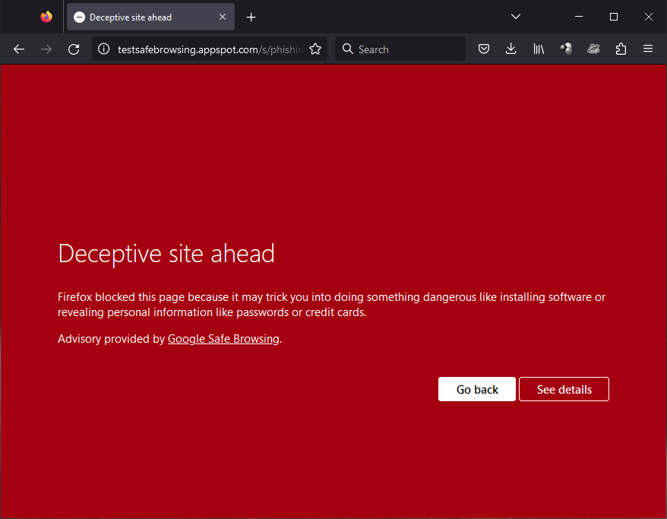By reporting phishing sites, you help them build these lists and protect other web surfers.

In this article, we will guide you through the steps to report phishing sites.

## Mozilla Firefox

The built-in reporting tool in Mozilla Firefox will send your report to Google. To report a phishing email while using Firefox, follow these steps:

1. Go to the phishing site;
2. Click the three horizontal lines (hamburger menu) in the upper-right corner;
3. Click "Help" from the menu;
4. Click "Report deceptive site”;

1. The reporting page is pre-filled with the URL. You can add some comments. Then check the “I’m not a robot” box, and click on the “Submit Report” button.

## Google Chrome and Apple Safari

Safari and, more surprisingly, Google Chrome have no integrated option to report a phishing site. However, you can go to <https://safebrowsing.google.com/safebrowsing/report_phish/?hl=en>, and you will find almost the same reporting page as for Firefox:

Fill in the suspicious URL, add a comment if you wish, check the “I’m not a robot” box and click on the “Submit report” button.

## Microsoft Edge

To report a phishing email while using Edge, follow these steps:

1. Go to the phishing site;
2. Click the three horizontal dots in the upper-right corner;
3. Hover your mouse on the “Help and feedback”, then click on the “Report unsafe site” menu entry;

1. Check the “I think this is a phishing website” box, answer the captcha and click on “Submit”.

## 