# **Decoding short URLs**

## Short URLs

While browsing the web, you have probably encountered references to web pages with a short and rather cryptic URL, like [*bit.ly/3rZ7Xws*](http://bit.ly/3rZ7Xws),[*t.co/sJpSI7yCEb*](http://t.co/sJpSI7yCEb), [*ow.ly/R7LE50PYCHn*](http://ow.ly/R7LE50PYCHn) or [*https://tinyurl.com/yahndvxn*](https://tinyurl.com/yahndvxn).

These are shortened URLs. They are not the real locations of the page you will read if you click, but they are shorthands. Bitly, Twitter/X, TinyURL, BL.INK, Zapier... are companies that allow you to use (for a fee - some have a limited free plan) a short URL under their domain name to point to a page with a more complicated path like *https://www.my-isp.com/myblog/the-page-i-want-to-share-with-my-neighborhood.html*.

Technically, they create a page at their site with a short name and use some code to redirect the reader's browser to the original page (they use a HTTP redirect (301) or a HTML meta refresh statement) .

Shortened URLs hide the actual destination of a click on the link, so they can be easily exploited by pirates to drive a user to a malicious or counterfeit site.

Note also that these aggregator sites gather statistics on the clicks, so it is not optimal for privacy; it is better to directly connect to the original site.

## How to decode short URLs

There are free websites that decode the shortened URLs for you without you actually accessing them.

[urlxray.com](http://urlxray.com/) is the most straightforward site. You enter the shortened URL and it displays the original one.

[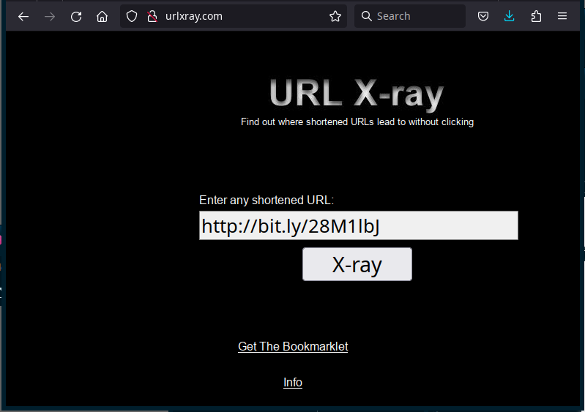unshorten.it](https://unshorten.it/) not only expands the shortened URL, but it shows you a preview of the site and safety ratin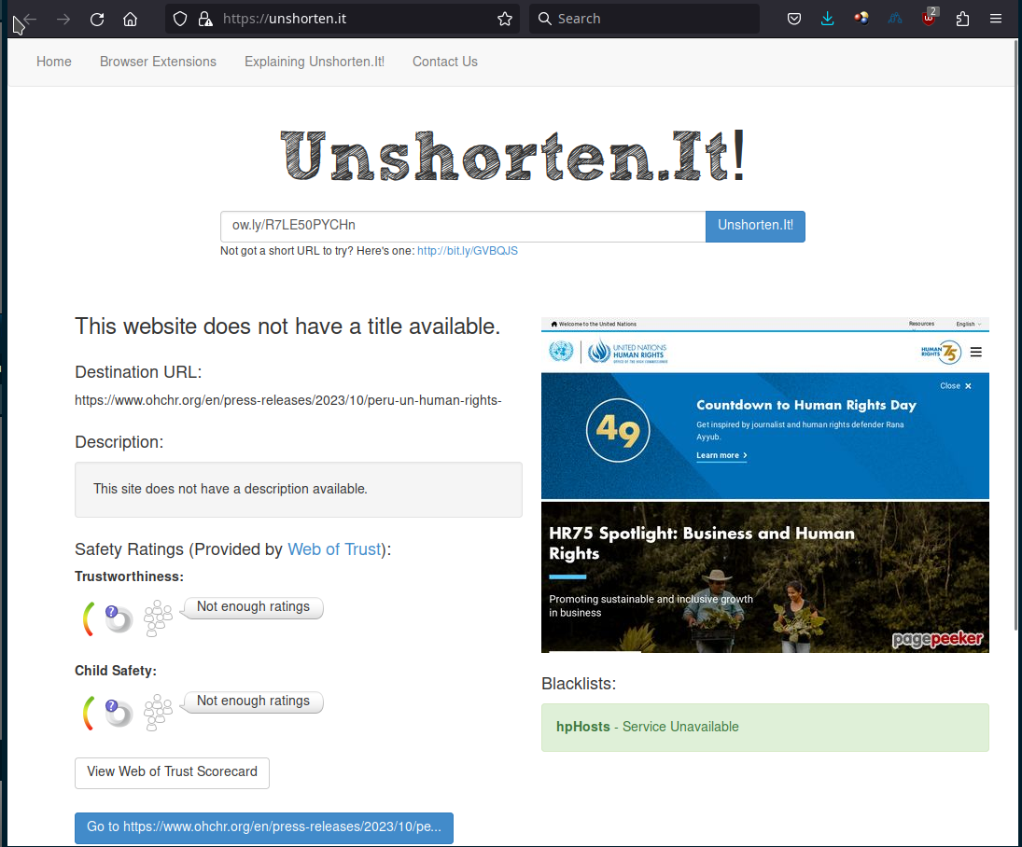gs.

[checkshorturl.com](https://checkshorturl.com/) does the job too, but with some ads and a more ... extravert design. It is less efficient as previewing the website and limits your free translations to 120/day.

[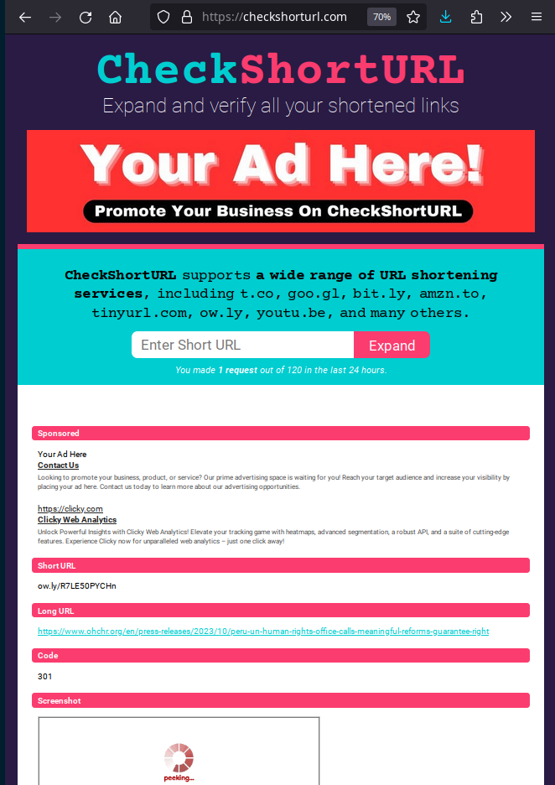ExpandURL.net](https://www.expandurl.net/) is also a simple site that creates and expands shortened URLs.

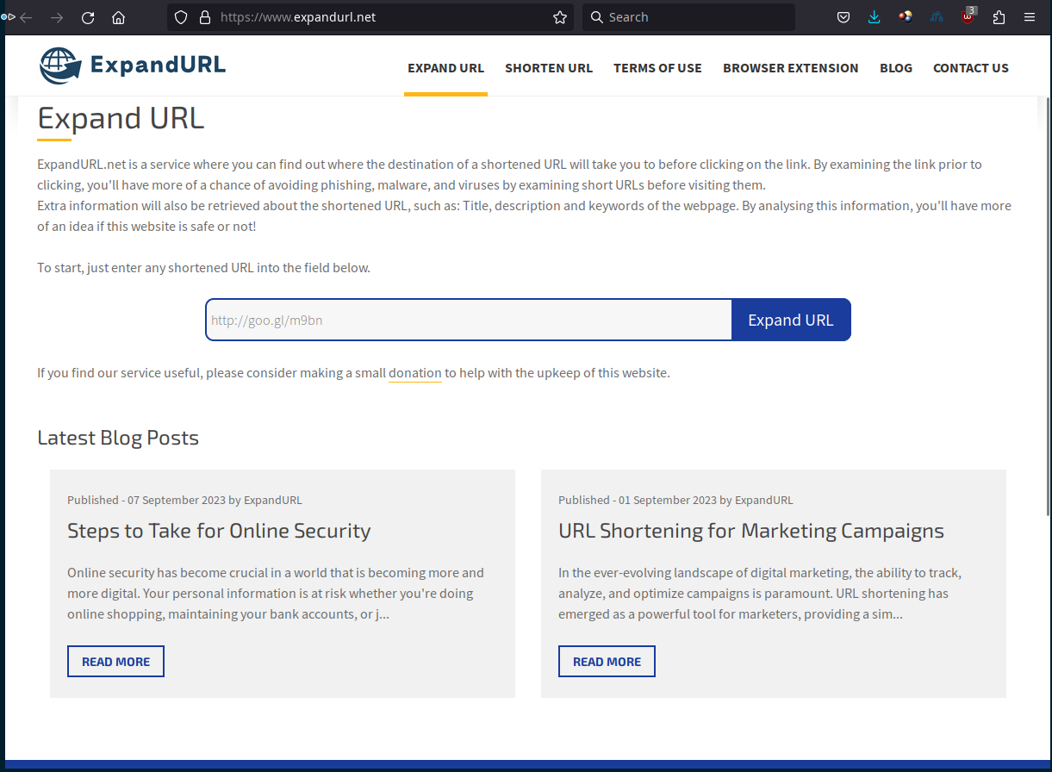

## Conclusion

Before clicking on a shortened URL, expand it with the help of one of the sites above, and check the real destination is what you expect.