CAV Energy and Demand Decomposition at the Aggregated National Level

Sept. 9, 2018

A compact and aggregated model of road vehicle travel and energy use is constructed to consider the interactions of multiple relevant identified mechanisms (Wadud et al. 2016, Stephens et al. 2016) by which automation can alter efficiency and activity. Travel demand and vehicle use derives from a standard utility-theoretic specification of driver/traveler behavior. Vehicle efficiency, travel (vehicle-kilometers traveled), average travel speed, congestion, and travel time are endogenous. Following Small and Verhoef (2007) and others, utility derives from travel, aggregate goods consumption, and liesure, subject to individual budget and time constraints.

Table of Contents

# 1. Introduction, Main Points, Key Factors

* Potential value of (goals for) compact/aggregate model:
  + determine minimum cost to achieve some level of energy use and level of mobility
    - large simulation models would have to do many simulations
  + simulate effect of changing costs from technological advances through vehicle automation, electrification, and sharing.

#### Important driving factors have an economic dimension

* Demand response to automation and shared mobility
  + consumer behavior model drives demand response
  + particularly, following Small & Verhoef, others, consumer behavior model determines choice of travel VKT, vehicle efficiency, and travel time
  + Utility derives from travel, goods, leisure.
  + Utility maximization subject to joint constraints on budget and time
* Endogenous interactions
  + Speed - (highway free-flow) endogenous to trade-off between energy cost, time and safety costs
  + Congestion – (determines average achieved speed in traffic) endogenous to vehicle mix, VKT, automation
  + Travel demand - endogenous to costs, including energy, congestion and safety, as well as travel time utility (VTT)
  + Distinguish between VKT and PKT, given car-sharing and ride-pooling
    - Compact representation of ride pooling choice
* CAV fuel efficiency follows one of three models
  + The technically feasible case
    - This provides an upper bound on achieved fuel savings, assuming system optimization with respect to energy.
  + CAFE-binding case
    - AVs achieve same MPG as CAFE average, counting some off-cycle benefits. AVs thus have similar intensity as MVs.
  + Cost-effective case
    - AVs may be more efficient than standard, *if* further efficiency reductions are cost-effective from a private perspective

#### Key Questions (in order of attention paid here)

* How may vehicle fuel intensity/economy change?
  + [technical and behavioral factors]
  + [dependence on infrastructure, and degree of penetration]
* How will travel demand change?
  + See EEMS2017 study of travel demand for different VOTT reports 30-50% increase in energy, mostly from demand, depending on VOTT [ToDo: see what this implies for VKTDemandElas]
  + Travel patterns - details omitted
    - Impact: Trip chaining patterns
    - Impact: detailed drive cycle changes (power use over different segments of trip, from detailed traffic interactions and speed changes)
* What are the implications of shared-mobility for energy use and VKT?
  + Important to differentiate shared vehicles (aTaxi or *ride-hailing*) and shared rides (*ride-pooling*)
  + Model through occupancy, incremental VKT from re-positioning, and implications to travelers’ cost
* To what extent can CAVs enable fuel switching or electrification?
* How/when will CAVs be adopted? (not addressed)
* What are the special challenges of the transitional period, when a mix of manual, partially automated, and automated vehicles will share the roadways? (not addressed)

#### Contributions of this paper

This paper describes a new aggregated framework, building on established travel demand literature, that account for key features of vehicle automation, and estimates demand and energy use implications. Unlike prior known aggregate work, which relied largely on fixed-coefficient scenario analysis or accounting, it integrates technological and economic factors, including fuel, vehicle and other travel costs, and incorporates energy and travel behavior responses to economic incentives. This work abstracts from much detail offered by micro and mesosimulation models, which estimate travel and energy implications of specific AV technologies using agent/micro/mesosimulation of travel and traffic in real-world spatial and road network models (MATSIM, BEAM, POLARIS, others). The aggregate approach here complements that evolving work and seeks to incorporate some of the insights from that detailed spatial travel modeling. Our framework also is novel in the integration of a utility-based behavioral framework with technological detail and private and public costs, emphasizing the role of financial incentives in the form of costs, fees or taxation/subsidy of transport energy or road use. It extends the private utility maximization framework for travel behavior of Small and Parry 2005, Small and Verhauf 2007, and Leiby and Rubin 2017, combining it with the vehicle efficiency and automated vehicle technological details of Wadud et al 2016. It seeks to address the important issue of how to promote the mobility and energy benefits of CAV technologies while deterring potential adverse outcomes (congestion, emissions) that can have large unaccounted social costs.

#### Limitations

* An incomplete consideration of role of AV safety and its endogenous effect on travel costs and travel behavior.
* The abstraction of potentially important detail, discussed above. It includes only an approximate representation of the effects of AV technologies and systems on vehicle energy use for specific drivetrains, roadway network, traffic conditions, and drivecycles, such as can be modeled in more detailed vehicle and spatial models such as Autonomie, FASTSim, BEAM/POLARIS, etc.

# 2. Decomposition of Energy and GHG Impacts of CAVs

The energy and GHG emissions of CAV transportation result from the interaction of a wide range of mechanisms, including the impact of vehicle technologies and vehicle design changes on vehicle operations and efficiency; system-level changes in infrastructure that alter traffic coordination, speeds, and patterns; and consumer behavioral responses that determine the number, length, and nature of trips demanded. The composition of the effects of many of these mechanisms can be conveniently accounted with a *Kaya Identity*, as used in transportation emissions by (McCollum & Yang, 2009, Greene and Plotkin, 2011) or equivalently the *Schipper ASIF framework* (Schipper et al. 2000, 2011). Mechanistic and scenario-base approaches of this type have been used to explore CAV impacts by Wadud, MacKenzie and Leiby (2016) and by Stephens et al. 2016. While this approch assumes a degree of separability in the impact of certain identified mechanisms on energy use, e.g. weight reduction versus aerodynamic load reduction through platooning, this is supported in some cases by more detailed models and experimental data [cite XXX].

From this so-called *ASIF* approach the total GHG emissions are the product of

1. the level of **A**ctivity (e.g., passenger miles of travel),
2. the **S**hare of activity for each mode, vehicle, and fuel type,
3. the energy **I**ntensity of the mode and vehicle type (e.g., energy use per vehicle mile), and
4. the **F**uel carbon intensity (ghg emission mass per unit energy)

Transportation GHG emissions are then the sum over all transportation modes, vehicle types, and fuels of the product of {Transportation Services Activity[1]} x {Shares of each mode-vehicle-fuel type} x {Energy Intensity} x {Fuel GHG Intensity}.

Energy use for particular vehicle type is given by total activity (travel demand) level , the share of travel on mode *m* and the average share-weighted energy intensity of travel by vehicle type and mode.

Vehicle energy intensity *I* is a function of a vector of CAV mechanism/technology levels.

Defining indices

* m = transportation mode
* v = vehicle type
* f = fuel type
* t = time period (year)

for sets[2]

* M = set of transportation modes *m*
* V = set of vehicle types *v*
* F = set of fuel types *f*
* T = set of time periods *t*

The variables are

* = the transportation services Activity provided by type (passenger v.s freight, or LDV/HDV) [billion passenger-km or tonne-km traveled/yr]
* = occupancy of each vehicle type v in year t [pass/veh, or PKT/VKT, for passenger travel; tonne/veh for freight]
* = share of energy services in transportation mode m by vehicle type v in year t [unitless]
* = the share of energy-service share produced by fuel type f [unitless]
* = the energy intensity of vehicle v in mode m using fuel type f in year t [MJ/veh-km] ([EJ/Bill veh-km])
* = the GHG intensity of fuel f in year t [g CO2e/MJ (MegaT CO2e/EJ)]
* = energy use in form of fuel f by vehicle type v in year t [EJ/y]
* = GHGs emitted in year t by type v [MT CO2e/y]

Focusing on passenger travel, we can write energy use as

with units

Total Emissions are

Combining, overall total emissions per year are

Alternatively, in the form of a vector expression over vehicle types *v*,

for v x 1, v x f and f x 1. And

In the work here, road travel demand is divided into LDV and HDV (passenger and freight), at the minimum, and can be further decomposed into vehicle size classes, and drivetrain classes.

## Mechanisms by Which CAVs Can Alter Energy Use and Emissiona

We identified a set *K* of “Mechanisms” or “Technologies” associated with vehicle automation, each of which has an effect represented by multiplier that can increase or decrease a component term in the ASIF decomposition. In general, a mechanism can affect travel activity levels *A*, vehicle energy intensities *I*, or mode and fuel shares . Furthermore, a mechanism could also effect vehicle class shares or occupancy, but we do not yet consider such effects.

Taking a Scenario Approach, we can construct scenarios *s* that combine technology cases and demand cases . For each scenario values are indexed by year *t* (for selected years), vehicle class *v*, mechanism *k* and by the Technology/Demand scenario *s*, i.e. ???.

The set of mechanisms *k* represented include: Platooning, De_emphasized_performance, Improved_crash_avoidance, Right-sizing, Eco_driving, Congestion_mitigation, Increased_feature_load, Higher_highway_speeds. We consider vehicle classes *v* in LDV, HDV. The model is explored over time for years *t* from 2035 to 2050.

# 3. Estimating Energy Impacts

We define the effects of automation on vehicle energy intensity (energy per vehicle km traveled) through a set of identified technological and operational “mechanisms.”

The estimation for the midcase energy intensity impacts of each mechanism is based on literature review[3] and the external calculations of the authors. Ranges of values, for sensitivity cases and scenarios, are constructed for each mechanism *k*, for effect sensitivity cases *s* from “zero” through “pessimistic,” “midcase,” and “optimistic.” Mechanism intensity effect values indicate the fractional change in energy intensity for a particular mechanism *k*, and are differentiated by year *t*, vehicle class *v*, and effect sensitivity *s*.

### 3.1 Construct multiplicative factors to apply to energy intensities for each mechanism

From the fractional changes in energy intensity, multipliers are constructed to apply for each mechanism/technology *k*, year *t*, vehicle class *v*, and effect sensitivity case *s*.

A multiplier value of 1.0 indicates no change and less/greater than one implies a multiplicative reduction/increase in energy intensity.

Intensity Multipliers by Vehicle-type, Year, and Case

|  |  |  |  |  |  |  |
| --- | --- | --- | --- | --- | --- | --- |
| VC | Year | Mech | Opt | Mid | Pess | Zero |
| LDV | 2035 | Congestion_mitigation | 0.966 | 0.9830 | 1.000 | 1 |
| LDV | 2035 | De_emphasized_performance | 0.770 | 0.8600 | 0.950 | 1 |
| LDV | 2035 | Eco_driving | 0.800 | 0.8750 | 0.950 | 1 |
| LDV | 2035 | Higher_highway_speeds | 1.070 | 1.1450 | 1.220 | 1 |
| LDV | 2035 | Improved_crash_avoidance | 0.771 | 0.8580 | 0.945 | 1 |
| LDV | 2035 | Increased_feature_load | 1.000 | 1.0500 | 1.100 | 1 |
| LDV | 2035 | Platooning | 0.752 | 0.8575 | 0.963 | 1 |
| LDV | 2035 | Right_sizing | 0.550 | 0.6700 | 0.790 | 1 |
| LDV | 2050 | Congestion_mitigation | 0.958 | 0.9790 | 1.000 | 1 |
| LDV | 2050 | De_emphasized_performance | 0.770 | 0.8600 | 0.950 | 1 |
| LDV | 2050 | Eco_driving | 0.800 | 0.8750 | 0.950 | 1 |
| LDV | 2050 | Higher_highway_speeds | 1.070 | 1.1450 | 1.220 | 1 |
| LDV | 2050 | Improved_crash_avoidance | 0.771 | 0.8580 | 0.945 | 1 |
| LDV | 2050 | Increased_feature_load | 1.000 | 1.0500 | 1.100 | 1 |
| LDV | 2050 | Platooning | 0.752 | 0.8560 | 0.960 | 1 |
| LDV | 2050 | Right_sizing | 0.550 | 0.6700 | 0.790 | 1 |
| HDV | 2035 | Congestion_mitigation | 0.966 | 0.9830 | 1.000 | 1 |
| HDV | 2035 | De_emphasized_performance | 1.000 | 1.0000 | 1.000 | 1 |
| HDV | 2035 | Eco_driving | 1.000 | 1.0000 | 1.000 | 1 |
| HDV | 2035 | Higher_highway_speeds | 1.000 | 1.0000 | 1.000 | 1 |
| HDV | 2035 | Improved_crash_avoidance | 1.000 | 1.0000 | 1.000 | 1 |
| HDV | 2035 | Increased_feature_load | 1.000 | 1.0000 | 1.000 | 1 |
| HDV | 2035 | Platooning | 0.750 | 0.8250 | 0.900 | 1 |
| HDV | 2035 | Right_sizing | 1.000 | 1.0000 | 1.000 | 1 |
| HDV | 2050 | Congestion_mitigation | 0.958 | 0.9790 | 1.000 | 1 |
| HDV | 2050 | De_emphasized_performance | 1.000 | 1.0000 | 1.000 | 1 |
| HDV | 2050 | Eco_driving | 1.000 | 1.0000 | 1.000 | 1 |
| HDV | 2050 | Higher_highway_speeds | 1.000 | 1.0000 | 1.000 | 1 |
| HDV | 2050 | Improved_crash_avoidance | 1.000 | 1.0000 | 1.000 | 1 |
| HDV | 2050 | Increased_feature_load | 1.000 | 1.0000 | 1.000 | 1 |
| HDV | 2050 | Platooning | 0.750 | 0.8250 | 0.900 | 1 |
| HDV | 2050 | Right_sizing | 1.000 | 1.0000 | 1.000 | 1 |

* Note “Right_sizing” and “Increased_feature_load” apply only to LDV passenger travel.

### 3.2 Energy Intensity by Vehicle Type and Technology Scenario, by Composing Mechanism Effects

We construct Scenario Multipliers (supressing subscripts *m, f*) for the vehicle energy intensity of each Scenario *j*, for Year *t* and Vehicle class *v* based on the combined the effect of all the mechanisms.

For each technology scenario *j*, year *t*, vehicle class *v* and mechanism *k*, the “EffectCase” or effect sensitivity case *s* is specified, i.e.

for .

This determines the appropriate intensity multiplier for each mechanism.

Effect Sensitivity Cases by Vehicle Class, Year, AV Mechanism and Tech Scenario

|  |  |  |  |  |  |  |  |  |  |
| --- | --- | --- | --- | --- | --- | --- | --- | --- | --- |
| VC | Mech | Year | 1 | 2 | 3 | 4 | 5 | 6 | 7 |
| LDV | Congestion_mitigation | 2035 | Mid | Opt | Zero | Opt | Zero | Zero | Zero |
| LDV | De_emphasized_performance | 2035 | Zero | Opt | Zero | Opt | Zero | Zero | Zero |
| LDV | Eco_driving | 2035 | Mid | Opt | Zero | Opt | Zero | Zero | Pess |
| LDV | Higher_highway_speeds | 2035 | Opt | Zero | Pess | Pess | Mid | Zero | Zero |
| LDV | Improved_crash_avoidance | 2035 | Mid | Pess | Zero | Pess | Zero | Zero | Zero |
| LDV | Increased_feature_load | 2035 | Opt | Opt | Pess | Opt | Opt | Zero | Opt |
| LDV | Platooning | 2035 | Mid | Opt | Zero | Opt | Pess | Zero | Mid |
| LDV | Right_sizing | 2035 | Zero | Opt | Zero | Opt | Zero | Zero | Zero |
| HDV | Congestion_mitigation | 2035 | Mid | Opt | Zero | Opt | Zero | Zero | Zero |
| HDV | De_emphasized_performance | 2035 | Zero | Zero | Zero | Zero | Zero | Zero | Zero |
| HDV | Eco_driving | 2035 | Mid | Opt | Zero | Opt | Zero | Zero | Mid |
| HDV | Higher_highway_speeds | 2035 | Opt | Zero | Pess | Pess | Mid | Zero | Opt |
| HDV | Improved_crash_avoidance | 2035 | Zero | Zero | Zero | Zero | Zero | Zero | Zero |
| HDV | Increased_feature_load | 2035 | Zero | Zero | Zero | Zero | Zero | Zero | Zero |
| HDV | Platooning | 2035 | Mid | Opt | Zero | Opt | Pess | Zero | Mid |
| HDV | Right_sizing | 2035 | Zero | Zero | Zero | Zero | Zero | Zero | Zero |
| LDV | Congestion_mitigation | 2050 | Mid | Opt | Zero | Opt | Zero | Zero | Zero |
| LDV | De_emphasized_performance | 2050 | Zero | Opt | Zero | Opt | Zero | Zero | Zero |
| LDV | Eco_driving | 2050 | Mid | Opt | Zero | Opt | Zero | Zero | Pess |
| LDV | Higher_highway_speeds | 2050 | Opt | Zero | Pess | Pess | Mid | Zero | Zero |
| LDV | Improved_crash_avoidance | 2050 | Mid | Pess | Zero | Pess | Zero | Zero | Zero |
| LDV | Increased_feature_load | 2050 | Opt | Opt | Pess | Opt | Opt | Zero | Opt |
| LDV | Platooning | 2050 | Mid | Opt | Zero | Opt | Pess | Zero | Mid |
| LDV | Right_sizing | 2050 | Zero | Opt | Zero | Opt | Zero | Zero | Zero |
| HDV | Congestion_mitigation | 2050 | Mid | Opt | Zero | Opt | Zero | Zero | Zero |
| HDV | De_emphasized_performance | 2050 | Zero | Zero | Zero | Zero | Zero | Zero | Zero |
| HDV | Eco_driving | 2050 | Mid | Opt | Zero | Opt | Zero | Zero | Mid |
| HDV | Higher_highway_speeds | 2050 | Opt | Zero | Pess | Pess | Mid | Zero | Opt |
| HDV | Improved_crash_avoidance | 2050 | Zero | Zero | Zero | Zero | Zero | Zero | Zero |
| HDV | Increased_feature_load | 2050 | Zero | Zero | Zero | Zero | Zero | Zero | Zero |
| HDV | Platooning | 2050 | Mid | Opt | Zero | Opt | Pess | Zero | Mid |
| HDV | Right_sizing | 2050 | Zero | Zero | Zero | Zero | Zero | Zero | Zero |

*??? Specify VoTT assumptions for LDV and HDV by Scenario here?*

The total energy intensity multiplier for each scenario *j* is the product of all mechanism multipliers[4]

is the sensitivity case value for mechanism *k* on vehicle class *v* in technology scenario *j* and year *t*.

The Net Energy Intensity change for the technology scenario *j* is the difference between the combined effect of the intensity mechanism multipliers and 1.0.

Net Energy Intensity Change by Scenario, Vehicle-type, and Year

|  |  |  |  |  |
| --- | --- | --- | --- | --- |
| Scenario_Number | HDV_2035 | HDV_2050 | LDV_2035 | LDV_2050 |
| 1 | -0.189025 | -0.192325 | -0.3228782 | -0.3268132 |
| 2 | -0.275500 | -0.281500 | -0.7674212 | -0.7693473 |
| 3 | 0.000000 | 0.000000 | 0.3420000 | 0.3420000 |
| 4 | -0.275500 | -0.281500 | -0.7162538 | -0.7186037 |
| 5 | -0.100000 | -0.100000 | 0.1026350 | 0.0992000 |
| 6 | 0.000000 | 0.000000 | 0.0000000 | 0.0000000 |
| 7 | -0.175000 | -0.175000 | -0.1853750 | -0.1868000 |

# 4. Demand Response to CAVs

In addition to the changes in energy intensity we account for a travel demand response based on the change in net generalized cost of travel.

## 4.1 Key parameters for Demand scenarios

The following are the default parameter values. (Note: Need to be clear which version of certain parameters dominate in subsequent application, e.g. from “DemScenCostChange” vs “DemRespParams” tables. The “Low, Med, High” cases in DemdRespParams table are separate from the Demand Scenario cases in DemScenCostChange table (section 4.3 below).

Key Parameters for LDV Demand Response (for all Demand Scenarios)

|  |  |  |  |  |  |
| --- | --- | --- | --- | --- | --- |
| VC | Parameter | Zero | Low | Med | High |
| LDV | ElasVKT | 0 | -1.0000 | -1.0000 | -1.0000 |
| LDV | InsurCostRed | 0 | 0.6000 | 0.7000 | 0.8000 |
| LDV | ExclVehCapCost | 0 | 0.0000 | 0.0000 | 0.0000 |
| LDV | C_deltaCAV | 0 | 0.0000 | 0.0000 | 0.0000 |
| LDV | ShrECostInt | 1 | 1.0000 | 1.0000 | 1.0000 |
| LDV | I_deltaCAV | 0 | -0.7186 | -0.7186 | -0.7186 |
| HDV | ElasVKT | 0 | -0.9700 | -0.9700 | -2.0000 |
| HDV | InsurCostRed | 0 | 0.4000 | 0.6000 | 0.8000 |
| HDV | ExclVehCapCost | 0 | 0.0000 | 0.0000 | 0.0000 |
| HDV | C_deltaCAV | 0 | 0.0000 | 0.0000 | 0.0000 |
| HDV | ShrECostInt | 1 | 1.0000 | 1.0000 | 1.0000 |
| HDV | I_deltaCAV | 0 | -0.2815 | -0.2815 | -0.2815 |

### Select a Single Scenario to Examine

Energy Intensity change is dependent on the Technology Scenario, and year of interest. For example consider Technology Scenario 4, the “Strong responses” scenario, in year 2050.

Demand response is a function of full (generalized) travel cost, and energy intensity affects the energy component of travel cost. The full scenario requires updating Demand Response parameters with energy intensity reduction (by vehicle class and year) for this Technology Scenario and year, and updating other costs (travel time cost, accident/insurance costs, vehicle capital and maintenance costs) based on the Demand Scenario assumptions.

DemRespParams: Important Parameters for the Calculation of Demand Reponse, by Vehicle-type, and Year

|  |  |  |  |  |  |
| --- | --- | --- | --- | --- | --- |
| VC | Parameter | Zero | Low | Med | High |
| HDV | C_deltaCAV | 0.0000 | 0.0000 | 0.0000 | 0.0000 |
| HDV | ElasVKT | 0.0000 | -0.9700 | -0.9700 | -2.0000 |
| HDV | ExclVehCapCost | 0.0000 | 0.0000 | 0.0000 | 0.0000 |
| HDV | I_deltaCAV | -0.2815 | -0.2815 | -0.2815 | -0.2815 |
| HDV | InsurCostRed | 0.0000 | 0.4000 | 0.6000 | 0.8000 |
| HDV | ShrECostInt | 1.0000 | 1.0000 | 1.0000 | 1.0000 |
| LDV | C_deltaCAV | 0.0000 | 0.0000 | 0.0000 | 0.0000 |
| LDV | ElasVKT | 0.0000 | -1.0000 | -1.0000 | -1.0000 |
| LDV | ExclVehCapCost | 0.0000 | 0.0000 | 0.0000 | 0.0000 |
| LDV | I_deltaCAV | -0.7186 | -0.7186 | -0.7186 | -0.7186 |
| LDV | InsurCostRed | 0.0000 | 0.6000 | 0.7000 | 0.8000 |
| LDV | ShrECostInt | 1.0000 | 1.0000 | 1.0000 | 1.0000 |

## 4.2 Establish Base Travel Costs for Each Cost Component

### Simple Base Travel Time Cost Calculation

Unit travel time cost per mile is differentiated by vehicle class, and depends on average speed and hourly time cost.

Base Travel Time Cost Parameters

|  |  |  |  |  |  |
| --- | --- | --- | --- | --- | --- |
| var | V_Class | local | intercity | average | Units |
| VoTT | LDV | 12.500 | 18.000 | 13.799 | $/hr |
| VMTtot | LDV | 1560941.000 | 482468.000 | 2043409.000 | mi/yr |
| average_speed | LDV | NA | NA | 27.600 | mi/hr |
| average_TTC_per_mi | LDV | NA | NA | 0.500 | $/mi |
| VoTT | HDV | 24.428 | 24.428 | 24.428 | $/hr |
| VMTtot | HDV | NA | NA | NA | mi/yr |
| average_speed | HDV | NA | NA | 39.980 | mi/hr |
| average_TTC_per_mi | HDV | 0.611 | 0.611 | 0.611 | $/mi |

## VoTT for LDV average value matches VMT-weighted average to within -3.663731e-09 $/hr.

## Average TTC per mile for LDV average value matches VoTT/speed to within 2.898551e-10 $/mi.

## Average TTC per mile for HDV average value matches VoTT/speed to within 0 $/mi.

Note: travel time parameter values for LDVs are an average for Car and Light-truck vehicle types

**ToDo** Needed data: Seek to benchmark average speed for local and intercity driving, for both LDVs and HDVs. These regional values should be consistent with overall average speed.

### Base Vehicle Travel Cost Components

Specify the primary (private) cost components for base case (conventional, manual) road vehicle travel.

## Warning: attributes are not identical across measure variables;  
## they will be dropped

## Check: Input VTCostBase Time cost for LDVs and HDV matches Average TTC per mile to within c(-2.00000016548074e-10, -2.00000016548074e-10, 0) cents/mi.

Base Vehicle Travel Cost Components by Vehicle Type (cents/mi)

|  |  |  |  |
| --- | --- | --- | --- |
| CostCat | HDVClass8 | LDVAvgLtTruck | LDVAvgSedan |
| Fuel | 59.0 | 19.630 | 14.590 |
| Maintenance | 19.4 | 6.150 | 5.470 |
| AccAndIns | 6.7 | 8.491 | 8.447 |
| VehCapCost | 18.9 | 43.491 | 29.907 |
| TollsFees | 5.5 | 0.000 | 0.000 |
| Parking | 0.0 | 2.273 | 2.110 |
| Time | 61.1 | 49.995 | 49.995 |
| Registration | 0.0 | 7.218 | 5.148 |
| Total | 170.6 | 137.248 | 115.667 |
| Note: these val | ues are the | average of local | and intercity. |

### Vehicle Travel Cost Shares by Component - Base

Base Vehicle Travel Cost: Components Share by Vehicle Type, Year=2018

|  |  |  |  |
| --- | --- | --- | --- |
| CostCat | HDVClass8 | LDVAvgLtTruck | LDVAvgSedan |
| Fuel | 0.346 | 0.143 | 0.126 |
| Maintenance | 0.114 | 0.045 | 0.047 |
| AccAndIns | 0.039 | 0.062 | 0.073 |
| VehCapCost | 0.111 | 0.317 | 0.259 |
| TollsFees | 0.032 | 0.000 | 0.000 |
| Parking | 0.000 | 0.017 | 0.018 |
| Time | 0.358 | 0.364 | 0.432 |
| Registration | 0.000 | 0.053 | 0.045 |
| Total | 1.000 | 1.000 | 1.000 |

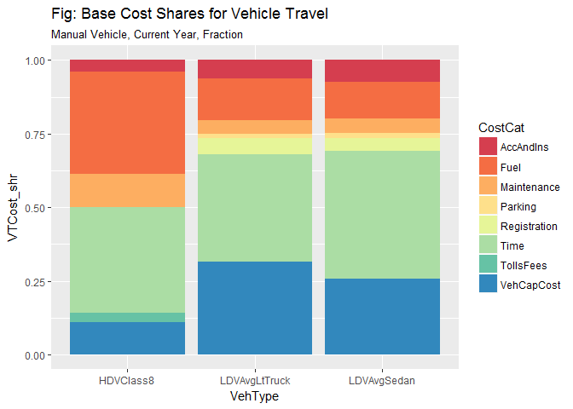

#### Display Base Travel Costs per Mile by Component

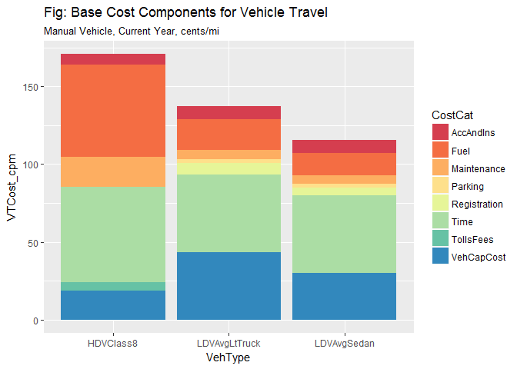

## 4.3 Fractional Increase in VKT for Demand Scenarios

Calculate fractional change in demand, by Demand Scenario *d*, Year *t*, and VehicleClass *v*, based on changes in time cost, other vehicle fuel and operating costs, and VMT demand elasticity w.r.t generalized cost.

### Demand Scenario Cost Reduction Parameters and Demand Response Parameters Drive Demand Scenarios

Automation *demand* scenarios are defined by assumptions regarding CAV impacts on selected component costs (e.g. travel time costs, internal accident and insurance costs, and vehicle costs), and on the sensitivity of road travel demand to costs. They are not CAV penetration scenarios. Penetration is exogenous, and initially assumed 100%.

Vehicle Travel Cost Component Change (Reduction) by Demand Scenario

|  |  |  |  |
| --- | --- | --- | --- |
| DemScen | VoTT | Insurance | Description |
| DS1 | 0.00 | -0.6 | Driver assistance, but no self-driving. Little benefits of comfort (0% reduction in VoT), lower end of insurance benefits (60%) |
| DS2 | -0.05 | -0.6 | Driver assistance, but no self-driving. Some benefits of comfort (5% reduction in VoT), lower end of insurance benefits (60%) |
| DS3 | -0.50 | -0.8 | Self driving. Large benefits of comfort + in vehicle use of time (50% reduction in VoT), large benefits of insurance (80%) |
| DS4 | -0.80 | -0.8 | Extreme Self driving case. Large benefits of comfort + in vehicle use of time (80% reduction in VoT), large benefits of insurance (80%) |

### Vehicle Travel Cost Shares by Component - CAV Scenario

Costs are adjusted relative to Base for cost and other assumptions of each Demand Scenario and for the Energy Intensity change associated with the current Technology Scenario. Energy intensity drives the energy cost, but this component is typically less than 15% of total costs for LDVs, and less than 35% of total costs for HDVs.

Base cost components are normalized and add to 1.0. Demand Scenario *relative* costs for each cost component *i* are relative to the Base (Manual Vehicle) level. The total relative cost can be greater than or less than 1.0. Denoted , they depend on cost component *i*, Vehicle class *v*, Year *t* and Demand Scenario *d*, and TechScenario *j*.

* Fuel costs per mile are adjusted by the Scenario Multipliers for energy intensity, for TechScenario *j*, Year *t*, Vehicle class *v*. The perceived change in fuel cost effects for consumers/riders also depends on the fraction of fuel costs that are assumed visible to or perceived by them. That is, for cost component :

Other cost components *i* have similar scenario-based adjustments:

## 4.4 Calculate Adjusted Travel Cost Components for Scenario Conditions

Updated cost component table based on Scenario VoTT and other costs. Calculate cost component fractions for all demand scenarios. The Technology (energy intensity) scenario is held at number 4, the “Strong responses” scenario.

Alt Travel Cost Components Relative to Base, by Demand Scenario & Vehicle Type

|  |  |  |  |  |
| --- | --- | --- | --- | --- |
| CostCat | DemScen | HDVClass8 | LDVAvgLtTruck | LDVAvgSedan |
| AccAndIns | DS1 | 0.016 | 0.025 | 0.029 |
| Fuel | DS1 | 0.248 | 0.040 | 0.035 |
| Maintenance | DS1 | 0.114 | 0.045 | 0.047 |
| Parking | DS1 | 0.000 | 0.017 | 0.018 |
| Registration | DS1 | 0.000 | 0.053 | 0.045 |
| Time | DS1 | 0.358 | 0.364 | 0.432 |
| TollsFees | DS1 | 0.032 | 0.000 | 0.000 |
| Total | DS1 | 0.879 | 0.860 | 0.866 |
| VehCapCost | DS1 | 0.111 | 0.317 | 0.259 |
| AccAndIns | DS2 | 0.016 | 0.025 | 0.029 |
| Fuel | DS2 | 0.248 | 0.040 | 0.035 |
| Maintenance | DS2 | 0.114 | 0.045 | 0.047 |
| Parking | DS2 | 0.000 | 0.017 | 0.018 |
| Registration | DS2 | 0.000 | 0.053 | 0.045 |
| Time | DS2 | 0.340 | 0.346 | 0.411 |
| TollsFees | DS2 | 0.032 | 0.000 | 0.000 |
| Total | DS2 | 0.861 | 0.842 | 0.844 |
| VehCapCost | DS2 | 0.111 | 0.317 | 0.259 |
| AccAndIns | DS3 | 0.008 | 0.012 | 0.015 |
| Fuel | DS3 | 0.248 | 0.040 | 0.035 |
| Maintenance | DS3 | 0.114 | 0.045 | 0.047 |
| Parking | DS3 | 0.000 | 0.017 | 0.018 |
| Registration | DS3 | 0.000 | 0.053 | 0.045 |
| Time | DS3 | 0.179 | 0.182 | 0.216 |
| TollsFees | DS3 | 0.032 | 0.000 | 0.000 |
| Total | DS3 | 0.692 | 0.666 | 0.635 |
| VehCapCost | DS3 | 0.111 | 0.317 | 0.259 |
| AccAndIns | DS4 | 0.008 | 0.012 | 0.015 |
| Fuel | DS4 | 0.248 | 0.040 | 0.035 |
| Maintenance | DS4 | 0.114 | 0.045 | 0.047 |
| Parking | DS4 | 0.000 | 0.017 | 0.018 |
| Registration | DS4 | 0.000 | 0.053 | 0.045 |
| Time | DS4 | 0.072 | 0.073 | 0.086 |
| TollsFees | DS4 | 0.032 | 0.000 | 0.000 |
| Total | DS4 | 0.585 | 0.556 | 0.505 |
| VehCapCost | DS4 | 0.111 | 0.317 | 0.259 |

#### Display Alternative Scenario Travel Costs per Mile by Component

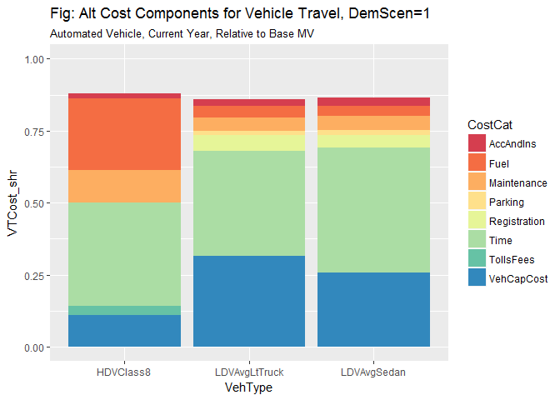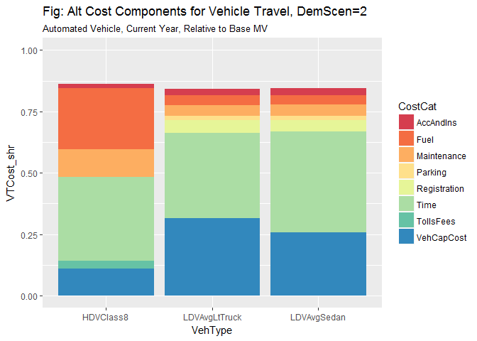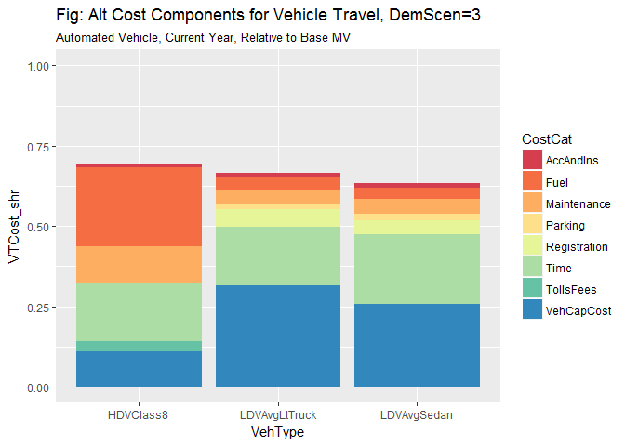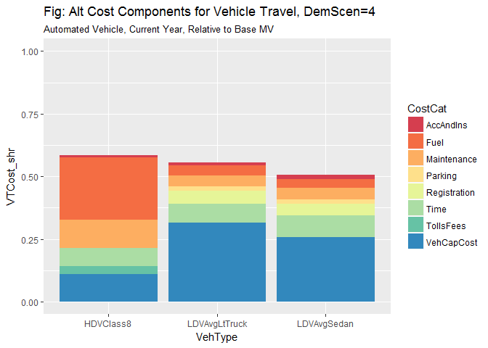

## 4.5 Fractional VMT Changes in CAV Scenario

Compute fractional increases in VMT from the changes in total generalized travel costs that result from automation.

For Demand Scenario *d*, Vehicle Type *v*, and Elasticity Case *c* (Low and High elasticity) [??? is elasticity case to be governed by demand scenario?]

Define

* = Relative Total Cost for vehicle travel [unitless, vehicle travel cost $/veh-km]
* = fractional increase in VKT [unitless, VKT is in km/vehicle-yr]

Note: The Elasticity of VKT with respect to (generalized) travel cost is key assumption. Does this include mode switching, vehicle efficiency, locational choices, etc? Sources for ElasVKT: (HERS-ST technical report, August 2005 + Graham and Glaister 2002)

Note: Additional adjustments to the fractional change in VKT for LDV travel follow from:

* multiplier factors on VMT to include larger travel by the elderly
  + Aside on original ests: =‘[CAV Energy ASIF Framework WadudMacKenzieLeiby V20161024_Test.xlsx]calcul Dem_LDV’!$IK$44
* multiplier factors on VMT to account for VMT decline in response to carsharing
  + Aside on original ests: =‘[CAV Energy ASIF Framework WadudMacKenzieLeiby V20161024_Test.xlsx]calcul Dem_LDV’!$IK$48

### Effects on VMT Demand from Elderly Drivers, and Car Sharing (Ride Pooling)

# 5. Policy and Scenario Calculations

VMT Demand Response: pick up chosen Demand and Technology Scenario, and value for chosen scenario, for years 2035 & 2050

LDV Demand impact (depends on scenario choice in B3) HDV Demand impact (depends on scenario choice in B3) Year 2035 2050 LDV penetration: automated/total stock 0.40 1.00 HDV penetration: automated/total stock 0.40 1.00

LDV Demand impact (depends on scenario choice in B3) (not year t dependent) HDV Demand impact (depends on scenario choice in B3) (not year t dependent) LDV penetration: total automated/total stock in 2050 HDV penetration: total automated/total stock in 2050

LDV Penetration rate=fullyauto/totalstock LDV Increase in VMT for each automated vehicle LDV VMT increase ratio/this is linked to calculation sheets

HDV Penetration rate=fullyauto/totalstock HDV Increase in VMT for each automated vehicle HDV VMT increase ratio/this is linked to calculation sheets

LDV Energy Intensity Multiplier, scaled by penetration HDV Energy Intensity Fractional Increase at full adoption - from above LDV Energy Intensity Multiplier, scaled by penetration HDV Energy Intensity Multiplier, scaled by penetration

## Final Scenario Results Table for 2050

|  |  |  |  |  |  |  |  |  |
| --- | --- | --- | --- | --- | --- | --- | --- | --- |
| TechScen | LDV.EIntens | HDV.EIntens | LDV.VMTpveh | HDV.VMTpveh | LDV.EUse | HDV.EUse | Tot.EUse | ScenarioName |
| 2 | -76.93% | -28.15% | 66.73% | 42.89% | -61.54% | 2.67% | -44.71% | Have our cake & eat it too |
| 7 | -18.68% | -17.50% | 11.91% | 11.00% | -9.00% | -8.43% | -8.85% | Stuck in the middle at Level 2 |
| 4 | -71.86% | -28.15% | 67.12% | 68.29% | -52.97% | 20.92% | -33.60% | Strong responses |
| 3 | 34.20% | 0.00% | 64.67% | 44.94% | 120.99% | 44.94% | 101.05% | Dystopian nightmare |
| 1 | -32.68% | -19.23% | 14.26% | 11.72% | -23.08% | -9.76% | -19.59% | Cautiously optimistic |
| 5 | 9.92% | -10.00% | 7.39% | 7.98% | 18.05% | -2.82% | 12.57 | Driver assist, limited other benefits |

## 5.2 Bar Chart Representation of Results

XXX

## Travel Time Budget

BGR2014:144 (referencing Shaefer et al. 2009) apply a Travel Time Budget constraint in the following straight-forward way:

Travel time (distance *D* over speed *S*) must equal reference travel time. (Appears that they apply this to all travel based on average speed, and assume a 50% increase in average speed.)

More generally, the travel time can be expected to vary in response to travel costs and income.

## Physical Constants

## Vehicle Scenario Parameters

## [1] 2000.06

## [1] 5.00015e+11

# 6. Simple functions for MPG as a function of highway speed

## 6.1 Fuel Consumption vs. Speed - Thomas et al. Approach

* Source: Thomas, J., Hwang, H.-L., West, B., & Huff, S. (2013). Predicting Light-Duty Vehicle Fuel Economy as a Function of Highway Speed. SAE International Journal of Passenger Cars - Mechanical Systems, 6(2), 2013-01-1113. <doi:10.4271/2013-01-1113>
* Thomas et al. performed “analysis of dynamometer testing results for 74 vehicles at steady-state speeds from 50 to 80 mph [80 to 129 km/h]. Data has been collected for 23 light-duty vehicles at ORNL’s vehicle research laboratory and a valuable data set for 51 vehicles was loaned to ORNL by Chrysler, LLC under a non-disclosure agreement. Vehicles were tested in dynamometer laboratories at steady speeds from 40 to 80 mph [64 to 129 km/h], with the proper road-load applied. … The study includes various sizes of sedans, wagons, and SUVs, as well as pickup trucks, minivans and a few”muscle" and sports cars. Vehicles from model years 2003 to 2012 with a wide variety of powertrains were represented" [ORNL researchers quantify the effect of increasing highway speed on fuel economy](http://www.greencarcongress.com/2013/01/thomas-20130117.html) Jan 18, 2013

**Summary of MPG vs. Speed data: Percent mpg decrease for a given 10 mph increase based on 74 vehicles.**

|  |  |  |  |  |
| --- | --- | --- | --- | --- |
| Speed increase | Average | Data range | Std. deviation | Middle 2/3s of vehicle data |
| 50 to 60 mph | 12.4 | 6.9-18.3 | 2.2 | 10.0-14.3 |
| 60 to 70 mph | 14.0 | 8.8-19.5 | 2.6 | 11.2-16.1 |
| 70 to 80 mph | 15.4 | 10.8-26.0 | 3.0 | 12.5-17.5 |
| All three speed increments | 13.9 | 6.9-26.0 | 2.9 | N/A |

We can calculate the percentage decrease in MPG for a range of speed changes using the methodology Thomas, Hwang, West and Huff 2013.

Table: Percent MPG Decreases With Speed (Rows are Ref Speed)

|  |  |  |  |  |  |  |  |
| --- | --- | --- | --- | --- | --- | --- | --- |
|  | 40 | 50 | 60 | 70 | 80 | 90 | 100 |
| 15 | NA | 5.68 | 6.70 | 7.72 | 8.75 | 9.77 | 10.79 |
| 20 | NA | 6.67 | 7.95 | 9.23 | 10.50 | 11.78 | 13.06 |
| 25 | NA | 7.79 | 9.34 | 10.89 | 12.44 | 14.00 | 15.55 |
| 30 | NA | 8.96 | 10.80 | 12.64 | 14.47 | 16.31 | 18.15 |
| 35 | NA | 10.16 | 12.29 | 14.42 | 16.56 | 18.69 | 20.82 |
| 40 | NA | 11.38 | 13.81 | 16.24 | 18.67 | 21.10 | 23.54 |
| 45 | NA | 12.62 | 15.35 | 18.08 | 20.81 | 23.54 | 26.27 |

## 6.2 Fuel Consumption vs Speed - Berry Approach

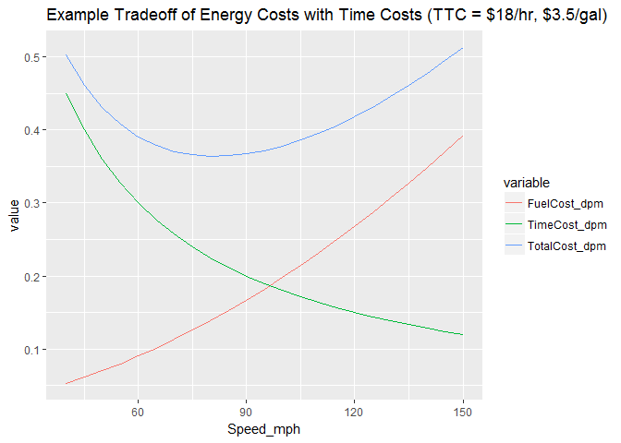

## Compute the Optimum Highway Speed for a Range of Time Costs and Fuel Costs

# 7. Safety Costs Associated with Speed

* [Road safety - Speed](http://www.who.int/violence_injury_prevention/publications/road_traffic/world_report/speed_en.pdf) World Health Organization, 2004
  + An increase in average speed of 1 km/h typically results in a 3% higher risk of a crash involving injury, with a 4-5% increase for crashes that result in fatalities.
  + Speed also contributes to the severity of the impact when a collision does occur. For car occupants in a crash with an impact speed of 80 km/h, the likelihood of death is 20 times what it would have been at an impact speed of 30 km/h.
* WHO 2004 World report on road traffic injury prevention ** Crash Risk**
  + WHO 2004 [World report on road traffic injury prevention](http://apps.who.int/iris/bitstream/10665/42871/1/9241562609.pdf)
  + <http://www.who.int/violence_injury_prevention/publications/road_traffic/world_report/en/>
  + The probability of a crash involving an injury is proportional to the square of the speed. The probability of a serious crash is proportional to the cube of the speed. The probability of a fatal crash is related to the fourth power of the speed (38, 39). [Chap 3, Crash Risk, p.78]
  + Empirical evidence from speed studies in various countries has shown that an increase of 1 km/h in mean traffic speed typically results in a 3% increase in the incidence of injury crashes (or an increase of 4-5% for fatal crashes), and a decrease of 1 km/h in mean traffic speed will result in a 3% decrease in the incidence of injury crashes (or a decrease of 4-5% for fatal crashes) (40).
  + Taylor et al. (41, 42), in their study on different types of roads in the United Kingdom, concluded that for every 1 mile/h (1.6 km/h) reduction in average traffic speed, the highest reduction achievable in the volume of crashes was 6% (in the case of urban roads with low average speeds). These are typically busy main roads in towns with high levels of pedestrian activity, wide variations in speeds and high frequencies of crashes.
  + A meta-analysis of 36 studies on speed limit changes showed, at levels above 50 km/h, a decrease of 2% in the number of crashes for every 1 km/h reduction in the average speed (43).
  + For car occupants in a crash with an impact speed of 50 miles/h (80 km/h), the likelihood of death is 20 times what it would have been at an impact speed of 20 miles/h (32 km/h) (48).

TABLE 3.4: Relative risks of involvement in a casualty crash for speed and alcohol

|  |  |
| --- | --- |
| Speed (km/h) | Speed (relative risk) |
| 60 | 1.0 |
| 65 | 2.0 |
| 70 | 4.2 |
| 75 | 10.6 |
| 80 | 31.8 |

Relative to a sober driver travelling at the speed limit of 60 km/h. (Source: Kloeden et al., 1997. See alos Kloeden et al. 2001)

### **Severity of crash injuries**

* Speed has an exponentially detrimental effect on safety. As speeds increase, so do the number and severity of injuries. Studies show that the higher the impact speed, the greater the likelihood of serious and fatal injury:
  + For car occupants, the severity of crash injury depends on the change of speed during the impact, usually denoted as v. As v increases from about 20 km/h to 100 km/h, the probability of fatal injuries increases from close to zero to almost 100% (46).
  + The probability of serious injury for belted front-seat occupants is three times as great at 30 miles/h (48 km/h) and four times as great at 40 miles/h (64 km/h), compared with the risk at 20 miles/h (32 km/h) (47).
  + For car occupants in a crash with an impact speed of 50 miles/h (80 km/h), the likelihood of death is 20 times what it would have been at an impact speed of 20 miles/h (32 km/h) (48).
  + Pedestrians have a 90% chance of surviving car crashes at 30 km/h or below, but less than a 50% chance of surviving impacts at 45 km/h or above (49, 50) (see Figure 3.3).
  + The probability of a pedestrian being killed rises by a factor of eight as the impact speed of the car increases from 30 km/h to 50 km/h (51).
  + Older pedestrians are even more physically vulnerable as speeds increase (52) (see Figure 3.4).
  + Excess and inappropriate speed contributes to around 30% of fatal crashes in high-income countries (53).
* Safety References
  1. Wegman F, Elsenaar P. Sustainable solutions to improve road safety in the Netherlands. Leidschendam, Institute for Road Safety Research, 1997 (SWOV Report D-097-8).
  2. Ogden KW. Safer roads: a guide to road safety engineering. Melbourne, Ashgate Publishing Ltd, 1996.
  3. Cities on the move: a World Bank urban strategy review. Washington, DC, The World Bank, 2002.
  4. Handboek: categorisering wegen op duurzaam veilige basis. Deel I (Voorlopige): functionele en operationele eisen [Handbook: categorizing roads on long-lasting safe basis. Part I (Provisional): functional and operational demands]. Ede, Stichting centrum voor regelgeving en onderwoek in de grond-, water- en wegenbouw en de verkeerstechniek, 1997 (CROW Report 116).
  5. Zone guide for pedestrian safety shows how to make systematic improvements. Washington, DC, National Highway Traffic Safety Administration, 1998 (Technology Transfer Series Number 181) (<http://> www.nhtsa.dot.gov/people/outreach/traftech/ pub/tt181.html, accessed 5 December 2003).
  6. Towards a sustainable safe traffic system in the Netherlands. Leidschendam, Institute for Road Safety Research, 1993.
  7. Safety of vulnerable road users. Paris, Organisation for Economic Co-operation and Development, 1998 (DSTI/DOT/RTR/RS7(98)1/FINAL) (http: //www.oecd.org/dataoecd/24/4/2103492.pdf, accessed 17 November 2003).
  8. Ossenbruggen PJ, Pendharkar J, Ivan J. Roadway safety in rural and small urbanized areas. Accident Analysis and Prevention, 2001, 33:485-498.
  9. Khan FM et al. Pedestrian environment and behavior in Karachi, Pakistan. Accident Analysis and Prevention, 1999, 31:335-339.
  10. Herrstedt L. Planning and safety of bicycles in urban areas. In: Proceedings of the Traffic Safety on Two Continents Conference, Lisbon, 22-24 September 1997. Linköping, Swedish National Road and Transport Research Institute, 1997:43-58.
  11. Kjemtrup K, Herrstedt L. Speed management and traffic calming in urban areas in Europe: a historical view. Accident Analysis and Prevention, 1992, 24:57-65.
  12. Brilon W, Blanke H. Extensive traffic calming: results of the accident analyses in six model towns. In: ITE 1993 Compendium of Technical Papers. Washington, DC, Institute of Transportation Engineers, 1993:119-123.

## 7.2 Speed and Accident Risk

* Notes from [Speed and Accident Risk](https://ec.europa.eu/transport/road_safety/specialist/knowledge/speed/speed_is_a_central_issue_in_road_safety/speed_and_accident_risk_en), European Road Safety Observatory
* <https://ec.europa.eu/transport/road_safety/specialist/knowledge/speed/speed_is_a_central_issue_in_road_safety/speed_and_road_safety_en>
* Assessing potential effectiveness of speed reduction measures Based on work by Nilsson in Sweden, a change in average speed of 1 km/h will result in a change in accident numbers ranging between 2% for a 120 km/h road and 4% for a 50 km/h road. This result has been confirmed by many before and after studies of different speed reduction measures. This relationship is used by other Scandinavian countries and by Australian and Dutch safety engineers.
* A similar relationship is assumed in Britain, based on empirical studies by Taylor, where changes in accident numbers associated with a 1 km/h change in speed have been shown to vary between 1% and 4% for urban roads and 2.5% and 5.5% for rural roads, with the lower value reflecting good quality roads and the higher value poorer quality roads.
* Higher speeds: more accidents : High speed reduces the possibility to respond in time when necessary. People need time to process information, to decide whether or not to react and, finally to execute a reaction. At high speed the distance covered in this period is longer. At high speeds the distance between starting to brake and a complete stand still is longer as well. The braking distance is proportional to the square of speed (v2). Therefore, the possibility to avoid a collision becomes smaller as speed increases. This is well illustrated at a broad average level by Finch [24].
* 1 km/h increase in speed implies a 3% increase in accidents
* In practice the relationship is more complex. …The higher the speed, the steeper the increase in accident risk. The relationship between speed and accident risk is a power function:
* Based on the principles of kinetic energy and validated by empirical data, Nilsson [[44](Nilsson,%20G.%20(1982)%20The%20effects%20of%20speed%20limits%20on%20traffic%20crashes%20in%20Sweden.%20In:%20Proceedings%20of%20the%20international%20symposium%20on%20the%20effects%20of%20speed%20limits%20on%20traffic%20crashes%20and%20fuel%20consumption,%20Dublin.%20Organisation%20for%20Economy,%20Co-operation,%20and%20Development%20(OECD),%20Paris)][[45](Nilsson,%20G.%20(2004)%20Traffic%20safety%20dimensions%20and%20the%20power%20model%20to%20describe%20the%20effect%20of%20speed%20on%20safety.%20Bulletin%20221,%20Lund%20Institute%20of%20Technology,%20Lund)] developed the following formula:
* In words: the number of injury accidents after the change in speed (A2) equals the number of accidents before the change (A1) multiplied by the new average speed (v2) divided by the former average speed (v1), raised to the square power.

# References

* Bösch, P. M., Becker, F., Becker, H., & Axhausen, K. W. (2017). Cost-based analysis of autonomous mobility services. *Transport Policy*, (October). <http://doi.org/10.1016/j.tranpol.2017.09.005>
* Brown, A., Gonder, J., & Repac, B. (2014). An Analysis of Possible Energy Impacts of Automated Vehicle. In G. Meyer & S. Beiker (Eds.), Road Vehicle Automation (pp. 61-70). Springer. Retrieved from <http://link.springer.com/book/10.1007%2F978-3-319-05990->
* European Road Safety Observatory 2018 [Speed and Accident Risk](https://ec.europa.eu/transport/road_safety/specialist/knowledge/speed/speed_is_a_central_issue_in_road_safety/speed_and_accident_risk_en) (last revised 06/07/2018).
* Kloeden, C. N., McLean, A. J., Moore, V. M. & Ponte, G. (1997) Travelling speed and the rate of crash involvement. Volume 1: findings. Report No. CR 172. Federal Office of Road Safety FORS, Canberra
* Kloeden, C. N., Ponte, G. & McLean, A. J. (2001) Travelling speed and the rate of crash involvement on rural roads. Report No. CR 204. Australian Transport Safety Bureau ATSB, Civic Square, ACT
* Schipper, Lee, Celine Marie-Lilliu, and Roger Gorham, 2000. Flexing the Link between Transport and Greenhouse Gas Emissions: A Path for the World Bank, Washington, DC: World Bank (<http://www.ocs.polito.it/biblioteca/mobilita/FlexingLink1.pdf>), June 2000.
* Schipper, Lee, Calanit Saenger and Anant Sudardshan 2011. “Transport and Carbon Emissions in the United States: The Long View,” Energies 2011, 4, 563-581; <doi:10.3390/en4040563>
* Shaefer et al. 2009.
* Stephens, T.S., J. Gonder, Y. Chen, Z. Lin, C. Liu, D. Gohlke, 2016 “Estimated Bounds and Important Factors for Fuel Use and Consumer Costs of Connected and Automated Vehicles,” NREL Technical Report NREL/TP-5400-67216 November 2016, <http://www.nrel.gov/docs/fy17osti/67216.pdf>
* Thomas, J., Hwang, H.-L., West, B., & Huff, S. (2013). Predicting Light-Duty Vehicle Fuel Economy as a Function of Highway Speed. SAE International Journal of Passenger Cars - Mechanical Systems, 6(2), 2013-01-1113. <doi:10.4271/2013-01-1113>
* Wadud, Z., MacKenzie, D., & Leiby, P. (2016). Help or hindrance? The travel, energy and carbon impacts of highly automated vehicles. Transportation Research Part A: Policy and Practice, 86, 1-18. <doi:10.1016/j.tra.2015.12.001>

1. We differentiate between transportation services (PKT) and vehicle travel (VKT).
2. Additional potential disaggregations include by region, vehicle size class, drivetrain type, and time of day (e.g. operating costs vary by time of day, as described in Bösch et al. 2017).
3. We start from the values developed in Wadud, MacKenzie and Leiby 2016.
4. Here mode *m* and fuel *f* are initially fixed and suppressed, i.e. *m* = road_vehicle and *f* = petro.