Industrial Plant Control

Referat

Authors: **Pleșca Evelyn-Iulia**

Scientific coordinator: **Ș.L. Mureșan Vlad**

Table of contents

1 Laboratory 1 2

2 Laboratory 2 5

3 Laboratory 3 9

3.1 Dahlin method 9

3.2 Kalman method 10

4 Laboratory 7 13

# Laboratory 1

For the first dataset, the Tangent Method was applied.

In the above figure, we can see the initial dataset plotted with a blue line, as well as the tangent drawn besides it.

After applying the method, the following parameters have been obtained:

The approximated transfer function has been plotted with a red line.

For the second dataset, the Tangent method was applied as well.

In this case, we can observe that we have a time delay. The initial data and the tangent was plotted with a blue line as well.

After applying the method, the following parameters resulted:

The approximated transfer function has been plotted with a red line.

For the third dataset, both the Tangent Method and the Cohen-Coon method have been applied.

The initial data and the tangent was plotted using the blue line.

After applying the tangent method, the following parameters resulted:

The transfer function approximated using the tangent method is plotted with a red line. We can see that it does not yield performances as well as with the following method.

After applying the Cohen-Coon method, the following parameters resulted:

The transfer function approximated using the Cohen-Coon method is plotted with a green line and we can clearly see that it approximated the first transfer function very well.

The obtained transfer functions are:

|  |  |  |
| --- | --- | --- |
| Nr | Transfer function | Method used for identification |
| 1 |  | The tangent method for first-order processes without dead time |
| 2 |  | The tangent method for first-order processes with dead time |
| 3 |  | The tangent method for first-order processes with dead time |
| 4 |  | Cohen-Coon method |

# Laboratory 2

For the following transfer function

the tangent and Cohen-Coon methods have been applied.

The following results have been obtained for the tangent method:

The following results have been obtained for the Cohen-Coon method:

In the figure below we can see the plots of the initial step response and of the transfer functions obtained using the tangent method and the Cohen-Coon method. Once again, the Cohen-Coon method yielded better results.

Next, Ziegler-Nichols, Chien-Hrones-Reswich and Oppelt methods have been applied to the transfer function obtained using the tangent method.

The process transfer function is

The transfer functions obtained using these methods and their performances can be seen in the table below.

|  |  |  |  |  |  |  |  |
| --- | --- | --- | --- | --- | --- | --- | --- |
| Nr | Transfer function | Control method | Controller type | System performances in closed loop | | | |
|  |  |  |  |
| 1 |  | Ziegler-Nichols | P | -2.8454 | 0 | 385 |  |
| 2 |  | Ziegler-Nichols | PI | 2.6064e-04 | 46 | 255 |  |
| 3 |  | Ziegler-Nichols | PID | 2.6515e-04 | 106.3 | 1.3973e+03 |  |
| 4 |  | Chien-Hrones-Reswich | P | -0.1536 | 0 | 385 |  |
| 5 |  | Chien-Hrones-Reswich | PI | -0.0016 | 50.9 | 660 |  |
| 6 |  | Chien-Hrones-Reswich | PID | 0.0027 | 98 | 1.4296e+03 |  |
| 7 |  | Oppelt | P | -2.8454 | 0 | 385 |  |
| 8 |  | Oppelt | PI | 0.0046 | 36.6 | 208 |  |
| 9 |  | Oppelt | PID | -0.0029 | 98.5 | 997.3495 |  |

The plots of the P, PI and PID controllers can be seen below.

We can observe that Ziegler-Nichols and Oppelt yield the best performances in the case of P controllers.

Oppelt yields the best performances for PI and PID controllers as well, followed by Ziegler-Nichols in the case of PI controllers and Chien-Hrones-Reswich in the case of PID controllers.

# Laboratory 3

## Dahlin method

The transfer function of the process is:

The transfer function discretized using ZOH with a sampling time of is:

I calculated a transfer function using the Dahlin method and afterwards I applied a filter. I got the following results:

The Simulink scheme for this method can be seen below.

The following plot is the command signal.

This is the output of the controller:

## Kalman method

The transfer function of the process is:

The transfer function discretized using ZOH with the sampling time is:

I calculated the transfer function using the Kalman method and then applied a filter and got the following functions:

The Simulink scheme can be found below:

The command signals are:

The results of the unfiltered and filtered control schemes are:

# Laboratory 7

The model of the asynchronous motor can be seen below:

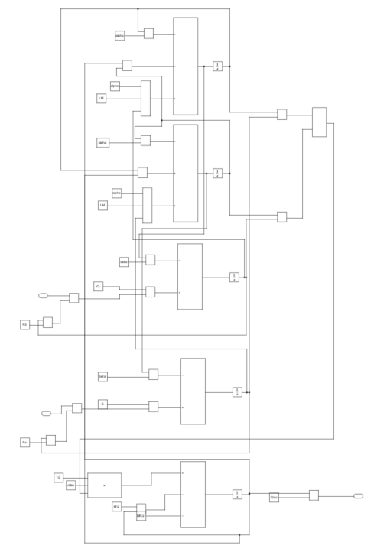

The output of the motor – the turation stabilises at and the synchronism turation is .

First, the relay method was applied. Below are the model and the plot.

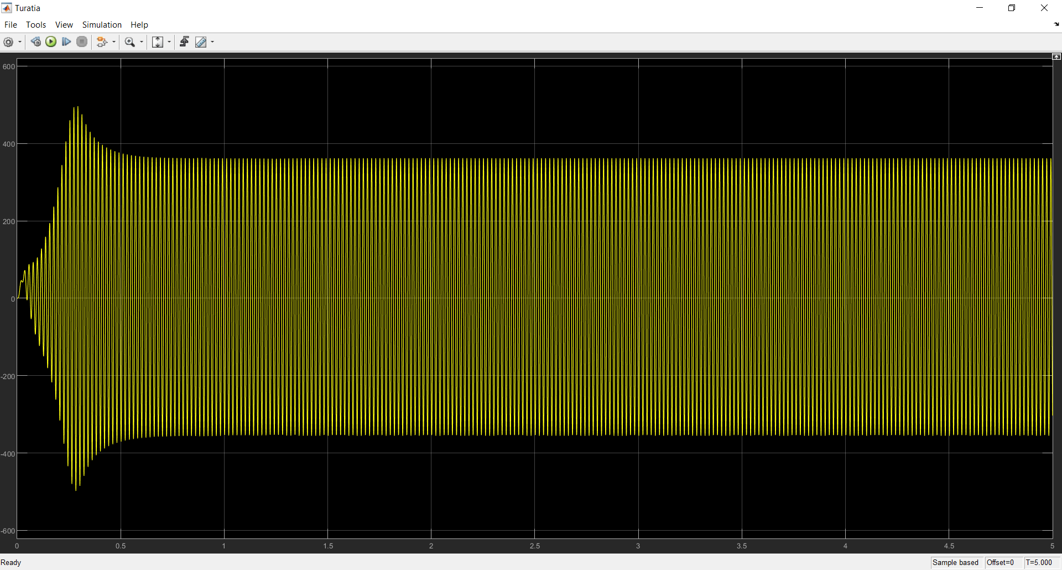

The following parameters were obtained:

Next, the following transfer functions were obtained by applying the Ziegler-Nichols method:

|  |  |  |  |  |  |
| --- | --- | --- | --- | --- | --- |
| Nr | Transfer function | Controller type | Parameters | | |
|  |  |  |
| 1 |  | P | 0.0122 |  |  |
| 2 |  | PI | 0.011 | 0.0976 |  |
| 3 |  | PID | 0.0146 | 0.061 | 0.0146 |

The PI controller was recomputed and the following parameters were obtained:

The following model was obtained for controlling the motor turation:

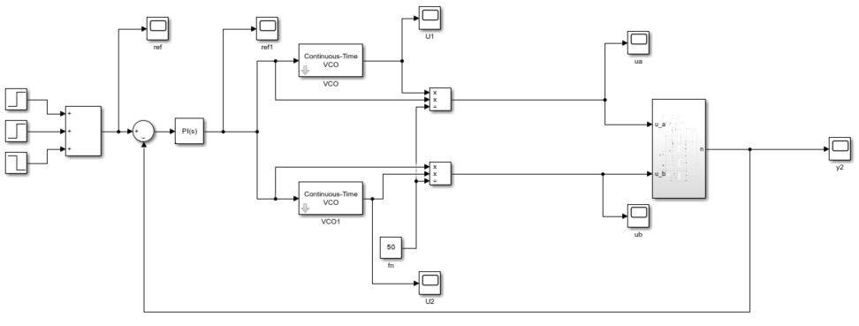

The following plots are for the reference and the command signals:

The following are the Ua and Ub signals plotted:

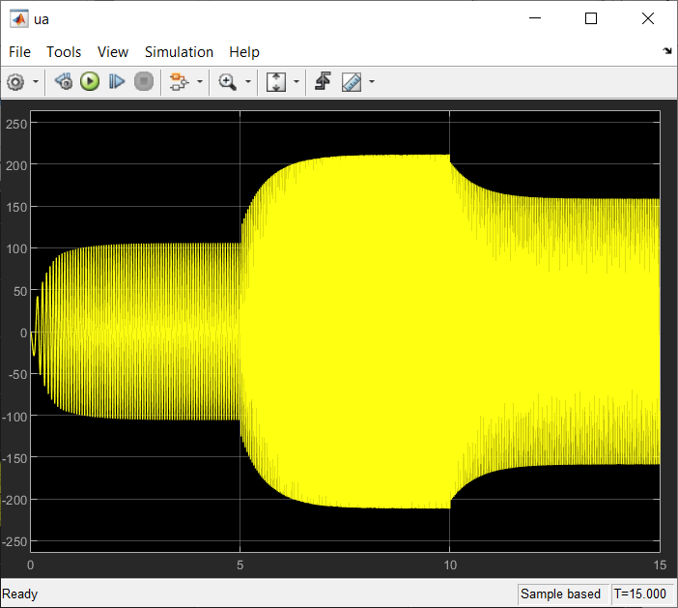

The motor turation with the modified PI parameters is:

