Narrative Suspects: Echoes of epic narrativity in Athenian Tragedy

Abstract
Despite a growing body of innovative approaches to the “messenger function” in Greek tragedy, scholars continue to wrestle with a clear definition of what makes a “messenger speech.” This paper presents and uses a Bidirectional Encoder Representations from Transformers (BERT) model to measure speakers’ “narrativity” in tragedy. The model has been trained to classify speech and narrative in the Iliad and the Odyssey, and its classification when applied to tragedy provides a useful proxy for how narrative a given passage is—that is, how much it resembles Homeric narrative. By applying this model to the extant tragic corpus, I show that the messenger function in tragedy is less a question of “who” and more a question of “when.” That is, the results from these experiments, alongside three close-reading case studies, suggest that we can productively eschew classification of narrative characters in favor of identifying narrative moments.

Introduction

Choruses and messengers
As Florence Yoon notes, “Messenger” is a “problematic” label for characters: “The word more accurately describes a fluid extra-dramatic function that can be performed by any character” (@Yoon2022 364). While I generally agree with Yoon’s definition and analyses, I have trouble with the notion that the messenger function is “extra-dramatic,” “a concern for the producer rather than a part of the world of the play” (@Yoon2022 374). The issue is that when a character—and I agree that any character can perform the messenger function—acts as a messenger, they signal an epistemic stance not just for the audience or the producer but for the other character’s in the play: they have witnessed an event that others have not seen, and they stand onstage to describe and interpret that event for their internal and external audiences at the same time.
Like Yoon, I use the phrase “messenger function” instead of “messenger speech” (or “messenger’s speech”) because any character can perform this function. In Sophocles’ Trachiniae, for example, nearly every character delivers what could be considered a “messenger’s speech” at some point, but there is only one character traditionally designated Ἄγγελος, so it is more precise to say that every character performs the messenger function. In addition to Yoon’s article (and its bibliography) and her work on anonymous characters (@Yoon2012), work by Felix Budelmann and Evert van Emde Boas on a cognitive approach to the messenger function; work by Eleanor Dickin on how messenger roles developed from bit parts to star platforms; and seminal monographs by James Barrett and Irene J. F. de Jong speak to the scholarly interest in tragic messengers over the past few decades (@Budelmann.vanEmdeBoas2020; Dickin2009; Barrett2002; deJong1991). Simon Perris and C. W. Marshall have also made valuable contributions to efforts to define this surprisingly elusive tragic figure/function (@Perris2011, @Perris2011a, @Marshall2006). Perris prefers “report-narrative” to describe the type speeches under investigation, and he usefully sums up the long-supposed epic associations with these speeches: “… tragic report-narratives have long been considered an ‘epic’ feature, principally due to the supposedly languid narrative style, the apparently objective stance, the frequency of direct speech, and the occurence of ‘Homeric’ linguistic features (epithets and unaugmented historic verbs) in some speeches” (@Perris2011 8). Where Perris is “loathe to universalise the epic quality” of the messenger function, Barrett, on the other hand, and Yoon more recently seem to take the messenger function’s epic heritage as more or less a given (@Perris2011 8; @Barrett1995; @Barrett2002 72 and passim; @Yoon2022 382 n. 62).
If the messenger function’s authority derives from its close association with the epic narrator, we should be able to quantify that influence using bidirectional encoder representations from transformers (BERT) trained to classify epic direct speech as opposed to narrative (@Vaswani.etal2023). BERT models learn to represent textual content as many-dimensional lists of numbers. By “fine-tuning” a BERT to classify these vectors according to pre-assigned labels, we can use these abstract representations of textual content to compare both text and its context. Classifying by epic speech versus epic narrative, as opposed to classifying according to an epic-tragic axis with the hypothesis that messengers will be more “epic” overall, avoids the meter conundrum by restricting the model to one meter (dactylic hexameter) and applying it to tragic meters (predominantly iambic trimeter, but the experiments apply the model to trochaic tetrameters, anapests, and lyric meters as well).
One might wonder whether the messenger function’s epic flavor comes from a preference for metrical resolution compared to other speaker classes. A full report is outside the scope of this paper, but I have conducted a computational metrical analysis of the iambic trimeters in tragedy and found that no character class shows a sufficient preference for or against resolution to distinguish it from other character classes.
![FIGURE SHOWING RESOLUTIONS]
Thus, we use a fine-tuned BERT to measure similarities between the learned vectors representing epic speech and narrative and the vectors representing sentences in tragedy.

Calculating influence
The computational methods for this work draw on a rich history of quantitative research on Homeric epic. In recent years, teams of scholars have taken various approaches to character type in drama, such as network analysis to capture the influence of servi callidi figures in Roman comedy (@Beine.etal2025); sentence embeddings using SBERT to calculate semantic similarity and capture repetition among speakers (@Szemes.Nagy2024); and training a classification model to track character archetypes (Keith.etal2026) or sentiment analysis in the New Testament (@Kang2025). Little work, however, has been done on quantifying the narrativity of the messenger function in Athenian tragedy. As described above, this paper uses a binary classifier trained on speech and narrative in the Homeric epics as one way of quantifying what sets messenger narratives in tragedy apart from other types of tragic speeches.

Methodology

Computational methods
In a recent paper on character archetypes in Calderón de la Barca, Allison Keith et al. use the performance of a pretrained automatic classification model to determine “how differentiable the speech of one archetype is from that of another” (@Keith.etal2026 2). In a similar vein, this paper does not use its model to classify speech and narrative per se, but rather to measure a passage’s affinity for Homeric narrative style.
To train the model, speeches in the Homeric epics were obtained from the Digital Initiative for Classics: Epic Speeches (DICES) database (@Forstall.etal2022). The texts of the epics were obtained from the Perseus Digital Library treebanks, and a script assigned each sentence—not line—a label of “speech” or “narrative” based on the speech ranges obtained from DICES. The result was 8633 lines labeled “narrative” and 7125 lines labeled “speech” for the Iliad (15,758 lines total); 3878 lines labeled “narrative” and 8404 lines labeled “speech” for the Odyssey (12,282 lines total).
![TABLE OF LINES AND LABELS]
The labeled sentences were then used as inputs to fine-tune a language model to classify a span of text as “speech” or “narrative.” The base model is pnadel/greek-bert, which in turn is a fine-tuned Ancient Greek version of answerdotai/ModernBERT-base. Fine-tuning is a process whereby a large language model trained on general tasks is further trained to perform specific tasks with higher accuracy. Fine-tuning thus significantly reduces energy demands by not requiring the whole model to be trained again and by enabling training even on relatively small datasets: the 15,148 sentences in this training set are a rounding error compared to the trillions of tokens on which most large language models have been trained.
In the interest of replicability, the model was trained for 5 epochs on consumer-grade hardware (a 2021 M1 MacBook Pro), achieving an accuracy of 92.7% and an F1 score (a combined measure of precision and recall) of 0.9268. As a preliminary experiment, the model was then run against two held-out datasets: Nestor’s long speech at Iliad 11.656–803, and Odysseus’ apologoi (9.2–12.453). Both of these speeches contain extended passages of narration, presenting particular challenges for the model’s accuracy.
On these held-out passages, the model performed notably worse than on its training data. It classified 25 sentences (68.75%) of Nestor’s speech as narrative, and 360 sentences (69.6%) of Odysseus’ apologoi. These results suggest that the divide between speech and narrative is less a binary and more a spectrum, and that we can understand a speech’s “narrativity” as the extent to which its sentences are classified as narrative—in other words, the extent to which a speech confuses the classification model.
![CONFUSION MATRIX FOR NESTOR’S SPEECH]
![CONFUSION MATRIX FOR APOLOGOI]
These results also suggest that the model can be usefully applied to tragedy: it will not simply label every sentence as “speech” but will instead provide an approximate measure of each sentence’s narrativity, which can then be aggregated according to speaker class and plotted for the play as a whole.
The tragic corpus uses a hand-curated list of line ranges that cover speeches typically classified as performing the messenger function. We use these as a baseline to compare against the rest of tragedy. The full list can be found >> LINK REMOVED FOR ANONYMITY <<. The only controversial inclusions are several main-character speeches in Trachiniae —Jebb provides supporting evidence for classifying them as messenger-type—and the Merchant in Sophocles’ Philoctetes.

Literary and performance studies methods
Before presenting the quantitative evidence for challenging current definitions of messenger speech, it will be useful to lay out a methodology drawn from literary and performance studies as a complement to the computational methods discussed above.
To understand the messenger’s epistemic and hermeneutic roles, I draw on the Jacques Rancière’s ideas on “the distribution of the sensible,” which he defines as “a delimitation of spaces and times, of the visible and the invisible, of speech and noise, that simultaneously determines the place and stakes of politics as a form of experience” (@Ranciere2004 13). He continues, “Politics revolves around what is seen and what can be said about it, around who has the ability to see and the talent to speak, around the properties of spaces and the possibilities of time” (@Ranciere2004 13). Rancière’s definition in terms of politics grounds my investigation of the messenger function in the democratic art of tragedy. It also orients the stakes of our discussion about messenger speeches and who can deliver them, as the distribution of the sensible entails the organization of a community, in which the messenger function is one way of participating.
In “The Aesthetic Dimension,” Ranciere clarifies the power imbalance at the heart of the distribution of the sensible and its connections to the formation of knowledge:
A belief is not an illusion in opposition to knowledge. It is the articulation between two knowledges, the form of balance between those forms of knowledge and the forms of ignorance they are coupled with. As Plato claimed, articulation or balance has to be believed. The economy of knowledge has to be predicated on a story. (@Ranciere2009 16)
The messenger function participates in the economy of knowledge by delivering news and exercising the power granted by unshared eyewitness experience. Other speech registers in tragedy—agonistic, emotive, etc.—share knowledge incidentally; the messenger function shares knowledge as its primary, though not only, purpose.

Results
These experiments confirm that the characters we typically call messengers do have more in common with epic narration than other tragic characters. At the same time, however, these experiments cast some doubt on that classification by showing that an affinity for epic narrative occurs across speaker classes and even in many choruses.
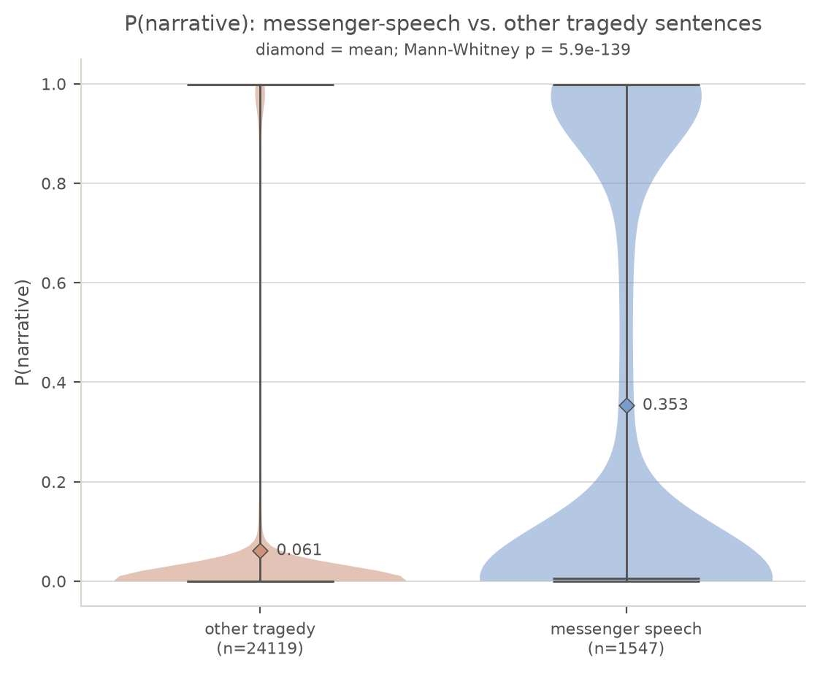
Violin plot showing messengers (right) versus other speakers (left) in tragedy.
The model reports the probability that a sentence is epic narrative; a probability of 1 means that the model thinks the line is definitely epic narrative, and a probability of 0 means that the model thinks the line is definitely not epic narrative. We can use these probabilities as a proxy for how narrative-like a sentence is—that is, to use this paper’s shorthand, as a proxy for its narrativity.
As can be seen in the above violin plot, sentences that appear in speeches typically labelled “messenger” (using the hand-curated list described above) show significantly higher narrativity than sentences in other characters’ speech, with a mean of 0.353, which is nearly six times the mean narrativity of other speakers at 0.061. The plot also shows that many messenger-labeled sentences have very high or very low narrativity scores, but we should keep in mind that the relatively thin middle is expected: the individual sentences that make up this plot are not the speeches themselves. We are looking for trends in groups of sentences, for which the averages are a much better measure.
For a similar reason, the trendlines on the plots of messenger narrative for individual tragedies below show a rolling seven-sentence average narrativity, rather than the per-sentence narrativity scores, as the rolling average makes the data more interpretable. (The seven-sentence average is somewhat arbitrary, but I felt that seven was a small enough window to show variation while still large enough to capture trends for longer speeches.)
In every play in which a character performs the messenger function—so excluding Prometheus Bound, Choephoroi, and Eumenides —the average narrativity of messenger labeled sentences exceeds that of other sentences, with the most striking differences appearing in Euripides’ Bacchae, Euripides’ Suppliants, and Sophocles’ Electra. Many plays, including Bacchae, have passages showing high narrativity outside of the traditional messenger function, providing evidence that we should consider expanding the definition of “messenger function” to include these other passages.

Euripides Bacchae
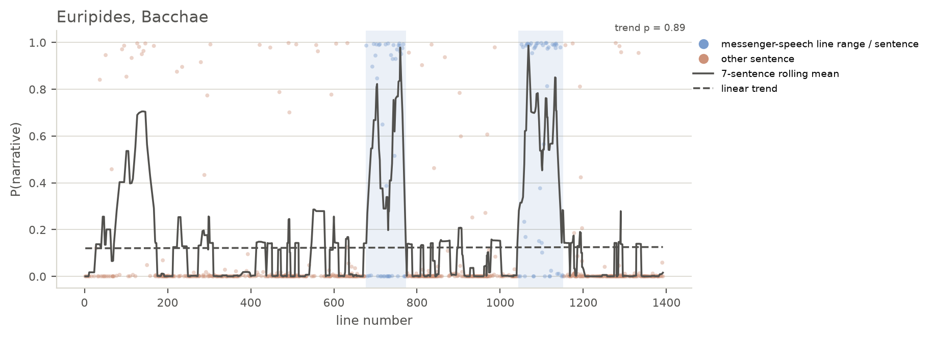
Chart showing per-sentence and rolling 7-sentence average narrativity for Euripides’ Bacchae
In addition to the Messengers’ undeniably narrative speeches in Bacchae, the parodos also contains marked narrative moments. The ode starts to grow narrative around the description of Dionysus’ birth in the first antistrophe at 88–104:
ὅν
ποτ’ ἔχουσ’ ἐν ὠδίνων
λοχίαις ἀνάγκαισι
πταμένας Διὸς βροντᾶς νη-
δύος ἔκβολον μάτηρ
ἔτεκεν, λιποῦσ’ αἰῶ-
να κερανίῳ πληγᾷ·
λοχίοις δ’ αὐτίκα νιν δέ-
ξατο θαλάμαις Κρονίδας Ζεύς,
κατὰ μηρῷ δ`καλύψας
χρυσέαισιν συνερέιδει
περόναις κρυπτὸν ἀφ’ Ἥρας.
ἔτεκεν δ’, ἁνίκα Μοῖραι
τέλεσαν, ταυρόκερων θεὸν
στεφάνωσέν τε δρακόντων
στεφάνοις, ἔνθεν ἄγραν θη-
ροτρόφον μαινάδες ἀμφι-
βάλλονται πλοκάμοις.
Bromius, whose
mother bore him cast-out
in the compulsions of labor pains
from her belly,
when the thunder
of Zeus struck: she died
with the lightning strike.
But just then Zeus son of Kronos
received him in a chamber for childbirth,
and he covered him in his thigh
and sewed him up with golden clasps,
hidden from Hera.
And when the Fates
brought it to fulfillment,
Zeus gave birth to the bull-horned god
and he crowned him with crowns
of snakes, which is why the maenads
throw the wild beast-eater
about their hair.
Despite the metrical differences between this lyric verse and epic hexameter, the model correctly identifies the narrative passage of Dionysus’ birth. This passage’s narrative flavor comes partly from the concentration of third-person main verbs: ἔτεκεν twice, δέξατο, στεφάνωσέν, and ἀμφιβάλλονται. But if third-person verbs sufficed to identify narrative, then every third-person passage would be marked by the model—clearly the vector-space embeddings have identified other markers of epic narrative as well. For instance, we can also see that the passage’s vocabulary and tenses seem to indicate the remoteness in time and place, rather than events taking place in the moment.
This high-narrative moment has striking echoes in the first traditional messenger-type speech, when the Messenger (@Buxton1991 calls this Messenger the “Cowherd”) describes Agave and the maenads’ ritual preparations. The maenads rearrange their fawnskins after the fastenings come loose (696–697), “and they fasten the spotted hides with snakes that lick their cheeks” (697–698: καὶ καταστίκτους δορὰς | ὄφεσι κατεζώσαντο λιχμῶσιν γένυν). The chorus narratively and thematically paved the way for this description already in the parodos. The Messenger’s function here cannot simply depend on his telling his audiences what he saw, but rather requires retelling what the external audience, at least, already knows from the chorus. The chorus’ etiological account becomes the Messenger’s revelation.
Nancy Worman links the play’s focus on attire and appearance to “a growing sense of coercion and menace” that “attaches to the various costumes” (@Worman2021 100). The narrative punctuations allow this menace to grow not just through what the characters say to each other but also through what they describe that the audience cannot see. The first Messenger’s “pointed counterfactual assertions about what Pentheus would have seen” are also counterfactuals for the audience (@Perris2011a 40). Apprehension builds towards the climax of the second Messenger’s speech through these moments of narration that allow the strange sights to grow stranger in each audience member’s mind precisely because the audience cannot view these sights collectively—cannot view them at all.
But where the audience is not initiated into the rituals that each time end in sparagmos—first of cattle, second of Pentheus—they witness Pentheus’ own transformation at the hands of Dionysus. This transformation dramatizes the chorus’ and the Cowherd’s descriptions of the maenads, turning unseen narrative into enacted ritual preparation. The dialogue, like the earlier chorus and monologue, pays particular attention to his hair and fawnskin mantle: “I will spread your hair out at length upon your head,” Dionysus says; and when asked “What else?” by Pentheus, the god replies, “A thyrsus in your hand and a dappled fawnskin” (831, 835; cf. 24–25). In a similar way, the chorus later prepares the audience for the second Messenger’s grisly report with their prophetic account of “justice made manifest” (992=1011: ἴτω δίκα φανερός). As Foley puts it, “In the fourth stasimon (977–1023) the chorus prophetically imagines Pentheus’ destruction on the mountain soon to be reported by the messenger; the messenger speech is immediately followed by a choral celebration of the god’s victory over Pentheus (1153–64)” (@Foley1985 221). Although the fourth stasimon does not register high on the narrativity skill, the previous narrative doubling by proleptic chorus and the analeptic Messengers joins the chorus and Messengers as two modes of sustaining the miraculous and profane sights that remain beyond the external audience’s point of view.
Perris also notes the echoes of the fourth stasimon in the second Messenger’s speech, but he does not connect these echoes to the further doubling that has occurred throughout the plays narrative and dramatic action (@Perris2011a 43). Richard Buxton, on the other hand, connects the Messengers’ narratives with the prologue, Pentheus’ opening speech, and the speech by the Servant who delivers Dionysus (as the Lydian Stranger) to Pentheus—together with the two Messengers’ reports, Buxton writes, “these five narratives may be seen as constituting a series, the later modifying the earlier; in no two cases is the relationship between content and narrator identical” (@Buxton1991 40). While the web of interrelated passages that emerges through the performance of this play is undeniable, Buxton’s throughline does not depend on narrative per se but rather on a sense of place established by the five passages that he isolates. By instead isolating moments of high narrativity, I mean to highlight the tenuous relationship between performance and description and the ways that the two are not easily separated. As Foley has observed, this difficulty gains special purchase within this play: “In the Bacchae myth and action, odes and iambic scenes, are intertwined from the start, as is appropriate in a plot that represents a penetration of the secular world by a divine power” (@Foley1985 207–208). The play’s moments of narrative action ensure that, like Pentheus at 918–922, the audience experiences double vision by seeing the narrative reports onstage and by witnessing the action in their minds.
“The action of the play gradually becomes, until the final scenes, fully ritualized and mythical, and Dionysiac poetry transforms reality as the chorus becomes one with and even predicts the action” (@Foley1985 208).
“Whatever we conclude occurs in the palace scene [576–603], whether nothing at all or a major or minor change in the stage building, no stage business at this point could adequately imitate the apocalyptic destruction of the palace, including lightning and earthquake, which the chorus sees while Pentheus does not. The miracle must become for the audience more symbolic and prophetic than realistic. The audience sees not a miracle, but a chorus enacting the experience of a miracle, or presenting a theatrical illusion.” (@Foley1985 221)
“It is not hard to see that any system of classification that could comprehend all of these figures in a single category would tell us little. But the challenge need not be that of deciding who is and who is not a messenger. Such a project, I submit ,would amount to a matter of definition. A more productive approach, I suggest, is to recognize that all tragic messengers, near messengers, and pseudomessengers have been produced more or less in accordance with, or at variance with, a conventional, ‘ideal’ type. As such, these ‘real’ tragic figures represent the texts’ ongoing engagement with an idealized conventional form.” (@Barrett2002 97)
- Right, so this gets close but doesn’t seem to be quite right. It’s rather that all speakers in tragedy — including choruses! — are more or less narrative. (But is “narrative” opposed to “dramatic” here?)
“I will argue that Buxton’s formulation, although laudable for the attention it pays to rhetorical variation in the narratives it studies, simplifies the status of the messengers in Euripides’ play [Bacchae]. Rather than being ‘firmly within the drama,’ the messengers occupy a place on the stage very different from that of the other dramatis personae. A reading founded on metatheatrical studies of the play will show that an important part of Bacchae’s self-conscious interest is directed at the status of the messengers, particularly with respect to how they define and are defined by Pentheus.” (@Barrett2002 103)

Aeschylus’ Agamemnon
Having looked at the play with the highest difference in narrativity between traditionally labeled messengers and other speakers, I turn now to the play where that difference is smallest: Aeschylus’ Agamemnon.
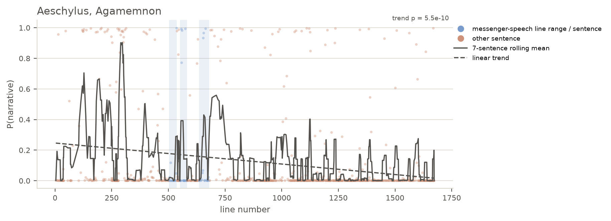
Chart showing per-sentence and rolling 7-sentence average narrativity for Aeschylus’ Agamemnon
While the speech Herald who announces the Achaeans’ return from Troy (503–582, 620–680) shows several peaks on the narrativity scale, these peaks pale in comparison to those of the parodos (40–257) and Clytaemestra’s “Beacon Speech” (281–316). This array of narrative speeches and speakers casts doubt on the traditional labeling of messenger versus not—or even on messenger function versus not—suggesting that we should think in terms of narrative moments rather than narrative characters.
The parodos opens with a long narrative sentence (40–54):
δέκατον μὲν ἔτος τόδʼ ἐπεὶ Πριάμου
μέγας ἀντίδικος
Μενέλαος ἄναξ ἠδʼ Ἀγαμέμνων,
διθρόνου Διόθεν καὶ δισκήπτρου
τιμῆς ὀχυρὸν ζεῦγος Ἀτρειδᾶν,
στόλον Ἀργείων χιλιοναύτην
τῆσδʼ ἀπὸ χώρας
ἦραν, στρατιῶτιν ἀρωγήν,
μεγάλ’ ἐκ θυμοῦ κλάζοντες Ἄρη,
τρόπον αἰγυπιῶν οἵτʼ ἐκπατίοις
ἄλγεσι παίδων ὕπατοι λεχέων
στροφοδινοῦνται
πτερύγων ἐρετμοῖσιν ἐρεσσόμενοι,
δεμνιοτήρη
πόνον ὀρταλίχων ὀλέσαντες·
This is the tenth year since
the great plaintiff against Priam,
Lord Menelaus–and with him Agamemnon–
the strong yoked Atreids, consisting of
two-throned and two-sceptred honor from Zeus,
set sail from this land the thousand-shipped
fleet of Argives, their martial aid,
crying out “Ares” loudly from their spirit,
like vultures who, in lonely pains
for their children,
eddy around high above their nest,
rowing with the oars of their wings,
because they lost the bed-watching
toil of their chicks.
The chorus quickly assumes a narrative stance in these opening anapests, including a near-simile about the vultures and their nest. As with the parodos in Bacchae, part of the narrative tilt here comes from extensive use of a third-person perspective, but third-person verbs do not suffice on their own for the model to classify a sentence as narrative. The following sentence, “Some god on high—Apollo or Pan or Zeus—hears the shrill-screaming bird-cried lament of these metics and sends a late-avenging [hysteropoinos] Erinys to their side” (55–60), also operates only in the third-person, but the model does not classify it as narrative. Although the model weights are a black box and difficult to interpret, the model’s discrimination between these two sentences suggests that it picks up on genuine similarities and dissimilarities among passages that it classifies as narrative and not. In this case, perhaps the vocabulary has some influence: as @Griffin1986 [38 and passim] and others have noted, the Homeric narrative tends to avoid subjects like vengeance (poinē).
Narrativity falls over the course of the Agamemnon, such that these early narrative moments establish the background before the play devolves into murder and Cassandra’s chaotic speech. This change over time—one of two statistically significant decreases in narrativity, the other being Euripides’ Electra—points to a change from story to spectacle. Like the beacon-flame itself, which Clytaemestra brings to rest upon the palace, the drama brings the action from distant Troy to the theater in front of the audience’s eyes. As Winnington-Ingram observes, “To show [the events of Agamemnon] as the inevitable product of past events, to accumulate foreboding, right upt to the striking blow, was well suited to the lyric mode which is employed” (@Winnington-Ingram1983 74).
This tension builds not only thanks to the “lyric mode” of the drama but also due to the audience’s growing realization that they must reconcile their internally visualized notion of narrated events with the action that gradually unfolds on- and just-off-stage. As Rancière writes, “Literature teaches us to choose between two interpretations: not two interpretations of the speech or actions of others, but two interpretations of our own perceptions and the feelings of affection that accompany them” (@Ranciere2005 101). Agamemnon, by gradually realizing our own misunderstandings in the spectacle that plays out before our eyes, builds tension by playing on the possibility that we have misunderstood.
Narrative moments create this space for misunderstanding by refusing to reconcile our interpretations with the other audience members’ and with what we see. Narrative thus creates the possibility for ruptured experience, for the pleasure and pain that accompany the sudden realization that we have not understood what we have heard and seen. Narrative moments thus also point to a leap of faith, a suspension of disbelief and trust in the reporter that might give way to betrayal. This trust and the possibilities that it raises stand at the heart not only of the theatrical endeavor but of every day communication: at a certain point, we must simply take our reporters at their word.

Euripides’ Suppliants
Suppliants does not have the same narrative echoes, but it’s interesting that only one speech registers as narrative, when it has both a herald and a messenger.

Sophocles’ Electra
Unsurprisingly, Sophocles’ Electra ranks among the most striking examples of the messenger function’s high narravity, with the Tutor’s speech sustaining scores above 0.5 for nearly its entire duration.
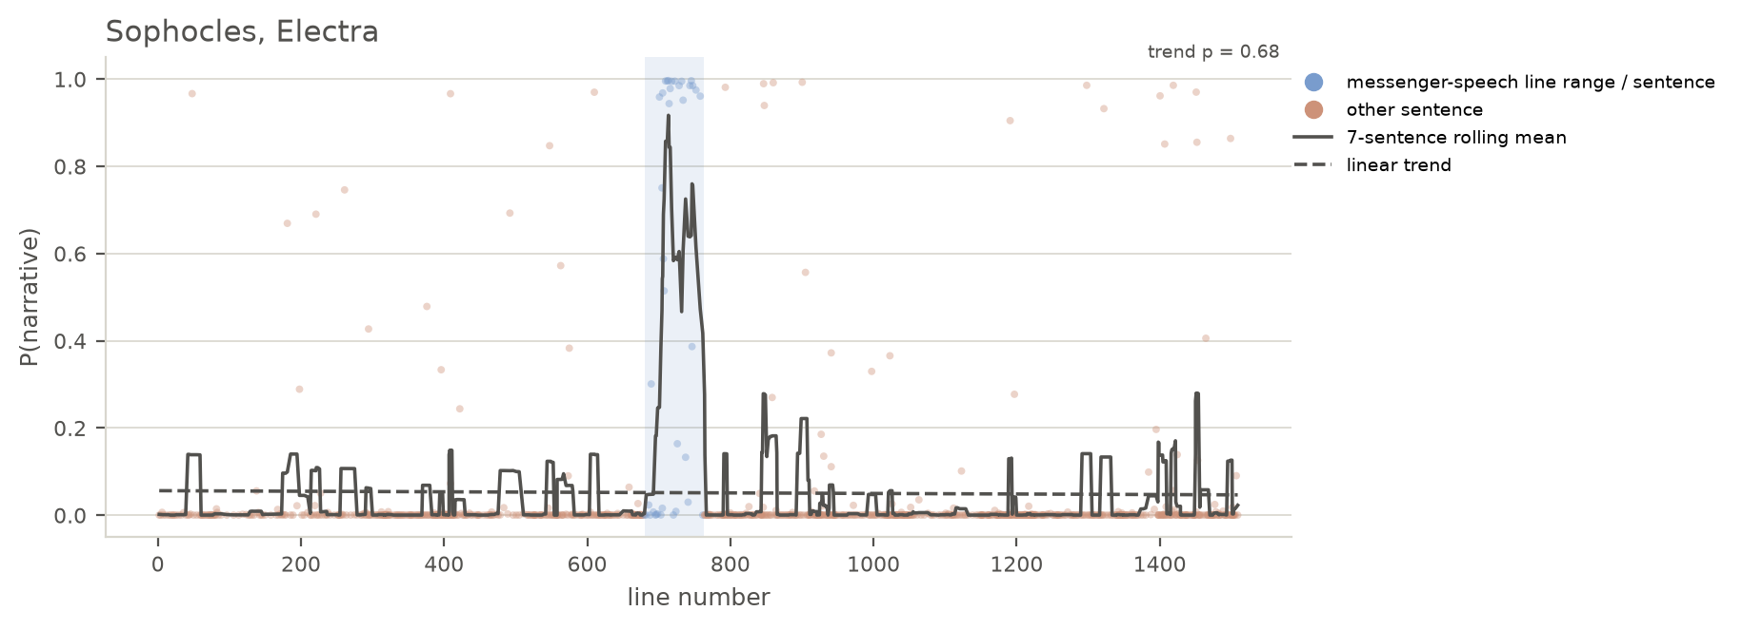
Scatter plot with a trendline showing seven-sentence average narrativity for Sophocles’ Electra
The rest of the play, by contrast, barely breaks above a narrativity score of 0.2.

Argument/interpretation
We have to stop thinking about “narrative characters” and start thinking about “narrative moments.”
“[A discipline] is a way of defining an idea of the thinkable, an idea of what the objects of knowledge themselves can think and know” (@Ranciere2009 17).
- This applies to the interpretive functions on the stage as well

Conclusion

Although C. W. Marshall does not use the phrase “messenger function,” he does acknowledge, “It is worth noting that when we speak of the messenger, we are denoting a function and not a role” (@Marshall2006 207n21).
Yoon rightly points out that Ἄγγελος is likely a late designation and prefers “Old Man” for this character (@Yoon2022 376).
The bibliography on quantitative approaches to Homer is voluminous, and I cannot cover all of it here. Tom McConnell’s recent monograph contains the most up to date methodologies alongside sophisticated linguistic insights and a wide-ranging bibliography in its own right (@McConnell2025; see esp. ch. 7). Ombretta Cesca and Matteo Romanello have recently demonstrated the use of the computational tool Passim to detect repetitions in Homeric characters’ speech (@Cesca.Romanello2026). On the speech-narrative divide in Homer, Jasper Griffin’s well-known article remains essential, if controversial, reading (@Griffin1986); Margalit Finkelberg provides a more measured but still quantitative approach to Homeric formulae (@Finkelberg1989). Deborah Beck has further elucidated performance and performative aspects of Homeric speech, and her digital publications provide additional tools for the reader to investigate claims made here (@Beck2020, @Beck2012a, @Beck2012, @Beck2026). Although a network-based approach is not used in this paper, Jeff Rydberg-Cox’s recent work with networks and words in Homer deserves to be flagged for potential follow-up research (@Rydberg-Cox2026).
https://perseusdl.github.io/treebank_data/
@Nadel2026; @Warner.etal2024
Translations are my own.
So @Foley1985 221n23: “Theatrical (or psychological) illusion is the only avenue by which the god can be worshipped and understood.” The Messengers and the chorus seem to represent or even enact, respectively, theatrical and pyschological illusion.
See @Zeitlin1994 [152] for how, as she puts it, Euripides “[expands] the traditional oracular quality of graphic signs into theatrical experimentation with the special powers of the visual imagination in the world of the stage.”

