Introduction
Narrative performs a hybrid function in drama. Long associated with “messenger” characters, its hybridity has led some scholars to label it “extra-dramatic,” “a concern for the producer rather than a part of the world of the play.” But this label neglects the epistemic stance that a character assumes when performing the “messenger function”: these characters have witnessed an event that others have not seen, and they stand onstage to describe and interpret that event for their internal and external audiences at the same time. As Florence Yoon has noted, “Messenger” is a “problematic” label for characters: “The word more accurately describes a fluid extra-dramatic function that can be performed by any character.” Taking this argument a step farther, I argue that we should look less for characters who perform the messenger function and more for moments of marked narrative speech. By “marked narrative speech,” I mean speech that resembles the kind of authorial narratives found in the Homeric epics, which have long informed discussion of narrative in tragedy. Dramatic narrative thus signals a claim to a special kind of authority to shape the audiences’—internal and external—interpretations and to control the knowledge that circulates onstage.
If the messenger function’s authority derives from its close association with the epic narrator, we should be able to quantify that influence using bidirectional encoder representations from transformers (BERT) trained to classify epic direct speech as opposed to narrative. BERT models learn to represent textual content as many-dimensional lists of numbers. By “fine-tuning” a BERT to classify these vectors according to pre-assigned labels, we can use these abstract representations of textual content to compare both text and its context.
In the first section of this paper, I review the results obtained from the computational model, arguing that a nuanced understanding thereof suggests that we eschew attempts to define “messengers” per se and look instead at passages of high narrativity. (Throughout this paper, I use “narrativity” as shorthand for the model’s measurement of the likelihood that a passage is narrative.) In the second section, I examine the consequences of this model through the Platonic view of narrative as a form of mimesis. Drawing on Jacques Rancière’s notion of the distribution of the sensible, I show how the deployment of narrative in tragedy reveals certain epistemic possibilities for the stage world even as it forecloses others. In the third and final section of the paper, I apply the computational and literary methods of the previous two sections to three brief case studies in narrative, reading passages from Sophocles’ Ajax, Aeschylus’ Agamemnon, and Euripides’ Bacchae. Narrative performs power in these (and other) dramas, controlling what characters can say about the stage world and what audiences can say about what the drama means for them.

Calculating influence
The computational methods for this work draw on a rich history of quantitative research on Homeric epic. In recent years, teams of scholars have taken various approaches to character type in drama, such as network analysis to capture the influence of servi callidi figures in Roman comedy; sentence embeddings using SBERT to calculate semantic similarity and capture repetition among speakers; and training a classification model to track character archetypes or sentiment analysis in the New Testament. Little work, however, has been done on quantifying the narrativity of the messenger function in Athenian tragedy. This paper uses a binary classifier trained on speech and narrative in the Homeric epics as one way of quantifying what sets messenger narratives in tragedy apart from other types of tragic speeches.

Methodology
In a recent paper on character archetypes in Calderón de la Barca, Allison Keith et al. use the performance of a pretrained automatic classification model to determine “how differentiable the speech of one archetype is from that of another.” In a similar vein, this paper does not use its model to classify speech and narrative per se, but rather to measure a passage’s affinity for Homeric narrative style.
To train the model, speeches in the Homeric epics were obtained from the Digital Initiative for Classics: Epic Speeches (DICES) database. The texts of the epics were obtained from the Perseus Digital Library treebanks, and a script assigned each sentence—not line—a label of “speech” or “narrative” based on the speech ranges obtained from DICES. The result was 8633 lines labeled “narrative” and 7125 lines labeled “speech” for the Iliad (15,758 lines total); 3878 lines labeled “narrative” and 8404 lines labeled “speech” for the Odyssey (12,282 lines total).
 | Iliad | Odyssey
Number of narrative lines | 8633 | 3878
Number of speech lines | 7125 | 8404
Total lines | 15,758 | 12,282
The labeled lines were then converted to sentences, and the labeled sentences were used as inputs to fine-tune a language model to classify a span of text as “speech” or “narrative.” The base model is pnadel/greek-bert, which in turn is a fine-tuned Ancient Greek version of answerdotai/ModernBERT-base. Fine-tuning is a process whereby a large language model trained on general tasks is further trained to perform specific tasks with higher accuracy. Fine-tuning thus significantly reduces energy demands by not requiring the whole model to be trained again and by enabling training even on relatively small datasets: the 15,148 sentences in this training set are a rounding error compared to the trillions of tokens on which most large language models have been trained.
In the interest of replicability, the model was trained for 5 epochs on consumer-grade hardware (a 2021 M1 MacBook Pro), achieving an accuracy of 92.7% and an F1 score (a combined measure of precision and recall) of 0.9268. As a preliminary experiment, the model was then run against two held-out datasets: Nestor’s long speech at Iliad 11.656–803, and Odysseus’ apologoi (9.2–12.453). Both speeches contain extended passages of narration, which pose challenges for the model’s accuracy. The DICES database correctly labels these passages as “speech,” but the experiment here involves applying the more naïve trained model and evaluating the assigned labels.
On these held-out passages, the model performed notably worse than on its training data. It classified 25 sentences (68.75%) of Nestor’s speech as narrative, and 360 sentences (69.6%) of Odysseus’ apologoi. These results suggest that the divide between speech and narrative is less a binary and more a spectrum, and that we can understand a speech’s “narrativity” as the extent to which its sentences are classified as narrative—in other words, the extent to which a speech confuses the classification model.
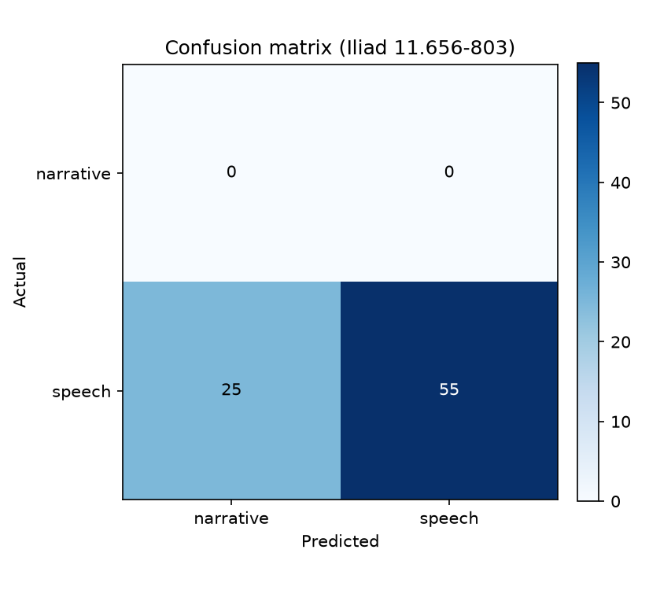
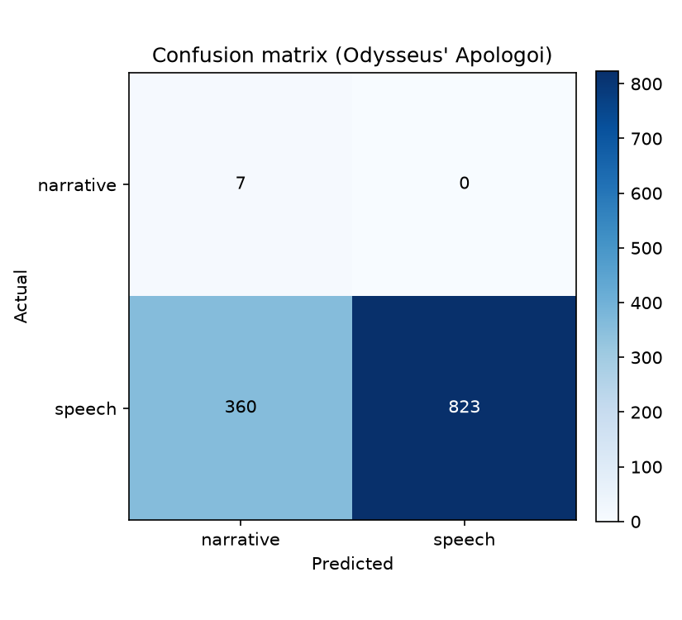
These results also suggest that the model can be usefully applied to tragedy: it will not simply label every sentence as “speech” but will instead provide an approximate measure of each sentence’s narrativity, which can then be aggregated according to speaker class and plotted for the play as a whole.
The tragic corpus uses a hand-curated list of line ranges that cover speeches typically classified as performing the messenger function. We use these as a baseline to compare against the rest of tragedy. The full list can be found >>LINK REMOVED FOR ANONYMITY<<. The only controversial inclusions are several main-character speeches in Trachiniae —Jebb provides supporting evidence for classifying them as messenger-type—and the Merchant in Sophocles’ Philoctetes.

Results
These experiments confirm that the characters we typically call messengers do have more in common with epic narration than other tragic characters. At the same time, however, these experiments cast some doubt on that classification by showing that an affinity for epic narrative occurs across speaker classes and even in many choruses.
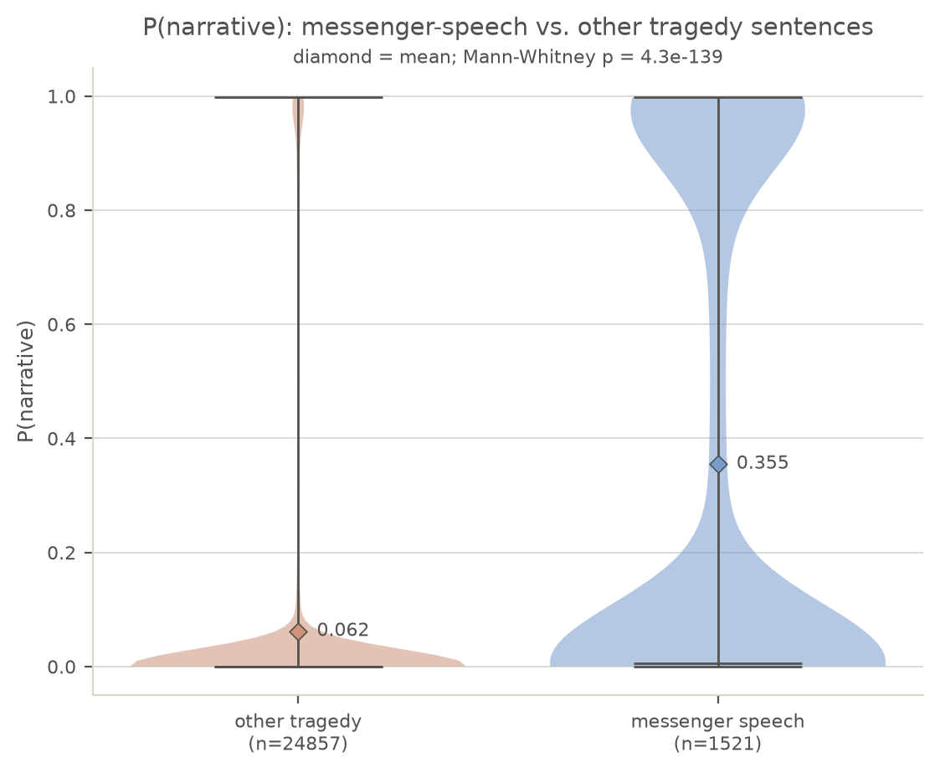
Violin plot showing messengers (right) versus other speakers (left) in tragedy.
The model reports the probability that a sentence is epic narrative; a probability of 1 means that the model thinks the line is definitely epic narrative, and a probability of 0 means that the model thinks the line is definitely not epic narrative. We can use these probabilities as a proxy for how narrative-like a sentence is—that is, to use this paper’s shorthand, as a proxy for its narrativity.
As can be seen in the above violin plot, sentences that appear in speeches typically labelled “messenger” (using the hand-curated list described above) show significantly higher narrativity than sentences in other characters’ speech, with a mean of 0.353, which is nearly six times the mean narrativity of other speakers at 0.061. The plot also shows that many messenger-labeled sentences have very high or very low narrativity scores, but we should keep in mind that the relatively thin middle is expected: the individual sentences that make up this plot are not the speeches themselves. We are looking for trends in groups of sentences, for which the averages are a much better measure.
For a similar reason, the trendlines on the plots of messenger narrative for individual tragedies below show a rolling seven-sentence average narrativity, rather than the per-sentence narrativity scores, as the rolling average makes the data more interpretable. (The seven-sentence average is somewhat arbitrary, but I felt that seven was a small enough window to show variation while still large enough to capture trends for longer speeches.)
In every play in which a character performs the messenger function—so excluding Prometheus Bound, Choephoroi, Eumenides, and Trojan Women—the average narrativity of messenger labeled sentences exceeds that of other sentences, with the most striking differences appearing in Euripides’ Bacchae, Euripides’ Suppliants, and Sophocles’ Electra. Many plays, including Bacchae, have passages showing high narrativity outside of the traditional messenger function, providing further evidence both to support the claims of Yoon (2022), Perris (2011b), and Marshall (2006) (among others) and to support shifting our focus from specific speakers to specific moments.
Moreover, the distribution of narrativity differs by tragedian. Euripides mainly uses traditional messengers and choruses for his narrative moments (shown below; see the appendix for a full visualization of every tragedy).
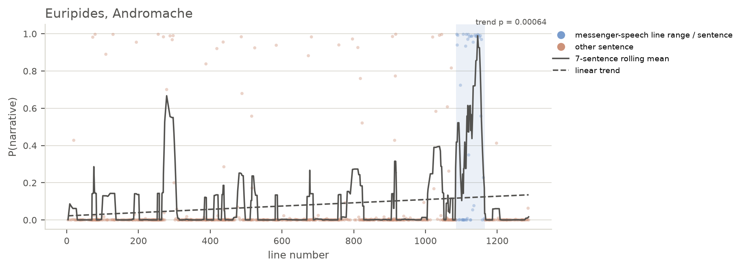
Figure 1. Chart showing the 7-line rolling average narrativity for Euripides' Andromache. The chorus has the second-highest narrative peak at 275–308.

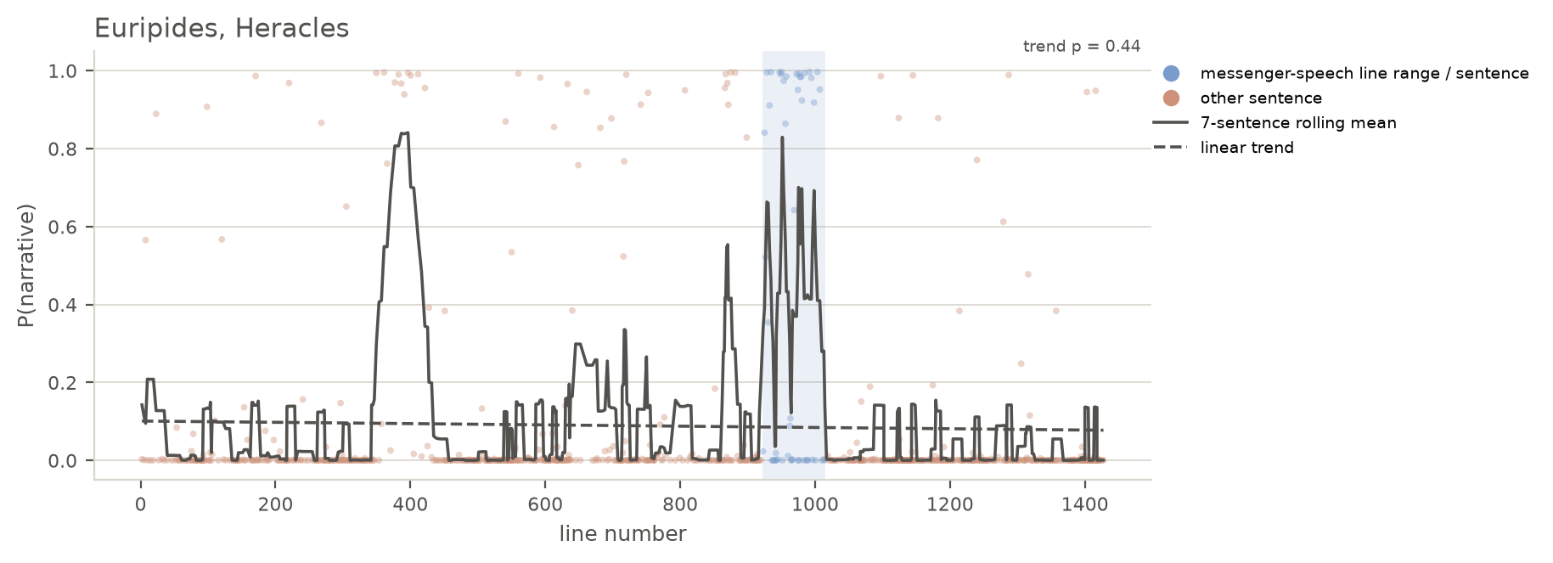
Figure 2. Chart showing the 7-line rolling average narrativity for Euripides' Heracles. The chorus at 348–450 has the strongest peak, sustaining high narrativity more consistently than the messenger at 925–1015.
Sophocles frequently has named characters deliver narrative speeches, most famously in Trachiniae but also in Philoctetes and Ajax (Figures 3 and 4); the narrative moments in the Theban plays—all delivered by traditional messenger figures—are marked by their speakers’ partial knowledge.
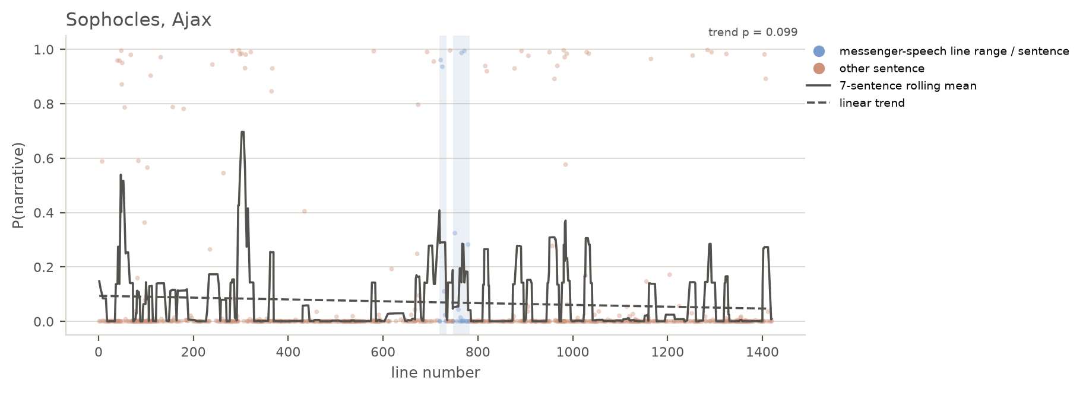
Figure 3. Chart showing the 7-line rolling average narrativity for Sophocles' Ajax. Tecmessa's speech at 284–330 has a higher narrativity score than the messenger's scene at 718–802.

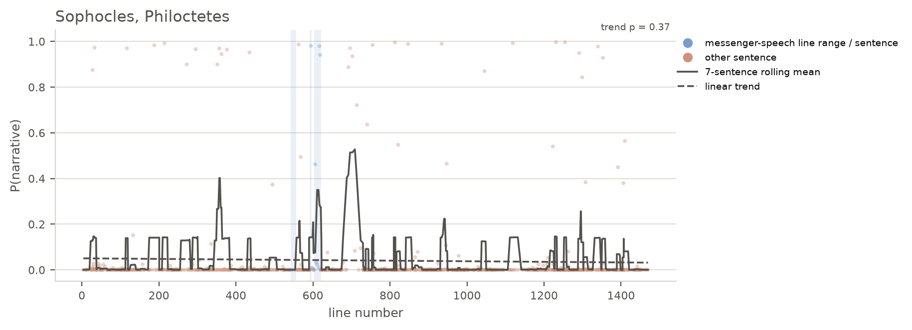
Figure 4. Chart showing the 7-line rolling average narrativity for Sophocles' Philoctetes. Neoptolemus' speech at 343–390 and the chorus at 677–729 both have higher narrativity scores than the False Merchant's speech at 603–621.
Aeschylus has several plays—Persians, Seven against Thebes, and Agamemnon—with moments of high narrativity. Persians and Seven deliver their narrative speeches through messengers that famously occupy much of the drama; Agamemnon (Figure 5), by contrast, concentrates its narratives in the first half of the drama, giving marked speeches to Clytaemestra and the chorus. After Agamemnon’s arrival onstage, narrativity drops for the rest of the Oresteia (Choephori in Figure 6, Eumenides in Figure 7), as if moving from the realm of epic storytelling to dramatic enactment.

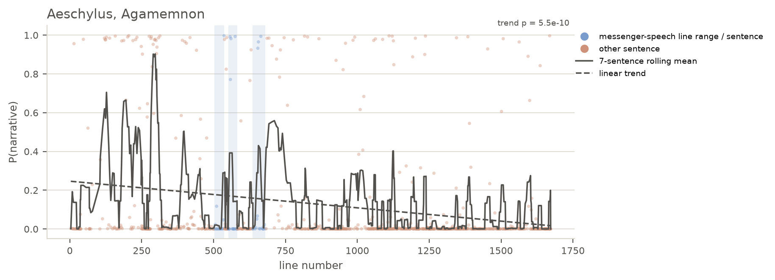
Figure 5. Chart showing the 7-line rolling average narrativity for Aeschylus' Agamemnon. Early narrative peaks in Clytaemestra and the chorus give way to lower narrative scores after Agamemnon's arrival.
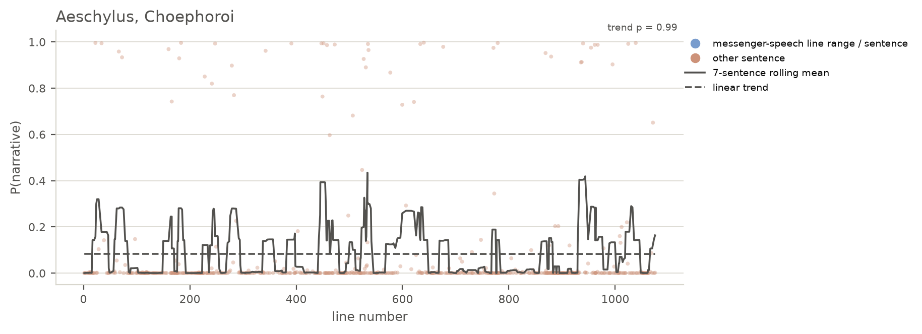
Figure 6. Chart showing the 7-line rolling average narrativity for Aeschylus' Choephoroi. There are no passages of sustained high narrativity.
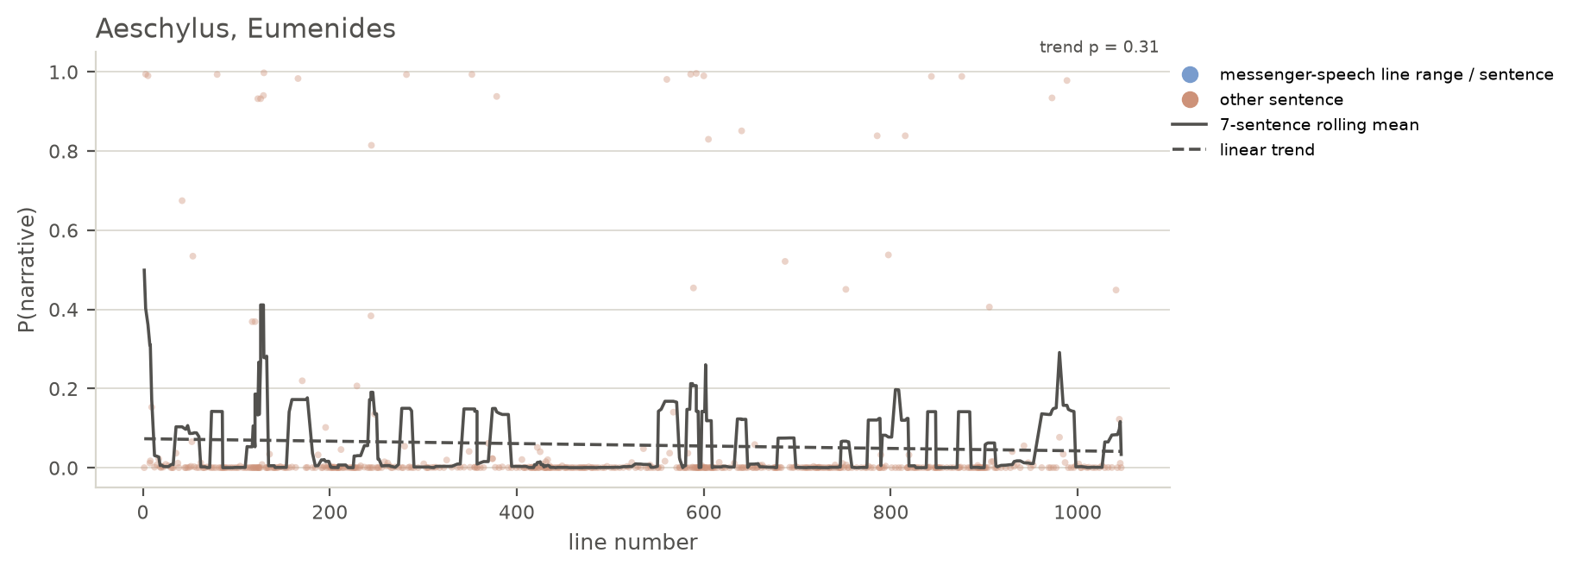
Figure 7. Chart showing the 7-line rolling average narrativity for Aeschylus' Eumenides. Narrativity remains low throughout the drama, suggesting a sustained focus on stage action.

Why narrative, why now?: Echoes of epic narrativity in Athenian Tragedy

Abstract
Despite a growing body of innovative approaches to the “messenger function” in Greek tragedy, scholars continue to wrestle with a clear definition of what makes a “messenger speech.” This paper presents and uses a Bidirectional Encoder Representations from Transformers (BERT) model to measure speakers’ “narrativity” in tragedy. The model has been trained to classify speech and narrative in the Iliad and the Odyssey, and its classification when applied to tragedy provides a useful proxy for how narrative a given passage is—that is, how much it resembles Homeric narrative. By applying this model to the extant tragic corpus, I show that the messenger function in tragedy is less a question of “who” and more a question of “when.” That is, the results from these experiments show that anonymous characters, choruses, and named characters all perform narrative speeches at some point, raising questions about who has the authority to speak and what they have the authority to say.

Introduction: Choruses and messengers
Like Yoon, I use the phrase “messenger function” instead of “messenger speech” (or “messenger’s speech”) because any character can perform this function. In Sophocles’ Trachiniae, for example, nearly every character delivers what could be considered a “messenger’s speech” at some point, but there is only one character traditionally designated Ἄγγελος, so it is more precise to say that every character performs the messenger function. In addition to Yoon’s article (and its bibliography) and her work on anonymous characters (Yoon (2012)), work by Felix Budelmann and Evert van Emde Boas on a cognitive approach to the messenger function; work by Eleanor Dickin on how messenger roles developed from bit parts to star platforms; and seminal monographs by James Barrett and Irene J. F. de Jong speak to the scholarly interest in tragic messengers over the past few decades (Budelmann and van Emde Boas (2020); Dickin2009; Barrett2002; deJong1991). Simon Perris and C. W. Marshall have also made valuable contributions to efforts to define this surprisingly elusive tragic figure/function (Perris (2011b), Perris (2011a), Marshall (2006)). Perris prefers “report-narrative” to describe the type speeches under investigation, and he usefully sums up the long-supposed epic associations with these speeches: “… tragic report-narratives have long been considered an ‘epic’ feature, principally due to the supposedly languid narrative style, the apparently objective stance, the frequency of direct speech, and the occurence of ‘Homeric’ linguistic features (epithets and unaugmented historic verbs) in some speeches” (Perris (2011b) 8). Where Perris is “loathe to universalise the epic quality” of the messenger function, Barrett, on the other hand, and Yoon more recently seem to take the messenger function’s epic heritage as more or less a given (Perris (2011b) 8; Barrett (1995); Barrett (2002) 72 and passim; Yoon (2022) 382 n. 62).

Literary and performance studies methods
Before presenting the quantitative evidence for challenging current definitions of messenger speech, it will be useful to lay out a methodology drawn from literary and performance studies as a complement to the computational methods discussed above.
To understand the messenger’s epistemic and hermeneutic roles, I draw on the Jacques Rancière’s ideas on “the distribution of the sensible,” which he defines as “a delimitation of spaces and times, of the visible and the invisible, of speech and noise, that simultaneously determines the place and stakes of politics as a form of experience” (Rancière (2004) 13). He continues, “Politics revolves around what is seen and what can be said about it, around who has the ability to see and the talent to speak, around the properties of spaces and the possibilities of time” (Rancière (2004) 13). Rancière’s definition in terms of politics grounds my investigation of the messenger function in the democratic art of tragedy. It also orients the stakes of our discussion about messenger speeches and who can deliver them, as the distribution of the sensible entails the organization of a community, in which the messenger function is one way of participating.
In “The Aesthetic Dimension,” Ranciere clarifies the power imbalance at the heart of the distribution of the sensible and its connections to the formation of knowledge:
A belief is not an illusion in opposition to knowledge. It is the articulation between two knowledges, the form of balance between those forms of knowledge and the forms of ignorance they are coupled with. As Plato claimed, articulation or balance has to be believed. The economy of knowledge has to be predicated on a story. (Rancière (2009) 16)
The messenger function participates in the economy of knowledge by delivering news and exercising the power granted by unshared eyewitness experience. Other speech registers in tragedy—agonistic, emotive, etc.—share knowledge incidentally; the messenger function shares knowledge as its primary, though not only, purpose.

Below, I take a closer look at Agamemnon, Sophocles’ Theban plays, and Bacchae in order to try to answer the question posed by this article’s title: why narrative now?

Aeschylus’ Agamemnon
Having looked at the play with the highest difference in narrativity between traditionally labeled messengers and other speakers, I turn now to the play where that difference is smallest: Aeschylus’ Agamemnon.

Chart showing per-sentence and rolling 7-sentence average narrativity for Aeschylus’ Agamemnon
While the speech Herald who announces the Achaeans’ return from Troy (503–582, 620–680) shows several peaks on the narrativity scale, these peaks pale in comparison to those of the parodos (40–257) and Clytaemestra’s “Beacon Speech” (281–316). This array of narrative speeches and speakers casts doubt on the traditional labeling of messenger versus not—or even on messenger function versus not—suggesting that we should think in terms of narrative moments rather than narrative characters.
The parodos opens with a long narrative sentence (40–54):
δέκατον μὲν ἔτος τόδʼ ἐπεὶ Πριάμου
μέγας ἀντίδικος
Μενέλαος ἄναξ ἠδʼ Ἀγαμέμνων,
διθρόνου Διόθεν καὶ δισκήπτρου
τιμῆς ὀχυρὸν ζεῦγος Ἀτρειδᾶν,
στόλον Ἀργείων χιλιοναύτην
τῆσδʼ ἀπὸ χώρας
ἦραν, στρατιῶτιν ἀρωγήν,
μεγάλ’ ἐκ θυμοῦ κλάζοντες Ἄρη,
τρόπον αἰγυπιῶν οἵτʼ ἐκπατίοις
ἄλγεσι παίδων ὕπατοι λεχέων
στροφοδινοῦνται
πτερύγων ἐρετμοῖσιν ἐρεσσόμενοι,
δεμνιοτήρη
πόνον ὀρταλίχων ὀλέσαντες·
This is the tenth year since
the great plaintiff against Priam,
Lord Menelaus–and with him Agamemnon–
the strong yoked Atreids, consisting of
two-throned and two-sceptred honor from Zeus,
set sail from this land the thousand-shipped
fleet of Argives, their martial aid,
crying out “Ares” loudly from their spirit,
like vultures who, in lonely pains
for their children,
eddy around high above their nest,
rowing with the oars of their wings,
because they lost the bed-watching
toil of their chicks.
The chorus quickly assumes a narrative stance in these opening anapests, including a simile comparing the Atreids to vultures watching over their nest. As with the parodos in Bacchae, part of the narrative tilt here comes from extensive use of a third-person perspective, but third-person verbs do not suffice on their own for the model to classify a sentence as narrative. The following sentence, “Some god on high—Apollo or Pan or Zeus—hears the shrill-screaming bird-cried lament of these metics and sends a late-avenging [hysteropoinos] Erinys to their side” (55–60), also operates only in the third-person, but the model does not classify it as narrative. Although the model weights are a black box and difficult to interpret, the model’s discrimination between these two sentences suggests that it picks up on genuine similarities and dissimilarities among passages that it classifies as narrative and not. In this case, perhaps the vocabulary has some influence: as Griffin (1986, 38 and passim) and others have noted, the Homeric narrative tends to avoid subjects like vengeance (poinē).
“It is essential to observe that the reference to a ‘sending’ by Zeus does not come until it has been firmly established (40ff.) that Agamemnon and Menelaus are purusing a human quarrel (recalled at 62); and that it is led up to by the simile of the vultures. And how are the vultures avenged? By a special divine interposition? Did Aeschylus or his audience believe this? The vultures go after the robbers and avenge themselves, wit hthe backing of divine powers.” (Winnington-Ingram (1983) 86)
Narrativity falls over the course of the Agamemnon, such that these early narrative moments establish the background before the play devolves into murder and Cassandra’s chaotic speech. This change over time—one of two statistically significant decreases in narrativity, the other being Euripides’ Electra—points to a change from story to spectacle. Like the beacon-flame itself, which Clytaemestra brings to rest upon the palace, the drama brings the action from distant Troy to the theater in front of the audience’s eyes. As Winnington-Ingram observes, “To show [the events of Agamemnon] as the inevitable product of past events, to accumulate foreboding, right up to the striking blow, was well suited to the lyric mode which is employed” (Winnington-Ingram (1983) 73–74).
This tension builds not only thanks to the “lyric mode” of the drama but also due to the audience’s growing realization that they must reconcile their internally visualized notion of narrated events with the action that gradually unfolds on- and just-off-stage. As Rancière writes, “Literature teaches us to choose between two interpretations: not two interpretations of the speech or actions of others, but two interpretations of our own perceptions and the feelings of affection that accompany them” (Rancière (2005) 101). Agamemnon, by gradually realizing our own misunderstandings in the spectacle that plays out before our eyes, builds tension by playing on the possibility that we have misunderstood.
Narrative moments create this space for misunderstanding by refusing to reconcile our interpretations with the other audience members’ and with what we see. Narrative thus creates the possibility for ruptured experience, for the pleasure and pain that accompany the sudden realization that we have not understood what we have heard and seen. Narrative moments thus also point to a leap of faith, a suspension of disbelief and trust in the reporter that might give way to betrayal. This trust and the possibilities that it raises stand at the heart not only of the theatrical endeavor but of every day communication: at a certain point, we must simply take our reporters at their word.
Although the narrativity trendlines for Choephoroi and Eumenides lack statistical significance (their p-values are much greater than 0.05), taken with Agamemnon we can see a clear trend away from narrative and towards speech.

Chart showing per-sentence and rolling 7-sentence average narrativity for Aeschylus’ Choephoroi

Chart showing per-sentence and rolling 7-sentence average narrativity for Aeschylus’ Eumenides
Such a trend speaks to the trilogy’s drive towards action that affects the audience: as an etiological tale, the Oresteia’s move from narrative to speech and action reinforces its explanation for the court on the Areopagus. But this movement is not one of diegesis to mimesis; it is rather a movement from narrative mimesis to dramatic mimesis, from representation by telling to representation by doing. Cassandra’s sudden transformation into a speaking role in Agamemnon forms part of this movement, as does Pylades’ similar transformation in Choephoroi.
The move away from narrative, punctuated by moments like Cassandra’s divestment of her priestly accoutrements (1264–67), also works as a movement away from the fictional world onstage to the lived experience of the audience.

Sophocles’ Theban plays
Sophocles exceeds both Aeschylus and Euripides in his willingness to use named characters for narrative purposes. Trachiniae offers the most famous example, in which every named character performs a messenger function. In Ajax, Tecmessa, not the late-arriving messenger, performs the most narratively-marked speech at 284–330; and in Philoctetes, for example, Neoptolemus (at 343–390) and the chorus (at 676–729), not the False Merchant, deliver the most narratively-tinged lines of dialogue.
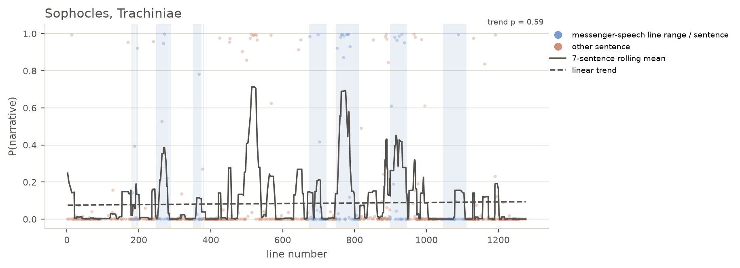
Chart showing per-sentence and rolling 7-sentence average narrativity for Sophocles’ Trachiniae

Chart showing per-sentence and rolling 7-sentence average narrativity for Sophocles’ Ajax

Chart showing per-sentence and rolling 7-sentence average narrativity for Sophocles’ Philoctetes
Electra acts as a notable exception to this rule, where the play concerns itself with action—not unlike _Choephoroi, as we have seen—except for the Tutor’s virtuosic (and false) report of Orestes’ death (680–763).
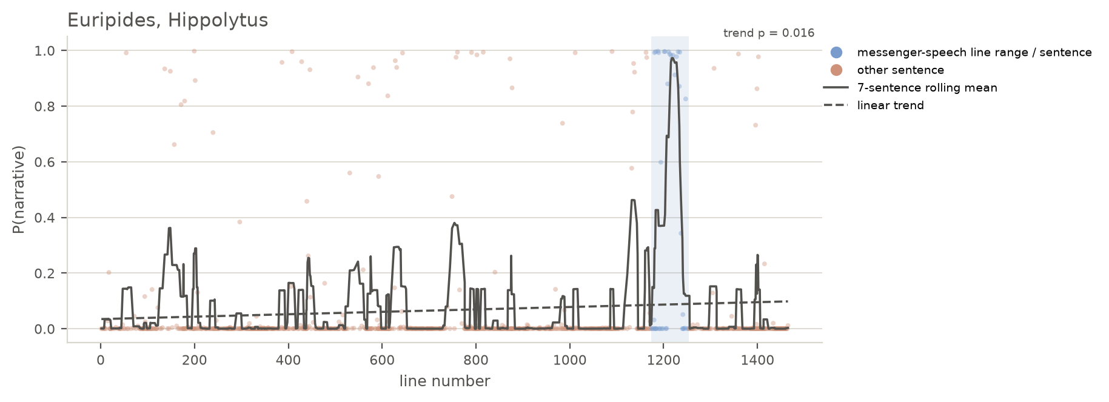
Chart showing per-sentence and rolling 7-sentence average narrativity for Sophocles’ Electra
In the Theban plays, however, Sophocles mainly sticks to what has emerged in this study as something of a convention, that anonymous characters and the chorus perform the rheseis with the highest narrativity. (Polyneices’ speech in Oedipus at Colonus (OC) is a minor exception.)
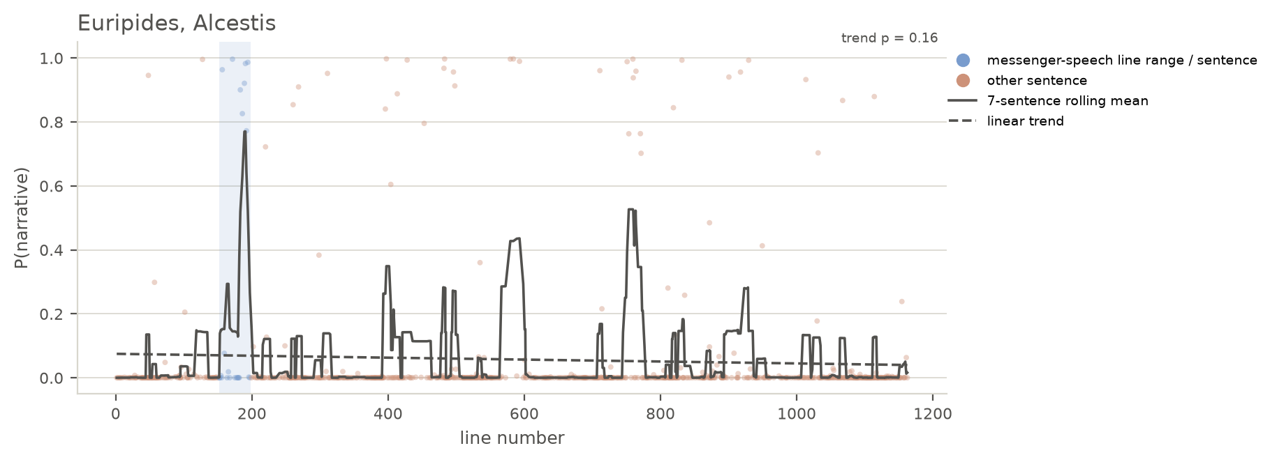
Chart showing per-sentence and rolling 7-sentence average narrativity for Sophocles’ Antigone
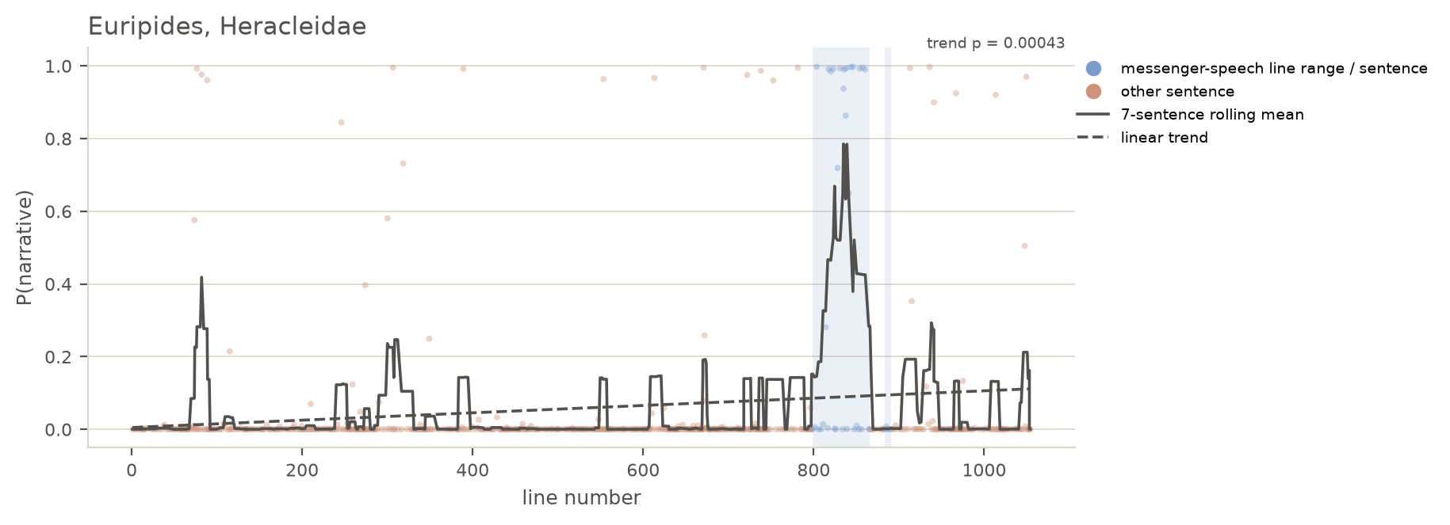
Chart showing per-sentence and rolling 7-sentence average narrativity for Sophocles’ Oedipus Tyrannus
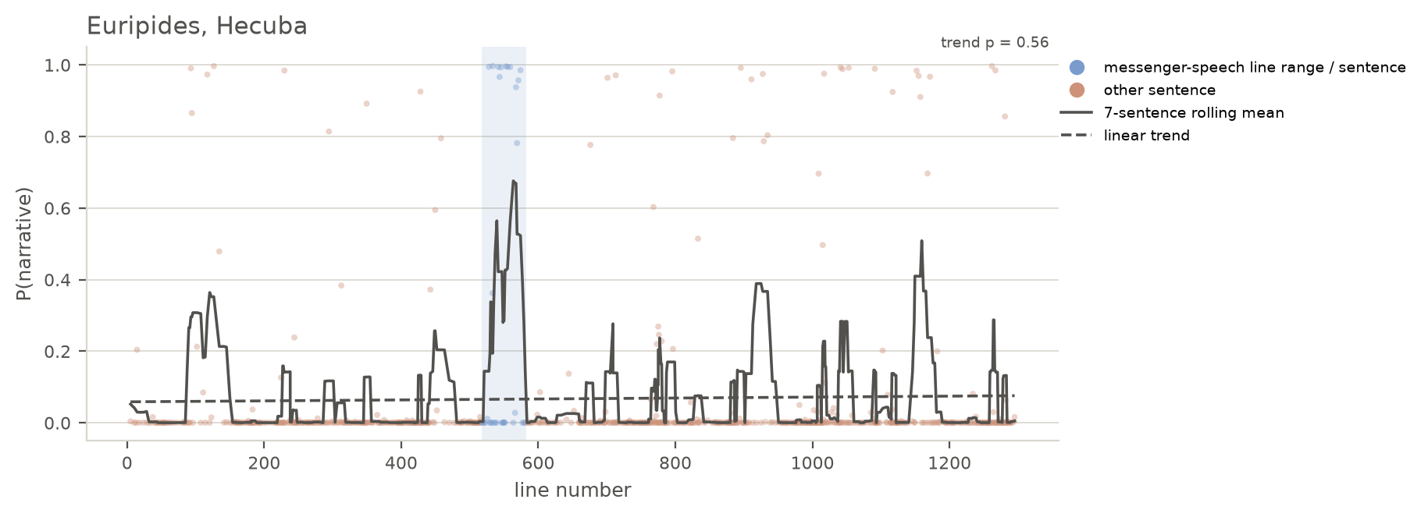
Chart showing per-sentence and rolling 7-sentence average narrativity for Sophocles’ Oedipus at Colonus
As with Aeschylus, it is difficult to draw strong inferences from so few plays. Nevertheless, Sophocles’ relatively conventional use of narrative in the the Theban plays contrasts with the narrative speeches of named characters in Ajax and Philoctetes. When named characters exercise narrative authority, they perform outside of the usual epistemic constraints of their roles, showing the audience an affective mode of interpreting events that they cannot see.
Tecmessa even begins her speech with a messenger-like formula: “You will learn the whole deed, as you are my accomplice” (284: ἅπαν μαθήσῃ τοὔργον, ὡς κοινωνὸς ὤν). But for the ὡς-clause, Tecmessa’s promise to relate the whole deed echoes promises made frequently by messenger-figures in other dramas. This promise also functions as a claim to narrative authority: unlike many named characters in tragedy, Tecmessa can tell the whole deed because she knows the whole deed. Her authority here recalls one of Rancière’s definitions of the distribution of the sensible:
A distribution of the sensible … establishes at one and the same time something common that is shared and exclusive parts. This apportionment of parts and positions is based on a distribution of spaces, times, and forms of activity that determines the very manner in which something in common lends itself to participation and in what way various individuals have a part in this distribution. (Rancière 2004, 12)
Tecmessa illuminates the distribution of the sensible at this moment in the play, highlighting the boundaries of inclusion and exclusion with the common ground established by koinōnos. She manipulates the distribution of spaces, times, and forms of activity by inviting the chorus to learn what Ajax did “at the peak of night” (285: ἄκρας νυκτός).
When she then ventriloquizes herself and Ajax, Tecmessa performs another essential narrative function by impersonating the characters in her story. Jonas Grethlein and others have argued that Plato’s use of mimēsis in Republic 2 and 3 corresponds not to the Aristotelian “representation” but rather to “impersonation”: “Direct speech is thus not a reproduction of what was said in a different ontological sphere but an act of impersonation” (Grethlein (2021, 365), citing Else (1972, 23), de Jong ([1989] 2011, 3), and Bakker (2005, 61)). Tecmessa’s narrative again reflects the sharing at the heart of koinōnos: by the ancient model, her ventriloquy works as if her audience were present for the original event.
Tecmessa’s self-quotation both recalls and anticipates key moments in the drama in such a way that she also comments on her own delivery. She tells the chorus (288–91)
κἀγὼ ’πιπλήσσω καὶ λέγω, τί χρῆμα δρᾷς,
Αἴας; τί τήνδ’ ἄκλητος οὔθ’ ὑπ’ ἀγγέλων
κληθεὶς ἀφορμᾷς πεῖραν οὔτε του κλύων
σάλπιγγος; ἀλλὰ νῦν γε πᾶς εὕδει στρατός.
And I chastised [Ajax] and said, “What are you doing,
Ajax? What is this attempt that you’re starting unbidden,
when you haven’t been called by messengers or heard
the salpinx? The whole army is asleep right now!”
With her reference to the salpinx’s summons, Tecmessa unknowingly recalls Odysseus’ description of Athena’s voice as “like a bronze-mouthed Tyrrhenian trumpet” (17: χαλκοστόμου κώδωνος ὡς τυρσηνικῆς) — a scholion explains that “a kōdōn is the broad part of a salpinx” (ad Soph. Ai. 17: κώδων καλεῖται τὸ πλατὺ τῆς σάλπιγγος). When she reminds Ajax that he has not been called by messengers, Tecmessa again unknowingly anticipates the messenger who arrives too late to save Ajax. Tecmessa’s narrative style in this speech appears to have granted her some extra-dramatic perspective, such that her speech both informs the chorus—and the external audience—about what took place and guides the audience’s understanding of how the drama fits together.
Tecmessa then takes on the voice of Ajax, continuing to speak in a diegesis di’amphoteron in the words of Republic 3.392d–394c: “And he spoke to me few but well-worn words: / ‘Woman, silence is a woman’s decoration.’ / And I listened and yielded, and he set out alone” (292–294: ὁ δ’ εἶπε πρός με βαί’, ἀεὶ δ’ ὑμνούμενα· / “γύναι, γυναιξὶ κόσμον ἡ σιγὴ φέρει.” / κάγω μαθοῦσ’ ἔληξ’, ὁ δ’ ἐσσύθη μόνος). Tecmessa may have yielded in the moment, but she breaks her silence here to take on a narrator’s voice for the chorus. Through the narrative style, Tecmessa stakes a claim to an authority that Ajax would not grant her.
As her report progresses and she describes Ajax’s mistreatment of the animals that he mistakes for the Achaean leaders, tension builds towards Ajax’s eventual arrival on the ekkyklema at 347, and the audience members’ own imagined scenes of animal slaughter contribute to this tension. William Gruber describes the effect of narratives like Tecmessa’s as “a kind of psychogenesis whereby only a few key stimuli are used by the mind to construct what then seem like real memories and fully complete visual perceptions” (Gruber (2010) 31). Such a description accords with the cognitive narratological view put forth by Grethlein (2021): “Mimesis,” he writes, “understood as impersonation, affects authors, reciters, and listeners alike, as it immerses them in the experiences of often questionable characters” (Grethlein (2021) 367). From this perspective, Tecmessa’s role as a reciter literally puts her in Ajax’s place: she embodies his affects even as she describes them, and her audiences take them on, too. The narrative style enables Tecmessa to enact her immersion in Ajax’s and her own experience. Tecmessa’s performance thus also rejects the opposition between narrative and performance by presenting them as mutually sustaining modes of communicating dramatic action.

Euripides’ Bacchae
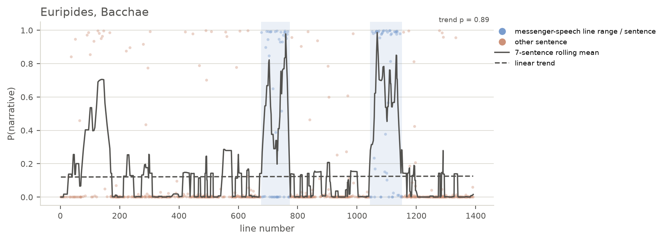
Chart showing per-sentence and rolling 7-sentence average narrativity for Euripides’ Bacchae
In addition to the Messengers’ undeniably narrative speeches in Bacchae, the parodos also contains marked narrative moments. The ode starts to grow narrative around the description of Dionysus’ birth in the first antistrophe at 88–104:
ὅν
ποτ’ ἔχουσ’ ἐν ὠδίνων
λοχίαις ἀνάγκαισι
πταμένας Διὸς βροντᾶς νη-
δύος ἔκβολον μάτηρ
ἔτεκεν, λιποῦσ’ αἰῶ-
να κερανίῳ πληγᾷ·
λοχίοις δ’ αὐτίκα νιν δέ-
ξατο θαλάμαις Κρονίδας Ζεύς,
κατὰ μηρῷ δ`καλύψας
χρυσέαισιν συνερέιδει
περόναις κρυπτὸν ἀφ’ Ἥρας.
ἔτεκεν δ’, ἁνίκα Μοῖραι
τέλεσαν, ταυρόκερων θεὸν
στεφάνωσέν τε δρακόντων
στεφάνοις, ἔνθεν ἄγραν θη-
ροτρόφον μαινάδες ἀμφι-
βάλλονται πλοκάμοις.

Bromius, whose
mother bore him cast-out
in the compulsions of labor pains
from her belly,
when the thunder
of Zeus struck: she died
with the lightning strike.
But just then Zeus son of Kronos
received him in a chamber for childbirth,
and he covered him in his thigh
and sewed him up with golden clasps,
hidden from Hera.
And when the Fates
brought it to fulfillment,
Zeus gave birth to the bull-horned god
and he crowned him with crowns
of snakes, which is why the maenads
throw the wild beast-eater
about their hair.
Despite the metrical differences between this lyric verse and epic hexameter, the model correctly identifies the narrative passage of Dionysus’ birth. This passage’s narrative flavor comes partly from the concentration of third-person main verbs: ἔτεκεν twice, δέξατο, στεφάνωσέν, and ἀμφιβάλλονται. But if third-person verbs sufficed to identify narrative, then every third-person passage would be marked by the model—clearly the vector-space embeddings have identified other markers of epic narrative as well. For instance, we can also see that the passage’s vocabulary and tenses seem to indicate the remoteness in time and place, rather than events taking place in the moment. In any case, the chorus’ narrative role challenges any idea of patent borders for the messenger function by showing once again that narrative operates outside of such confines.
Barrett seems to try to account for the fluidity of the messenger function when he writes,
It is not hard to see that any system of classification that could comprehend all of these figures in a single category would tell us little. But the challenge need not be that of deciding who is and who is not a messenger. Such a project, I submit, would amount to a matter of definition. A more productive approach, I suggest, is to recognize that all tragic messengers, near messengers, and pseudomessengers have been produced more or less in accordance with, or at variance with, a conventional, ‘ideal’ type. As such, these ‘real’ tragic figures represent the texts’ ongoing engagement with an idealized conventional form. (Barrett (2002) 97)
But is it true that the chorus works “more or less in accordance with … [an] ‘ideal’ type”? Or is it rather that onstage narrative signals the always-fraught claim to authority that characters make when they describe events their audiences cannot see?
The chorus’ high-narrative moment has striking echoes in the first traditional messenger-type speech, when the Messenger (Buxton (1991) calls this Messenger the “Cowherd”) describes Agave and the maenads’ ritual preparations. The maenads rearrange their fawnskins after the fastenings come loose (696–697), “and they fasten the spotted hides with snakes that lick their cheeks” (697–698: καὶ καταστίκτους δορὰς | ὄφεσι κατεζώσαντο λιχμῶσιν γένυν). The chorus narratively and thematically paved the way for this description already in the parodos. The Messenger’s function here cannot simply depend on his telling his audiences what he saw, but rather requires retelling what the external audience, at least, already knows from the chorus. The chorus’ etiological account becomes the Messenger’s revelation.
Nancy Worman links the play’s focus on attire and appearance to “a growing sense of coercion and menace” that “attaches to the various costumes” (Worman (2021) 100). The narrative punctuations allow this menace to grow not just through what the characters say to each other but also through what they describe that the audience cannot see. The first Messenger’s “pointed counterfactual assertions about what Pentheus would have seen” are also counterfactuals for the audience (Perris (2011a) 40). Apprehension builds towards the climax of the second Messenger’s speech through these moments of narration that allow the strange sights to grow stranger in each audience member’s mind precisely because the audience cannot view these sights collectively—cannot view them at all.
But where the audience is not initiated into the rituals that each time end in sparagmos—first of cattle, second of Pentheus—they witness Pentheus’ own transformation at the hands of Dionysus. This transformation dramatizes the chorus’ and the Cowherd’s descriptions of the maenads, turning unseen narrative into enacted ritual preparation. The dialogue, like the earlier chorus and monologue, pays particular attention to his hair and fawnskin mantle: “I will spread your hair out at length upon your head,” Dionysus says; and when asked “What else?” by Pentheus, the god replies, “A thyrsus in your hand and a dappled fawnskin” (831, 835; cf. 24–25). In a similar way, the chorus later prepares the audience for the second Messenger’s grisly report with their prophetic account of “justice made manifest” (992=1011: ἴτω δίκα φανερός). As Foley puts it, “In the fourth stasimon (977–1023) the chorus prophetically imagines Pentheus’ destruction on the mountain soon to be reported by the messenger; the messenger speech is immediately followed by a choral celebration of the god’s victory over Pentheus (1153–64)” (Foley (1985) 221). Although the fourth stasimon does not register high on the narrativity skill, the previous narrative doubling by proleptic chorus and the analeptic Messengers joins the chorus and Messengers as two modes of sustaining the miraculous and profane sights that remain beyond the external audience’s point of view.
Perris also notes the echoes of the fourth stasimon in the second Messenger’s speech, but he does not connect these echoes to the further doubling that has occurred throughout the plays narrative and dramatic action (Perris (2011a) 43). Richard Buxton, on the other hand, connects the Messengers’ narratives with the prologue, Pentheus’ opening speech, and the speech by the Servant who delivers Dionysus (as the Lydian Stranger) to Pentheus—together with the two Messengers’ reports, Buxton writes, “these five narratives may be seen as constituting a series, the later modifying the earlier; in no two cases is the relationship between content and narrator identical” (Buxton (1991) 40). While the web of interrelated passages that emerges through the performance of this play is undeniable, Buxton’s throughline does not depend on narrative per se but rather on a sense of place established by the five passages that he isolates. By instead isolating moments of high narrativity, I mean to highlight the tenuous relationship between performance and description and the ways that the two are not easily separated. As Foley has observed, this difficulty gains special purchase within this play: “In the Bacchae myth and action, odes and iambic scenes, are intertwined from the start, as is appropriate in a plot that represents a penetration of the secular world by a divine power” (Foley (1985) 207–208). The play’s moments of narrative action ensure that, like Pentheus at 918–922, the audience experiences double vision by seeing the narrative reports onstage and by witnessing the action in their minds.
Taken together, the narrative moments of the messengers and the chorus offer the audience two modes of entry into the play’s rituals. As Foley has noted, “The action of the play gradually becomes, until the final scenes, fully ritualized and mythical, and Dionysiac poetry transforms reality as the chorus becomes one with and even predicts the action” (Foley (1985) 208). Yet by focusing on moments of heightened narrative, we also notice how the chorus anticipates the action before merging with it, and the messengers react to what they have seen. Likewise, the audience can choose to have entered the Theater of Dionysus fully committed to the god, or they can participate through the rituals of which they are now spectators; they can arrive late or early, but the play does not leave them the choice to refuse.
Hence also the emphasis on what the audience must imagine through these narratives. After the process of initiation, the audience can properly understand miracles that cannot be staged—so Foley:
“Whatever we conclude occurs in the palace scene [576–603], whether nothing at all or a major or minor change in the stage building, no stage business at this point could adequately imitate the apocalyptic destruction of the palace, including lightning and earthquake, which the chorus sees while Pentheus does not. The miracle must become for the audience more symbolic and prophetic than realistic. The audience sees not a miracle, but a chorus enacting the experience of a miracle, or presenting a theatrical illusion.” (Foley (1985) 221)
Narrative serves as the playwright’s technology for welcoming the initiand. The palace scene demands that the audience imagine events that cannot be staged, importing the practice of imagining events that they have honed on the narrative of the parodos so that they can see even what they are not shown. Perhaps there really were special effects representing fire (596) and lightning bolts (594, 598–99), or perhaps pillars representing the palace really fell down. Either way, as Foley argues, the audience must see more than what is shown onstage, and so must join their imagined visualizations with the chorus’ descriptions—just as they must do during moments of heightened narrative.

Argument/interpretation
We have to stop thinking about “narrative characters” and start thinking about “narrative moments.”
“From the Platonic point of view, the stage, which is simultaneously a locus of public activity and the exhibition-space for ‘fantasies’, disturbs the clear partition of identities, activities, and spaces.” (Rancière 2004, 13)
“Plato contrasts a third, good form of art with writing and the theatre, the choreographic form of the community that sings and dances its own proper unity. In sum, Plato singles out three ways in which discursive and bodily practices suggest forms of community: the surface of mute signs that are, he says, like paintings, and the space of bodily movement that divides itself into two antagonistic models (the movement of simulacra on the stage that is offered as material for the audiences identifications and, on the other hand, the authentic movement characteristic of communal bodies).” (Rancière 2004, 14)
“[A discipline] is a way of defining an idea of the thinkable, an idea of what the objects of knowledge themselves can think and know” (Rancière 2009, 17).
- This applies to the interpretive functions on the stage as well
“Fiction is a way of changing existing modes of sensory presentations and forms of enunciation; of varying frames, scales and rhythms; and of building new relationships between reality and appearance, the individual and the collective” (Rancière ([2010] 2015, 149); quoted in O’Leary (2024, 52))
“Textual space, not to be confused with dramatic space (the way in which a text talks about sapce), is a metaphor for the enunciation of the text in space-time, a metaphor for its rhythmic architecture, ‘the pure configuration of masterpieces’ that Copeau described [Jacques Copeau, Appels, Registres 1 (Paris: gallimard, 1974), 199]. It is the way in which the spectator inscribes the recitation of the text in space.” (Pavis ([1996] 2003) 155)

Conclusion
Bakker, Egbert J. 2005. Pointing at the Past: From Formula to Performance in Homeric Poetics. Hellenic Studies 12. Center for Hellenic Studies, Trustees for Harvard University.
Barrett, James. 1995. “Narrative and the Messenger in Aeschylus’ Persians.” American Journal of Philology 116 (4): 539–57.
Barrett, James. 2002. Staged Narrative: Poetics and the Messenger in Greek Tragedy. University of California Press.
Beck, Deborah. 2012b. “Speech Presentation in Homeric Epic.” https://homeric-speech-beck.la.utexas.edu/home.
Beck, Deborah. 2012a. Speech Presentation in Homeric Epic. University of Texas Press. https://doi.org/10.7560/738805.
Beck, Deborah. 2020. “Speech.” In The Cambridge Guide to Homer, edited by Corinne Ondine Pache, Casey Dué, Susan M. Lupack, and Robert Lamberton. Cambridge University Press. https://doi.org/10.1017/9781108333931.
Beck, Deborah. 2026. “Κερτομέω in Context(s) in Greek Epic Poetry.” In Direct Speech in Greek and Latin Epic: Expanding the Methods and Canon, edited by Christopher Forstall and Berenice Verhelst. BRILL. https://doi.org/10.1163/9789004750227.
Beine, Julia Jennifer. 2025. “How to Figure Out a Schemer: Tracing Types of Roman Comedy in Classical Receptions Through Digital Methods.” In Transnational Encounters in Early Modern Drama, 1450–1750, edited by Dinah Wouters and Jan Bloemendal.
Bourdieu, Pierre. 1991. Language and Symbolic Power. Translated by Gino Raymond and Matthew Adamson. Polity Press.
Budelmann, Felix, and Evert van Emde Boas. 2020. “Attending to Tragic Messenger Speeches.” In Experience, Narrative, and Criticism in Ancient Greece: Under the Spell of Stories, edited by Jonas Grethlein, Luuk Huitink, and Aldo Tagliabue. Oxford University Press.
Buxton, Richard G. A. 1991. “News from Cithaeron : Narrators and Narratives in the Bacchae.” Pallas 37 (1): 39–48. https://doi.org/10.3406/palla.1991.1223.
Cesca, Ombretta, and Matteo Romanello. 2026. “A Computational Approach to Characters’ Intentional Repetitions in Homeric Epic.” In Direct Speech in Greek and Latin Epic: Expanding the Methods and Canon, edited by Christopher Forstall and Berenice Verhelst. Brill. https://doi.org/10.1163/9789004750227.
Easterling, P. E. 1968. “Sophocles, Trachiniae.” Bulletin of the Institute of Classical Studies, no. 15: 58–69.
Else, Gerald F. 1972. The Structure and Date of Book 10 of Plato’s Republic. Carl Winter-Universitätsverlag.
Finkelberg, Margalit. 1989. Formulaic and Nonformulaic Elements in Homer. 84 (3): 179–97.
Foley, Helene P. 1985. Ritual Irony. Cornell University Press.
Fornieles Sánchez, Raquel. 2018. “Sobre el mensajero trágico: propuesta de clasificación.” Euphrosyne 46 (January): 27–44. https://doi.org/10.1484/J.EUPHR.5.125260.
Forstall, Christopher W., Simone Finkmann, and Berenice Verhelst. 2022. “Towards a Linked Open Data Resource for Direct Speech Acts in Greek and Latin Epic.” Digital Scholarship in the Humanities 37 (4): 972–81. https://doi.org/10.1093/llc/fqac006.
Grethlein, Jonas. 2021. “Mimesis and Experience: A Platonic Perspective on Ricoeur’s Time and Narrative.” Poetics Today 42 (3): 361–80. https://doi.org/10.1215/03335372-9026145.
Griffin, Jasper. 1986. “Homeric Words and Speakers.” The Journal of Hellenic Studies 106 (November): 36–57. https://doi.org/10.2307/629641.
Gruber, William. 2010. Offstage Space, Narrative, and the Theatre of the Imagination. Palgrave Macmillan US. https://doi.org/10.1057/9780230105645.
Heiden, Bruce. 1989. Tragic Rhetoric: An Interpretation of Sophocles’ Trachiniae. Hermeneutic Commentaries. Peter Lang.
Heiden, Bruce. 2012. “Trachiniae.” In Brill’s Companion to Sophocles, edited by Andreas Markantonatos. Brill.
Jong, Irene J. F. de. (1989) 2011. Narrators and Focalizers: The Presentation of the Story in the Iliad. Bristol Classical Press.
Kang, Young Un. 2025. “Emotions in the Identity of Paul: A Sentiment Analysis Approach to Paul’s Jewish Identity.” PhD thesis, School of Theology, Yonsei University.
Keith, Allison, Antonio Rojas Castro, Kerstin Jung, Hanno Ehrlicher, and Sebastian Padó. 2026. “A Computational Analysis of Character Archetypes in the Works of Calderón de La Barca.” Journal of Computational Literary Studies 5 (1): 1–20. https://doi.org/10.48694/JCLS.4167.
Lämmle, Rebecca, and Cédric Scheidegger Lämmle. 2013. “Homer on Kithairon: Dramatic and Narrative Representation in the Bacchae.” The Classical Journal 108 (2): 129–158. https://doi.org/10.5184/classicalj.108.2.0129.
Marshall, C. W. 2006. “How to Write a Messenger Speech (Sophocles, Electra 680–763).” Bulletin of the Institute of Classical Studies. Supplement, no. 87: 203–21.
McConnell, Tom. 2025. “Homeric Speech, Narrative, and Style.” In Chronology, Dialect, and Style in Early Greek Hexameter Poetry. Oxford University Press. https://doi.org/10.1093/9780198932345.003.0007.
Nadel, Peter. 2026. pnadelofficial/Greek-Bert: V1.0.0. V. 1.0.0. Zenodo, released July 14. https://doi.org/10.5281/ZENODO.21363922.
O’Leary, Timothy. 2024. “Years and Years: The Distribution of the Sensible in Woolf and Ernaux.” Journal of Modern Literature 47 (4): 39–54. https://doi.org/10.2979/jml.00043.
Pavis, Patrice. (1996) 2003. Analyzing Performance: Theater, Dance, and Film. Translated by David Williams. Editions Nathan. Reprint, University of Michigan Press.
Perris, Simon. 2011a. “Perspectives on Violence in Euripides’ Bacchae.” Mnemosyne 64 (1): 37–57. https://doi.org/10.1163/156852511X505024.
Perris, Simon. 2011b. “What Maketh the Messenger: Reportage in Greek Tragedy.” In Selected Proceedings, edited by A. Mackay. www.ascs.org.au/news/ascs32/Perris.pdf.
Raeburn, David, and Oliver Thomas. 2011. The Agamemnon of Aeschylus: A Commentary for Students. Oxford University Press.
Rancière, Jacques. 2004. “The Politics of Aesthetics: The Distribution of the Sensible.” In The Politics of Aesthetics: The Distribution of the Sensible, translated by Gabriel Rockhill. Continuum International Publishing Group.
Rancière, Jacques. 2005. “Literary Misunderstanding.” Paragraph 28 (2): 91–103. https://doi.org/10.3366/para.2005.28.2.91.
Rancière, Jacques. 2009. “The Aesthetic Dimension: Aesthetics, Politics, Knowledge.” Critical Inquiry 36 (1): 1–19. https://doi.org/10.1086/606120.
Rancière, Jacques. (2010) 2015. Dissensus: On Politics and Aesthetics. Translated by Steven Corcoran. Bloomsbury Academic.
Rydberg-Cox, Jeff. 2026. “Using Networks to Explore the Relationships Between Characters and the Words They Speak in Homer’s Iliad.” In Direct Speech in Greek and Latin Epic: Expanding the Methods and Canon, edited by Christopher Forstall and Berenice Verhelst. BRILL. https://doi.org/10.1163/9789004750227.
Szemes, Botond, and Mihály Nagy. 2024. “Repetition and Innovation in Dramatic Texts. An Attempt to Measure the Degree of Novelty in Character’s Speech.” Journal of Computational Literary Studies 3 (1). https://doi.org/10.48694/jcls.3923.
Vaswani, Ashish, Noam Shazeer, Niki Parmar, et al. 2023. “Attention Is All You Need.” Pre-published August 2. https://doi.org/10.48550/arXiv.1706.03762.
Warner, Benjamin, Antoine Chaffin, Benjamin Clavié, et al. 2024. “Smarter, Better, Faster, Longer: A Modern Bidirectional Encoder for Fast, Memory Efficient, and Long Context Finetuning and Inference.” Pre-published December 19. https://doi.org/10.48550/arXiv.2412.13663.
Winnington-Ingram, R. P. 1983. Studies in Aeschylus. Cambridge University Press.
Worman, Nancy. 2021. Tragic Bodies: Edges of the Human in Greek Drama. Bloomsbury.
Wyles, Rosie. 2011. Costume in Greek Tragedy. Bristol Classical Press.
Yoon, Florence. 2012. Anonymous Characters in Greek Tragedy: The Shaping of Heroes. Brill.
Yoon, Florence. 2022. “Heralds and Messengers: Character Identity and Function in Greek Tragedy.” Classical Philology 117 (2): 364–85. https://doi.org/10.1086/718685.
Zeitlin, Froma I. 1994. “The Artful Eye: Vision, Ecphrasis, and Spectacle in Euripidean Theatre.” In Art and Text in Ancient Greek Culture, edited by Simon Goldhill and Robin Osborne. Cambridge University Press.

Dickin 2009, 13–52; Lämmle and Lämmle 2013, 134.
Yoon 2022, 374.
Yoon 2022, 364. Cf. Marshall 2006, 207 n. 21: “It is worth noting that when we speak of the messenger, we are denoting a function and not a role.”
Yoon 2022, 364.
Perris 2011b, 8. See also Barrett 1995, 540 n. 4 for additional discussion and bibliography on the epic influence on messengers stretching back to the 19th century.
Vaswani et al. 2023.
The bibliography on quantitative approaches to Homer is voluminous, and I cannot cover all of it here. Tom McConnell’s recent monograph contains the most up to date methodologies alongside sophisticated linguistic insights and a wide-ranging bibliography in its own right (McConnell 2025, esp. ch. 7). Ombretta Cesca and Matteo Romanello have recently demonstrated the use of the computational tool Passim to detect repetitions in Homeric characters’ speech (Cesca and Romanello 2026). On the speech-narrative divide in Homer, Jasper Griffin’s well-known article remains essential, if controversial, reading (Griffin 1986); Margalit Finkelberg provides a more measured but still quantitative approach to Homeric formulae (Finkelberg 1989). Deborah Beck has further elucidated performance and performative aspects of Homeric speech, and her digital publications provide additional tools for the reader to investigate claims made here (Beck 2026; Beck 2020; Beck 2012a; Beck 2012b). Although a network-based approach is not used in this paper, Jeff Rydberg-Cox’s recent work with networks and words in Homer deserves to be flagged for potential follow-up research (Rydberg-Cox 2026).
Beine 2025.
Szemes and Nagy 2024.
Keith et al. 2026.
Kang 2025.
Keith et al. 2026, 2.
Forstall et al. 2022.
https://perseusdl.github.io/treebank_data/
Nadel 2026; Warner et al. 2024.
A confusion matrix is read by looking at the “actual” label on the left (the y-axis) and the predicted label on the bottom (the x-axis). The number given at the intersection is the frequency of for that combination of actual and predicted labels: when the actual and predicted labels are the same, the model predicted the correct label.
The list draws on the appendix of Barrett 2002 as well as the recent classificatory work of Fornieles Sánchez 2018, although it does not align perfectly with either of them, in part because it attempts to be more precise by focusing exclusively on lines spoken by the messengers as part of their reports.
Although C. W. Marshall does not use the phrase “messenger function,” he does acknowledge, “It is worth noting that when we speak of the messenger, we are denoting a function and not a role” (Marshall (2006) 207n21).
Yoon rightly points out that Ἄγγελος is likely a late designation and prefers “Old Man” for this character (Yoon (2022) 376).
See Raeburn and Thomas (2011, xlvii) for Aeschylus’ use of the third actor for Cassandra.
See Raeburn and Thomas (2011, 203–4) for Cassandra’s removal of parts of her costume. On this moment, Wyles (2011, 66) writes “Once Cassandra has stripped herself of the parts of her costume, which defined her in semiotic terms, then she has become ‘dead’ as a stage character. Her mask remains and may continue to identify her, but it offers limited clues to her identity, conveying gender, age, and possibly status, but nothing more of ‘who’ she is. So this ‘semiotic death’ plays out in symbolic visual terms the actual death, which she is about to experience off-stage.” The movement from semiotic to symbolic closely parallels the movement from narrative to active.
I leave Trachiniae to the side because it is in the one play in which this phenomenon of narrative named characters has been widely noticed. See especially the studies of Easterling (1968), Heiden (1989), and Heiden (2012).
Translations are my own.
See Bourdieu (1991###) for a discussion of the skeptron and its role in authorizing speech.
So Foley (1985) 221n23: “Theatrical (or psychological) illusion is the only avenue by which the god can be worshipped and understood.” The Messengers and the chorus seem to represent or even enact, respectively, theatrical and pyschological illusion.
See Zeitlin (1994, 152) for how, as she puts it, Euripides “[expands] the traditional oracular quality of graphic signs into theatrical experimentation with the special powers of the visual imagination in the world of the stage.”

