Supporting Information

**Reactive silver ink coatings for antiviral, repellent, bleach-durable fabric, and their advantages compared to silver nanoparticles**

Anthony J. Galante1, Brady C. Pilsbury1, Kathleen A. Yates2, Melbs, LeMieux3, Daniel J. Bain4, Robert M.Q. Shanks2, Eric G. Romanowski2, and Paul W. Leu1*

1Department of Industrial Engineering, University of Pittsburgh, 3700 O'Hara, Benedum Hall, Pittsburgh, PA, 15261, United States

2Department of Ophthalmology, Charles T. Campbell Laboratory for Ophthalmic Microbiology, University of Pittsburgh School of Medicine, 203 Lothrop Street, Pittsburgh, PA 15213, United States

3Electroninks Inc, 7901 East Riverside Drive, Bldg 1,Unit 150, Austin TX 78744

4Department of Geology and Environmental Science, University of Pittsburgh, Pittsburgh, PA 15261, United States

* E-mail: pleu@pitt.edu

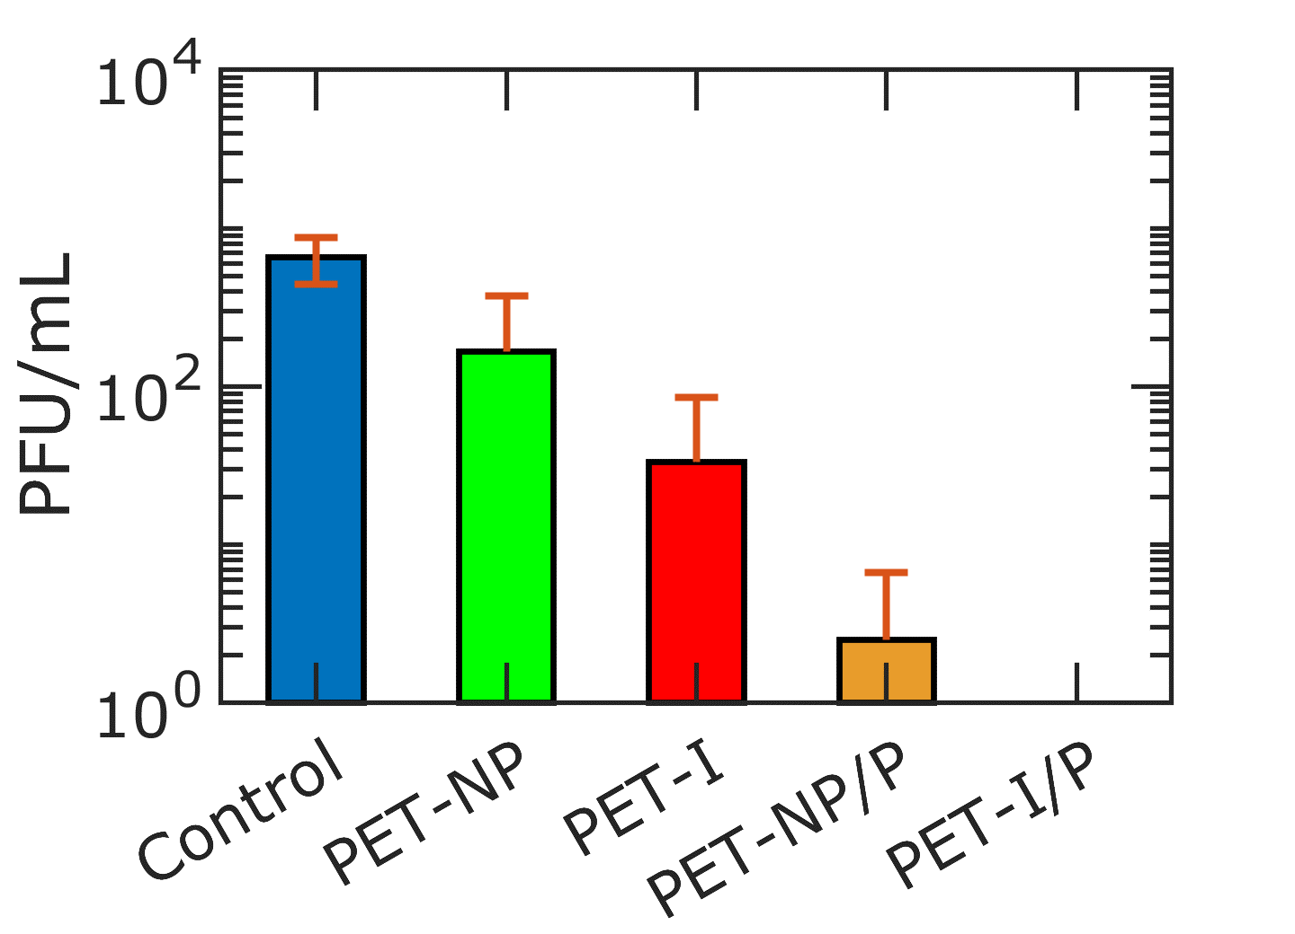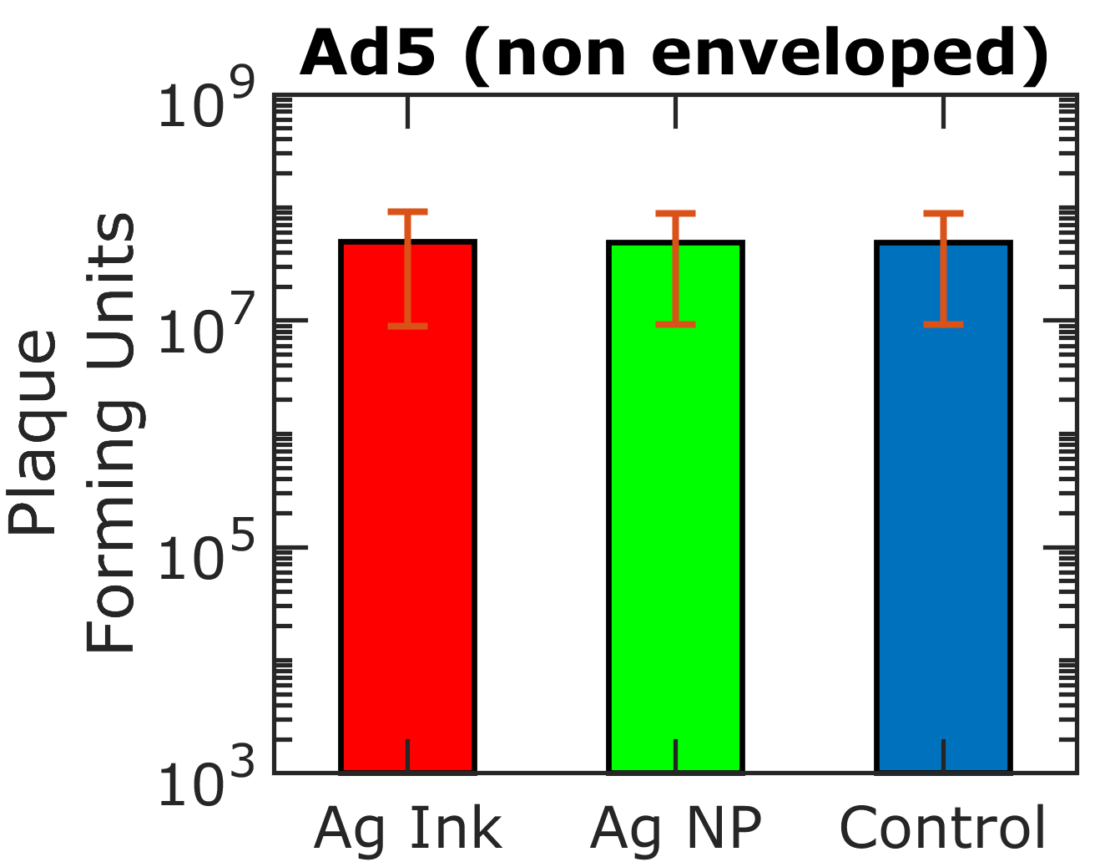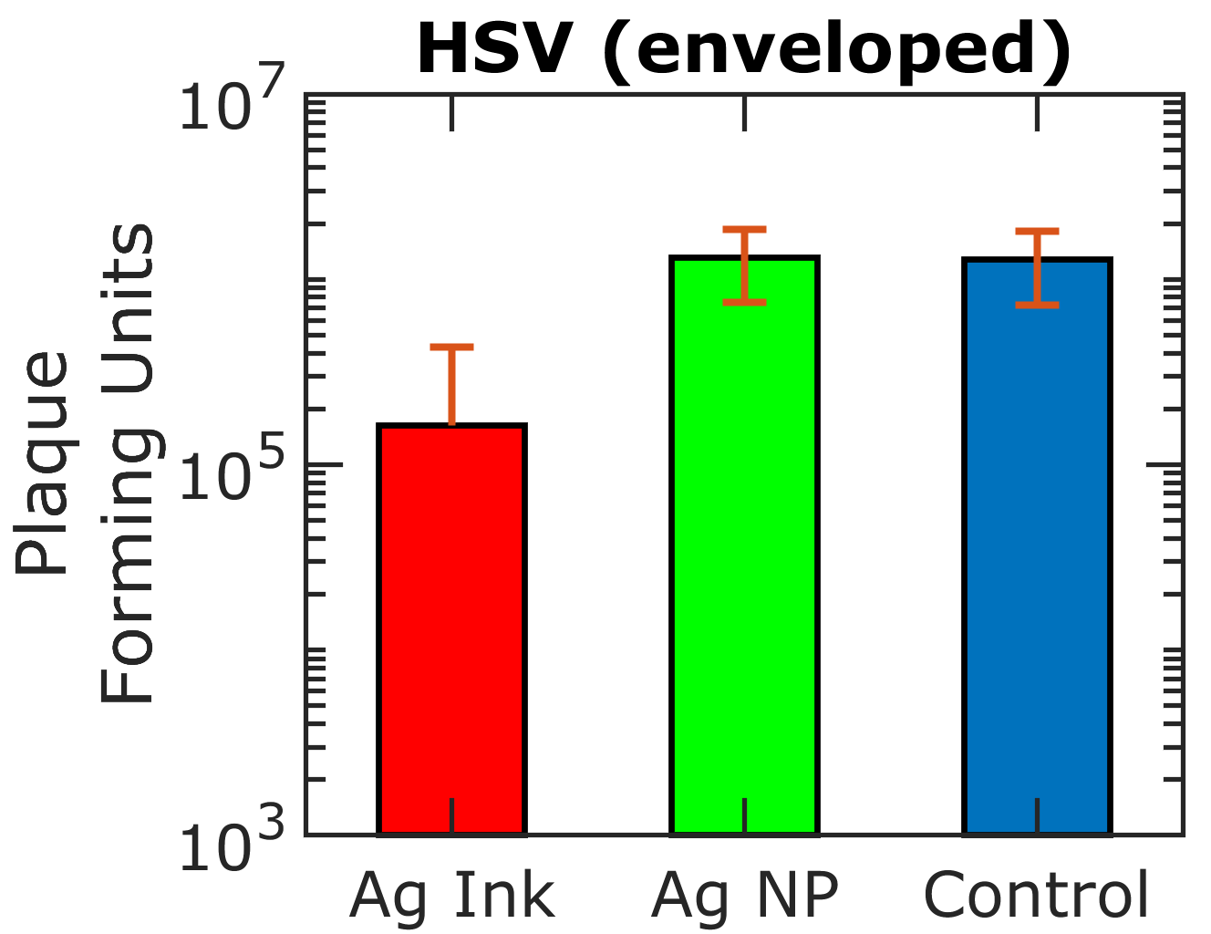

a)

b)



**Figure S1.** Results from virus inactivation experiments using 0.1% Ag ink and 20 nm Ag nanoparticles (NP) in PBS against virus stocks (a) human adenovirus serotype 5 (HAdV5, non enveloped) and (b) herpes simplex (HSV-1, enveloped). Mean log difference for Ag Ink is -0.05 ± 0.67 for HAdV5 and -1.57 ± 0.89 for HSV-1. Mean log difference for Ag NP is 0.00 ± 0.00 for HadV5 and -0.03 ± 0.08 for HSV-1.

Neither silver ink, nor silver 20 nm nanoparticles show significant virus inactivation for non enveloped adenovirus at 0.1% concentration in PBS. Silver ink shows virus inactivation properties for enveloped herpes simplex virus, but silver nanoparticles do not at 0.1% concentration in PBS.

**Figure S2.** (a) Goniometer images of static water droplets on (i) PET-NP, (ii) PET-Ink, (iii) PET-NP/P, and (iv) PET-I/P fabric samples

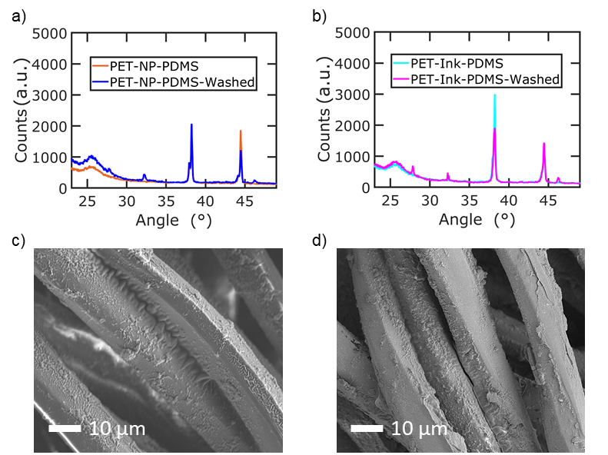

**Figure S3.** (a-b) XRD spectra of (a) PET-NP/P and (b) PET-IP/P samples after 300 minutes of ultrasonic bleach washing.

XRD confirms the presence of silver for both samples. The XRD spectra shows new peaks after bleach washing believed to be from structural damage. XRD spectra of samples after bleach washing shows new distinct peaks observed at 2θ=27.8°, 32.3°and 46.3°corresponding to the (111), (200) and (220) crystal planes, respectively, of silver chloride. This is likely the result from some silver reacting with bleach to form silver chloride.

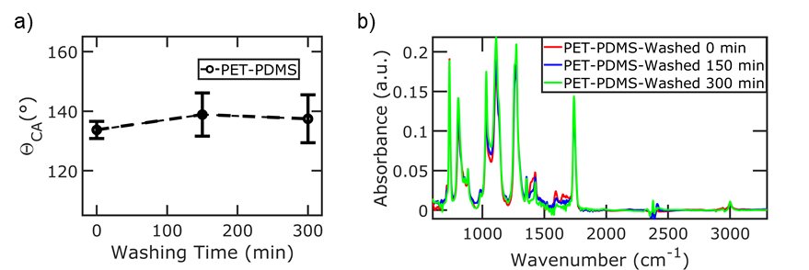

**Figure S4.** (a) Static water contact angle of PET-PDMS samples as a function of ultrasonic bleach washing. (b)FTIR spectra of PET-PDMS samples before and after ultrasonic washing

The average static water contact angle slightly increases after bleach washing, confirming the PDMS layer is roughened from ultrasonic bleach washing. The standard deviation increases suggesting the PDMS layer is roughened non uniformly. FTIR does not show oxidation damage to the PDMS layer after washing with bleach. A small decrease in absorbance of C=C stretching around 1520-1660 cm-1 is observed.