PROP MAS 2009
Hidato game

Group members:
Matus Pleva (matus@kktts.sk)
Michal Babacek (michal.babacek@gmail.com)
Adrien Daunou (daunou.adrien@free.fr)

Project code: 13.3

Version: 1.0
Table of contents
Detailed definition 3
Use Case Diagram 4
Domain static diagram 6
Non-functional requirements 7

Detailed definition

Use Case Diagram
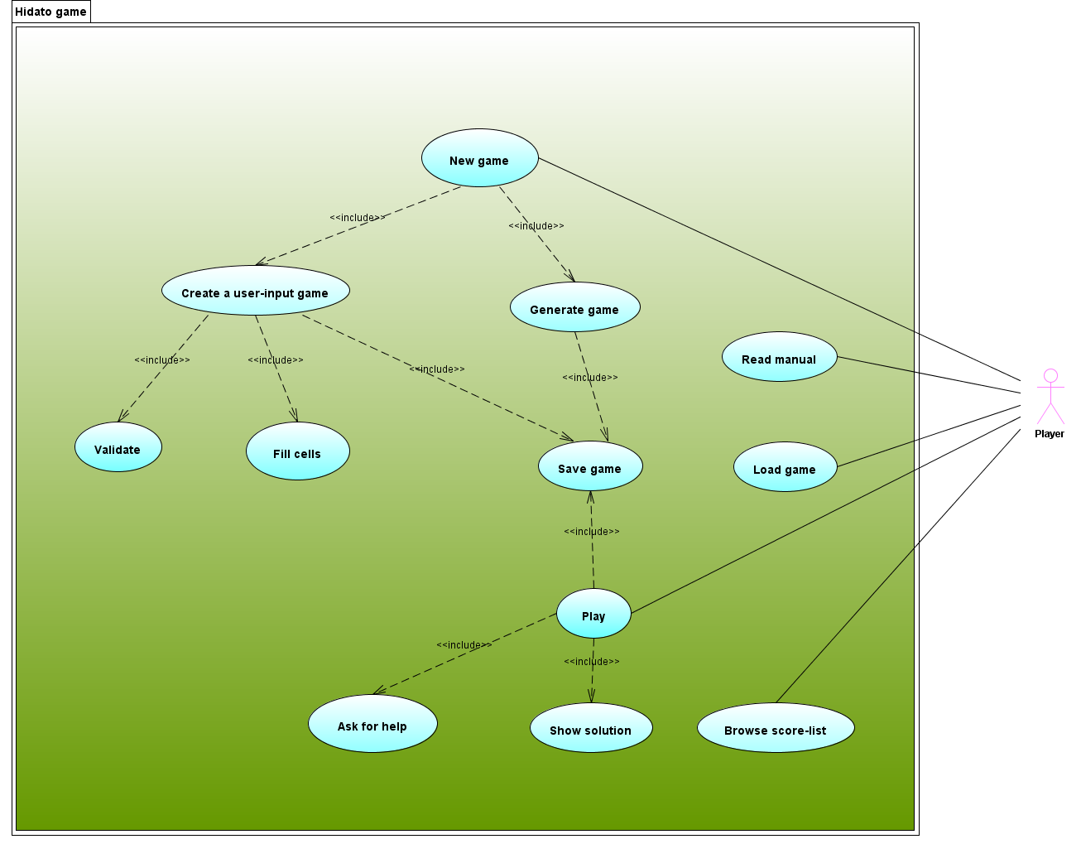

Description:

- new game - user starts a new game
  - generate game - user can let the system generate the game according to provided parameters (difficulty level, board shape, number of cells, number of cells already filled)
    - save game – user can save game
  - create a user-input game - user can create its own game (he sets number of cells)
    - fill cells – user fills cells with numbers
    - validate – validate matrix
    - save game – user can save game
- play - user solves Hidato game (if user reaches high score, his name and score is saved in score-list)
  - ask for help – user can ask for help
  - save game – user can save game
  - show solution – reveals either the generated or user-input game solution
- load game – user loads saved game
- browse score-list – score list is shown
- read manual – user manual for Hidato game is shown

Domain static diagram

Non-functional requirements

