**CSEE5590-0005/490-0005**

**IOT / Robot Programming**

**Lesson Plan #1**

**IDE Download :** [**Click Here**](https://www.arduino.cc/en/Main/Software)

**Lesson Title:** Spaceship Interface

**Lesson Description:** *Basic IoT project to control spaceship / Fire alarm by the blinks of LED’s*

**[Source Code](https://umkc.box.com/s/1yc6o64zcg1new2bu77298jw6nydb4e7)**

**In Class Exercise**

* It is a basic IoT project where you are going to design and program the circuit as follows:
* Three LED’s
* Green LED on
* Button press
* Two other LED’s starts blinking
* Change the delay and compare the difference
* Report it to your TA.

**Circuit Diagram**

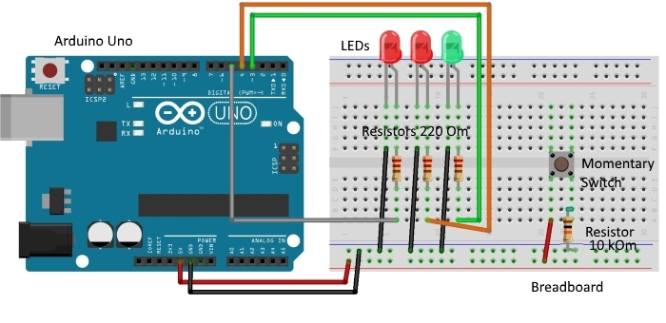

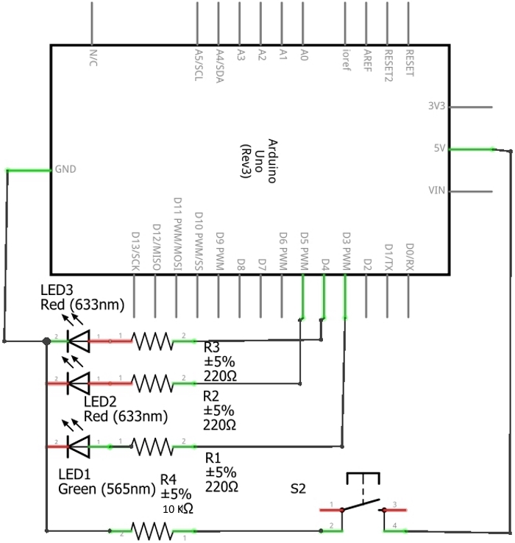

**Bonus Point Question will be announced in class**

**ICP Guidelines (In Class Students):**

1. ICP Submission is in pairs of two students.
2. Once completed, must be presented to TA or Instructor before the completion of the class
3. Submission after class is considered as late submission. (Check the late submission policy in the syllabus)
4. Record a video of your working project with brief explanation
5. ICP Code with brief explanation and recorded video should be pushed to GitHub for evaluation of the grade.