**CSEE5590-0005/490-0005**

**IOT / Robot Programming**

**Lesson Plan #2**

**Lesson Title:** IoT*Heartbeat Monitoring*

**Lesson Description:** *Heart Beat Monitoring over Internet using Arduino and ThingSpeak*

**Circuit Diagram and Instructions:**

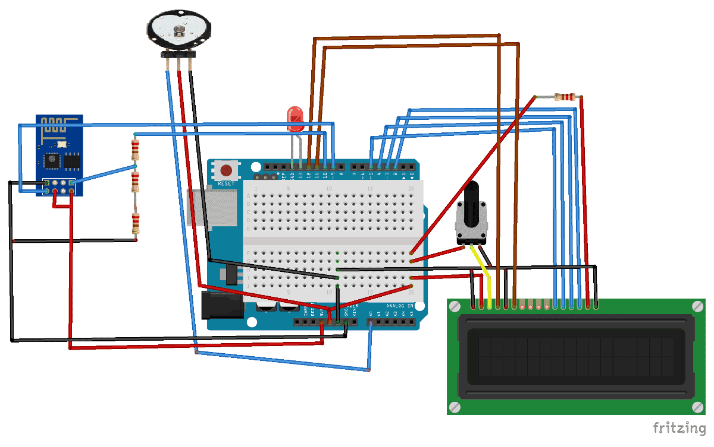

**In Class Exercise**

**ICP / ICE Part 1**

* Create a heartbeat module
* Which can display heartbeats on LCD
* Change the delay between heartbeats and compare the results.

**ICP / ICE Part 2:**

* Connect Wifi Module
* Which is able to transmit the data to cloud
* Using ThingSpeak API key, try to fetch the sensor data
* Using ThingSpeak visualize the data

**ThingSpeak Set up:**

[ThingSpeak](https://thingspeak.com/) provides very good tool for [IoT based projects](http://circuitdigest.com/internet-of-things-iot-projects). By using ThingSpeak site, we can monitor our data and control our system over the Internet, using the Channels and webpages provided by ThingSpeak. ThingSpeak ‘Collects’ the data from the sensors, ‘Analyze and visualize’ the data and ‘Acts’ by triggering a reaction.

* Create account
* Create new channel
* Name the field
* Copy the API key and use it in your code

### Using Android App

You'll be able to visualize data in any browser. But you might also check it on you Android based smart phone and visualize it whenever you want.

* Download and install **[ThingsView](https://play.google.com/store/apps/details?id=com.cinetica_tech.thingview)** app from Google Play store on your Android device
* On the app, insert your channel ID number and click add. You'll find the ID on your ThingSpeak channel configuration
* The current values of each variable will be displayed in a graph

Have fun!

**ICP / ICE Part 3:**

* Integrate project 1 with the current.
* If the heartbeat goes above 170 red led should blink
* If it drops below 100 green light should blink
* Put three push buttons for reset, turn off and turn on the LCD.

**ICP / ICE Bonus Points:**

When there is no finger on the pulse sensor the reading should be reset to zero. For example if the BPM drops below 50 or boosts above 300 the BPM rate should be reset to zero or you can make your own scenario according to your feasibility.

**ICP Guidelines (In Class Students):**

1. ICP Submission is in pairs of two students.
2. Once completed, must be presented to TA or Instructor before the completion of the class
3. Submission after class is considered as late submission. (Check the late submission policy in the syllabus)
4. Record a video of your working project with brief explanation
5. ICP Code with brief explanation and recorded video should be pushed to GitHub for evaluation of the grade.