**Part 3**

GitHub is a web-based repository hosting service. It is a graphical interface and desktop as well as mobile integration. It also provides access control and collaboration features such as wikis, task management, bus tracking, and feature request for ever project. It usually hosts open-source software. It was created on October 1st, 2007 by Tom Preston-Werner, Chris Wanstrath, and PJ Hyett. GitHub was created mostly for open source code and projects, but also supports documentation, issue tracking, and small websites and social networking-like functions. Other open source software alternatives are BitBucket, Kiln, and Rhodecode. GitHub could be used while working on a project for other coders feedback and recommendations on the software they are working on. It is also a great way for programmers to get their work out to broadcast to potential employers and also a great way for employers to find employees.

**Part 4 : GitHub Tutorial Command Lines Entered Below:**

git init

git status

git add octocat.txt

git status

git commit –m “Add cute octocat story”

git add ‘*.txt’

git commit –m ‘Add all the octocat.txt files’

git log

git remote add origin https://github.com/try-git/try_git.git

git push –u origin master

git pull origin master

git diff HEAD

git add octofamily/octodog.txt

git diff –staged

git reset octofamily/octodog.txt

git checkout – octocat

git branch clean_up

git checkout clean_up

git rm ‘*.txt’

git status

git checkout master

git merge clean_up

git branch –d clean_up

git push

**Part 5**

Define the following terms in the context of Git (2 lines maximum):

* Repository: A storage space where your projects can live. It can be in a folder on a personal computer or in a storage space on GitHub or another online host.
* Commit: A command line that takes a “snapshot” of your repository at that point in time and gives you a checkpoint to restore your project to that previous “snapshot” state.
* Push: Pushes the changes you make (on your local computer) visible online on GitHub.
* Branch: Allows multiple people to work on the same project without getting them confused about who changes what. They will “branch off” the main project with their own versions full of changes they made. They can then choose to merge their branch back with the master program when they are finished with their branch.
* Fork: A copy of a repository that is mainly used to experiment with changes without changing the original project. Developers propose changes to someone else’s project or uses someone else’s project as a starting point for your own idea.
* Merge: When you are done making the changes on your program, you merge the new additions from your branch, to the master program.
* Clone: After forking a version of the repository, you can clone it to GitHub or your local computer so you can have a sync able local copy
* Pull: When on your local computer, you can get the most up-to-date version of your repository and pull the changes down from GitHub.
* Pull request: Lets the user tell others on the project about the changes you’ve pushed into a repository on GitHub.

**Part 7**

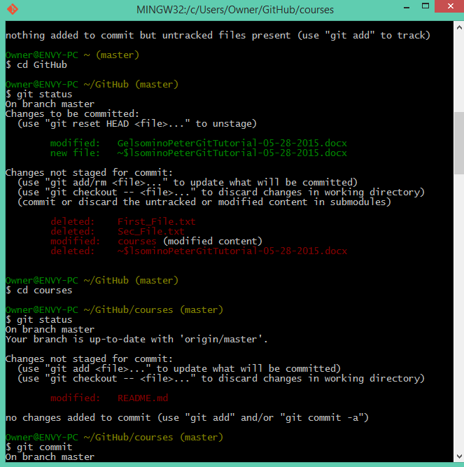

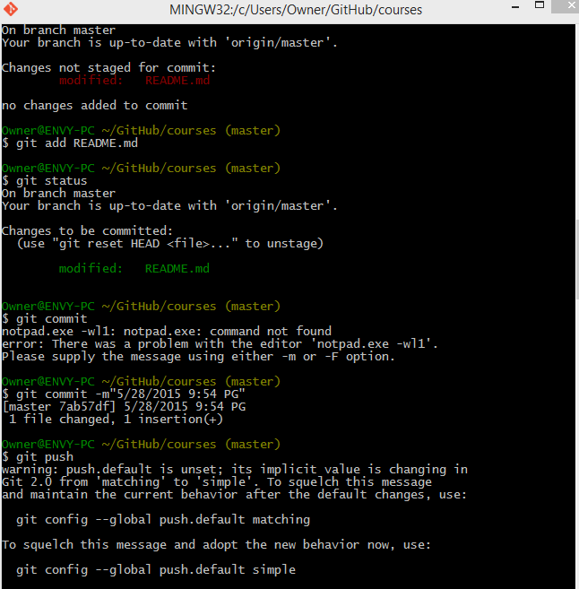

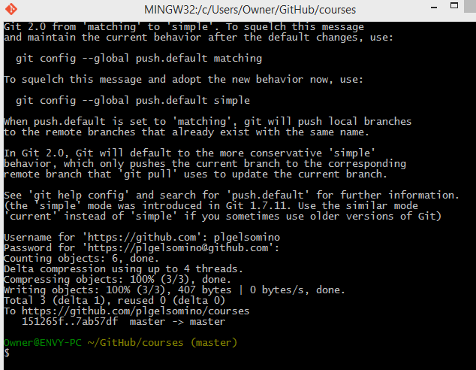

First I cloned the copy of the README file from the repository on git hub.

Next, I set the directory to the <https://github.com/paceuniversity/courses> . Then I made the local directory to my computer to the file location I stored the cloned copt of the README file.

$ git remote set-url origin <https://github.com/plgelsomino/courses>.

Then I check git status and it showed that my README file was modified.

I added the file (git add READEME.md) and then commited it (git commit –m” ”).

Then git push to push into the resposity online. Then I made the pull request.