Install EZsheets using pip

Pip install ezsheets

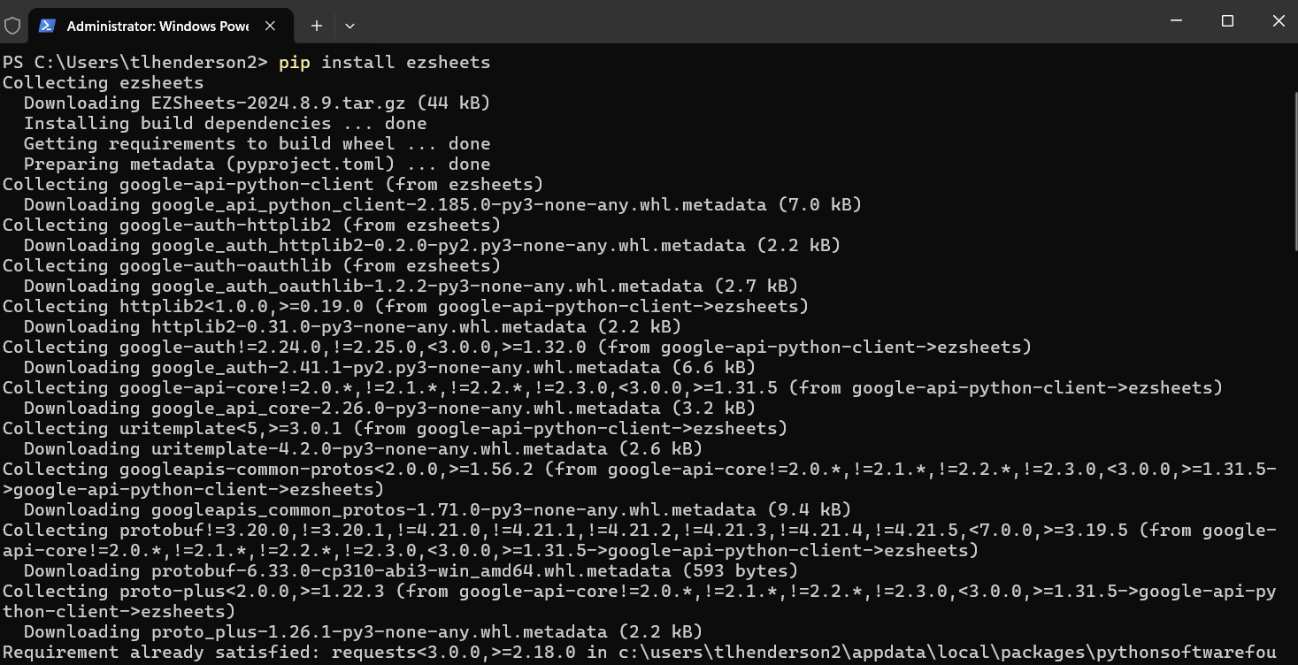

After ezsheets is installed, visit <https://console.cloud.google.com> (Must have a google account). On the project screen, click the Create Project button.

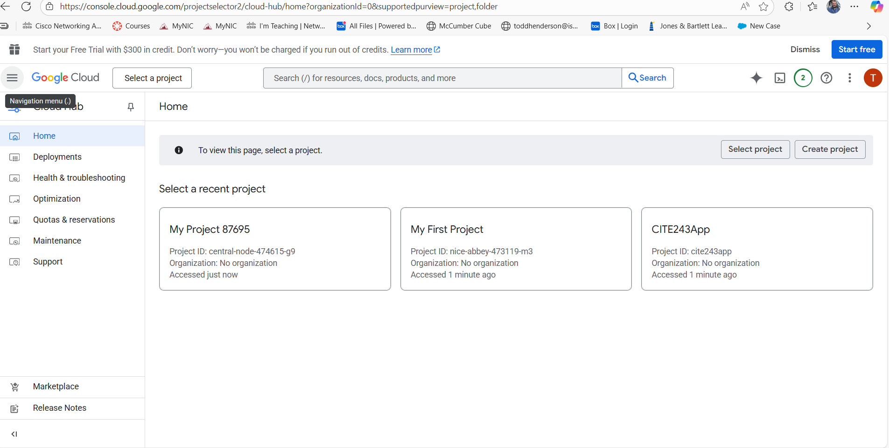

Create a new project and call it CITE243Project and click the blue Create button.

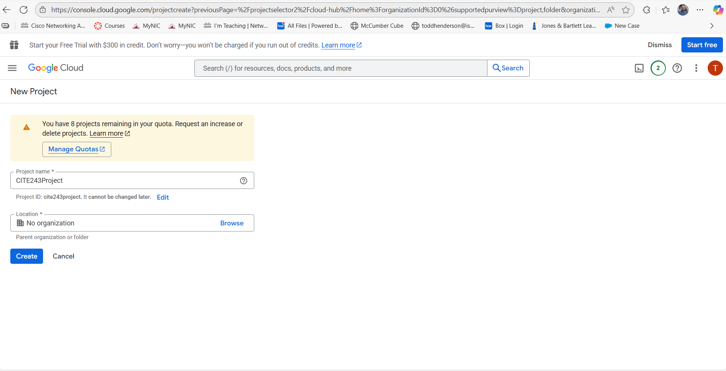

Click the three ellipse and select cloud overview. From the cloud overview, select dashboard. Make sure the project name is selected.

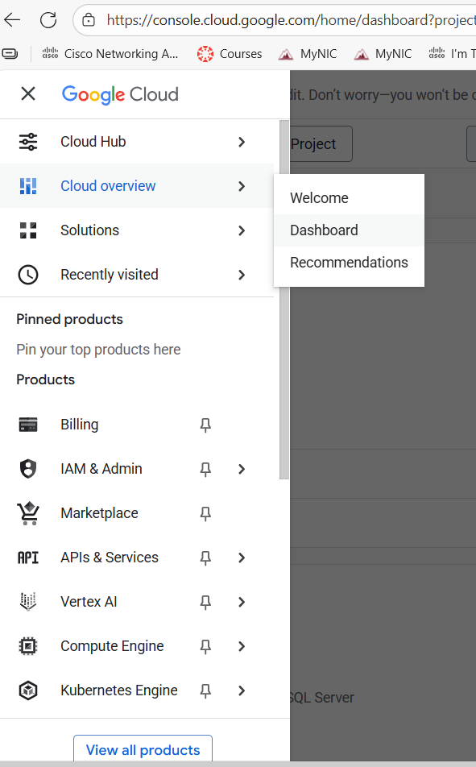

This should be the page for the dashboard. Note the project info.

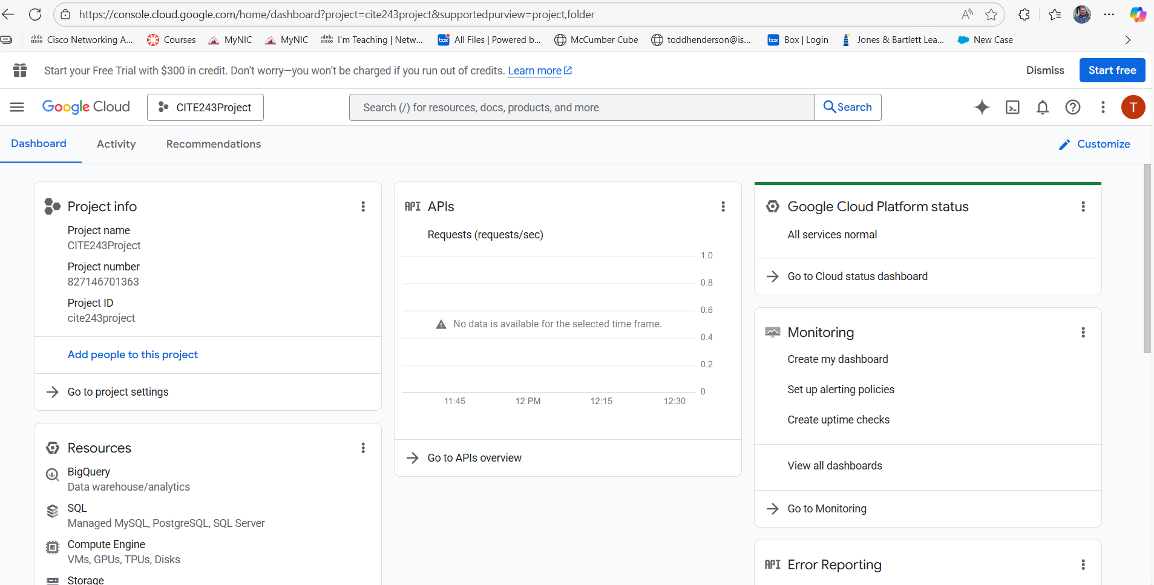

Next click on Go to API’s overview.

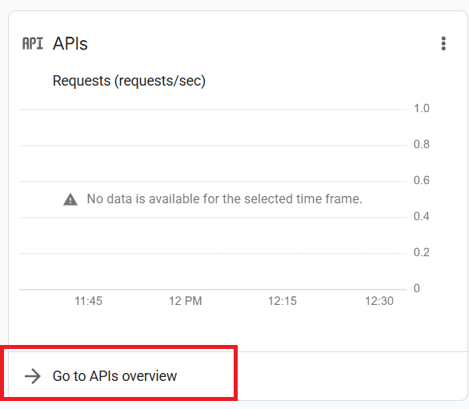

On the API Overview page, click the blue Enable API and Services link.

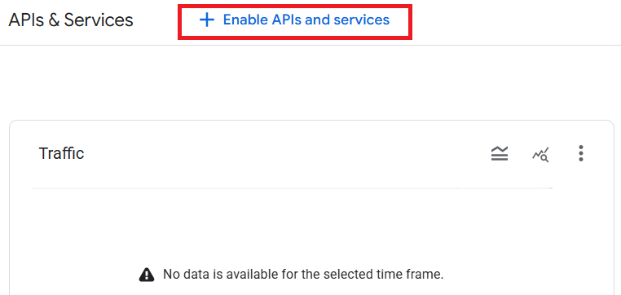

In the search for API and Services search bar, type Google Sheets. Select the Google Sheets API by clicking on the Google Sheets API.

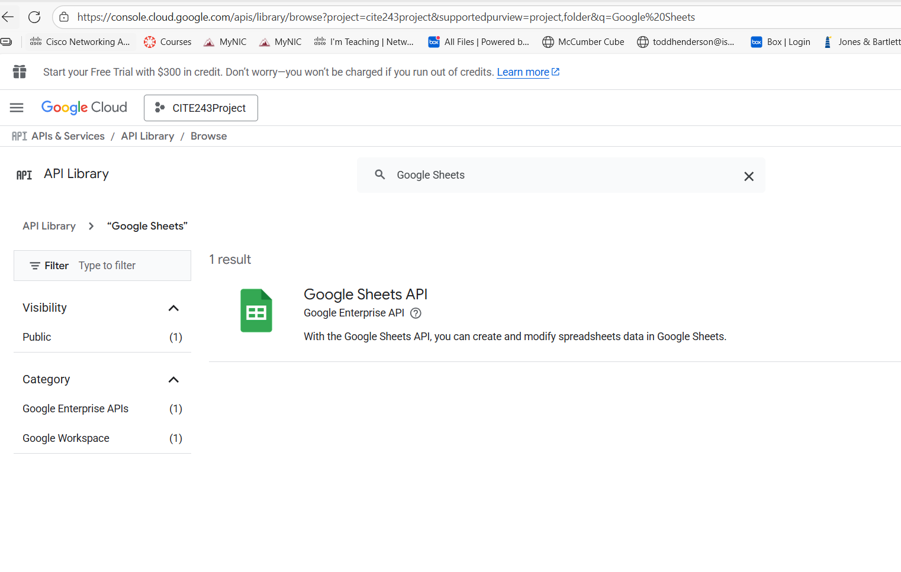

Click the blue Enable button for the Google Sheet API.

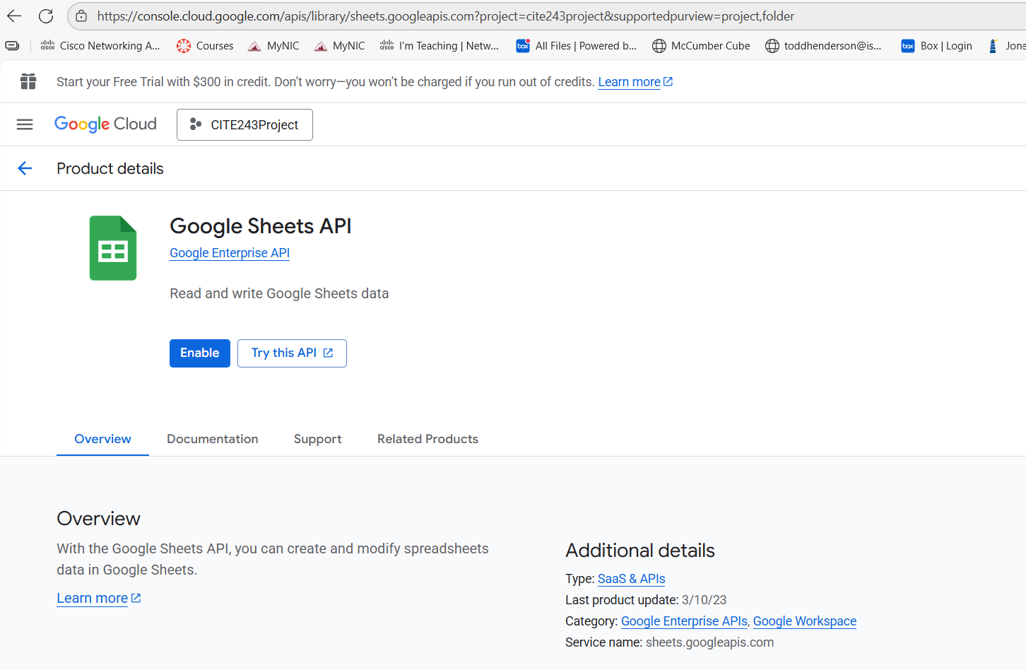

Click the blue arrow pointing to the left next to the words API/Service Details.

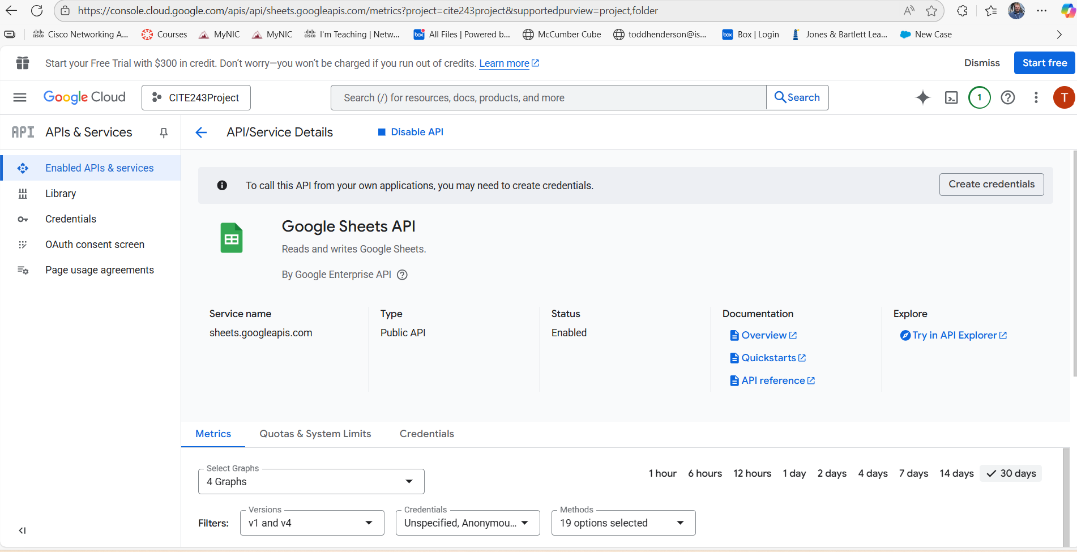

Click the blue + Enable APIs and services link again.



In the search for API and Services search bar, type Google Sheets. Select the Google Drive API by clicking on the Google Drive API which would be the first search result.

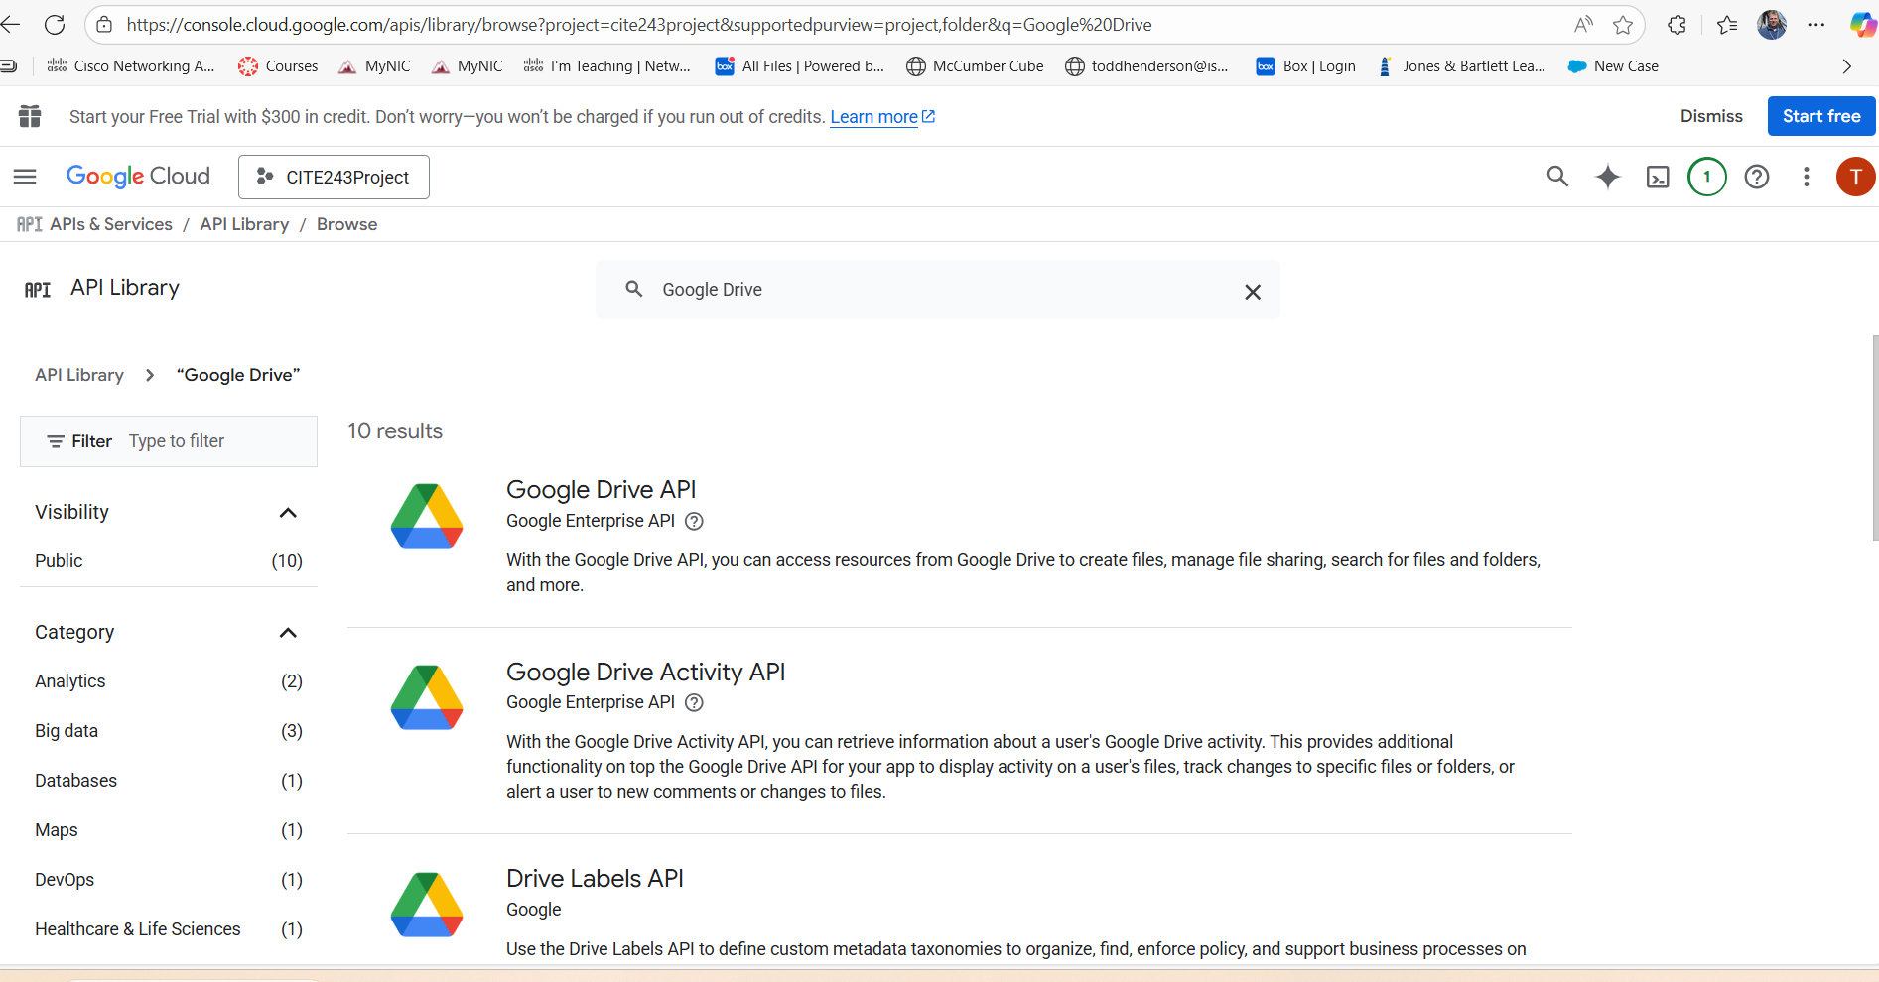

Click the blue Enable button for the Google drive API.

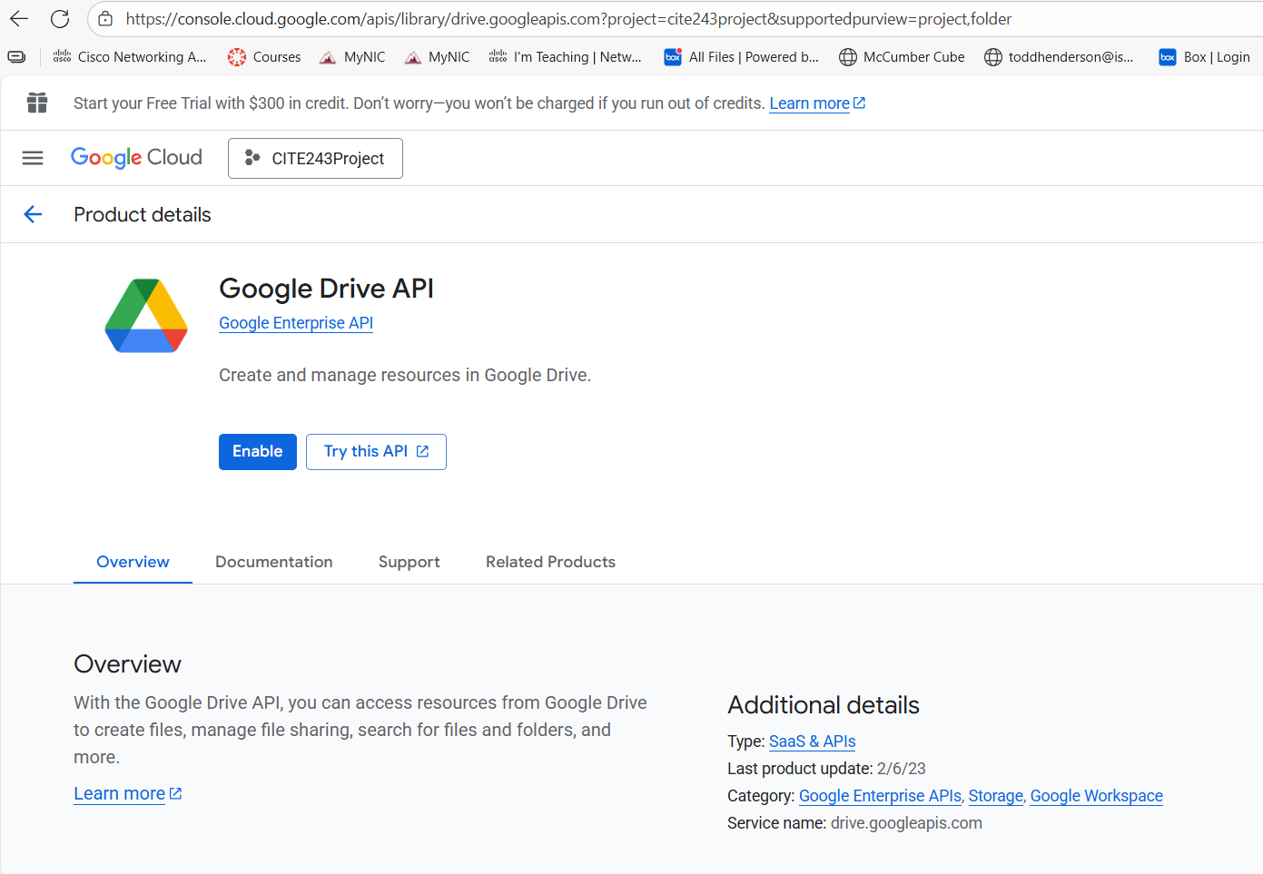

From the APIs & Services page, click the Credentials on the left pane.

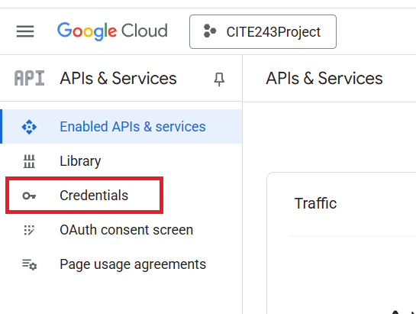

On the Credentials page, click on the blue + Create credentials link

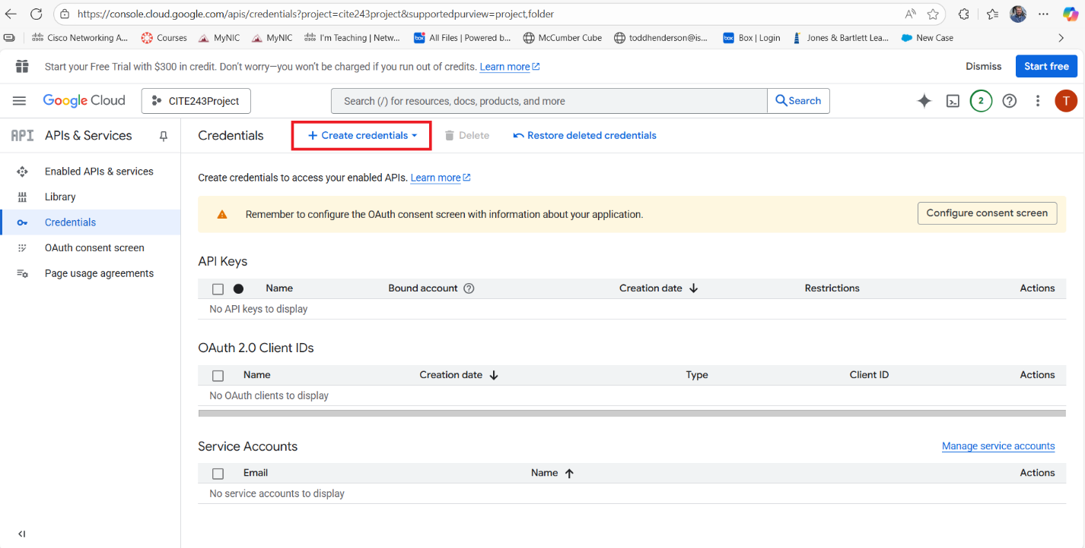

Select the OAuth Client ID option.

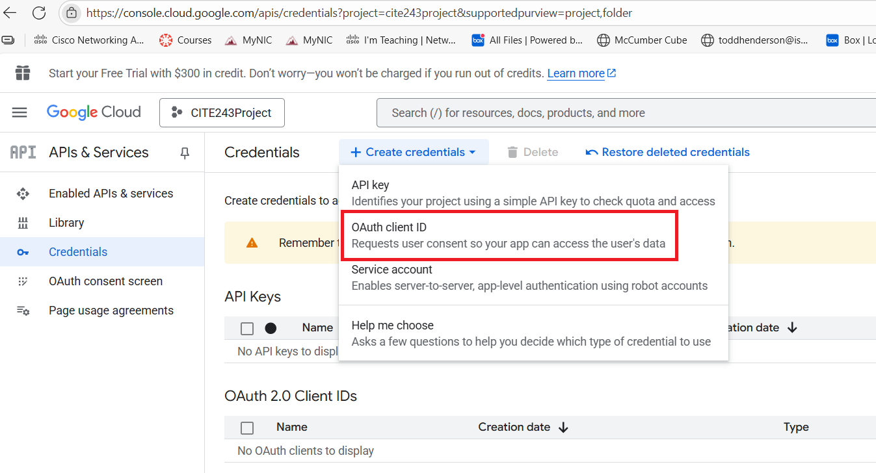

On the Google Auth Platform Overview, OAuth Overview, click the blue Get Started button.

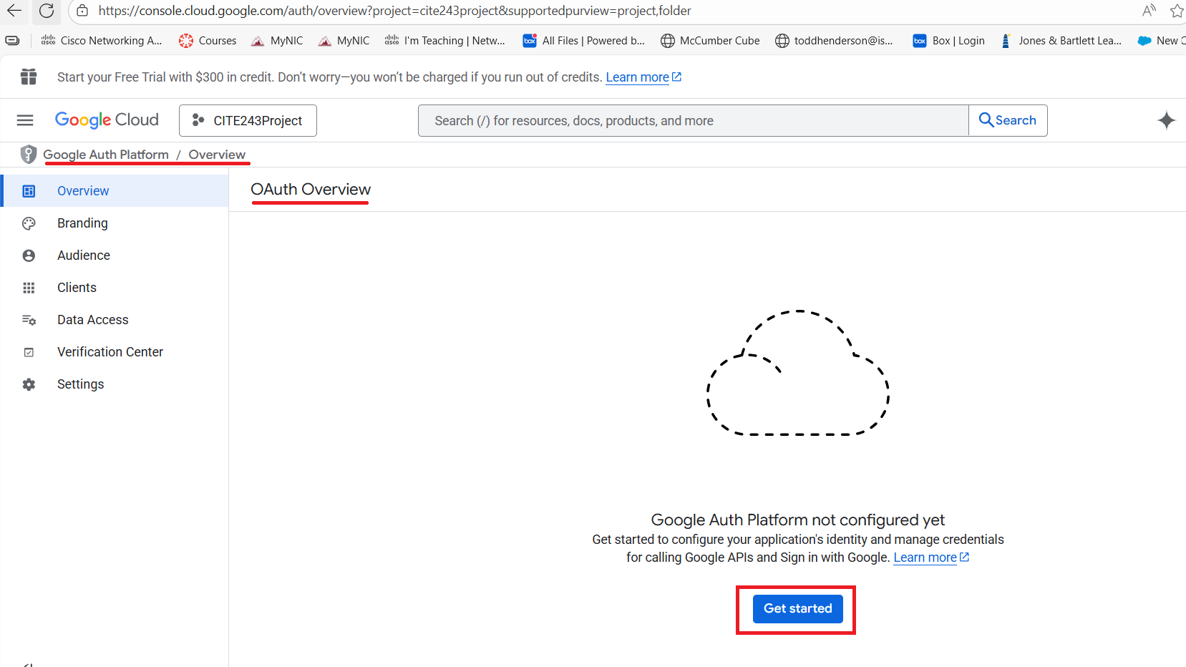

Fill out the information for App information

App Name: CITE243Proj

Email: Use your Gmail email that you used to log into Google cloud

Click the Next button

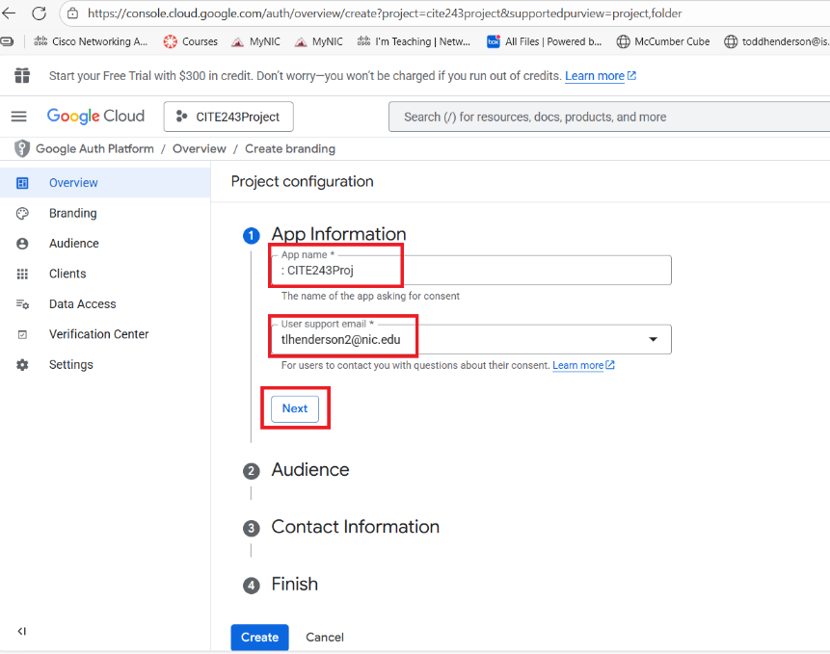

Select the External for the Audience selection and click the Next button.

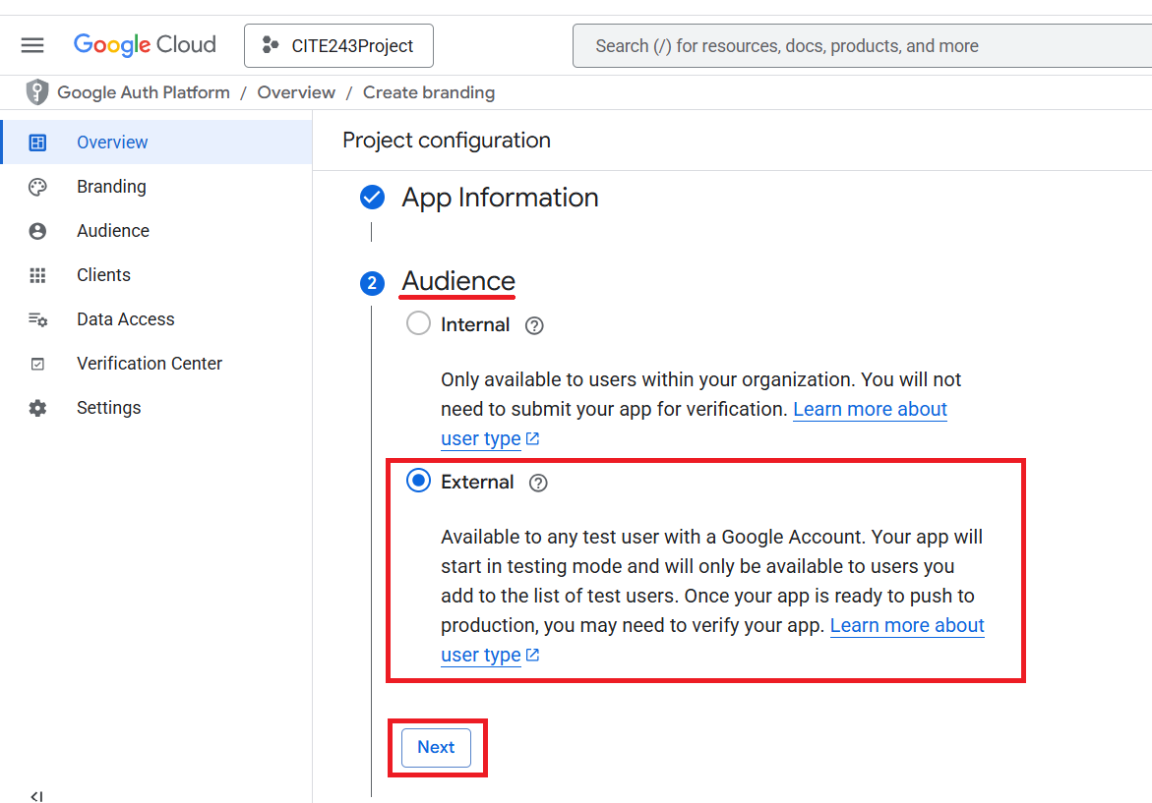

Enter your email that you used for the Google cloud in the Contact Information section and click the Next button.

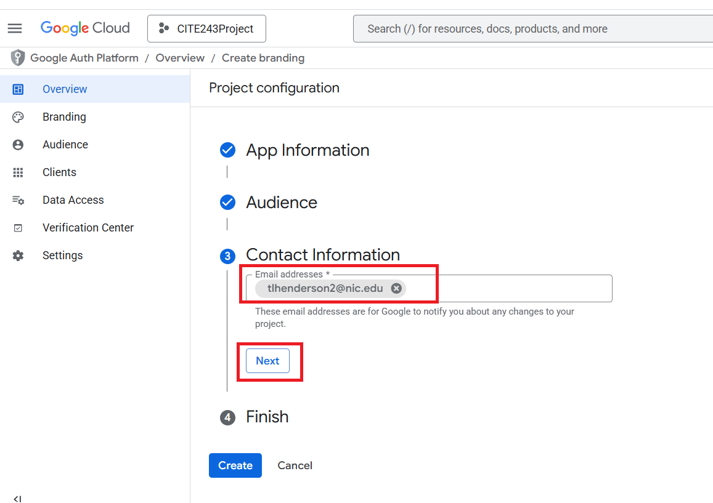

On the finish section check the checkbox to the I agree and click the Continue button. Next click the create button.

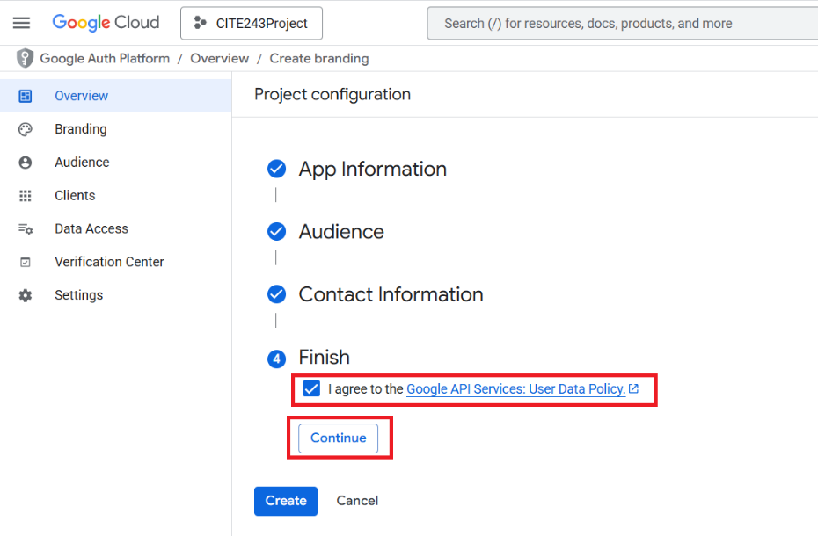

Next click the Create OAuth client button.

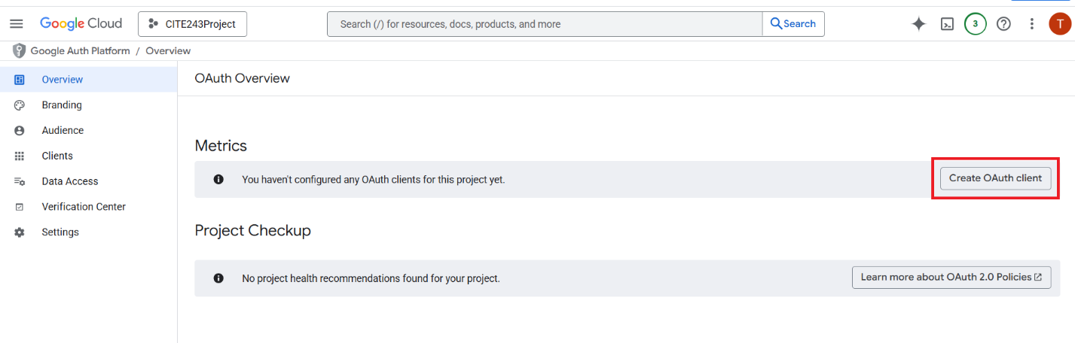

On the Create Oauth Client ID page, select the application type drop down arrow and select Desktop app. Name the desktop app as CITE243ProjApp, then click the blue Create button.

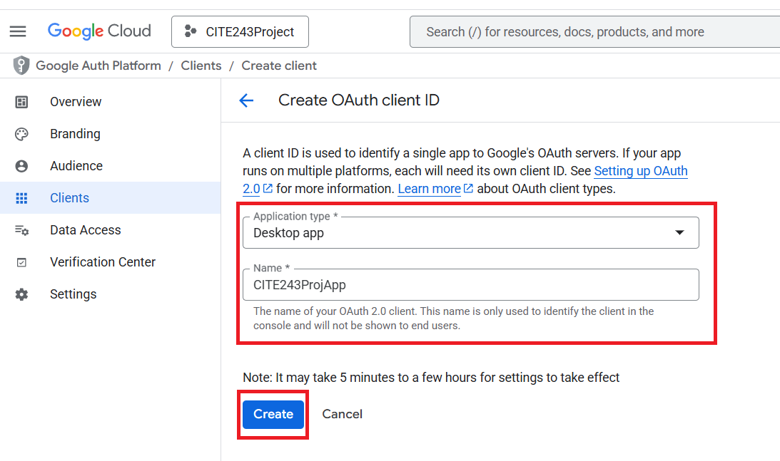

A pop-up box appears with OAuth client created Title. Scroll to the bottom and click the download JSON file. Save this file in a safe place as you will need it for upcoming project. When done downloading, click the blue OK link.

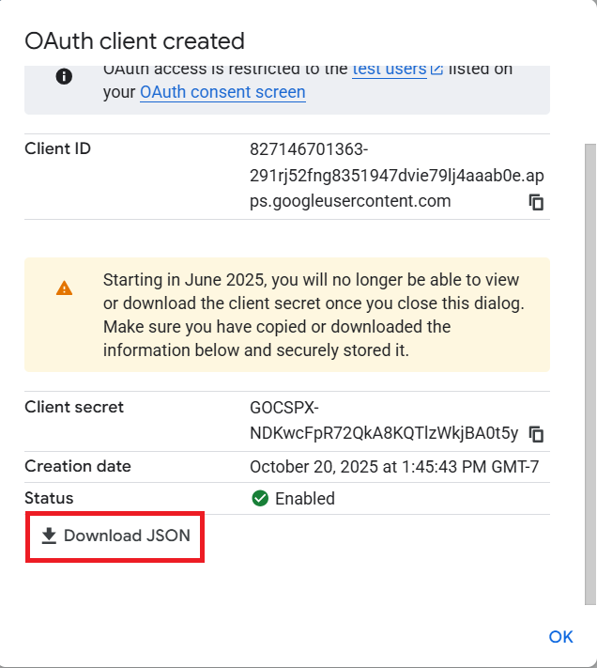

From the OAuth 2.0 Client IDs, on the left pane, click the Data Access.

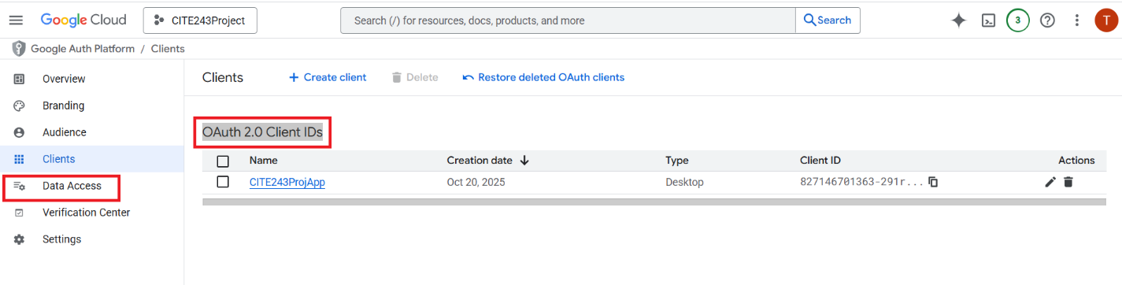

On the Data Access page, click the add or remove scopes button.

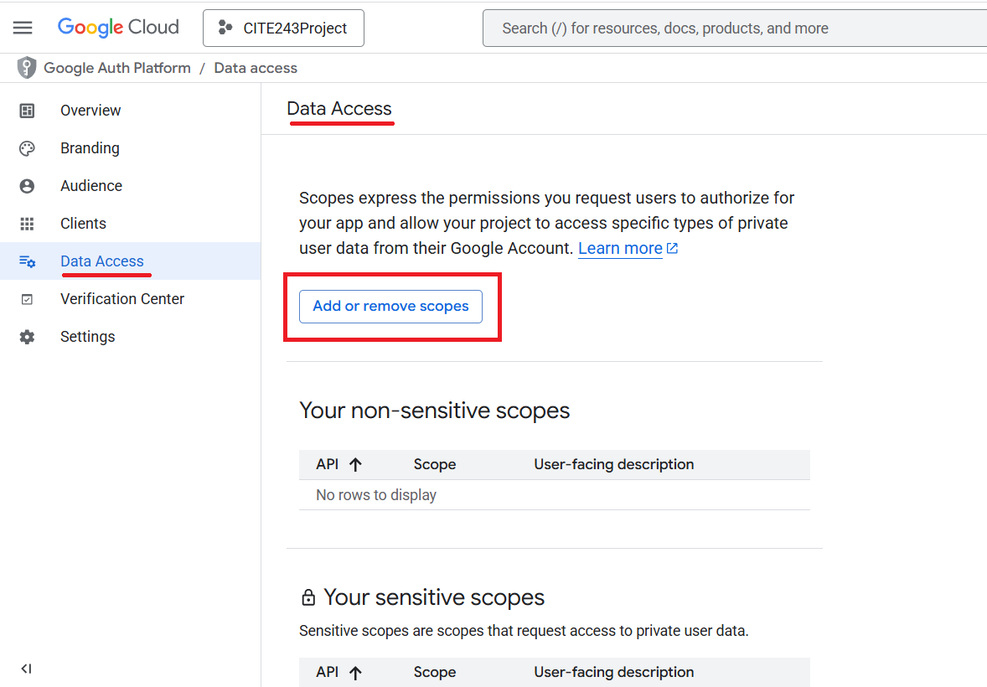

Check the checkbox for Google Sheets API with the scope …/Auth/Spreedsheets. Then click the blue Update button

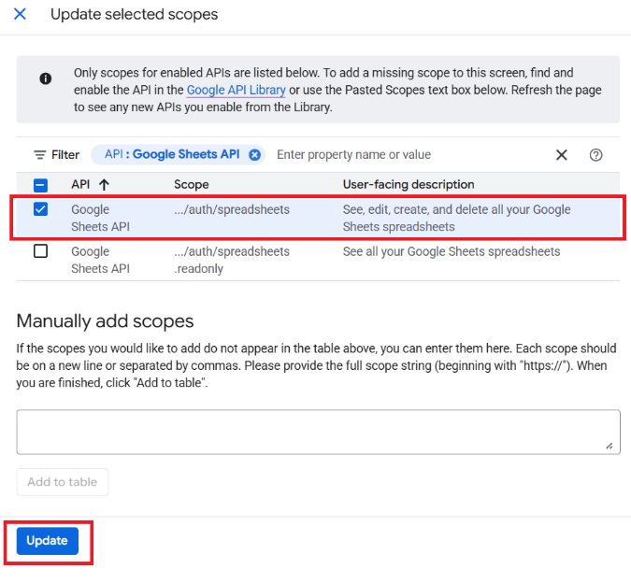

Click on the click the add or remove scopes button again and click on the Google Drive API and scope …/auth/drive then click the blue Update button.

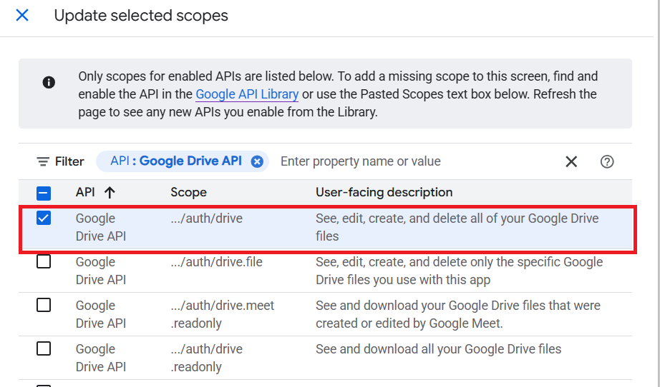

Confirm that the two scopes are added. Scroll to the bottom of the Scope page and click the blue Save button.

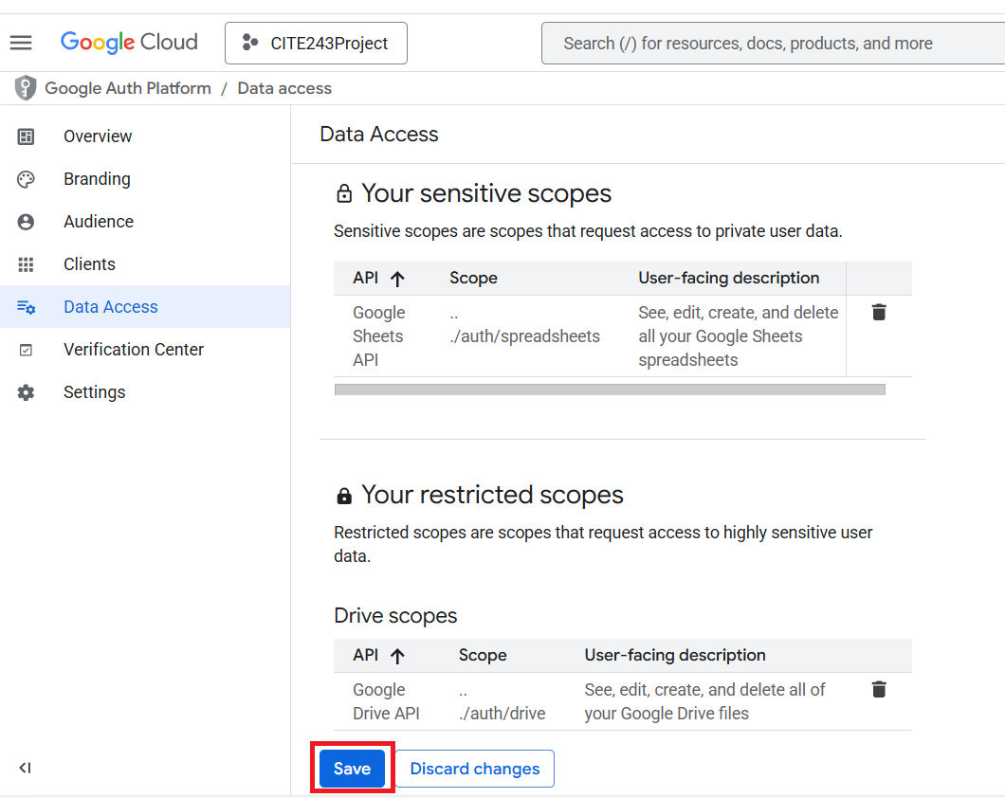

Final step is to select the Audience from the left pane.

Scroll to the user type and click the blue + Add users link.

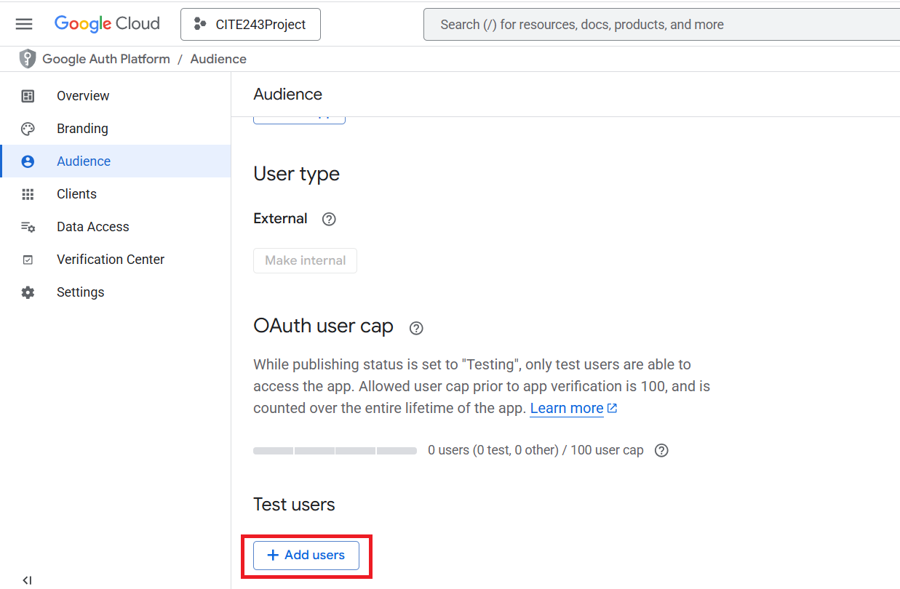

Enter your Google Cloud email and click save.

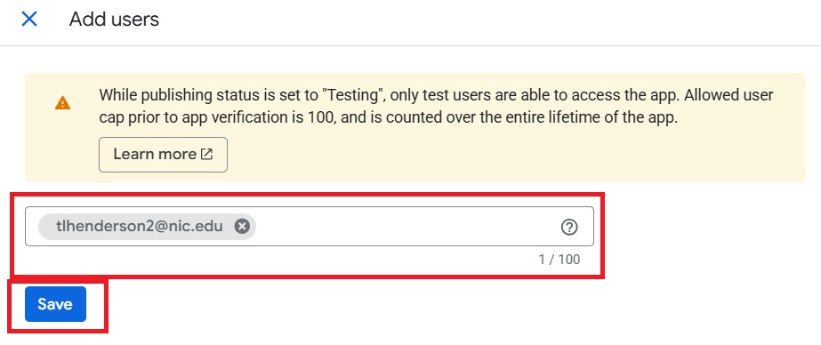

You are now setup for the APIs in Google Cloud. Back at the command prompt, make sure you are working out of where the JSON file was saved at. For example, my JSON file was saved in Downloads folder. I use the cd (Change Directory) to go to the download folder.

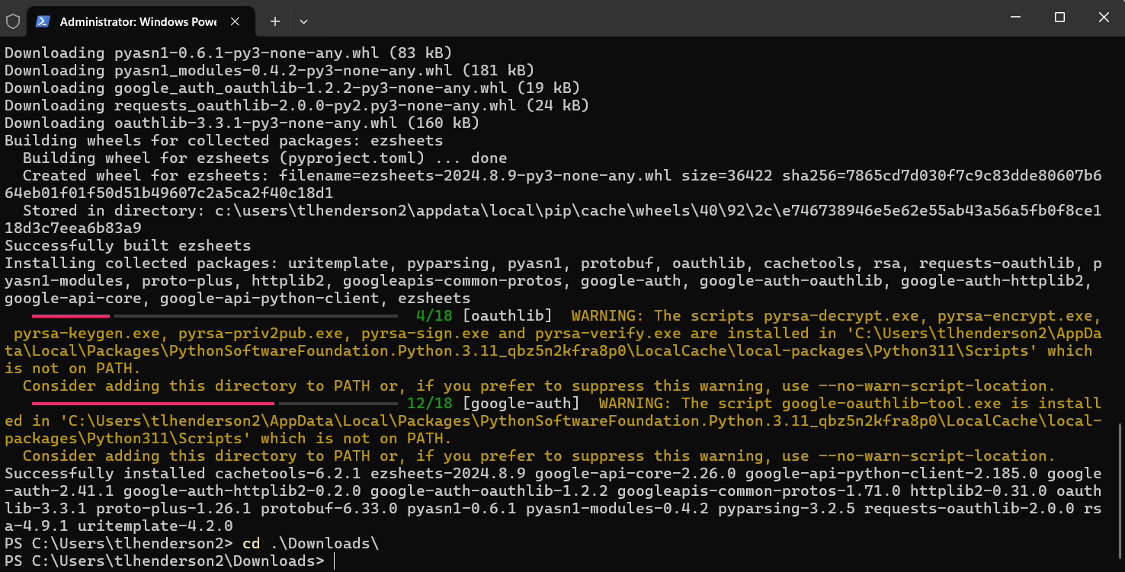

Next type py or python and press the enter key to open an interactive mode. In the python interactive mode, type import ezsheets and this will open the Google login page in a new web browser.

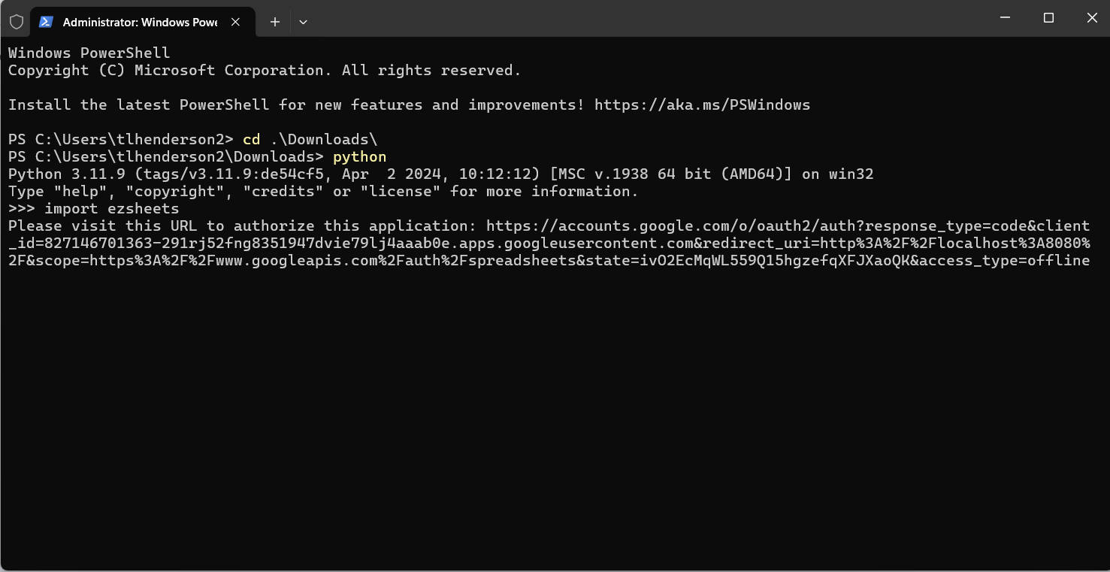

Login with the Google Cloud account

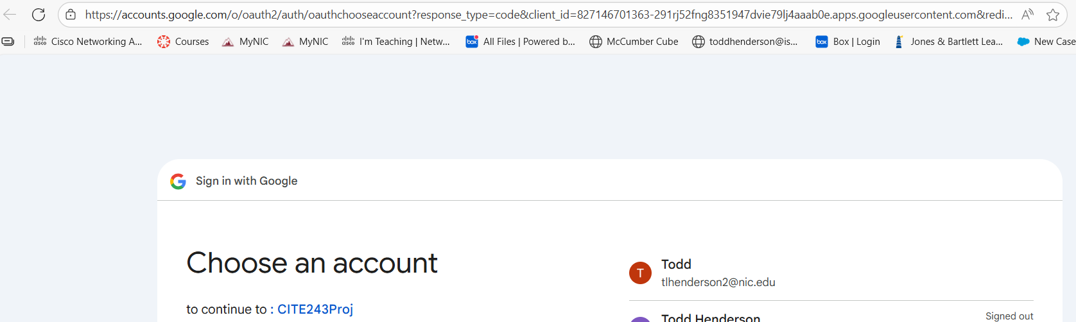

On the Google hasn’t verified this app page, click the Blue Continue link.

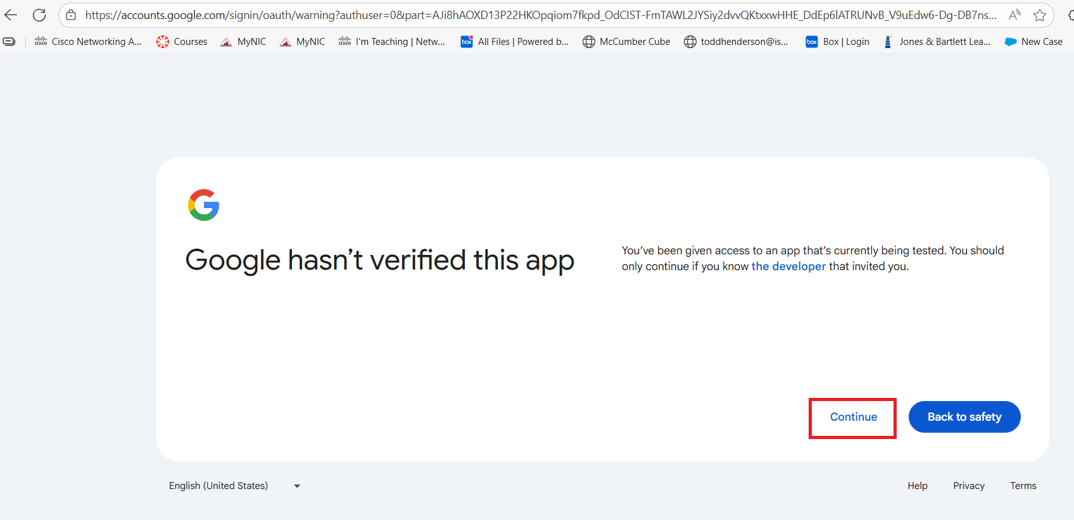

On the :CITE243Proj wants access to your Google Account page, click the Continue button.

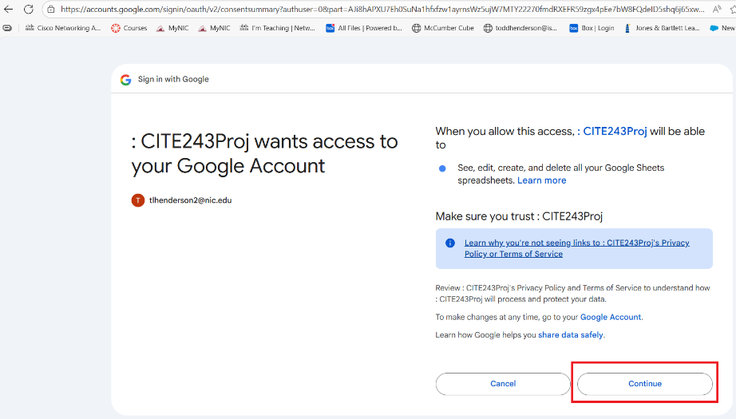

Test by creating a Google Sheet from the interactive shell.

>>> ss = ezsheets.Spreadsheet()

>>> ss.title = 'Title of My New Spreadsheet'

>>> ss.title

