CV
name: Tomáš Plhák
date of birth: 31.3.2000

Education
- Jungmannova základní škola Beroun (2005–2011)
- Gymnázium Joachima Barranda, Beroun (2011–2019)
- Charles University, Faculty of Mathematics and Physics, Computer Science with focus on game development (2019–2023)

Career

Flying Rat Studio (2023–2025)
web: https://www.flying-rat.studio
Flying Rat Studio is a game studio with a focus on technology, helping other studios finish their games, porting them to consoles, optimizing them, adding advanced features and generally providing expertise, a helping hand, and most importantly partnership. The studio is also developing a game of their own. I was part of the following projects:
- Wrath – Age of Ruin (~7 months)
- Beat Saber (~9 months)
- Unannounced Unreal Engine project (~10 months)
- learning (~1 month)
note: more about those projects later

Programming skills
Unity, C#
- 14 months of work experience + 3 years’ worth of university projects and lectures
- C# is the language I understand the inner workings of the most (where data is stored, what its lifetime is, the architecture of the garbage collector, …)
Unreal Engine, C++, Blueprints
- 10 months of work experience + small university projects and a few dedicated courses
- C++ is a language I know reasonably well, but sometimes I have to look up how exactly things are stored or computed
Godot, GDScript
- I’ve done some university projects in it and some gamejams, but I’m nowhere near proficient in it
Python, Dart, Bash, PowerShell, JavaScript
- all of these languages I have encountered and used for small things
- Python has a special place for me because I’ve been using it quite often for small things (I also started with it at university)

Projects
All of the projects (apart from the ones done for Flying Rat Studio) can be seen on a Google Drive here: https://drive.google.com/drive/folders/1Oi18t2zWhE8bXBGEt11r2jBymHIOHDJ9?usp=sharing

BattleShips - Python
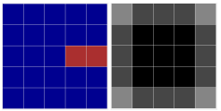
My first nontrivial lines of code (University project). The game was entirely in the console, had simple AI for the opponent with adjustable difficulty and also supported two-player gameplay.

BattleShips - C#, WinForms
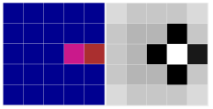
This was again a University project and the game contained many improvements. The biggest change was the UI done in WinForms, the player could place any shape of a ship they wanted and the game featured much improved AI again with adjustable difficulty. The AI awarded points to tiles based on if a ship could be placed there with bonus points near damaged tiles. The first image contains an undamaged ship and the second a damaged one with corresponding heatmap that the AI generated.

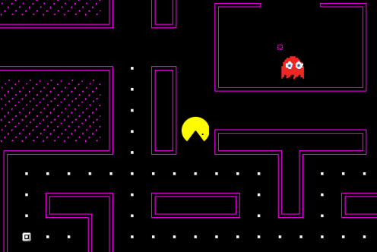
PacMan - C++, SFML
This was a University project for my programming in C++ class. It was using a very basic graphical library called SFML (very simple library so much so that I had to write my own implementations for animations). The game was a modified version of the real-time game Pacman. The game got progressively harder and it was possible to even edit the map layout before the start of the game.

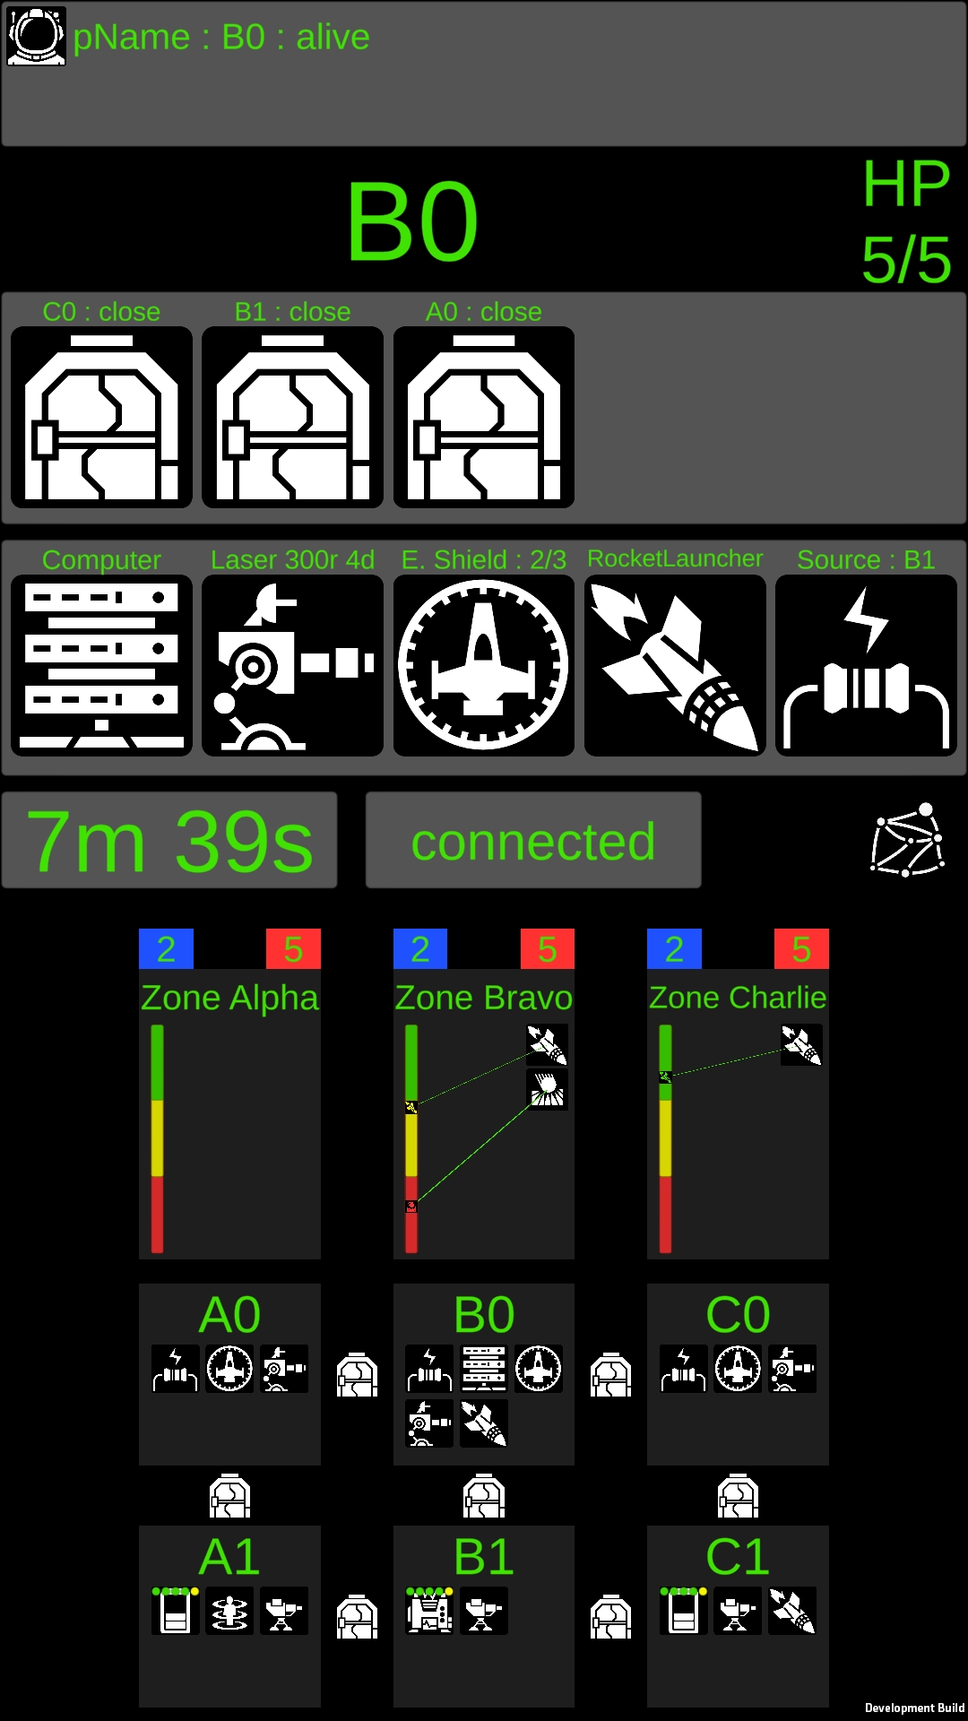
Unnamed jumping platform game - C#, Unity
This was a University project in which I first encountered Unity. It was a level created within 2D Game Kit assets and there was nothing interesting about it, so it is included on the Google drive.

Space Alert IRL - C#, Unity
This was a University Project that my Bachelor's thesis should have been about. I finished the project but never got around to writing the thesis (I started working for Flying Rat Studio and didn’t get around to writing it).
It is a cooperative multiplayer (LAN) mobile game that is inspired by the boardgame Space Alert. The game is split into several 10 minute missions in which the ship gets attacked by enemies and you have to use the spaceship's equipment to survive. The twist is that in order to move from one room to another, you have to load a physical NFC tag that you spread across the game area, thus connecting the real world with the virtual one.
(Connecting NFC and Unity was a nightmare, I ended up writing a post myself on how I did it.)

Park Game - C#, Unity
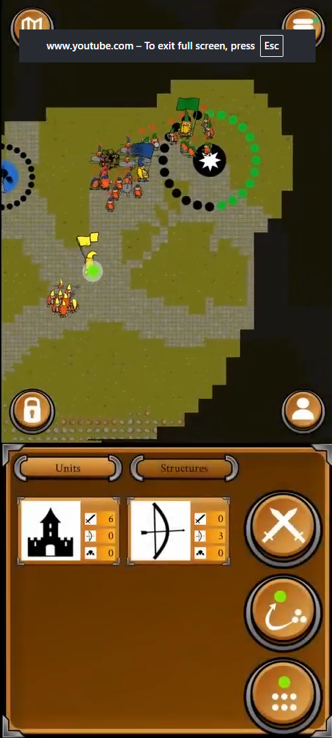
presentation:https://docs.google.com/presentation/d/10t0tSr6BHFGeSa3_eGlfUoxlw7u5ifwKaBAuGrrjfeU/edit?usp=sharing
trailer: https://youtu.be/xOWQxrlXrCQ?si=pdxH90Ep1AdYEjf8
gameplay: https://www.youtube.com/watch?v=H3VAlvPWSDw&t=1s
This is a University project that we did in a team of 5 people. I was mostly functioning as a designer, project lead and a little bit as a programmer.
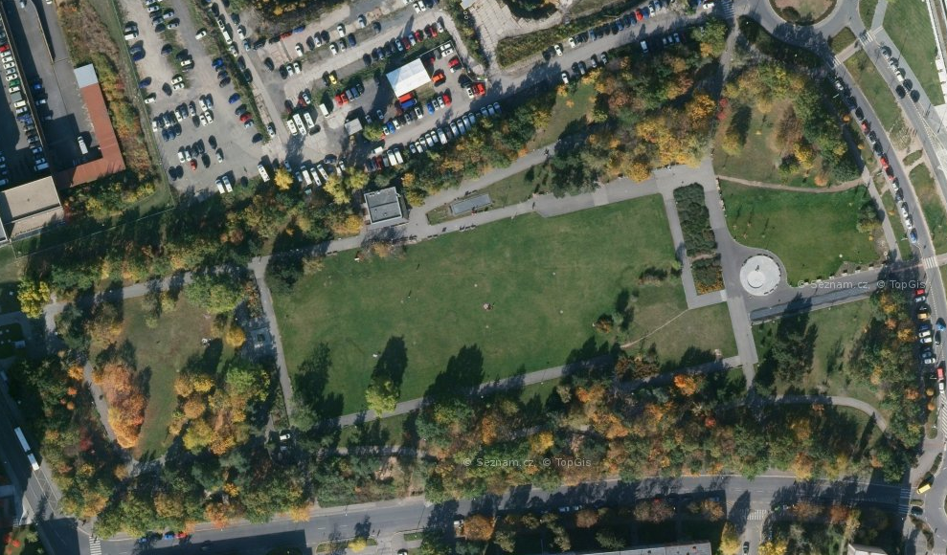
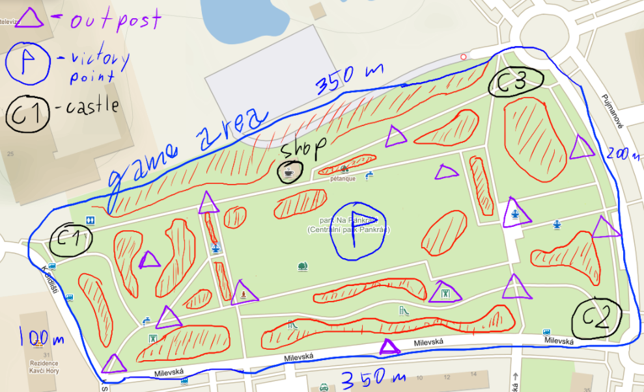
The game is multiplayer commander-based RTS with a little bit of extended reality. First the players meet up in a park, then they draw the arena and then they play a simple commander-based RTS game where the commander's location is linked to your GPS location.
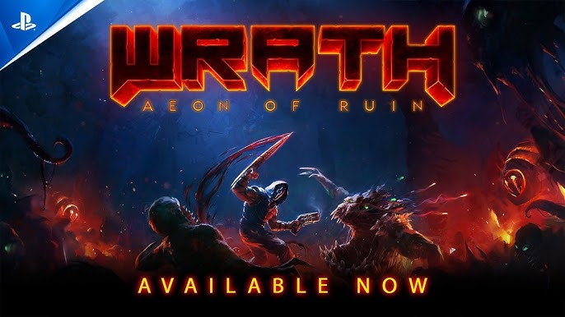

Wrath - Age of Ruin - C#, Unity
trailer: https://www.youtube.com/watch?v=6x97Bzoz3xM
Wrath is a boomer shooter game that is originally written in the DarkPlaces game engine and we were porting it to consoles (PS4, PS5, Xbox One, Xbox Series X|S, Nintendo Switch) by rewriting the game in Unity. It was my first project in Flying Rat Studio and my workload was to implement gameplay features, UI features and fixing bugs (both normal and console-specific).

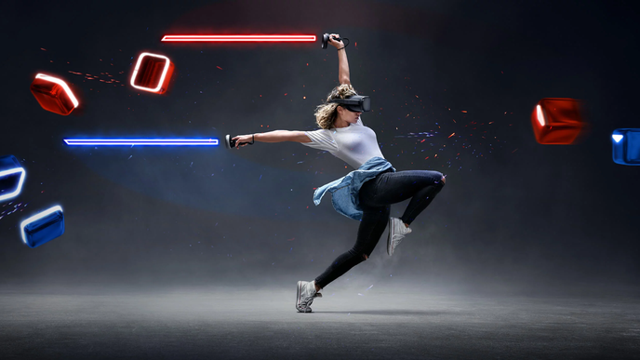
Beat Saber - C#, Unity
trailer: https://www.youtube.com/watch?v=vL39Sg2AqWg
Beatsaber is the most popular, best-selling VR game and I was part of the team in Flying Rat Studio that was responsible for the PS VR2 port. Later we gradually moved to more generic cooperation regarding optimizations, tool creation and general bug fixes.

Unannounced Unreal project - C++, Blueprints, Unreal Engine
This is an internal project of Flying Rat Studio. It is a game done in Unreal Engine and will be released at some point. This was my first real project in Unreal Engine and my involvement in it was in coding in C++ and Blueprints, implementing gameplay features, behaviour trees, hooking sound effects and general debugging.

Game Jam games
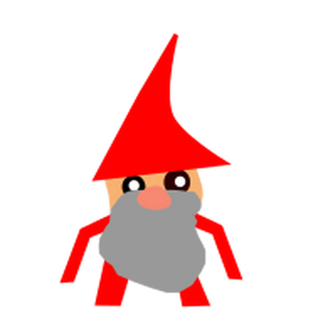
GAMEDEV CUNI JAM 2022, GDS Jam 2021, LUDUM Dare 2023, Spring Game Jam @ Matfyz 2023, RatJam 2024, GDS Prague Game Jam 2024, RatJam 2025, GDS Prague Game Jam 2025

Clumsy Dwarves - https://itch.io/jam/gamehighed-jam-2021/rate/1002139
- GAMEDEV CUNI JAM 2022 - theme: YOLO
- my first encounter with Unity
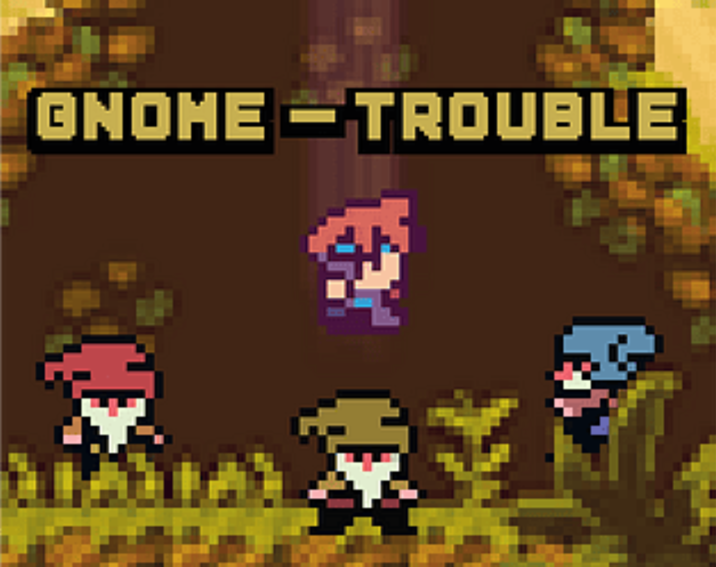
- game about gnomes working in a factory delivering boxes to a warehouse and powerstations, but they die if: they hold the box for too long, they are too stupid to operate the powerplant or if they get too old
Gnome Trouble - https://tombuben.itch.io/gnome-trouble
- trailer: https://youtu.be/GWPuuZ04QII?si=WbvYqSxbWSPavubk
- GDS Prague Jam 2024 - theme: Everything changes
- this game won third place out of 50 entries
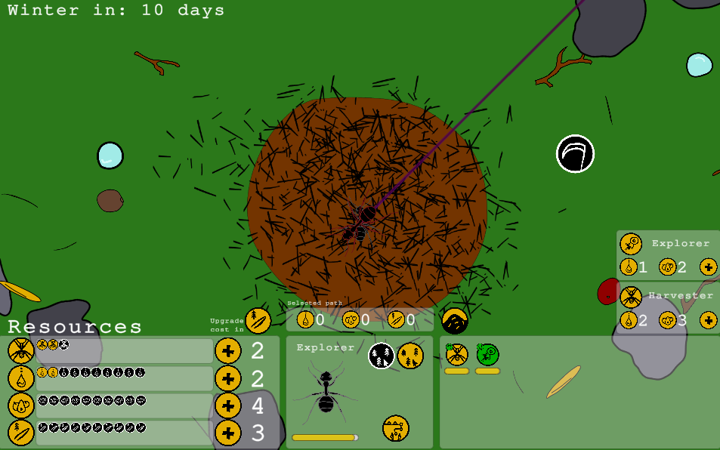
- the game is about a Mario-style platformer that switches in the middle of the game into a top-down 3D Octopath Traveler style game. In the first half of the game you throw gnomes off the cliff and in the second half you have to go and apologize to them (by solving their troubles, Gnome troubles)
∆ntHill - https://redcoff.itch.io/anthill
- LUDUM Dare 2023 - theme: Harvest
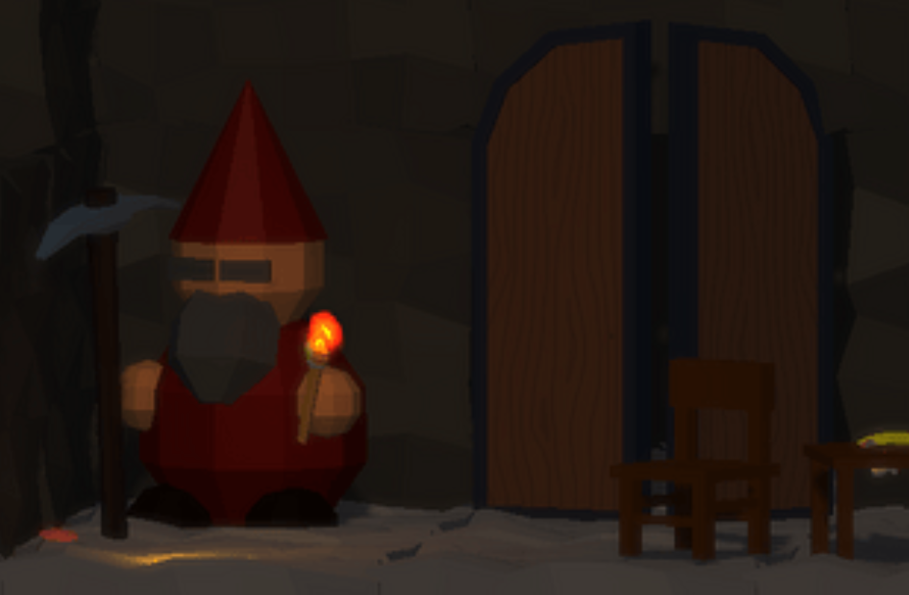
- this game is about managing an anthill, sending scouts and harvesters into the surrounding area, slowly upgrading your anthill
The Dwarves delved too cautiously and diligently - https://redcoff.itch.io/the-dwarves
- Spring Game Jam Matfyz 2023 - theme: Devil is in the detail
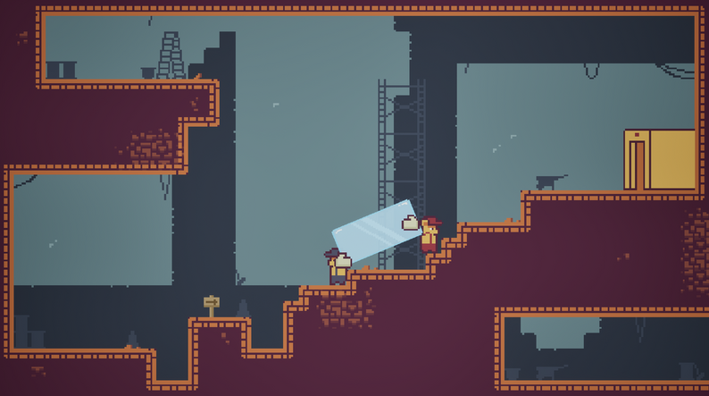
- the game is about mining gold on a grid with progressively more and more regulations added after each level
Bear Breakout: 25D Glass Conundrum - https://plhacko.itch.io/bear-breakout-25d-glass-conundrum
- FlyingRat GameJam 2024 - theme: Fragile
- Local co-op platformer game for 2 players trying to move a glass panel from left to right.
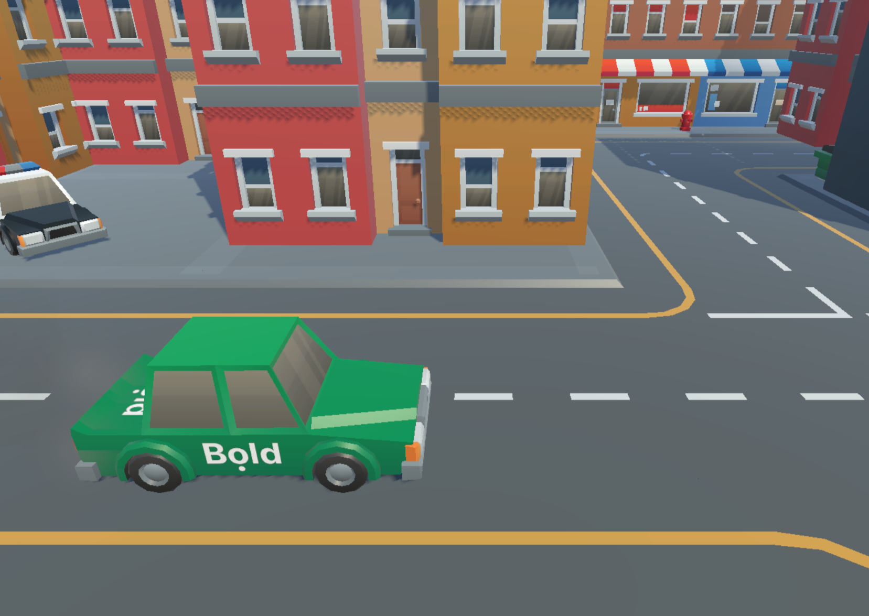
Bold Drive - https://plhacko.itch.io/bold-drive
- GDS Prague Game Jam 2025 - theme: Fortune favours the bold
- in the game you are a Bold driver (wordplay on taxi company Bolt) and drive your car and chat with customers

Summer camps and volunteer work with youth
Since I was 15 I volunteered at summer camps and at weekly meetings with the youth. During my volunteering I prepared countless small games for summer camps and weekly meetings. Here I will mention two boardgame-like games that the kids played a round of after each weekly meeting and one grand final game of one of our summer camps.

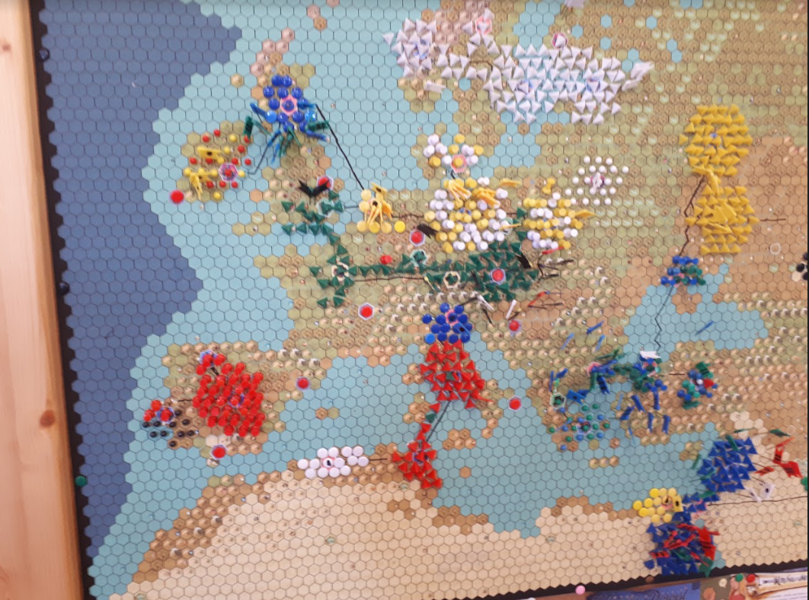
Legend
The game uses a PNG of a Civilization V realistic Europe map. The players earn points for weekly meetings and they spend those points on upgrading cities, colonizing their surroundings, building armies, moving armies, building roads and collecting rare resources into sets, earning them a nice bonus.
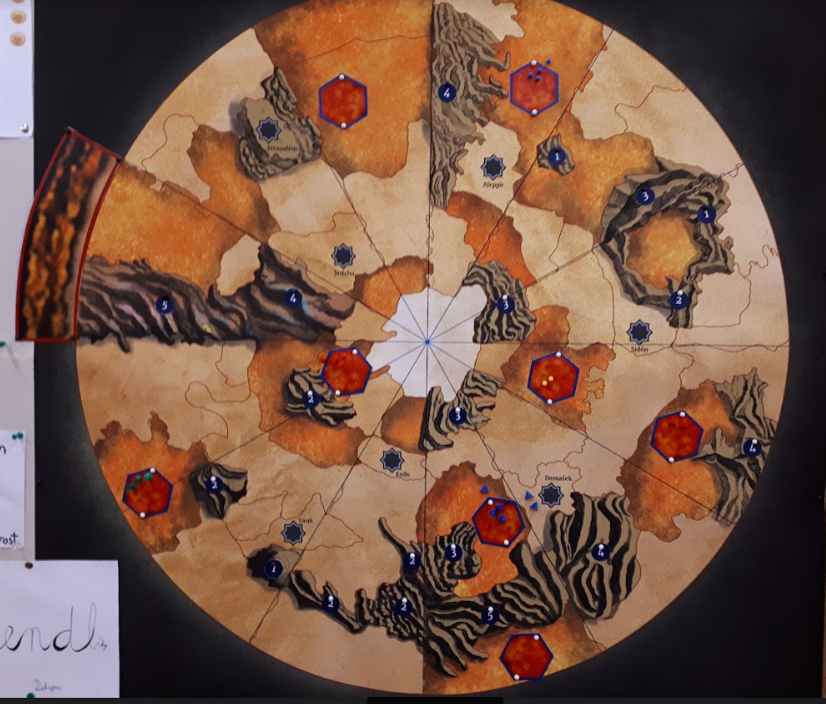
The game ran every Friday for almost 2 years, required a ton of colored pins and was designed in a way to enable conflict, but in a very limited way.

Dune
Another game that took a year to play. This one was inspired by the boardgame Dune from the 70s. In this game you spend your points from weekly meetings to raise armies in cities and then travel with them to the spice fields to harvest victory points. Every week the storm would move a couple of degrees destroying everything in its path. The game's combat system was inspired by the boardgame “878 Vikings: Invasions of England” where the troops have a chance to run away (saving their lives, but no longer helping in the conflict).

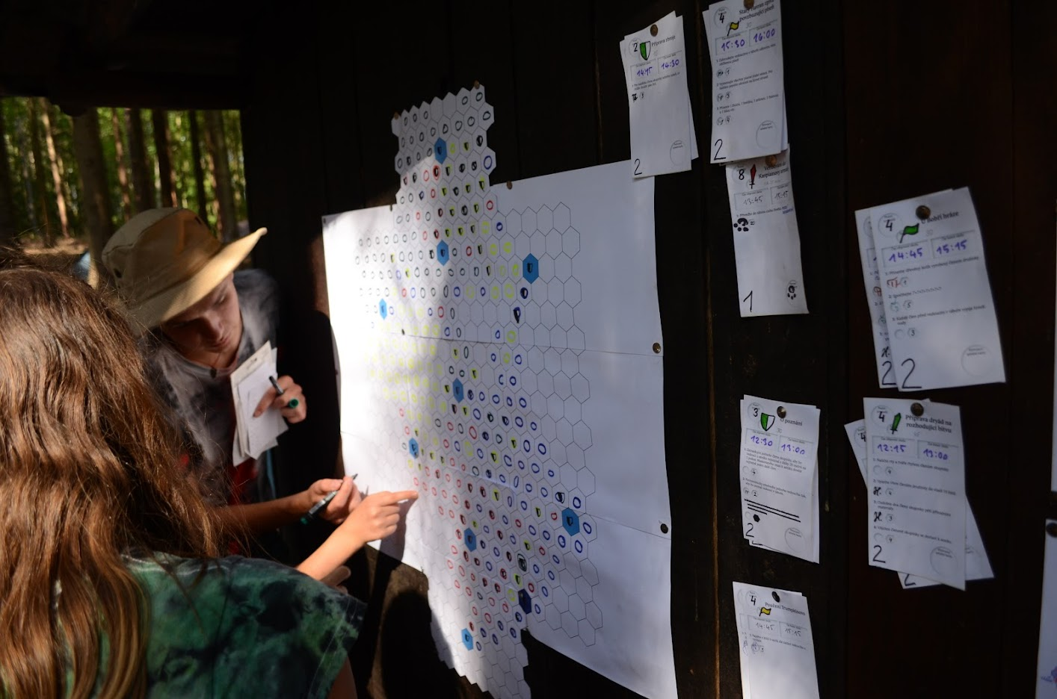
The large final game of a summer camp
I collaborated on this game with a few of my friends. The game centered around a board, where teams could score points by capturing hexagon tiles and bonus ones for creating certain shapes. In order for the players to be able to capture, recapture or shield a tile, they completed tasks on the task board that were released gradually (with lifespan). Teams could ignore some of the tasks by spending points they accumulated during the summer camp.

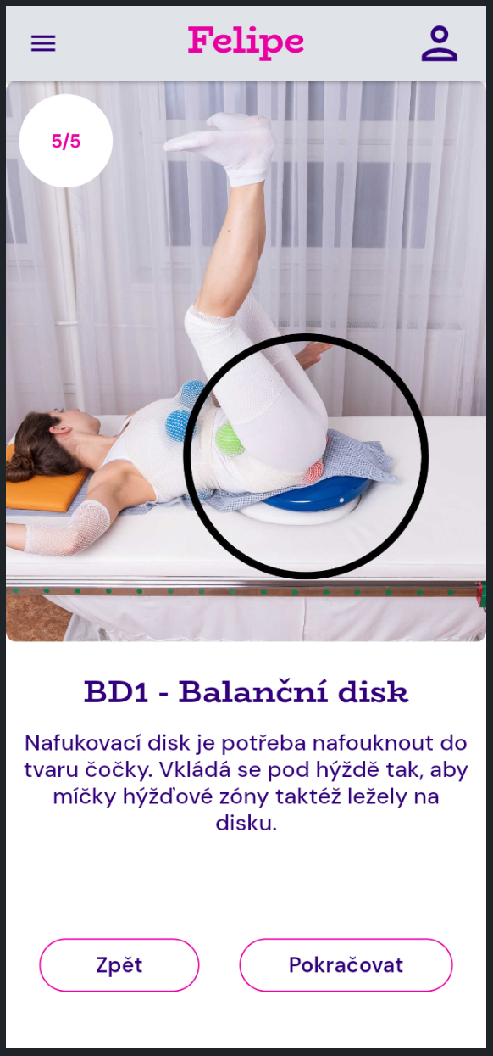
Other projects

Reflex locomotion app - FlutterFlow, Flutter, Dart
I’m currently developing an app (work in progress) for a rehabilitation research center (Rehabilitace Karlovy Vary s.r.o.) that should help its users to exercise the Reflex locomotion rehabilitation method (also known as Vojta’s Method).

The app is being developed in Flutter which utilizes Dart as a programming language and I’m building most of it in FlutterFlow which gives me an editor like UI while still being able to export it to a raw Flutter project.
The app will feature multiple languages and will be finished at some point in 2026.

note: To develop the app I’m following the design document done by my friend Vojtěch Pinc.
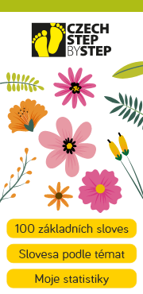

Step by Step app - FlutterFlow, Flutter, Dart
I’m also currently developing an app for learning the Czech language for foreigners. The app is in early development and will be tied to the successful textbook series Step by step.

The app will use the same technologies as the Reflex locomotion app and is also designed by Vojtěch Pinc

