**Department of Electrical and Computer Engineering**

**University of Canterbury**

**ENEL400: Final Year Project**

**Progress Report**

**Indoor Positioning System**

by

Aryan Srivastava – 43958596

Project Sponsor

**Aryan Srivastava**

Supervisors

**Shayne Crimp**

Report submitted on 28th May 2021

Contents

Executive Summary 3

Project Overview 5

Introduction 5

User Requirements 5

Specifications 6

Project Split 6

Progress to date 7

Background research 7

Theoretical design. 11

Simulations 11

Conclusions 13

Next steps 14

Sustainability 16

Life Cycle Analysis 16

Initial material Procurement 16

Production 16

Distribution 16

Usage 17

End of Life 17

Conclusion 18

References 19

# Executive Summary

This project aims to enhance office workers’ well-being by providing an ergonomic solution to 3D positional mapping. The average person spends ninety-thousand hours at work and can develop many ailments while working. To mitigate the unwanted adverse effects of working, ergonomics are applied. Ergonomics are the study of optimising the work environment. This is important as it directly results in the improvement of employee health, happiness and productivity.

Through this project, the software will be designed to add a new feature to the LIMPET design. The LIMPET is a small data collection device that can be placed on desks and tables. It records data continuously and is battery powered. It is designed by Wellnomics, the sponsor of this project. Wellnomics is a world leader in the development of ergonomic office solutions. The development of this product will benefit Wellnomics, employees everywhere, the University of Canterbury and most importantly, us, group E14.

The new feature will allow for the monitoring of assets within the office. The placement of desks and tables will be recorded, and that data can be used to change the layout or energy distribution of the office in a way that is most fitting for the employees there. This creates the most comfortable environment possible for employees. Wellnomics greatly benefits from this as it has the potential to provide them with profit and reputation. The university strengthens its relationship with Wellnpomics, opening pathways to future development. As students we learn of the job of a professional engineer and gather skills that will be essential for the rest of our working lives.

|  |  |
| --- | --- |
| Requirement | Description |
| Measure distance | Various methods can be used to achieve this. The measurements taken are essential to the mapping of the room. |
| Build a model to estimate positions accurately | Using measured distances, a mapping system must be created to position devices accurately. |
| Low cost | The aim is to produce a low-cost system, as the LIMPET overall is a low-cost solution. |
| Low power requirement | The LIMPET only has a certain amount of available power, so the hardware used for this design cannot draw too much of this power. |
| Small design | The LIMPET is a small device and, as such, cannot house large hardware. The hardware chosen for this project must be small enough to fit into the LIMPET. |
| Robustness to noise | The Applicable environment may be noise rich, and as such, the method of communication must be considerate of those. |

The user requirements for this project are described in the table below.

To date, we have formulated specifications, divided roles and made significant progress towards our respective sections. The specifications are included further in the report, and the project has now been split and assigned into four separate parts: the sound transmission, microphone, speaker and the 3D mesh.

Personally, I have researched and simulated sound transmission. I have concluded that the frequency of the delivered sound is essential and perhaps one of the critical facets of this project. The need to reliably transmit a signal is paramount, as it is the basis of the project. The frequency of the sent signal will determine attenuation, noise impacts and the initial delivery pressure level from the microphone. After considering all of these factors and testing, a frequency can be selected to mitigate these factors best and produce the cleanest and strongest communication between LIMPETs.

Research has surrounded how waves interact with each other, with the environment and with increasing frequency.

The following steps for this project will be to settle on a definite frequency to transmit after testing has concluded. Once this has been solidified, the final project concept can take shape and be validated, and development can begin.

The project’s sustainability has been examined as a whole using the Life Cycle Analysis (LCA). LCA encapsulates the lifetime of the project and breaks down its impacts based on different sections. The sections are material procurement, production, distribution, usage and end of life. It is essential to examine the device at various life stages, as the impacts are continuously varying due to the varying needs of the device. For example, in the production and procurement stage, a large amount of energy is expended, creating the device, but in the usage stage, much less is used due to the battery-powered nature of its function.

# Project Overview

## Introduction

The average person spends ninety-thousand hours at work [1]. For office workers, their work environment is vital to their overall health and well-being. This project aims to develop software for a device that improves the well-being of employees and the ergonomics of office spaces. The project will deliver an indoor mapping system through the use of audio technology.

Ergonomics is the study of optimising the work environment to encompass the requirements of the workers there best. The increase of ergonomics in an office space can be correlated to healthier and more productive workers, benefiting all parties. Ergonomics reduces the chances of workplace injury and can help improve employee morale. This, in turn, results in better production and more wealth for the employee. Critical elements of ergonomic office design are the equipment/furniture of the office, the layout and the environmental factors present (such as sound and temperature). [2]

This project into indoor mapping via sound will help companies and their employees, aiding Wellnomics, the University of Canterbury, and most importantly, the group. Wellnomics is a Christchurch based company that is a world leader in ergonomics. Wellnomics develops products to improve the health of employees across the world. Their software is used in a multitude of products that enable businesses to optimise their office environments. Wellnomics will benefit from this project as it has the potential to develop a feature that can be packaged in a device that can be included in hundreds of thousands of desks.

This project also enables engineering students to develop real-world design skills, preparing them for their actual jobs. It forces students to work professionally and understand design thinking. By having regular meetings, presenting findings and setting tasks, students advance their knowledge of engineering procedure and become better engineers.

## User Requirements

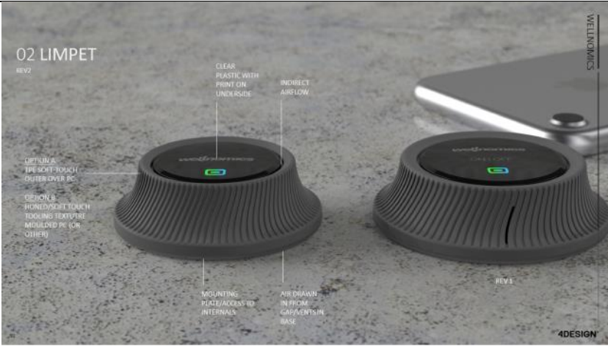The user requirements outline what the project must achieve. These are the initial conditions that must be met for the project to be a success. The project aims to produce software designs and hardware recommendations towards integrating a new 3D mapping feature in the already developed LIMPET. The LIMPET is a Wellnomics design that collects data on various factors around an office. The design for it can be seen below in figure 1.

Figure : LIMPET design

The LIMPET is designed to placed on desks and office furniture and continuously collect data throughout the day. It collects temperature, humidity, desk height and other data that impacts the well-being of the user. The aim is to add positioning functionality so that each LIMPETs position can be found in relation to other LIMPETs. The user requirements to achieve this are outlined below in The are summarised below in table 1.

|  |  |
| --- | --- |
| Requirement | Description |
| Measure distance | Various methods can be used to achieve this. The measurements taken are essential to the mapping of the room. |
| Build a model to estimate positions accurately | Using measured distances, a mapping system must be created to accurately position devices. |
| Low cost | The aim is to produce a low cost system, as the LIMPET overall is a low cost solution. |
| Low power requiremen | The LIMPET only has a certain ampunt of available power, and so the hardware used for ythis design cannot draw too much of ths power. |
| Small design | The LIMPET is small device and as such cannot house large hardware. The hardware chosen for this project must be small enough to fit into the LIMPET. |
| Robustness to noise | The Applicable environment may be noise rich and as such the method of communication must be considerate of those. |

Table :User Requirements

## Specifications

The specifications outline what the final product will look like and how it fulfils the user requirements. They are summarised below in table 2.

Table :Specifications

|  |  |
| --- | --- |
| Specifications | Description |
| Measuring distance using Audio signals. | The devices use a microphone and speaker to communicate noises, which can be turned into distance measurements. |
| Positioning using 3D mesh | Each LIMPET can be treated as an individual node by procuring distance information, and a map of the room can be formed. |
| Sends at specific frequency and wave shape. | To mitigate the impact of noise and attenuation, the transmitted wave can be filtered for and received accurately. |
| MEMs Microphone | A small digital MEMs microphone, SPH0644LM4H-1, is used. These are small, power-efficient and cheap. |
| Mobile Speaker | Similar to the microphone, the speaker used in this design is small and cheap. It is also powerful and can transmit high dB sound. |

## Project Split

The project naturally splits into four sections, The microphone, speaker, sound and the 3D mesh. Each part has equal importance as they are all required for the completion of the project. The sound decides what sort of signal is sent. This signal must be equipped to mitigate attenuation and noise and be reliably transmitted over a distance. The speaker must be driven with the correct input to produce the ideal signal. The proper amplifier must be constructed and tested for this. Similarly, on the other side, the microphone output must be processed and turned into reliable data. Finally, the distance data gained must be turned into 3d mesh

The project in between the four members, I, Aryan, took the sound part, while Bill was assigned to the microphone, Toby got the 3D mesh, and the speaker was given to Laurence.

# Progress to date

The progress to date currently involves background research, theoretical designs and simulations. The plan revolves around the concept of audio propagation, an area that the group overall was very inexperienced with. Therefore, a significant amount of time was allocated to research to familiarise the group with audio communications. This report will focus on the wave of the sound and the factors affecting and determining it.

## Background research

The initial background research was to see how sound travelled. This is an integral part of the project, as the sound parameter determines the range and accuracy of the product. To maximise these, the sound emission at the source, the loss/distortion of sound as it travels, and the reception of sound.

The two main factors of sound propagation are the Sound Pressure Level (SPL) and the frequency. The SPL describes the relative ‘loudness’ of the sound [3], while frequency conveys the oscillations in the sound wave.

SPL is one of the methods to measure sound. The others are sound intensity level and sound power level. These parameters portray the sound wave, but SPL was chosen for his project as the microphone and speaker specifications are both given in SPL. SPL describes the ratio of the sound wave pressure and the ambient pressure that the wave is travelling through. The average variation caused by the sound wave in the atmosphere. Their relationship can be described by the equation below,

Where is the pressure of the sound wave, and is the atmospheric pressure. The SPL is used instead of the pure pressure value due to the scale of sound pressure. For example, a sound pressure of 63.2 micro Pascals is equivalent to 10dB, but a 100-dB measurement is 2 Pascals. Due to this wide range of values that produce audible sound, a logarithmic ratio is used to describe sound loudness.

On the surface, the frequency of the wave simply affects the pitch of the sound heard. The audible sound ranges from 20Hz to 20kHz [4]. Beyond those, the human ear cannot pick anything up. But this doesn’t apply to speakers and microphones. Digital and analogue devices can produce and receive sound beyond human hearing range, and they do this due to the other effects’ frequency has on the sound.

Interference is the interaction of two or more waves. Interference can be either in-phase or out of phase, and it can be either destructive or constructive. The figure 2 below illustrates this visually.

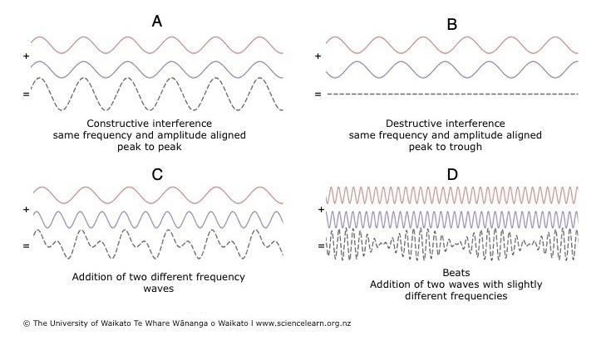

Figure : Visualisation of interference in out of phase and in-phase waves [5]

In the case of A, the signals are in-phase, i.e. they have the same frequency and amplitudes match, and as such, the peaks and troughs of the signal match up and result in constructive interference, as seen but the dotted line output. The signal amplitude here has essentially doubled. Conversely, in B, the signals still have the same frequency, but they do not have matched amplitudes, and as such destructive interference occurs, the amplitudes cancel out. The focus of this project will be more on cases C and D. C and D focus on variations in frequency. When two different frequencies interact, the resultant signal is a ‘noisy’ signal. This signal is distorted in amplitude and, as such harder to detect.

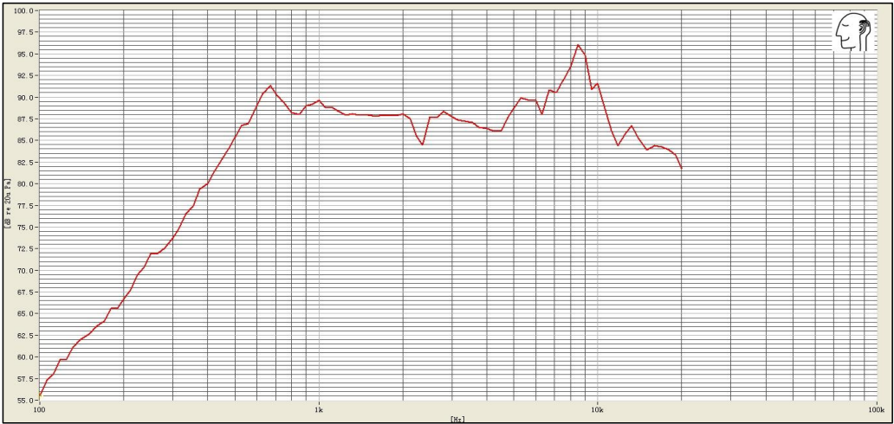The frequency also determines the SPL output of the speaker. Every speaker has a frequency response, meaning it can propagate specific frequencies better than others. The frequency response for the given speaker can be seen below in figure 3.

Figure : Frequency Response of AS01508MS-SP11-WP-R speaker [23]

The frequency response above 1kHz is 90+ dB for the given speaker, while at lower frequencies, it can even drop to 55dB. This is very important as, on the other side microphones have sensitivity, i.e. they require a certain level of sound to receive the signal accurately. Therefore, the higher SPL is better, and as frequency determines this, the frequency is the most significant decision that must be made in the sound area.

To maximise the SPL transmitted, the effect of the channel must be considered. When sound is emitted, it is subjected to attenuation and noise, both factors that result in loss and distortion. Which ultimately results in lower reliability and range.

Attenuation is the loss of sound energy as the wave travels. The absorption of the sound wave can cause this by the air and any objects the wave interacts with.

Attenuation over distance follows the inverse square law. This stipulates that a point source emits a sound wave spherically, which diminishes over distance. This relationship can be described mathematically by the following

Where is the SPL at a distance , and is the SPL at distance [6]. Through this equation, the loss of SPL purely due to distance travelled can be computed. It is frequency independent. The frequency component of attenuation only becomes relevant at high frequencies. At very high frequencies, like 10kHz, the attenuation can potentially be 33dB/km [7].

Finally, there is absorption due to materials. This is measured using the absorption coefficient, which is the percentage of sound absorbed by material on a scale of 0 to 1, 1 being complete absorption. There are two types of materials commonly present in office environments, porous and reflective. Porous absorbers are materials that allow airflow, which lets the sound enter the material and dissipate as heat. These are the materials generally used in sound-proofing, as they prevent the transmission of sound. Some examples are carpet, curtains, plaster and ceiling tiles. These are commonly found materials in offices as most of them are made to reduce noise.

In contrast, reflective materials are generally hard, don’t allow airflow, and minimal sound enters the material. Most of the sound is reflected, and little is absorbed. Typical materials of this type are plywood, glass, and screens. [8].

Each type of material reacts differently to frequency. Below in figure 4, an example of this can be seen.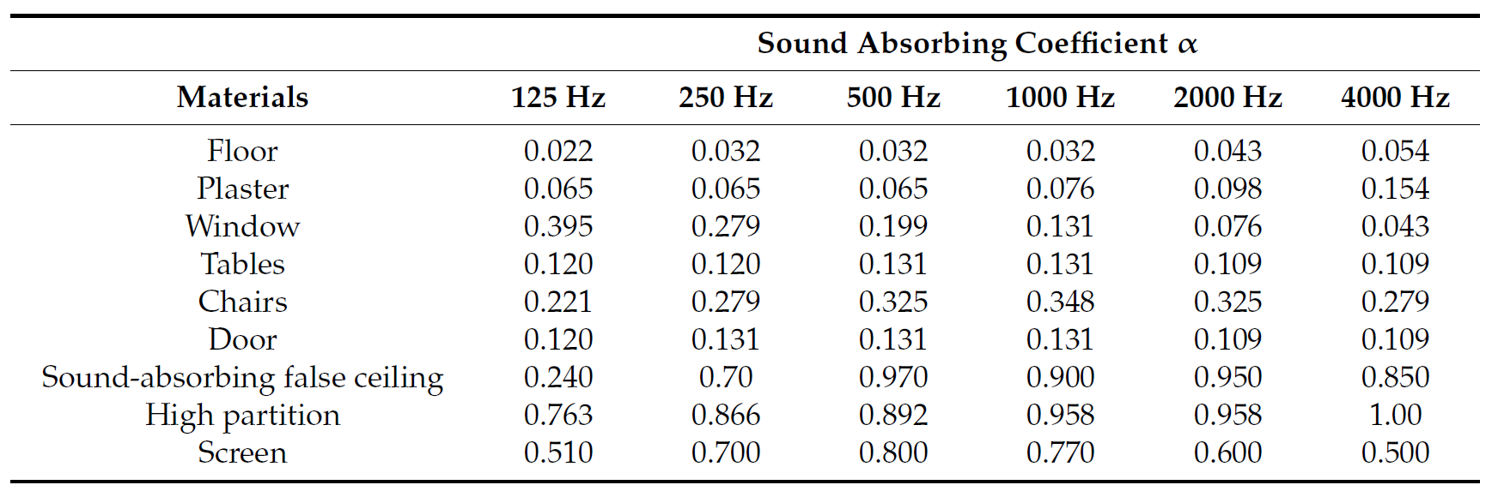

Figure : Sound absorption Coefficients of Various Materials. [9]

The reflective materials have a tendency to attenuate lower frequency sound better, while absorbent materials attenuate higher frequencies better. For example, plaster, a porous material, has an absorption coefficient of 0.154 at 4kHz, while only has a 0.065 coefficient at 125Hz. Conversely, a hard-reflective material like a window has a coefficient of 0.043 at 4 kHz, while at 125 Hz, it has a coefficient of almost 0.4. This illustrates that the chosen frequency will also determine the attenuation loss via objects within the office.

The change in frequency also affects attenuation due to temperature and humidity, due to how air particles are affected. Increases in temperature and humidity result in less attenuation. Still, these factors were not heavily investigated, as the temperature and humidity of the target environment are regulated and not a variable.

In summary, the attenuation of travelling sound is greatly affected by frequency and initial sound pressure. To maximise both, the correct frequency must be chosen.

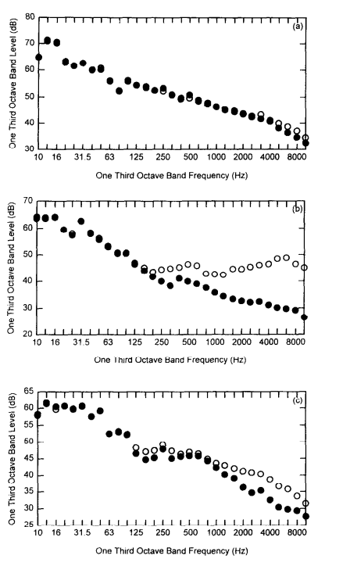Noise is the interference of outside sound sources, corrupting the transmitted signal. The interference of the signal can cause it to lose SPL and be less detectable at the microphone. The main aim of noise investigation is to find common noise sources in an office and what common frequencies are present. This is important so that the chosen frequency is not one that is commonly found in the target environment, and as such, can be easily filtered for without being corrupted. The distribution of noise in an average office can be seen in the figure 5 below.

Figure : Ambient Sound levels in various offices [24]

The figure describes the ambient noise level at different frequencies in 3 various offices. More noise is present at frequencies lower than 1600 Hz, particularly in the sub 250 Hz range. This information is factored into the frequency decision, as ambient noise frequencies with high SPL will interfere with similar frequencies signals and cause loss.

## Theoretical design.

Some designs must be thought out once understanding the factors affecting sound and the decisions required to be made for reliable communications. Firstly I examined the environment the device will be applied to. The device will be in an office environment and may potentially only need to be played once or twice a day to gain readings. This is essential as it allows the group to ignore certain factors. For example, due to environmental concerns, temperature and humidity can be narrowed down, as these will be regulated in the office. Also, the ability to choose when to play the sound can mitigate the noise factor, allowing us to select frequencies that may not be available otherwise. Below is a table of design considerations for different frequencies, depending on their limiting factor

Table : Limiting factors of frequency

|  |  |
| --- | --- |
| Limitng factor | Frequency Contstarint |
| Speaker | >700 Hz |
| Noise | >1600 Hz |
| Porous Materials | <250 Hz |
| Reflective Material | >1kHz |
| Air Attenuation | <10kHz |

The main concerns now are the attenuation factors due to materials, as they are the most significant constraints. Investigations will be made into which materials are most common in offices and which have the most effect on the transmitted signal. A weighting can be applied to each factor by doing tests and simulations, furthering the end goal of an ideal transmission frequency.

It is also the most significant advantage of the project that the transmitted signal can be standardised. This enables the group to produce a reception filter, which will be tailored for the transmit signal. The signal can be easily band-passed to narrow down the noise.

## Simulations

Simulations were conducted to gain a better understanding of how the sound changed as it travels. The first simulation was to determine the max transmission distance with the current equipment in an undisturbed channel, i.e. no noise or attenuation other than distance. Equation 2 was used to simulate this on MATLAB. The measurement was at 10cm and the was 90dB for the theoretical 1kHz frequency being delivered, found on the frequency response of the speaker. The lowest detectable sound for the microphone can be found by examining its datasheet. The SNR is the difference in decibels between the noise level and the reference signal (1kHz). The microphone does not produce an output if any input signals are below the noise floor, which is defined by the following relationship

By calculating both parameters and graphing them, the intersection will illustrate the max free communication distance. The simulation can be seen below in figure 1



Figure : Attenuation with distance

The calculated noise floor of the microphone was calculated to be 28.5 dB, as indicated by the black line on the figure above. The SPL of the sound falls away as distance increases and interacts with this line at 120m. this is the approximate, max unobstructed communication distance for sound at 1kHz.

Investigating the effect of rising frequency on the air absorption attenuation ISO standard 9613-1 [7] was used to value dB loss over distance. These were plotted in the figure 7 below.

Figure : Affect of Frequency on atmospheric absorption

The attenuation via air increases as the frequency increases, but even at very high frequencies, the loss I relatively small, not even more than 1 dB. This illustrates that the air absorption due to frequency is minimal and that this limitation can be ignored or given less weighting when deciding the output frequency.

Simulations for the attenuation of the conflicting material types, reflective and absorptive were made, to illustrate their differences. The comparison of carpet and plywood can be seen below in figure 8

Figure : Comaprision of Absoption Coeffecients for Plywood and Carpet

The opposing trends visualise the difference. One falls as frequency rises while the other rises with it. There is a balance point at 1000 Hz wherein both attenuation coefficients are of comparable values at 0.1. In future simulations, all common materials can be simulated to find common issues where attenuation can be equally minimised.

## Conclusions

Through research and simulations, I have concluded that the frequency of the delivered sound is essential and perhaps one of the most critical facets of this project. The need to reliably transmit a signal is paramount, as it is the basis of the project. The frequency of the sent signal will determine attenuation, noise impacts and the initial delivery pressure from the microphone. After considering all of these factors and testing, a frequency can be selected to mitigate these factors best and produce the cleanest and strongest communication between LIMPETs.

# Next steps

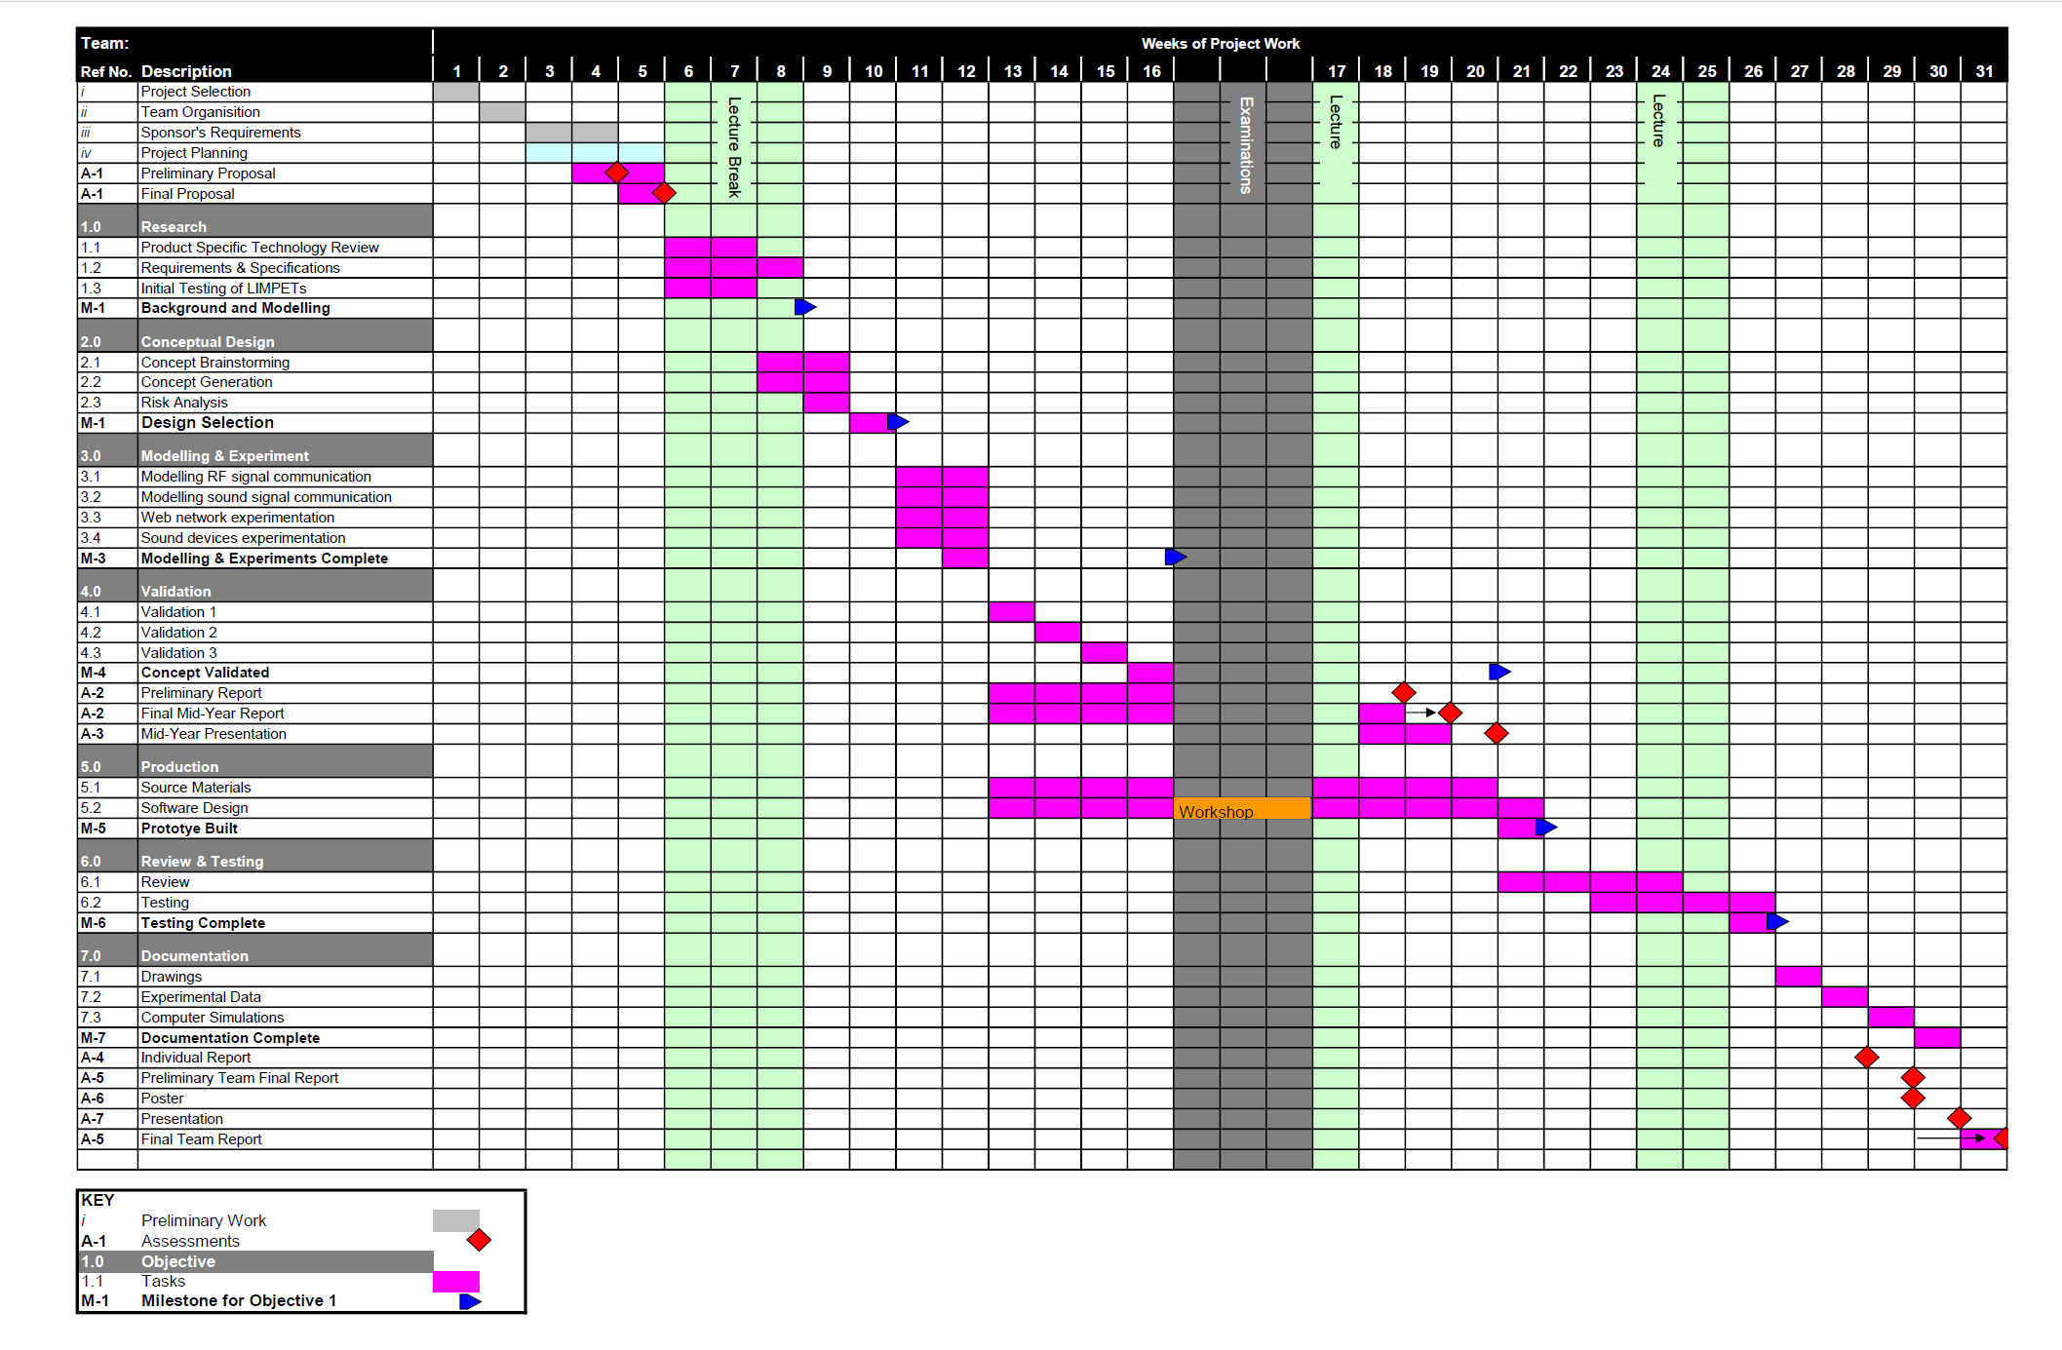About the Gannt chart below in figure 9

Figure :Initial Gannt Chart

Currently, we are slightly behind schedule. The Gannt chart states we should be well past the testing and experimentation phase and onto the validation and development of our product. The following steps would then be to complete testing and experiment with the testing apparatus and then begin creating and solidifying an idea to develop.

Specifically, the next for me will be to use the mic and speaker and see the attenuation in actual would test and compare them to the simulated models. The tests will mainly revolve around the changing distance at a fixed frequency to see attenuation and the changing frequency at a fixed distance to see how big a determinant frequency is in the received signal pressure. A revised model of the Gannt can be seen below in figure 10.

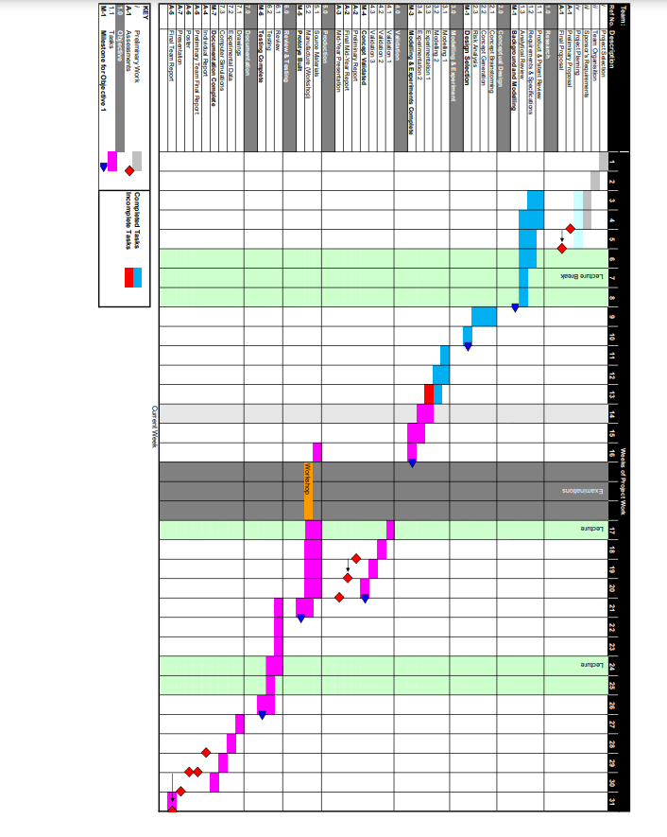

Figure : Revised Gannt Chart

A definite transmission frequency will be confirmed in the coming weeks after testing of attenuation factors. This is planned to be achieved before the validation of the final design concept.

As the year progresses, the group’s focus will turn to the actual development of the design concept. New tasks and a new distribution must be made up, as ideally, the sound, microphone and speaker are set in stone here. The new facets of this project will mainly revolve around the software development and accuracy of the distance measurement and the 3D mesh design. Finally, towards the end of the year, the group must prepare for the presentation and delivery of the product.

# Sustainability

## Life Cycle Analysis

The LCA describes the impact of the product at every stage of its lifecycle. LCA looks at the initial material procurement, production, distribution, usage and finally, the end of life, and how at each stage there are different impacts caused by the product [10]. I acknowledge that the following is not wholly mine, as we worked on the sustainability part as a group.

### Initial material Procurement

#### PCBs

The PCB used for this project requires the procurement of earth materials like copper and silicon. Silicon is mined as quartz (SiO2) and is refined repeatedly to produce a silicon wafer. Due to the arduous refinement procedure, there is wastage of production resources, and the loss of silicon Processing silica to a wafer requires 2100kWh/kg of energy [11]. The total amount of carbon emissions, as a result, is dependent on where it is being refined. It will most likely be sourced from a non-renewable source, as 80% of the world’s energy is currently produced in that manner [12].

#### Housing

It is assumed the housing is constructed using a 3D printer with polylactic acid or PLA. PLA is made from fermented plant starch such as corn, sugar cane etc. The growth of these plants requires land preparation, maintenance, and harvesting, which all impact the environment through energy usage or chemicals. For sugarcane grown PLA, the total CO2 emissions from growth to PLA production is 501kg/ton PLA [13]. PLA plastic produces less CO2 emissions than other 3D printer materials when looking at transportation [14].

### Production

The production will most likely take place in the factory. The components will be soldered onto the PCB using automation. The process involves the use of solder paste, placing via machines, and reflow oven to set the components on the board. All three processes require energy, electrical and heat. The solder paste has a relatively low melting point at 183 degrees and, as such, will minimise the heat energy needed at the reflow oven stage. The actual placing and soldering of the final step are quite energy-intensive, as it has various waste emissions. These range from thermal and mechanical energy to flux, nitrogen and solder emissions. [15].

### Distribution

Limpets can be sold individually or attached to desks, meaning they can be shipped in different forms. The primary distribution method is freight on ships due to the size of desks and quantity of limpets used by each user. Freight ships have extensive environmental impacts; for example, air pollution spills from vessels, ship-strikes on marine megafauna, and ballast water containing aquatic invasive species [16]. Limpets attached to desks have to be shipped at least twice before they arrive with a customer. This double shipping comes from the limpet being shipped to desk distributors to attach the limpets, then the desk distributor shipping the desks. The installation process has related costs as it requires labour to complete the installation, though this cost is limited as the installation process is simple. Limpets sold individually from desks have less related shipping costs as they will go directly from Wellnomics to customers. The installation costs for the customer is higher than if they came preinstalled with the desks as each limpet require to be manually installed either by a user or qualified worker. The costs incurred would not be significant as the installation process is designed to be simple.

### Usage

At this stage where the devices are in use in offices. The needs of the LIMPETs must be addressed in this stage. The needs can be broken down into operational requirements and maintenance. The functional requirements outline the resources required to function the LIMPETs. The main one being power usage. The devices are battery-powered. The battery used is a lithium button battery which has the potential lifetime of 10 years [17] This is advantageous as the device will be sourcing power from a stored supply for its lifespan. The batter will most likely be unreplaceable as it will require the opening and refitting of the design. This has both negative and positive impacts. The use of a battery is good as it does not impact the environment over its lifetime, but also the lifetime is not as long as it would be it was powered via mains. The devices also impact the energy usage of the overall office they are within. As the LIMPETs indicate the use of specific desks and areas, the power distribution within the office can be optimised. Things like air conditioning, computers and lighting can be distributed based on the usage of certain areas in the office, which the LIMPETs can now monitor. This reduces energy usage across the whole office, which positively affects the environment—finally, the repair and maintenance of the device. If the device starts to malfunction or requires repairs, it will be most likely be replaced, as the repair of such devices incurs more cost than a straight replacement. A repair would require two-way postage between the supplier and user and then need someone to work hours to diagnose and repair the LIMPETs. It is far more effective to replace the part, requiring one-way postage and no work hours spent repairing.

### End of Life

At the end of life of the limpets, the batteries are removed and are shipped to a battery recycling facility. The battery recycling facility removes all non-metal parts and ships the leftover mixed metal to a metal separation facility [18]. The PCB of the limpets can be recycled in three ways, thermal recovering, chemical recovering, and physical recovering [13]. For the thermal recovering process, you must heat the PCB to a high temperature the remove the metals present on the board. PCBs are generally made from FR-4, a composite material composed of woven fibreglass cloth with an epoxy resin binder. Thermal recovery will incinerate the FR-4 but retain the copper. This method will produce harmful gases, and these gasses can contain lead and dioxin, for example. For the chemical recovering process, a bed of acid is used to recover metal from the PCB. The board gets put into the acid, which destroys the FR-4. This process produces large quantities of wastewater that need to be handled and processed further. The physical recovery process involves shredding, smashing, breaking, and separating the metal from non-metal components. While this method does have the most negligible environmental impact, it is hazardous for workers. The process produces metal and glass particles that are released into the air. Small particles can lead to respiratory issues if exposed for prolonged periods. This method does retain all the metal components.

# Conclusion

The project aims to improve the well-being of office employees by adding a new feature to the LIMPET product designed by Wellnomics. The part will enable the LIMPET to gain positioning data about itself and other LIMPETs to form a 3D map. It will benefit office workers, Wellnomics, UC and the students working on the project. The project can be split into four individual sections, the microphone, the speaker, the transmitted sound and the 3D mesh design. The transmitted sound must combat noise, attenuation and produce the best output with hardware available in my area. All of these factors depend on the frequency of the sound, the main focus of my research. Through research, many factors bind the choosing the frequency and one can only be determined after testing has been completed. The most significant factors have become the type of materials present n the target environment, as porous and reflective materials have different frequency responses, in most cases opposite responses. This is the immediate next step for the project. The sustainability of the final design was also considered. LCA was used to examine the product from start to finish of its lifetime. There are significant energy and material cost in producing PCBs and plastic housing, but the reduced usage cost slightly mitigates this by giving the device a long lifetime. Also, the device’s presence can prove to be an energy saver by providing more information about the office environment to building managers.

# References

|  |  |
| --- | --- |
| [1] | A. Naber, “One third of your life is spent at work,” [Online]. Available: https://www.gettysburg.edu/news/stories?id=79db7b34-630c-4f49-ad32-4ab9ea48e72b&pageTitle=1%2F3+of+your+life+is+spent+at+work#:~:text=The%20average%20person%20will%20spend%2090%2C000%20hours%20at%20work%20over%20a%20lifetime.. |
| [2] | “The Advantages of Ergonomics,” [Online]. Available: https://osha.oregon.gov/OSHAPubs/ergo/ergoadvantages.pdf. |
| [3] | nem0nic, “Tell it how it is: SPL vs SL vs Intensity vs Perceived Loudness,” 12 April 2001. [Online]. Available: https://arstechnica.com/civis/viewtopic.php?t=949354. |
| [4] | A. G. F. D. Purves D, “Neuroscience. 2nd edition.,” in *Neuroscience. 2nd edition.*, 2001. |
| [5] | “Constructive and destructive interference,” 13 September 2019. [Online]. Available: https://www.sciencelearn.org.nz/images/4105-constructive-and-destructive-interference. |
| [6] | WKC, “Sound Attenuation – Inverse Square Law,” [Online]. Available: https://www.wkcgroup.com/tools-room/inverse-square-law-sound-calculator/#:~:text=In%20terms%20of%20the%20propagation,as%20a%20function%20of%20the. |
| [7] | International Organization for Standardization, “Acoustics - Attenuation of Sound during propagation outdoors,” International Organization for Standardization, Switzerland, 1993. |
| [8] | University of Cambridge, “5. SOUND ATTENUATION,” [Online]. Available: http://www.phase-trans.msm.cam.ac.uk/2000/amjad/b.pdf. |
| [9] | S. D. Macchie, “Acoustic issuews in Open Plan Offices,” Buildings , Florence , 2018. |
| [10] | Ecochain, “Life Cycle Assessment (LCA) – Complete Beginner’s Guide,” [Online]. Available: https://ecochain.com/knowledge/life-cycle-assessment-lca-guide/. |
| [11] | S. B. Boyd, “Life-cycle assessment of semiconductors,” 2009. |
| [12] | International Energy Agency, “World Energy Balances: Overview,” July 2020. [Online]. Available: https://www.iea.org/reports/world-energy-balances-overview. |
| [13] | F. d. B. A. Morao, “Life cycle impact assessment of polylactic acid (pla) produced from sugarcane,” 2019. [Online]. Available: https://link.springer.com/article/10.1007/s10924-019-01525-9. |
| [14] | J. J. Shen, “Comparative life cycle assessment of polylactic acid (pla) and polyethylene terephthalate (pet),” 2011. |
| [15] | S. H. T. J. J. F. Alireza Esfandyari, “A Lean Based Overview on Sustainability of Printed Circuit Board production assembly,” in *12th Global Conference on Sustainable Manufacturing*, Nürnberg, Germany, 2015. |
| [16] | O. A. M. C. D. A. F. E. E. T. H. S. J. E. T. R. Walker, World Seas: an Environmental Evaluation (Second Edition),, Acedmic Press, 2019. |
| [17] | Maxim Integrated, “LITHIUM COIN-CELL BATTERIES: PREDICTING AN APPLICATION LIFETIME,” [Online]. Available: https://www.maximintegrated.com/en/design/technical-documents/app-notes/5/505.html#:~:text=Abstract%3A%20The%20typical%20specification%20for,the%20absence%20of%20system%20power.. |
| [18] | “How to recycle batteries,” 2021. [Online]. Available: https://batteryuniversity.com/learn/article/recycling_batteries. |
| [23] | Pui Audio, “Data Sheet AS01508MS-SP11-WP-R,” 2017. [Online]. Available: https://nz.mouser.com/datasheet/2/334/AS01508MS-SP11-WP-R-1267054.pdf. |
| [24] | T. S.K, “Some Characteristics of noise in air-conditioned landscaped offices,” Applied Acoustics, 1996. |