Absorptive

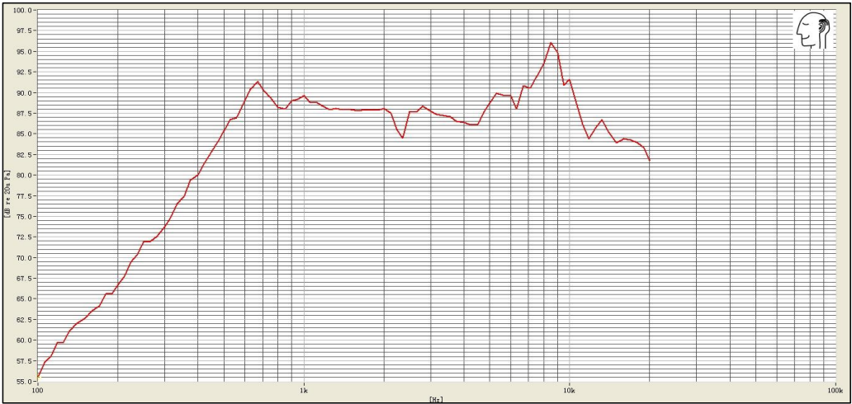

Speaker

Reflective

Noise

Atmospheric Attenuation

1600 Hz -> 11kHz