Research

Ultrasonic Sensors

Use high frequency waves.

Reflection sensing

Bandpass filtering

Small Range

Frequency spectra in Offices

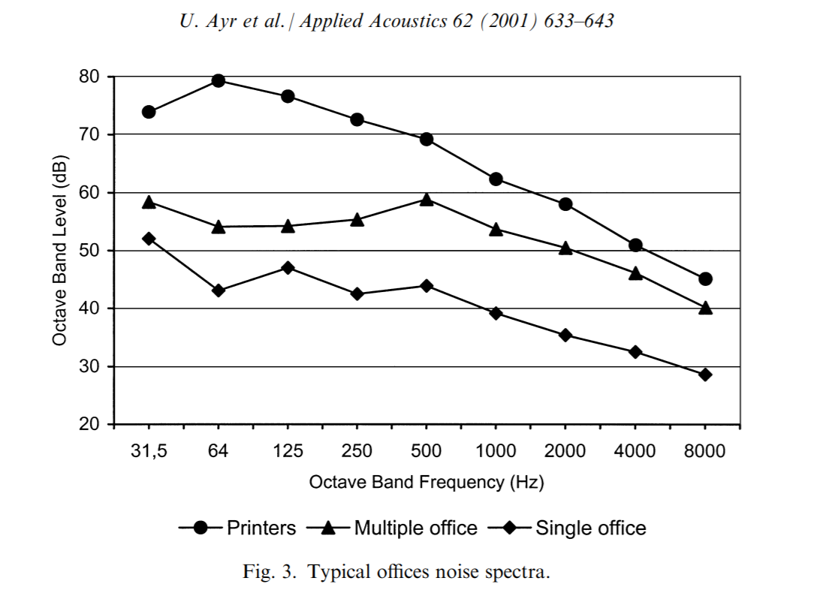

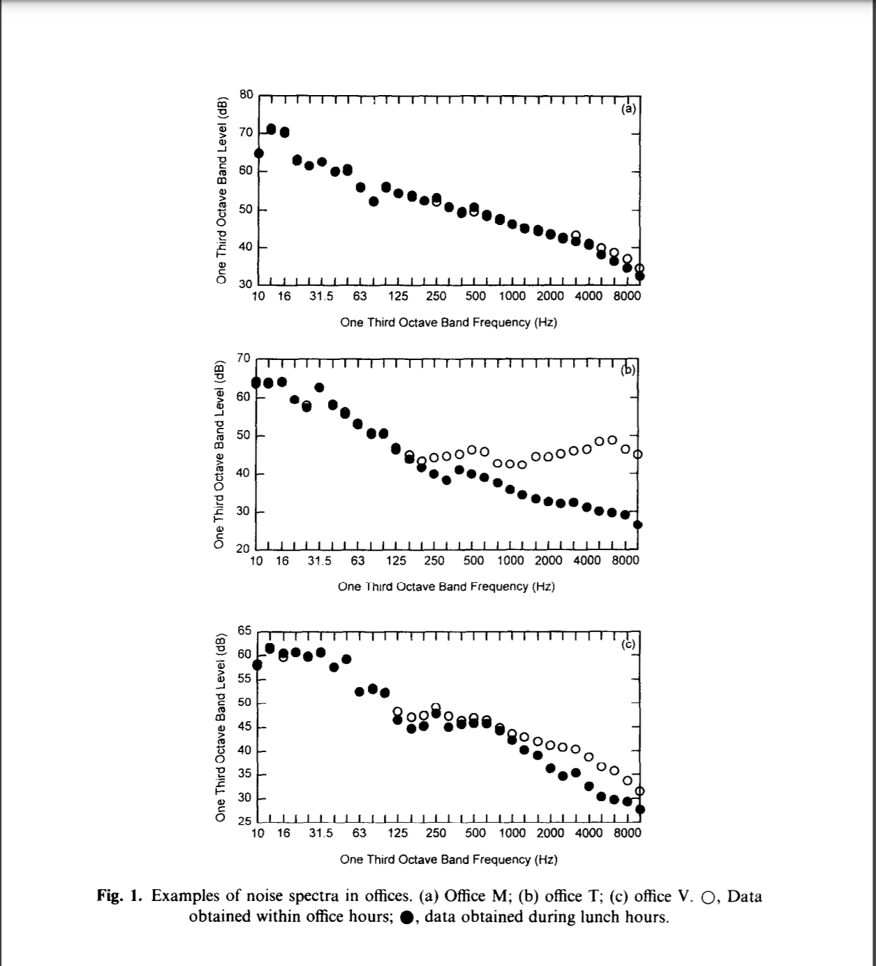

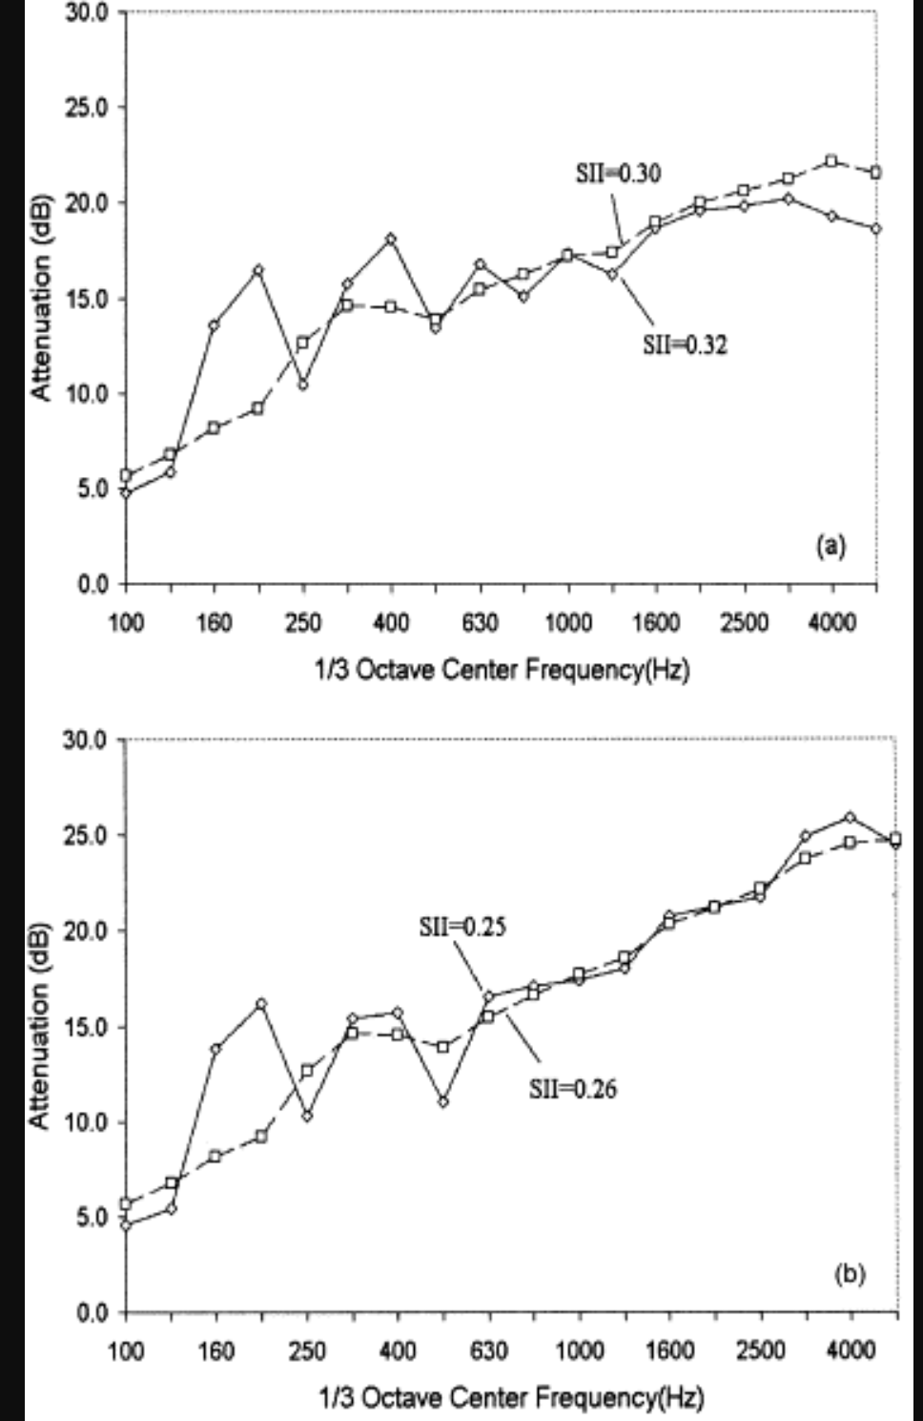

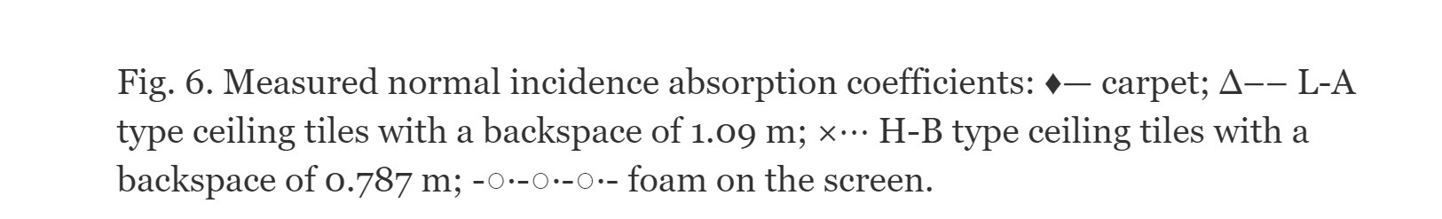

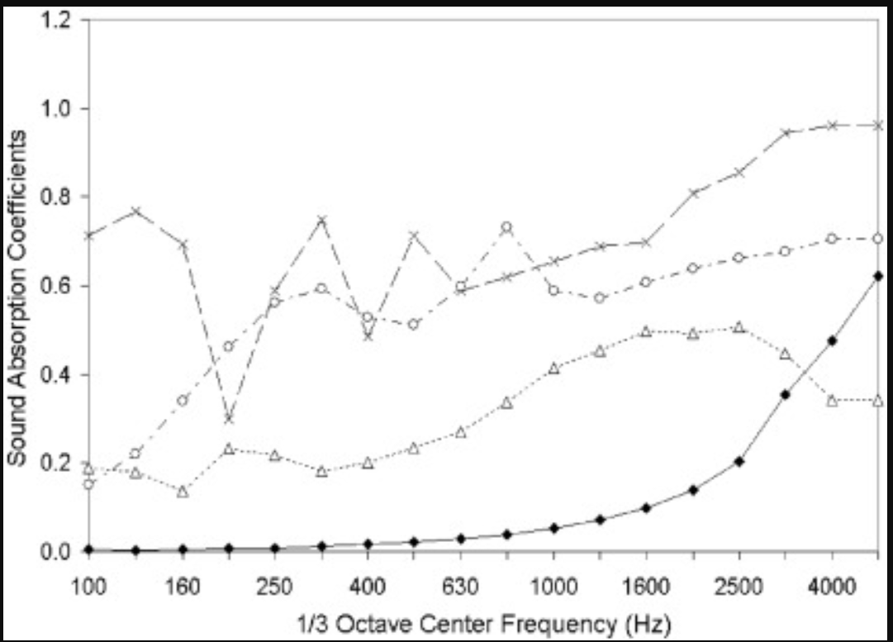

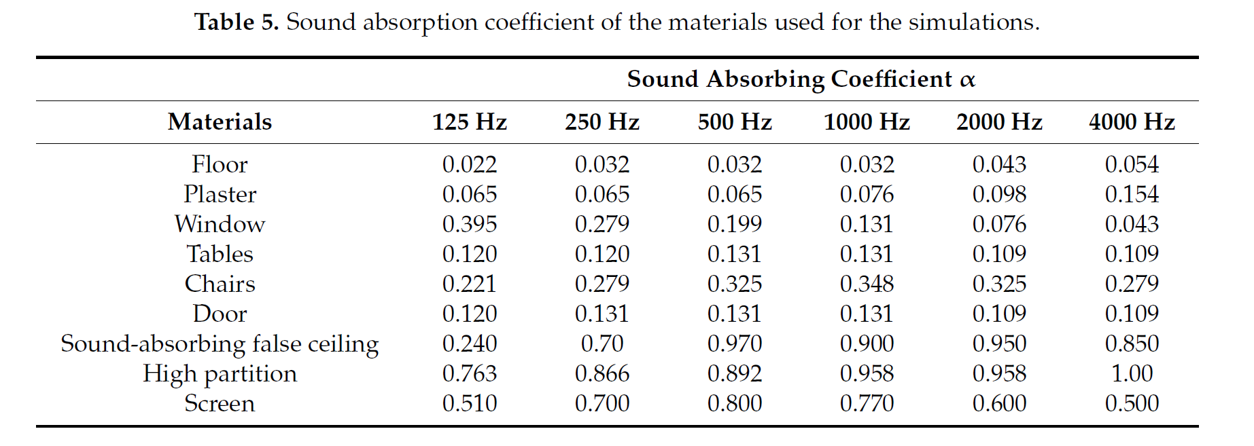

Testing

Fixed distance/Varying frequency/ with/without barriers

Fixed frequency/Varying distance with/without barriers

