Sound

# Sound Measurement

Sound is measured in dB so that the large variations in pressure, power and intensity can be easily expressed. For example, the sound pressure of 10 dB relates to a 63.2 microPa pressure, while a 100 dB measurement relates to a 2 Pa pressure. In Pascals the variation is very large, but in decibels the measurement is more convenient.

There are 3 main sound measurements, Sound power, intensity and pressure level.

The SPL, sound pressure level, describes the ratio of the pressure of the sound wave and the ambient pressure that the wave is travelling through. The average variation caused by the sound wave in the atmosphere. They are related by the following equation

SPL = 20log(p/pref)

The SPL is use to describe the “loudness” of a sound. Devices used in this project have specifications related to the SPL measurement.

# Maximum Distance

The maximum distance in an unobstructed environment can be found for different frequencies. We ca produce this by looking at the frequency response of the speaker and by examining the signal to noise ratio of the microphone. The SNR is the difference in decibels between the noise level and the reference signal (1kHz). The microphone does not produce an output if any input signals are below the noise floor, which is defined by the following relationship

Noise floor = ref - SNR

If testing was conducted at 1kHz, the SPL output of the speaker would be 90 dB at 10cm (from frequency response curve). At 1kHz the noise floor of the microphone is 28.5 dB

NF = 94 dB – 65.5 dB

NF = 28.5

In an unobstructed setting, sound attenuates to with distance, due to the absorption properties of Air. This relationships is described by the following

SPL_2 = SPL_1 – 20log(r_2/R_1)

This will indicate to us the SPL at a certain distance. If the absolute minimum SPL detectable by the microphone is 28.5 dB, the maximum distance of unobstructed noise at 1kHz is 118m

Now this is very long, but that’s because we are only considering air as the attenuation factor.

# Attenuation

Attenuation is the result of sound absorption, which is when an object or medium absorbs sound energy and dissipates it as heat. Different materials have different absorption coefficients, depending on their composition. Bu the absorption coeff is also affected by the humidity of air. As humidity affects the speed of sound.

The amount of absorption in a material can be described by the absorption coefficient, which is a ratio of the absorbed energy vs the total energy. It is measured from 0 to 1, with 1 being complete absorption, with no reflected waves and 0 is the opposite.

As sound travels, 3 things happen, Attenuation via the air, absorption via the materials and there is also transmission loss via the materials it passes.

Sound Attenuation in Air.

As the wave travels through a medium it is constantly losing energy due to the friction of the wav against the medium. This energy is dissipated as heat when the wave is travelling through the air. The relationship of this has already been described using the SPL calculation above. In the Air higher frequencies are more readily attenuated then lower frequencies. As the oscillation of the wave is already so high frequency the wave is losing energy more energy by simply travelling, by adding the effect of air absorption, the wave attenuates fast. Low frequency waves attenuate less.

For example, for our given microphone the 20kHz travel distance is 50m. Humidity and temperature also affect attenuation. Dry air absorbs far more energy than moist air, and as such there is more attenuation in lower humidity levels.

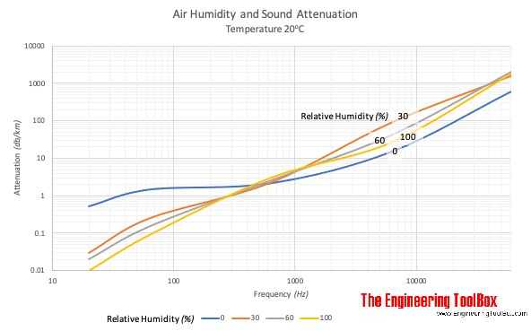

Temperature also affects sounds. As temperature rises the energy within the wave also increases, leading to a higher velocity, which will attenuate less, as it has more overall energy than previously.

The proprtionaloity of these factors can be seen in the table below

|  |  |
| --- | --- |
| Parameter | Relationship with attenuation (in Air) |
| Frequency | Proportional |
| Temperature | Inversely Proportional |
| Humidity | Inversely Proportional |
| Distance | Proportional |

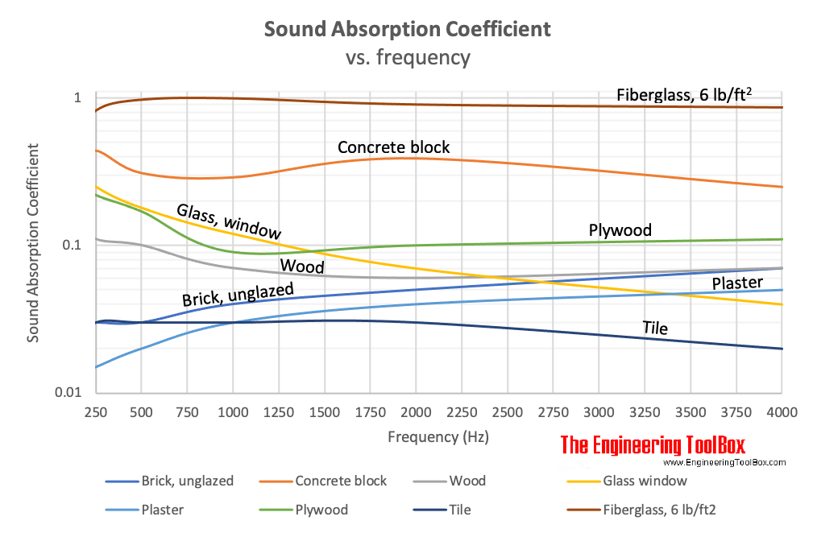The other thing sound will do is interact with materials in the environment. When sound waves meet an object they will either be absorbed, transmitted or reflected. The split of absorption and reflection is expressed by the absorption coefficient. Different materials have different coefficients, at different frequencies. There are 2 main types of materials that affect sound, that being porous, absorbative materials, which allow airflow, and reflective materials, which do not allow for airflow.

Absorbative materials like carpets, and drapes allow for absorption. The energy from the soundwave enters the the structure where it can be converted into heat energy. The general frequency characteristic for such materials is that as the frequency increases, the attenuation increases. Conversely with reflective materials have less attenuation as frequency rises. Thes materials include plywood, concrete, plaster.

Lastly there is the sound transmission loss. This is the sound loss in dB when it travels through a barrier, such as walls. The loss in dB is roughly equivelenet to the STC or sound transmission class. For example an insulated drywall has an STC of 39, which results in an approximate 39dB loss for the sound being transmitted through that wall.