Research

Doing research for 3D Mesh
I have found Delaunay Triangulation is something that might be able to be used but will need to understand it better.

Further research and asking around, this problem can be broken down into how GPS works.
GPS MOOC is apparently a good resource for GPS.

Interfacing for Speaker, Mic, and Microcontroller - 1st of April

- Speaker
  - Speaker interfaces via a driver circuit to the Teensy 4.0 to take the current load off the output pins
    - This interface method is limited as

30 April 2021
Finding stuff on telling when notes start
Keywords:
Audio Onset
http://www.eecs.qmul.ac.uk/former/people/jbc/Documents/Bello-TSAP-2005.pdf
https://dianasiwiak.com/docs/enzcon2017.pdf

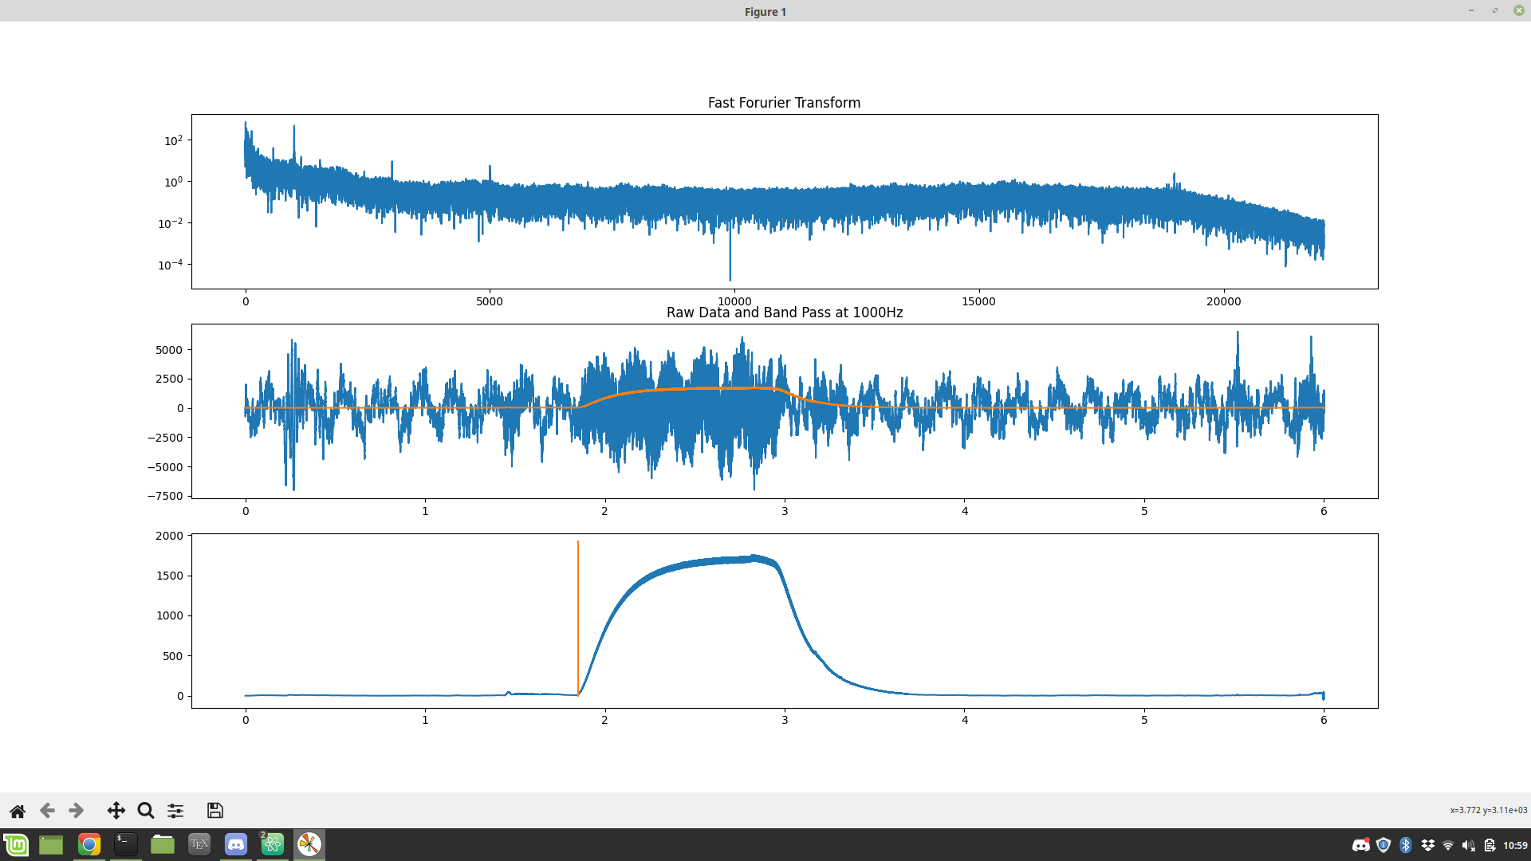
23rd May
Success using gradient

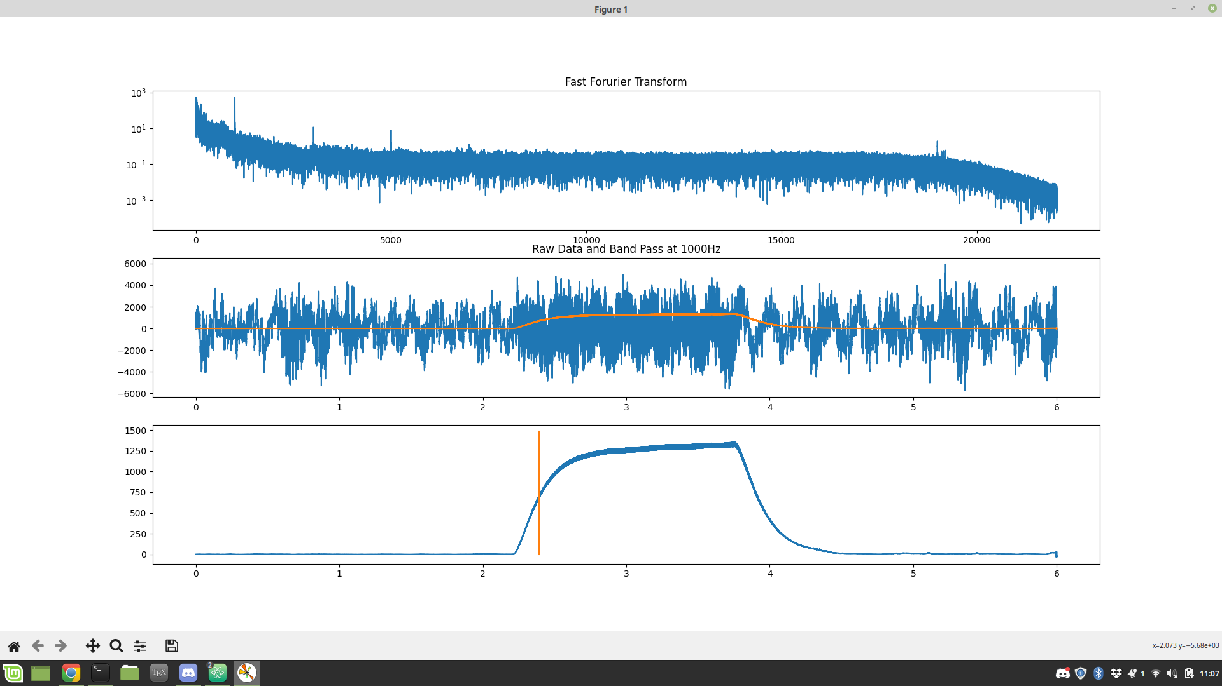
But not reliable
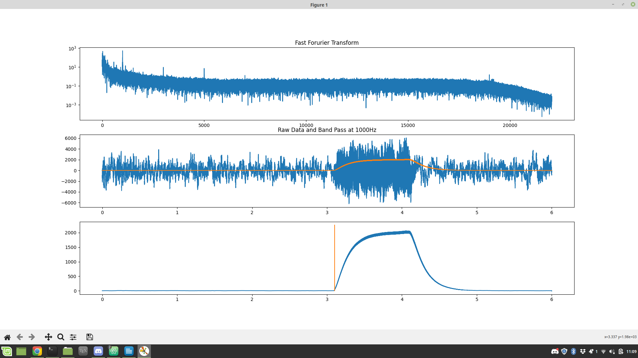
Reliability improved when increasing gap between two values used calculating gradient to a 1000 instead of around 100, 44100 values per second.
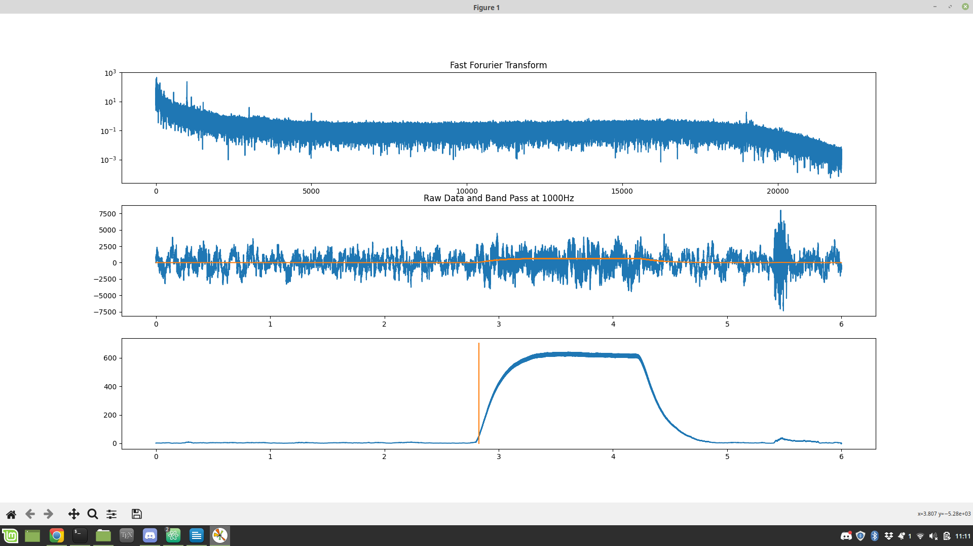
Though not 100% accurate its pretty good
Further tuning may be necessary

