Machine Learning Practical (MLP)
Coursework 3
Georgios Pligoropoulos - s1687568

Million Song Dataset Classification Problem
We are given a subset of the MSD dataset which contains 40000 instances in the training set and 10000 instances in the validation dataset.
The songs have been preprocessed to extract timbre, chroma and loudness from various segments within the song. Each segment is represented by 25 features in total. In order to have a fixed input length we are keeping the centra 120 segments. This gives a total input of dimensionality 3000.

MSD-10 Classification Problem
Our goal is to classify which of the ten genres correspond to which song, as accurately as possible using a multilayer perceptron (MLP) deep neural network.

MSD-25 Classification Problem
Our goal is to classify which of the 25 genres correspond to which song, as accurately as possible using a multilayer perceptron (MLP) deep neural network.

Tools
For all experiments we are using Python Programming Language and Tensorflow Framework.

Baseline Architecture
Before research the optimal architecture we pick a very simple architecture to serve as a basis for our further exploration.
We will be using affine transformations which are interleaved with nonlinearities, and at the end we always have a softmax output layer.
We are using a Shallow Neural Network with one hidden layer of 200 dimensionality.
Activation function is ReLU.
Learning Rate is AdamOptimizer with default learning rate of 1e-3.
There are no other hyperparameters to tune.
Note that we are introducing a small positive bias of 0.1 in ReLU layers, instead of zero, in order to avoid dead-neurons effects.
We will be using a batch size of 50 for training.
Note: When in our explanations refer to accuracy we mean the final validation accuracy and when we refer to performance we mean how fast we reached the optimal accuracy for the current experiment.
Note that we will not be reporting final errors and accuracies after each experiment because in most cases the final error is not the minimum error and the final accuracy is not the maximum accuracy. We are most interested in the approximate results since we are far away from 100% accuracy to care for the decimal part of the metrics.
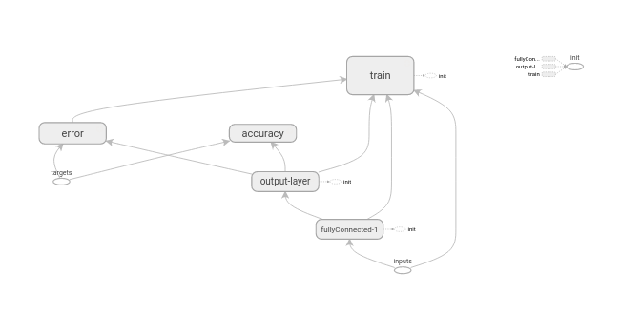
Graph 1: Shallow Neural Net – single hidden layer of 400 dimensionality – ReLU

Results
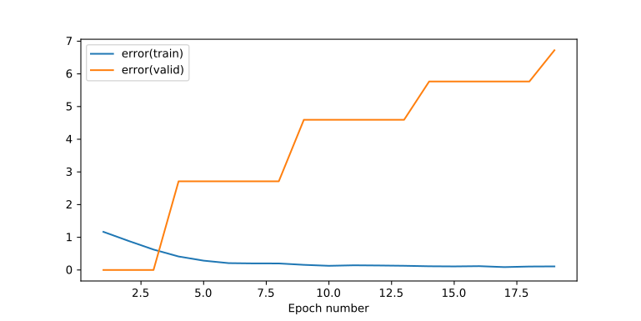
Plot 1: Training & Validation Error - Shallow neural net - 200 dimensionality of single hidden layer - ReLU nonlinearity

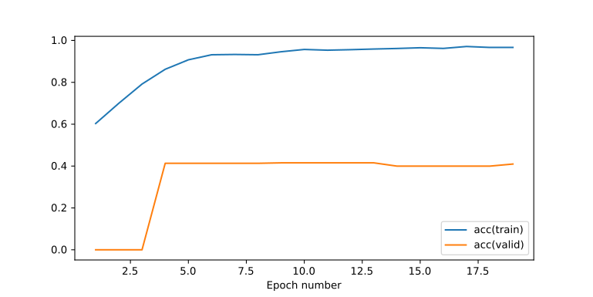
Plot 2: Training & Validation Accuracy - Shallow neural net - 200 dimensionality of single hidden layer - ReLU nonlinearity

Conclusion
This shallow unregularized and non-optimized neural network starts with a validation accuracy of 40%. Our efforts will be focused on increasing the validation accuracy.

Research Question: Pretraining Helps shallow neural network?
One thing we can consider is that we are starting off at a very “bad” place by random initialization and perhaps the model could perform better if we initialize the variables more properly

Method of Pretraining: Stacked Autoencoder
Stacked Autoencoders is a way to pretrain a neural network by making each layer be the autoencoded representation of the previous layer. In other ways each layer is like a distorted version of the input which is actually better than having the weights be randomly initialized.
The process is as follows:
- We forward propagate the neural network up to the already pretrained layer, unless we have not pretrained any layers at all yet
- We then use the result of the forward propagation for both input and output and we introduce a hidden layer between them.
- We use as error the Mean Sum of Squares
- We train for several epochs until the rate of which the error is decreasing becomes too low
- We keep the weights and biases for the layer from input to hidden layer. We discard the weights and biases from hidden layer to output
- We repeat from step 1 until all layers are pretrained.
We will experiment with only Non-Linear Stacked Autoencoders which use Sigmoid non-linearities.

Here we used non-linear autoencoder with sigmoid non-linearities of hidden dimensionality of 200 and then 400.
We use the latter one to train our classifier.

Results
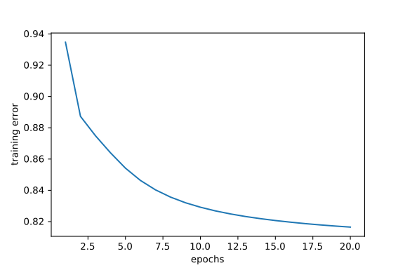
Plot 3: Autoencoder Training Error - 200 dimensionality of hidden layer - Sigmoid nonlinearity

Conclusion
The result from the experiment above is that the hidden dimensionality of 200 seems too little to autoencode the data. The error of 0.82 where the autoencoder converged before than 20 epochs means that we could perhaps do better with a larger dimensionality.

We are going to repeat the experiment by doubling the dimensionality from 200 to 400.
So the layer is 3000 ↔ 400 ↔ 3000

Results
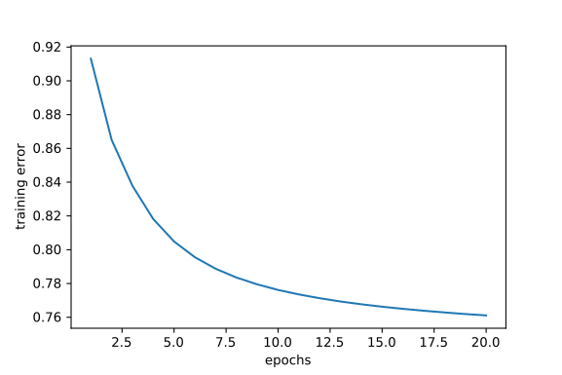
Plot 4: Autoencoder Training Error - 400 dimensionality of hidden layer - Sigmoid nonlinearity

Conclusion
Here we see that the performance has increased in terms of better autoencoding.
Next step is to train our classifier by initializing the weights and biases based on the pretrained values of the stacked autoencoder

Results
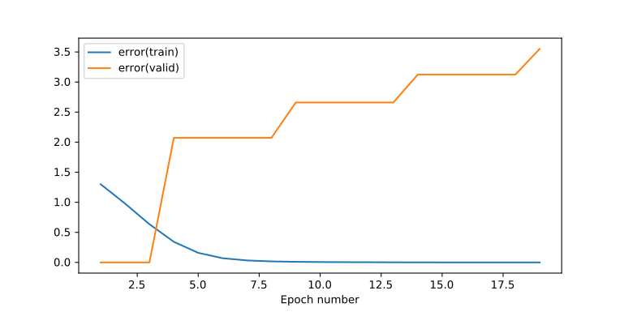
Plot 5: Training & Validation Error - Pretrained with Stacked Autoencoder - ReLU nonlinearity - 400 dimensionality of hidden layer

Conclusions
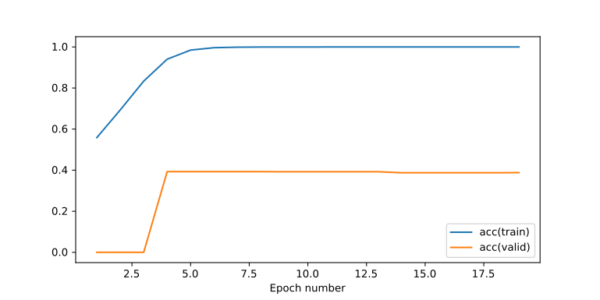
Plot 6: Training & Validation Accuracy - Pretrained with Stacked Autoencoder - ReLU nonlinearity - 400 dimensionality of hidden layer
The answer to the original research question is no. The pretraining, at least for this shallow neural network with one hidden layer of 400, is not able to help our classification problem at all.
We will try at a later step for pretraining when we build a deeper neural network.
From all the above plots one major apparent issue are the overfitting effects which we need to address.

