Research Question: Dropout before readout layer helps mediating overfitting effects of the shallow neural network?
Commonly there are one or more intermediate dropout layers used to tackle overfitting effects.

Method of Regularization: Dropout before readout layer
Dropout as a layer keeps randomly only a part of the full dimensionality of the layer and zeros everything else. This has the effect of simulating approximately an exponential number of neural networks.
Here we are using one layer of Dropout before the final readout layer.
The keep probability is equal to 50%.
The tensorflow graph is displayed below.

Results
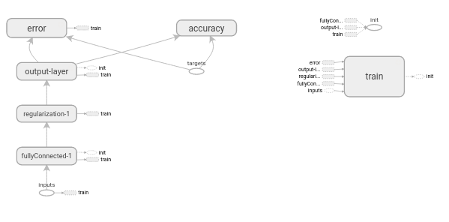
Graph 2: Shallow Neural Net - single hidden layer with 400 dimensionality - Dropout at readout with keep probability as placeholder – ReLU nonlinearity
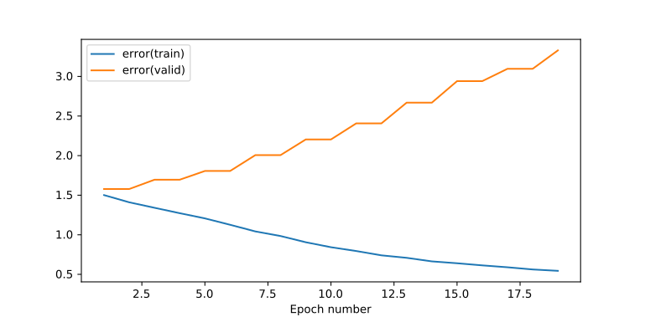
Plot 7: Training & Validation Error - Shallow Neural Net - single hidden layer with 400 dimensionality - Dropout at readout with 50% keep prob – ReLU nonlinearity
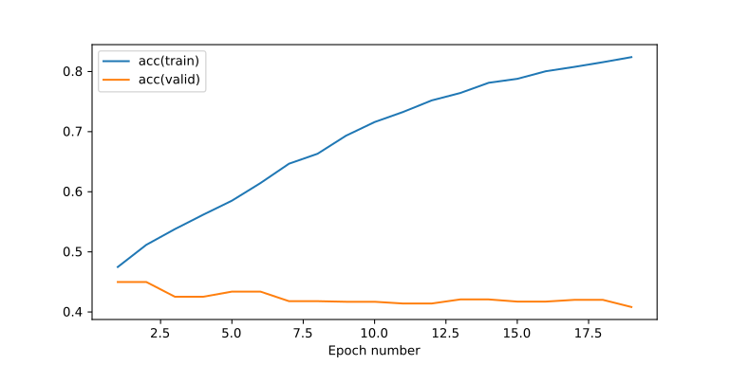
Plot 8: Training & Validation Accuracy - Shallow Neural Net - single hidden layer with 400 dimensionality - Dropout at readout with 50% keep prob – ReLU nonlinearity

Conclusions
The dropout of probability 50% before the readout layer has helped to increase the validation accuracy from 40 to 45%, as it is visible of the first two epochs.
The issue is that we are still experiencing severe overfitting by observing the monotonically increase of the validation error which reduces the validation accuracy.
Next step is to introduce more regularization via dropout.

Research Question: Dropout on both layers helps mediating overfitting effects of the shallow neural network?
The difference from the previous experiment is that we are introducing a dropout layer at the inputs.

Method of Regularization: Dropout on both layers, .9 input probability, .5 hidden probability
Here we are using one layer of Dropout before the final readout layer and one layer of Dropout at the input layer. Typically dropout probability at the input layer should be relatively high so that the neural network has a good chance to see a noisy representation of the input. If the probability at the input is too low then the neural network will be trained against a severly distorted input and it will fail to generalize properly.
The input dropout probability is equal to 90%
The readout layer dropout probability is equal to 50%
The tensorflow graph is displayed below.
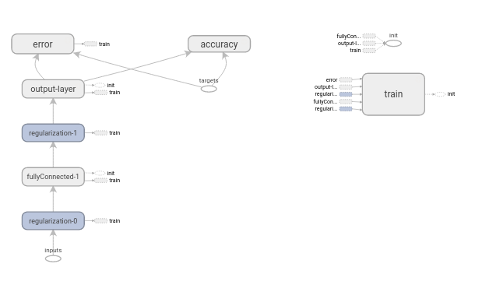
Graph 3: Shallow Neural Net - single hidden layer with 400 dimensionality - Dropout at input and readout with keep probabilities as placeholders – ReLU nonlinearity

Results
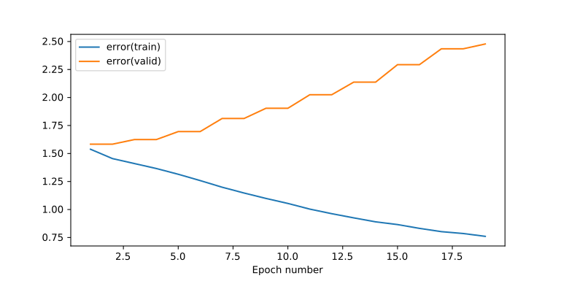
Plot 9: Training & Validation Error - Shallow Neural Net - single hidden layer with 400 dimensionality - Dropout at input with 90% keep prob and at readout with 50% keep prob – ReLU nonlinearity
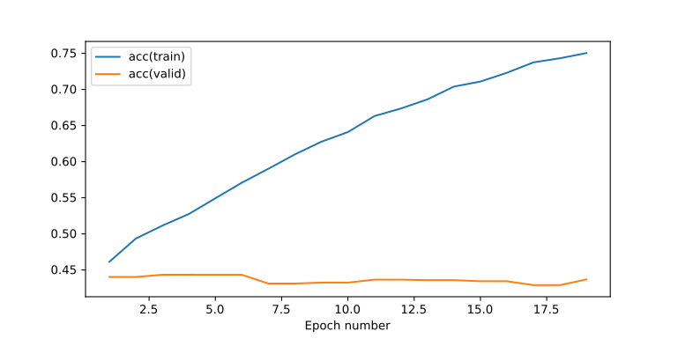
Plot 10: Training & Validation Accuracy - Shallow Neural Net - single hidden layer with 400 dimensionality - Dropout at input with 90% keep prob and at readout with 50% keep prob – ReLU nonlinearity

Conclusions
By introducing a dropout at the input layer means that we did not let the algorithm train itself within 20 epochs. The final training error is smaller than the previous experiment.
The good outcome however is that we managed to maintain a higher validation probability which is a good sign that regularization with dropout helps but it is not optimally tuned yet.

We are going to lower a little both drop probabilities and let it run for more epochs.

Method of Regularization: Dropout, 85% input probability, 45% hidden probability
We are going to let the neural network train for twice as more epochs and we are lowering the probabilities to try and achieve a stable regularization.
The input dropout probability is equal to 85%
The readout layer dropout probability is equal to 45%

Results
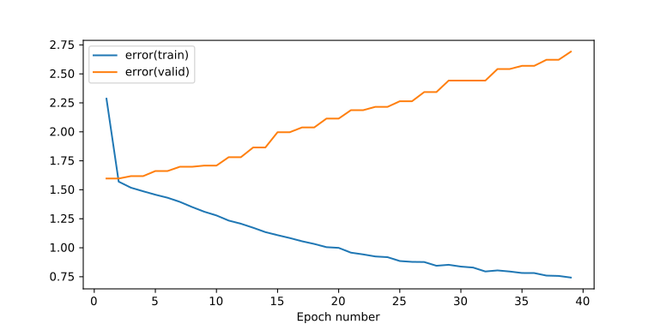
Plot 11: Training & Validation Error - Shallow Neural Net - single hidden layer with 400 dimensionality - Dropout at input with 85% keep prob and at readout with 45% keep prob – ReLU nonlinearity

Conclusions
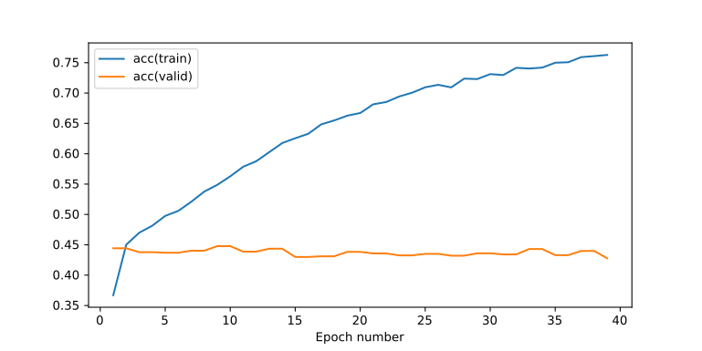
Plot 12: Training & Validation Accuracy - Shallow Neural Net - single hidden layer with 400 dimensionality - Dropout at input with 85% keep prob and at readout with 45% keep prob – ReLU nonlinearity
Here we see that despite the model is gradually getting better for the training dataset it does not improve its classification performance for the validation dataset within more epochs.
In fact the validation error is gradually increasing meaning that we have not managed to prevent overfitting.
Since this manual tweaking of the dropout probabilities has not converged to any solid results or conclusions we will try and use annealing dropout and see if we could get an overall better performance and result.

Research Question: Linear Annealing Dropout helps mediating overfitting effects of the shallow neural network better than simple dropout?
With annealing dropout we start from a lower probability where we have only a few neurons, randomly chosen, play the role of small models which are expected to fail but they are going to be highly pretrained ancestors of the new more complex models when we start increasing the probability. Unnecessary co-adaptation between neurons that we might have if we start training the entire network altogether is now avoided.

Method of Regularization: Linear Annealing Dropout
The initial probability of the input layer is 50% and is linearly increamented for 90% of the epochs and then stays at the top probability of 100% for the rest 10% of the epochs.
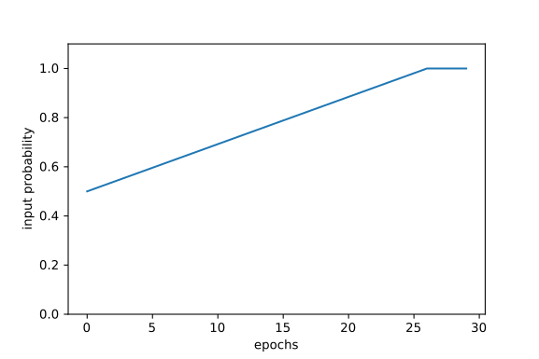
Plot 13: linear increment of dropout keep probability at the inputs along time steps (epochs)

The initial probability of the hidden layer is 1% and is linearly increamented for 90% of the epochs and then stays at the top probability of 100% for the rest 10% of the epochs.
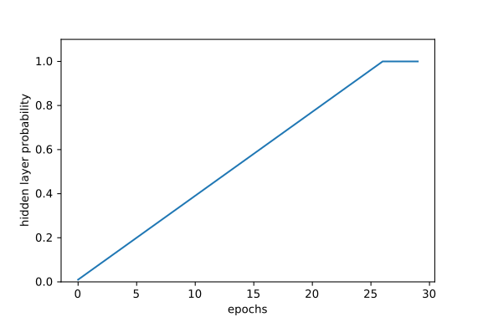
Plot 14: linear increment of dropout keep probability at the hidden layer along time steps (epochs)

Results
After running the experiment for 30 epochs we get the following results:
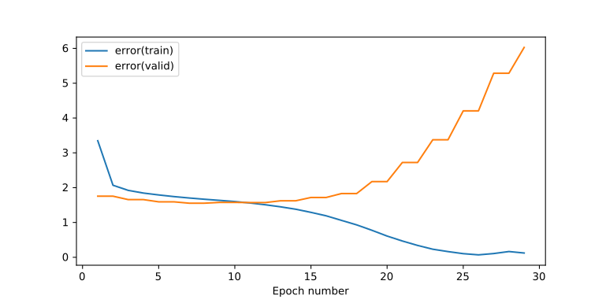
Plot 15: Training & Validation Error - Shallow Neural Net - single hidden layer with 400 dimensionality – Linear Annealing Dropout – ReLU nonlinearity

Conclusions
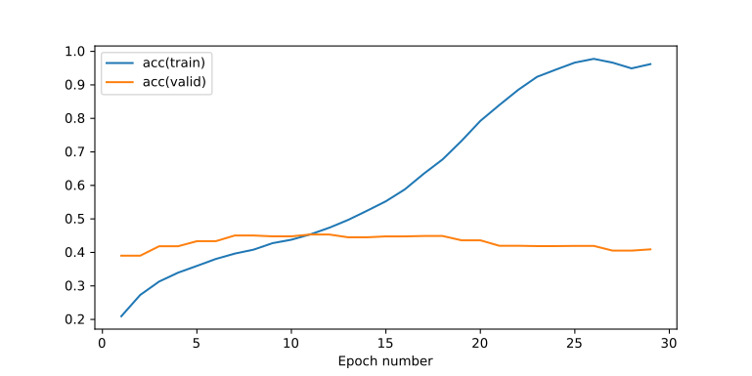
Plot 16: Training & Validation Accuracy - Shallow Neural Net - single hidden layer with 400 dimensionality – Linear Annealing Dropout – ReLU nonlinearity
The result from this experiment is that while at the beginning the regularization was enough to keep the validation error at low levels the linear increment of the drop probabilities results in the drop of the validation accuracy.
As a next step we will consider annealing dropout which is not linear but it is slowly increasing for most of the epochs with a more fast increment at the end.

Research Question: Exponential Annealing Dropout helps mediating overfitting effects of the shallow neural network better than simple dropout?

Method of Regularization: Exponential Annealing Dropout
Here we have the same experiment as previously but the probability of the hidden layer has an exponential growth, starting slowly and increasing faster towards the end.

The initial probability of the input layer is 80% and is again still linearly increased for 50 epochs until 100%.
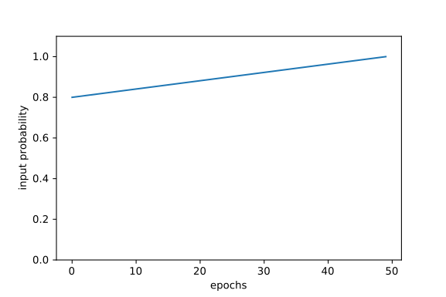
Plot 17: linear increment of dropout keep probability at the inputs along time steps (epochs)
The initial probability of the hidden layer is near zero and then is exponentially increased for 50 epochs until 100%.
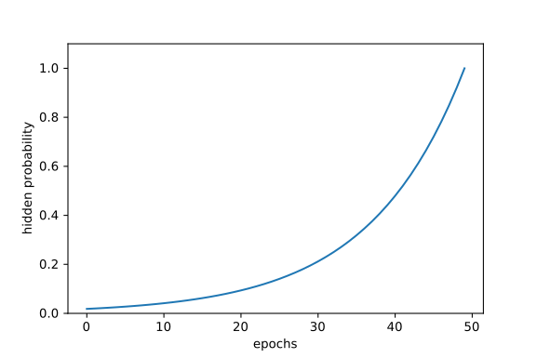
Plot 18: exponential increment of dropout keep probability at the hidden layer along time steps (epochs)

Results
After running the experiment for 50 epochs we get the following plots:
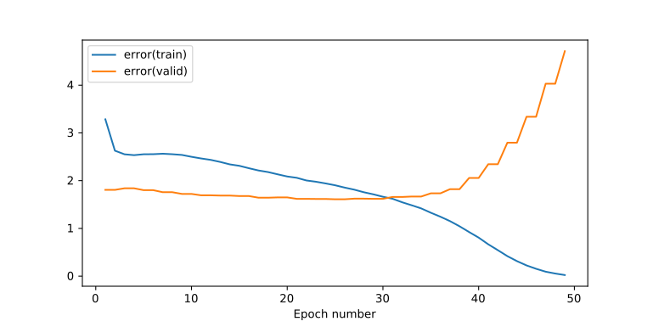
Plot 19: Training & Validation Error - Shallow Neural Net - single hidden layer with 400 dimensionality – Exponential Annealing Dropout – ReLU nonlinearity

Conclusions
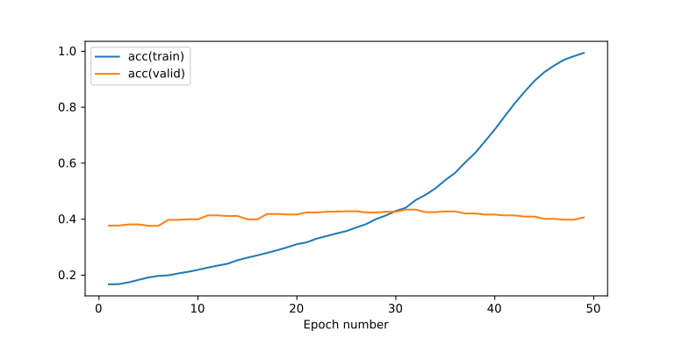
Plot 20: Training & Validation Accuracy - Shallow Neural Net - single hidden layer with 400 dimensionality – Exponential Annealing Dropout – ReLU nonlinearity
We notice that in the Linear Annealing Dropout we have an increase in validation error after 10 epochs which is when the hidden layer probability is at ~40%.
While at the Exponential Annealing Dropout we have an increase in validation error after 30 epochs which is when the hidden layer probability is at ~20%.

Research Question: Configuring Dropout probability dynamically based on the validation error helps mediating overfitting effects of the shallow neural network better than simple dropout?
We have failed to choose manually a proper number of parameters so we will try an iterative algorithm where the probability dropout will change dynamically based on the validation accuracy (or error)

Method of Regularization: Dynamic Dropout
Here we are using the most simple conceivable algorithm in an attempt to automatically search for the best dropout probabilities of the input and the hidden layers.
We are keeping the history of the validation error in a variable called prevValidError and given that the current validation error is provided by the valid_error variable this mathematical formula holds:

Where gamma is a hyperparameter that we need to configure in order for enough of the validation error history to be “remembered”.
So the dropout probabilities are being increased and decreased according to the comparison between the current validation error and the history of the previous validation errors.
If the current validation error is smaller that previous validation errors then this means that the system converges towards a better classifier and we can reduce the regularization by increasing the input and hidden dropout probabilities.
On the other hand if the current validation error becomes larger than the history of the previous errors then we are increasing the regularization by reducing the input and hidden dropout probabilities.
In order to avoid getting invalid or unwanted probabilities we will be thresholding them by setting a minimum value different for the dropout input probability and the hidden dropout probability.
So here minimum input dropout probability is 50% and minimum hidden dropout probability is 10%. Maximum probability is allowed to always be 100%.
Note that for this experiment the gamma hyperparameter is set to: 0.7
The rate at which we increase or decrease the dropout probabilities is handled by another hyperparameter which we call resolution. Resolution is a fraction of the distance between the maximum and minimum dropout probability.
There two formulas hold:

Results
After running the experiment for 50 epochs we get the following plots:
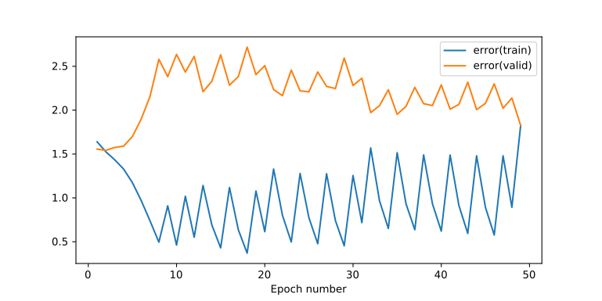
Plot 21: Training & Validation Error - Shallow Neural Net - single hidden layer with 400 dimensionality – Dynamic Dropout – ReLU nonlinearity

Conclusions
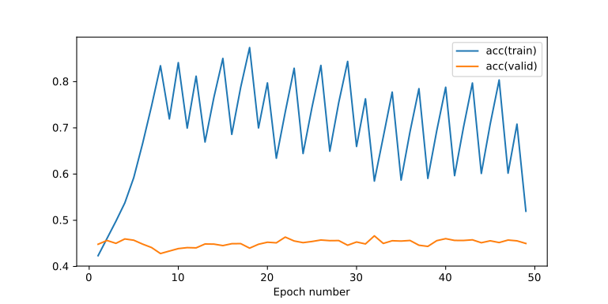
Plot 22: Training & Validation Accuracy - Shallow Neural Net - single hidden layer with 400 dimensionality – Dynamic Dropout – ReLU nonlinearity
From the above experiment we managed to maintain the best level of validation accuracy around 45-47% for 50 epochs which is better than all the previous experiments.
On the other hand our current approach includes a lot of oscilation which means that it takes longer to converge.
The main outcome however is that we let the algorithm try different combinations of dropout probabilities instead of trying to figure out the best values manually.
Moreover the validation error is maintained within some boundary and it does not have an increasing trend.

