Research Question: Larger dimensionality helps in producing a better classifier?
Here we have an input dimensionality of 3000 and a difficult classification problem so it is reasonable a single hidden layer of dimensionality 400 to not be enough to produce a good model for our classification problem. We will try a deeper architecture.

Method: Deep architecture with four levels of 500 dimensionality each
Here we start without any regularization trying to see the initial behavior of the deeper architecture but we set the learning rate of Adam Learning Rule at 1e-4. The tensorflow graph is displayed below:
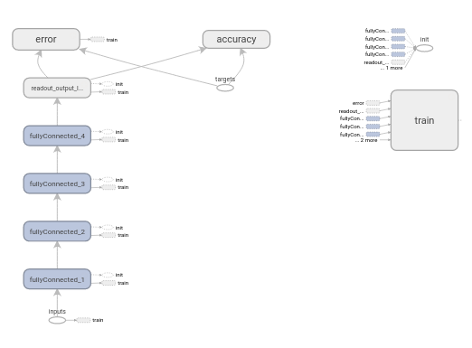
Graph 4: Deep Neural Network - 4 hidden layers of 500 dimesionality each - Adam Learning Rule 1e-4 learning rate - ReLU nonlinearity

Results & Conclusions
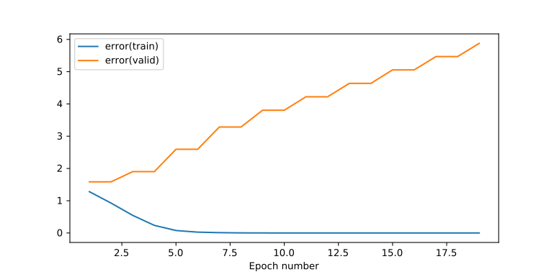
Plot 23: Training & Validation Error - Deep Neural Net - 500 dimensionality of all hidden layers - Learning Rate 1e-4 - ReLU non-linearity
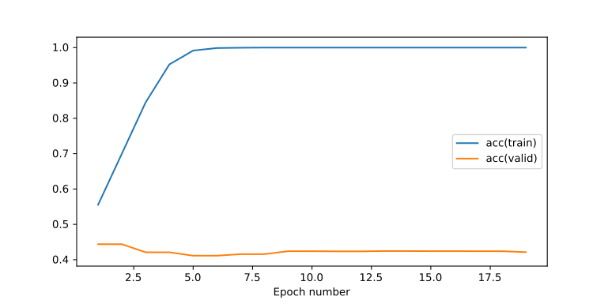
Plot 24: Training & Validation Accuracy - Deep Neural Net - 500 dimensionality of all hidden layers - Learning Rate 1e-4 - ReLU non-linearity
We started at 45% without regularization which is a good indication that this model performs better but because of overfitting we cannot derive any concrete conclusions.
Even though we have introduced a smaller learning rate we still get high overfitting effects, so no real conclusion can be derived until we amend the overfitting effect

Research Question: Can we use Dropout to regularize the deep neural network?
It makes sense to use Dropout for regularization purposes as it already worked for the shallow neural network.

Method: 4 hidden layers of dimensionality 500 regularized with Dropout at inputs and readout layer
First we will try and introduce the dropout layer only at the input and the readout layer and see the effect.
Dropout probability for the input is 90%
Dropout probability for the readout layer is 50%
The new tensorflow graph is as follows:
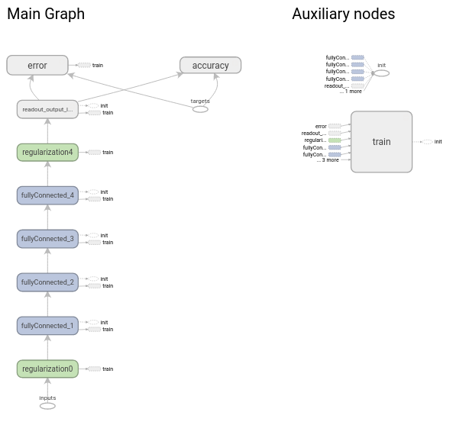
Graph 5: Deep Neural Network - 500 dimensionality of all hidden layers - Learning Rate 1e-4 - ReLU non-linearity - Dropout at Input and Readout layers with keep probabilities as placeholders

Results
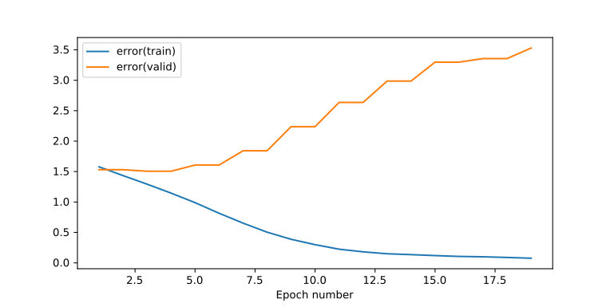
Plot 25: Training & Validation Error - Deep Neural Net - 500 dimensionality of all hidden layers - Learning Rate 1e-4 - ReLU non-linearity - Dropout Keep Probability at Input layer 90% - Dropout Keep Probability at Hidden Layer 50%

Conclusions
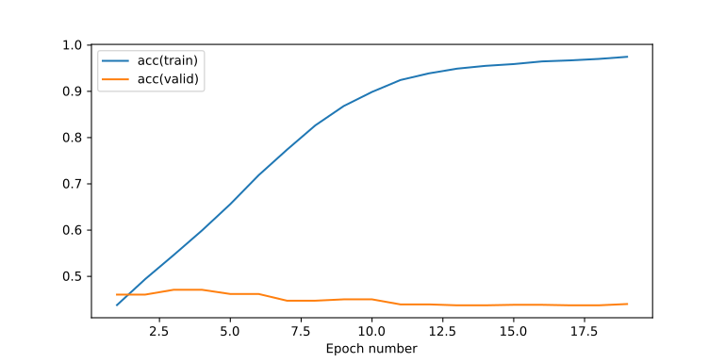
Plot 26: Training & Validation Accuracy - Deep Neural Net - 500 dimensionality of all hidden layers - Learning Rate 1e-4 - ReLU non-linearity - Dropout Keep Probability at Input layer 90% - Dropout Keep Probability at Hidden Layer 50%
We are seeing some regularization occuring since the final validation error is half than it was before but the overfitting effects are still severe.

Research Question: Will dropout on all layers of the deep neural network will work better than before?
More regularization is needed so introducing one dropout layer before each layer of the deep neural network is expected to bring a better regularization.

Method: 4 hidden layers of dimensionality 500 regularized with Dropout at all layers
We are using a dropout layer on all layers of our deep neural network.
Dropout probability for the input is 90% and
dropout probability for all the hidden layers is 50%.
The Learning Rate of Adam Learning Rule is set at the default of 1e-3
The new tensorflow graph is as follows:
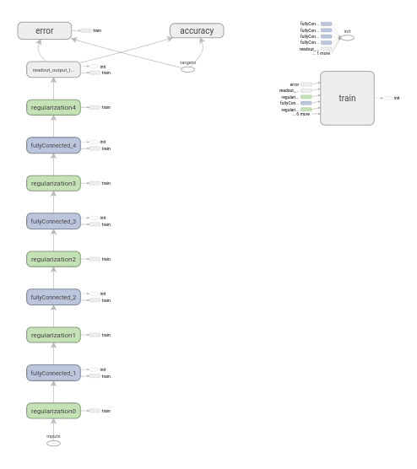
Graph 6: Deep Neural Network - 500 dimensionality at all hidden layers - ReLU non-linearity – Dropout at all layers with keep probabilities as placeholders

Results
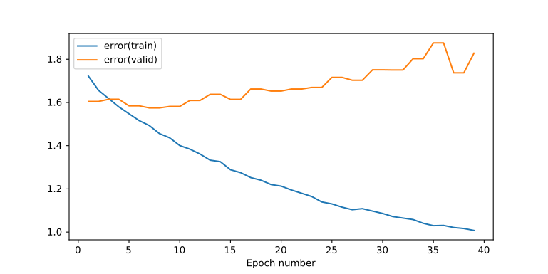
Plot 27: Training & Validation Error – Deep Neural Net – 500 dimensionality at all hidden layers – ReLU nonlinearity - Dropout at Input with keep prob 90% - Dropout at all hidden layers with keep prob 50%

Conclusions
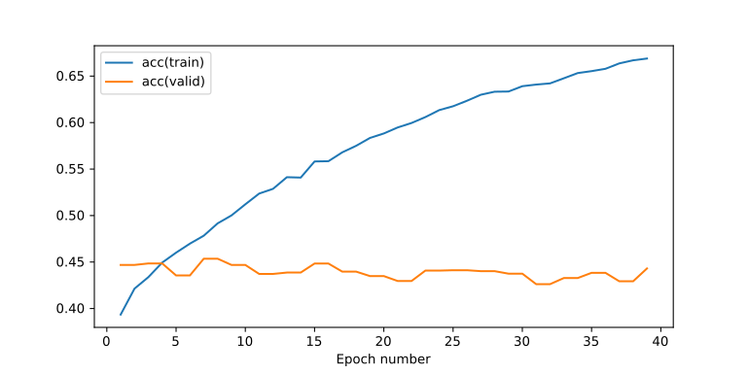
Plot 28: Training & Validation Accuracy – Deep Neural Net – 500 dimensionality at all hidden layers – ReLU nonlinearity - Dropout at Input with keep prob 90% - Dropout at all hidden layers with keep prob 50%
We see that by using dropout on all layers and by setting dropout probabilities low enough we have not achieved a very good regularization and the training has become quite slow.

Research Question: Using Tanh Activation Function yields better results?
One alternative to ReLU which has yielded good results in other classification problems is the tanh non-linearity to be used as activation function of the output of the affine layers.
"For the learning time to be minimized, the use of non-zero mean inputs should be avoided. Now, insofar as the signal vector xx applied to a neuron in the first hidden layer of a multilayer perceptron is concerned, it is easy to remove the mean from each element of xx before its application to the network. But what about the signals applied to the neurons in the remaining hidden and output layers of the network? The answer to this question lies in the type of activation function used in the network. If the activation function is non-symmetric, as in the case of the sigmoid function, the output of of each neuron is restricted to the interval [0,1][0,1]. Such a choice introduces a source of {\em systematic bias} for those neurons located beyond the first layer of the network. To overcome this problem we need to use an antisymmetric activation function such as the hyperbolic tangent function. With this latter choice, the output of each neuron is permitted to assume both positive and negative values in the interval [−1,1][−1,1], in which case it is likely for its mean to be zero. If the network connectivity is large, back-propagation learning with antisymmetric activation functions can yield faster convergence than a similar process with non-symmetric activation functions, for which there is also empirical evidence (LeCun et al. 1991)."
The cited reference is:
Y. LeCun, I. Kanter, and S.A.Solla: "Second-order properties of error surfaces: learning time and generalization", Advances in Neural Information Processing Systems, vol. 3, pp. 918-924, 1991.

Method: 4 hidden layers of dimensionality 500 regularized with Dropout at all layers and using Tanh as the activation function
We will be using exactly the same architecture as above but all of ReLUs non-linearities are substituted with Tanh activation functions

Results
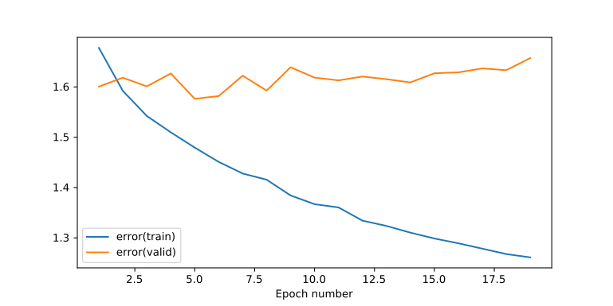
Plot 29: Training & Validation Error – Deep Neural Net – 500 dimensionality at all hidden layers – Tanh nonlinearity - Dropout at Input with keep prob 90% - Dropout at all hidden layers with keep prob 50%

Conclusions
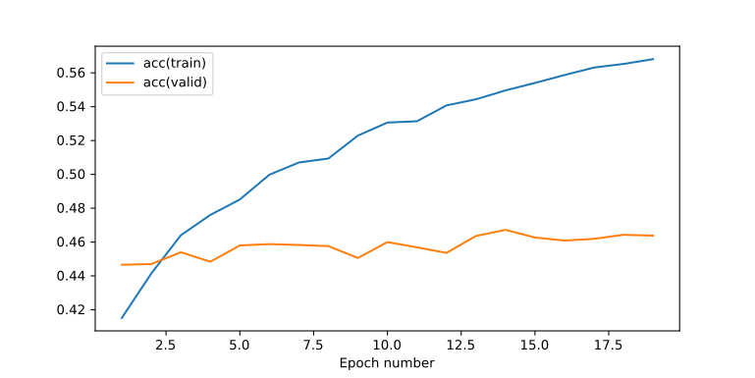
Plot 30: Training & Validation Accuracy – Deep Neural Net – 500 dimensionality at all hidden layers – Tanh nonlinearity - Dropout at Input with keep prob 90% - Dropout at all hidden layers with keep prob 50%
The results are better. The system seems to behave in a more stable way than before but the learning rate is still slower than expected.
The curve of the validation error is more stable.
The curve of the validation accuracy has a slightly increasing trend.
It seems that overall Tanh is more suited for this classification task. We will use Tanh is all of our experiments below unless noted otherwise.

Research Question: How many hidden layers and how large hidden dimensionalities cause a plateau on the training error graph that is above zero ?
Since the attempt to find the best regularization for a certain set of high dimensionality will take lots of resources timewise, we should instead go back and experiment what would be the maximum number of layers and dimensionalities that would make sense for our classification problem.
Since we do not have a solid metric to check how many layers are too many and how many are just enough we are going to base it on the training error rate. (We will not care about validation at this experiment).
Based on the training error we can consider two things:
- If the error is minimized and the training accuracy is close to 100% within only a few epochs then this means that we could introduce more complexity in the model with larger hidden dimensionalities and/or more hidden layers.
- On the other hand if we see that for a few epochs the error reaches at a plateau then we could consider that this architecture is too large and we should try and reduce the hidden dimensionalities and/or hidden layers.

Method: Multiple layers of fixed dimensionality
We are not using any regularization here.
All of the eight hidden layers have dimensionality of 2000.
To simplify the problem even further we are using simple Gradient Descent with Learning Rate of 1e-1 as our optimizer.
We are trying various different combinations.
Minimum layers are 4 and maximum layers are 8.
Minimum dimensionality of each layer is 500 and maximum is 2000.
We already know that 4 layers with dimensionality of 500 each do not cause a plateau so we are not expecting that smaller architectures will have this effect.
The maximum layers of 8 and the maximum dimensionality for each layer of 2000 are chosen because of restriction on the computational resources
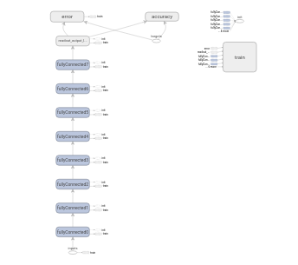
Graph 7: Deep Neural Network – 500-2000 dimensionality at minimum 4 hidden layers and maximum 8 hidden layers – Tanh nonlinearity

Results
We are only showing here the plots of the largest architecture we could implement within our computation restrictions which is 8 layers with 2000 dimensionality for each hidden layer. Only 4 epochs are shown.
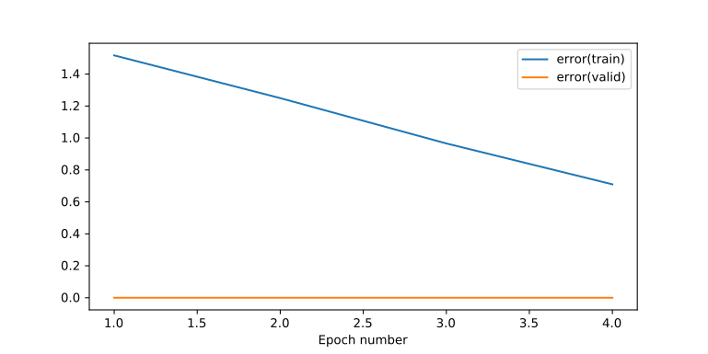
Plot 31: Training Error – Deep Neural Net – 8 hidden layers – 2000 dimensionality at all hidden layers – Tanh nonlinearity – (validation error equal to zero because it is not measured)

Conclusions
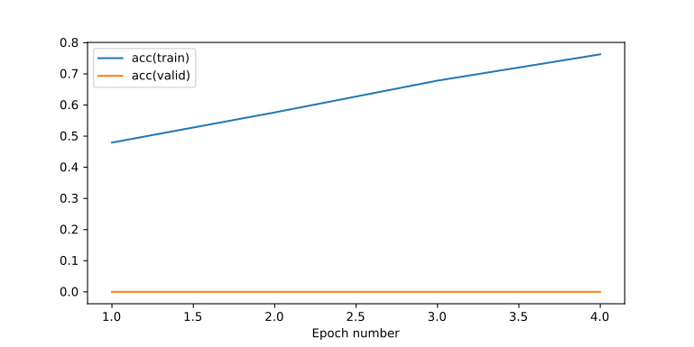
Plot 32: Training Accuracy – Deep Neural Net – 8 hidden layers – 2000 dimensionality at all hidden layers – Tanh nonlinearity – (validation error equal to zero because it is not measured)
Unfortunately after lots of experiments we have not managed to reach to a plateau within our computational limits. Meaning that using 8 hidden layers of 2000 attributes each was not enough. The Gradient Optimizer with learning rate of 1e-1 was able to train the model. The training was slow and also far from optimal but this experiment did not gave an indication that the neural network would have trouble to train fully if enough epochs were calculated.

Research Question: Does a gradual reduction of the dimensionality of the hidden layers helps the performance or the accuracy?
We want to implement a deep architecture but we do not have the computational resources to have all the layers as wide as we wish. Therefore we need to decrease our dimensionality in a sensible way. Since the input dimensionality is 3000 and the output dimensionality is 10 it makes sense to gradually reduce the dimensionality of the layers asking for less and less neurons to be able and carry the burden of representing the genres of the songs.

Method: 6 layers of gradually decreasing dimensionality.
The dimensionality starts from 1000 for the first layer and is linearly decreased up to the sixth layer with final dimensionality of 25, and then the readout layer which is 10.
More specifically the dimensionality of the layers from input to ouput are these:
3000 → 1000 → 805 → 610 → 415 → 220 → 25 → 10

We are not using any regularization yet.
The graph of tensorflow is as follows:
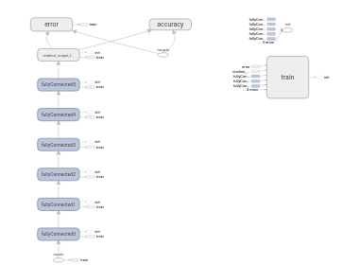
Graph 8: Deep Neural Network – 6 hidden layers – Tanh nonlinearity – Hidden dimensionalities [1000, 805, 610, 415, 220, 25]

Results
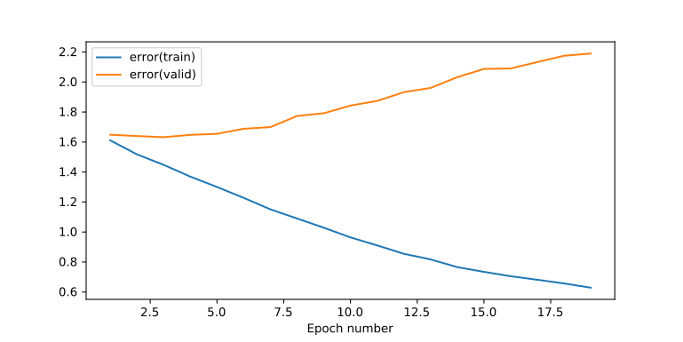
Plot 33: Training & Validation Error - Deep Neural Network – 6 hidden layers – Tanh nonlinearity – Hidden dimensionalities [1000, 805, 610, 415, 220, 25]

Conclusions
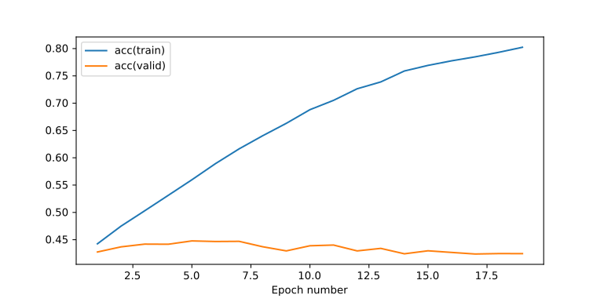
Plot 34: Training & Validation Accuracy - Deep Neural Network – 6 hidden layers – Tanh nonlinearity – Hidden dimensionalities [1000, 805, 610, 415, 220, 25]
We should note that the deep neural network has an improved accuracy to begin with which these are signs of a better classifier. As the epochs go by the overfitting effects are apparent which is expected.
We will use these results as a basis for our deep neural network.

