Research Question: Will pretraining yield better results for the deeper neural network?
The first attempt for pretraining did not yield any wanted results at the shallow neural network. Now that we have a deeper neural network we might get some added value from pretraining.

Method: Stacked Autoencoder Pretraining for all layers
We are using the exact same methodoly we used above but now the stacked autoencoder is executed iteratively for multiple layers
The tensorflow graph is available below:

Results
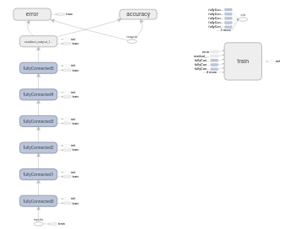
Graph 9: Deep Neural Network – six hidden layers – Tanh nonlinearity – Hidden dimensionalities [1000, 805, 610, 415, 220, 25] – Pretraining with Stacked Autoencoder
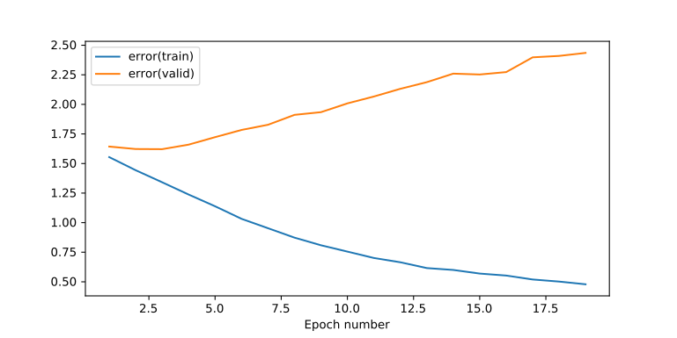
Plot 35: Training & Validation Error - Deep Neural Network – six hidden layers – Tanh nonlinearity – Hidden dimensionalities [1000, 805, 610, 415, 220, 25] – Pretraining with Stacked Autoencoder

Conclusions
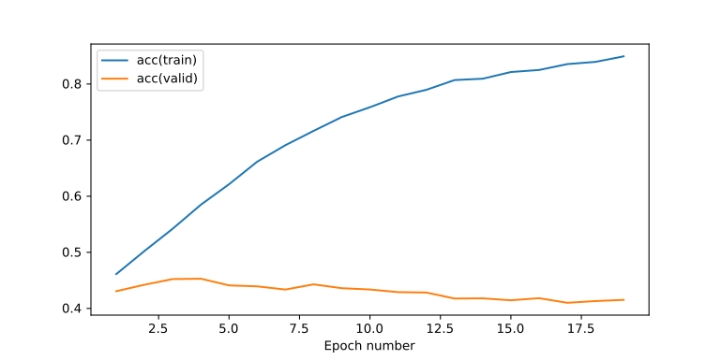
Plot 36: Training & Validation Accuracy - Deep Neural Network – six hidden layers – Tanh nonlinearity – Hidden dimensionalities [1000, 805, 610, 415, 220, 25] – Pretraining with Stacked Autoencoder
After pretraining we get a maximum of ~45% which is not different than before.
Of course after a few epochs due to overfitting the accuracy is gradually decreasing.
The training is low with maximum training accuracy of ~80% after 20 epochs.

Research Question: Will Batch Normalization increasing the learning rate of the Deep Neural Network?
As the data goes through the neural network the weights and biases are adjusted making them too big or too small. This is called the “internal covariate shift”. So by normalizing the data in each batch the problem is avoided.
This helps the learning rate because the weights do not have large and noisy fluctuations. In most cases you also get a higher accuracy as well.

Method: Batch Normalization in all layers with scaling and shifting factors
We are applying batch normalization to all outputs of the affine layers in order to have normalization all over the place.
Note that we are including a scaling and a shifting factor which are both trainable so that we will not confine our representations to only normalized values.
Here the graph that includes batch normalization is slightly different than before because it includes the tf.cond which is a way of tensorflow to express an if-statement in the graph according to a boolean placeholder.
We recall that batch normalization works differently on training and validation/testing scenario. We need to use the batch mean and the batch variance during training while we need to use the population mean and population variance at validation/testing cases.
The population mean and variance are computed as the exponential moving average of the batch mean and variance accordingly. They are derived from the following formulas:

The decay factor is set to 0.999 to give a higher weight at the population mean and lower weight at the batch mean. This works ok for cases where we have lots of batches like this one.
Note that the population mean is initialized to zeros and population variance is initialized to ones.
Here is the tensorflow graph:
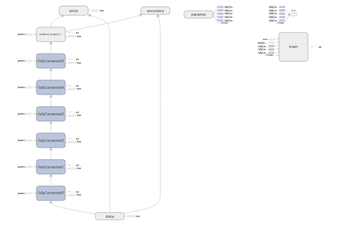
Graph 10: Deep Neural Network – six hidden layers – Tanh nonlinearity – Hidden dimensionalities [1000, 805, 610, 415, 220, 25] – Pretraining with Stacked Autoencoder - Batch Normalization on all layers

Results
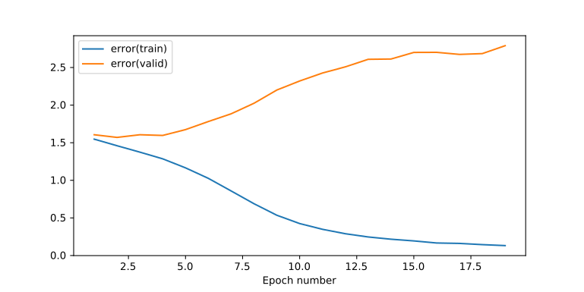
Plot 37: Training & Validation Error - Deep Neural Network – six hidden layers – Tanh nonlinearity – Hidden dimensionalities [1000, 805, 610, 415, 220, 25] – Pretraining with Stacked Autoencoder - Batch Normalization on all layers

Conclusions
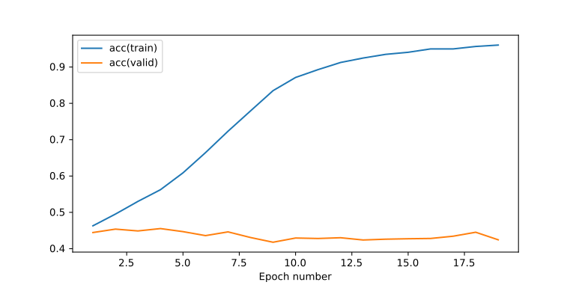
Plot 38: Training & Validation Accuracy - Deep Neural Network – six hidden layers – Tanh nonlinearity – Hidden dimensionalities [1000, 805, 610, 415, 220, 25] – Pretraining with Stacked Autoencoder - Batch Normalization on all layers
The results of this experiment were as expected and wanted.
Batch normalization helped the learning rate, resulted in higher overall training accuracy within 20 epochs and the validation accuracy peaked at a higher level, before the overfitting effects reduce it.

Research Question: Will Dropout help increase the maximum validation accuracy and regularize the deep neural network?
We are attempting to use Dropout as our only means for regularization.

Method: Dynamic Dropout in all layers
We are using the exact same algorithm we used before for dynamically configuring the dropout probabilities of the input and hidden layers.
The initial dropout probabilities are 50% for all layers.
The minimum dropout probabilities are 50% for the input layer and 10% for all the other layers
Maximum dropout probability for all layers is 100%.
Resolution hyperparameter is 10
Gamma hyperparameter is 0.6.
The tensorflow graph is as follows:
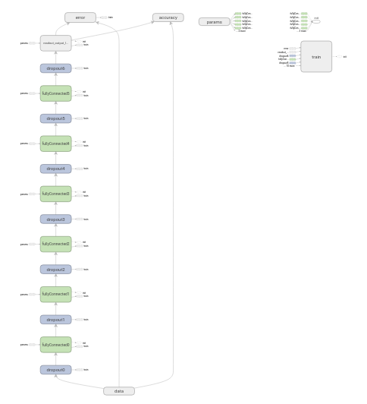
Plot 39: Deep Neural Network – six hidden layers – Tanh nonlinearity – Hidden dimensionalities [1000, 805, 610, 415, 220, 25] – Pretraining with Stacked Autoencoder - Batch Normalization at all layers – Dropout layer before all layers with keep probabilities as placeholders

Results
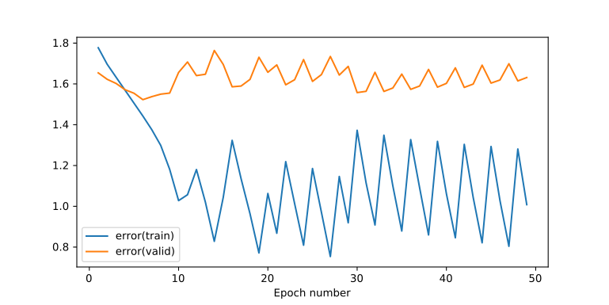
Plot 40: Training & Validation Error - Deep Neural Network – six hidden layers – Tanh nonlinearity – Hidden dimensionalities [1000, 805, 610, 415, 220, 25] – Pretraining with Stacked Autoencoder - Batch Normalization at all layers – Dropout layer before all layers with keep probabilities dynamic – min input prob 50% - min hidden prob 10% - Resolution hyperparameter 10 - Gamma hyperparameter 0.6

Conclusions
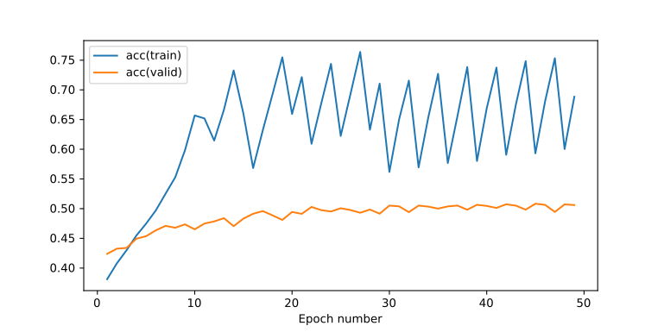
Plot 41: Training & Validation Accuracy - Deep Neural Network – six hidden layers – Tanh nonlinearity – Hidden dimensionalities [1000, 805, 610, 415, 220, 25] – Pretraining with Stacked Autoencoder - Batch Normalization at all layers – Dropout layer before all layers with keep probabilities dynamic – min input prob 50% - min hidden prob 10% - Resolution hyperparameter 10 - Gamma hyperparameter 0.6
Due to the varied dropout probability caused by our dynamic algorithm we can see that the validation error has remained constant, on average, for the 50 epochs without any trend of increase and the 50 epochs.
We can also see that the validation is on average slowly increasing until epoch ~30 and then remained still at ~50%. It peaked at 50.8% which is the largest accuracy value we have seen so far.

Research Question: Is L2 regularization going to be stable to regularize the deep neural network?
So far we have only considered Dropout as our means of regularization. Next we will check if L2 regularization is useful as well.

Method: L2 regularization
We are using the architecture we used above but we have removed all the dropout layers and the source code related to dynamic dropout.
Instead we have got the L2 loss for all of the weights of the fully connected layers of our deep neural network.
No regulation for the biases.
This loss is added to the total loss/error that is passed as input to our Adam Optimizer.
The L2 losses of all the weights are multiplied by a common lambda factor equal to 1e-2.
Tensorflow graph is as follows:
Graph 11: Deep Neural Network – six hidden layers – Tanh nonlinearity – Hidden dimensionalities [1000, 805, 610, 415, 220, 25] – Pretraining with Stacked Autoencoder - Batch Normalization at all layers – L2 regularization with factor 1e-2

Results
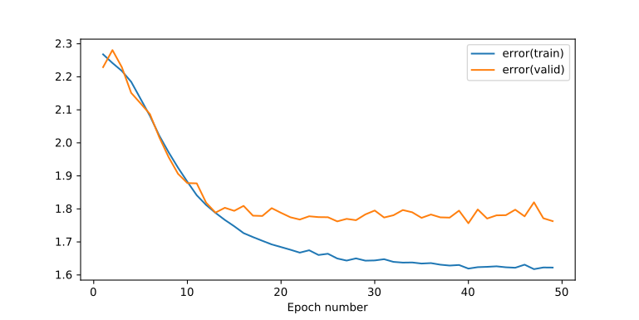
Plot 42: Training & Validation Error - Deep Neural Network – six hidden layers – Tanh nonlinearity – Hidden dimensionalities [1000, 805, 610, 415, 220, 25] – Pretraining with Stacked Autoencoder - Batch Normalization at all layers – L2 regularization with factor 1e-2

Conclusions
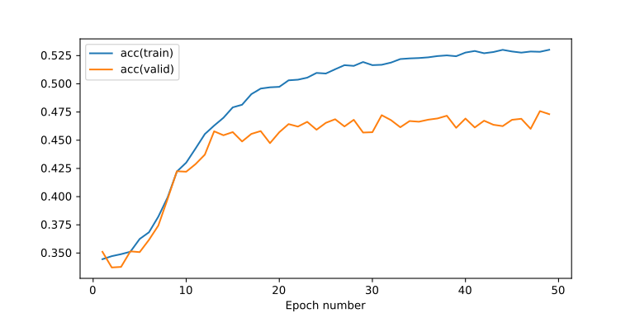
Plot 43: Training & Validation Accuracy - Deep Neural Network – six hidden layers – Tanh nonlinearity – Hidden dimensionalities [1000, 805, 610, 415, 220, 25] – Pretraining with Stacked Autoencoder - Batch Normalization at all layers – L2 regularization with factor 1e-2
L2 regularization is successful when the lamda2 hyperparameter is set to 1e-2.
It is noticable how the validation error is maintained within a certain region, even if there are small oscillations, and the validation accuracy reaches to a steady value of 47%, again with some oscillations.

