Protocol followed for the MSD-10 classification task:
Through the process of trying to achieve better classification accuracy for the MSD-10 classification task we have followed a certain protocol:
- We have first pretrained the network with Stacked Autoencoder to start from a good place.
- Then we picked a deep neural network with dimensionality that was slowly decreasing.
- We replaced ReLU with Tanh as our activation functions.
- We introduced Batch Normalization at the output of each affine layer.
- We introduced Dropout layers before the input of all hidden layers with a shared keep-probability. We also used a typically higher Dropout probability for the input layer.
- We used an algorithm to calibrate the dropout probabilities according to the validation error in order to achieve the best possible dropout probabilities that would keep the validation error as low as possible.

Research Question: What kind of results will the current protocol have on the MSD-25 classification task?
We are using the same protocol that we used for MSD-10 task.

Method: Deep Neural Network with 8 layers and same protocol as MSD-10 classification task
For MSD-25 we will follow the same protocol as we did for MSD-10 but we will use a deeper architecture since we expect that a more rich model will be needed to represent the 25 genres.
The hidden dimensionality from input to ouput layer by layer is as follows:
3000 → 1000 → 860 → 721 → 582 → 442 → 303 → 164 → 25

The dynamic dropout used here has the following hyperparameters:
Minimum Input Dropout Probability: 50%
Minimum Hidden Dropout Probability = 10%
Resolution = 10
Gamma = 0.6

The tensorflow graph is available below:
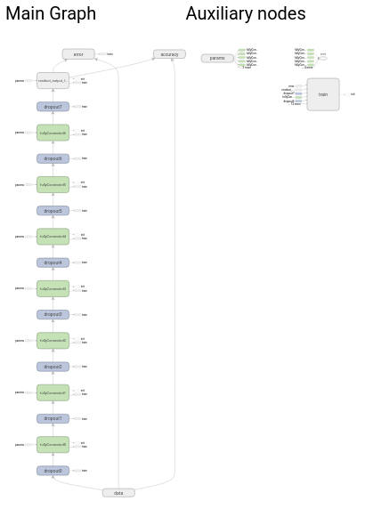
Graph 12: Deep Neural Network – 8 layers – Hidden dimensionalities [1000, 860, 721, 582, 442, 303, 164] – Tanh nonlinearity – Pretraining with Stacked Autoencoder – Batch Normalization at all layers – Dropout at all layers with keep probabilities as placeholders

Results
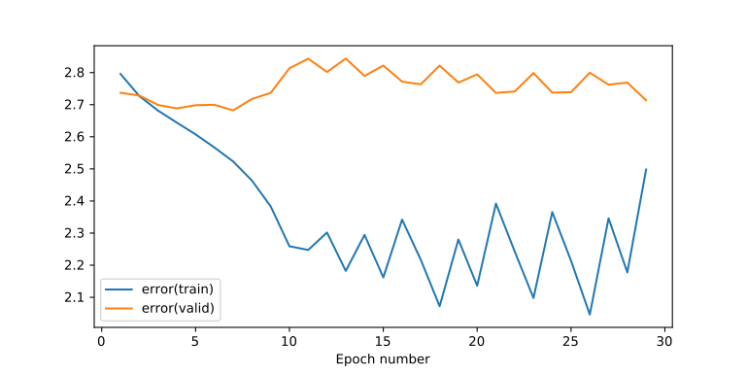
Plot 44: Training & Validation Error - Deep Neural Network – 8 layers – Hidden dimensionalities [1000, 860, 721, 582, 442, 303, 164] – Tanh nonlinearity – Pretraining with Stacked Autoencoder – Batch Normalization at all layers – Dynamic Dropout with min input keep prob. 50% and min input keep prob 10% - Gamma hyperparameter 0.6 – Resolution hyperparameter 10
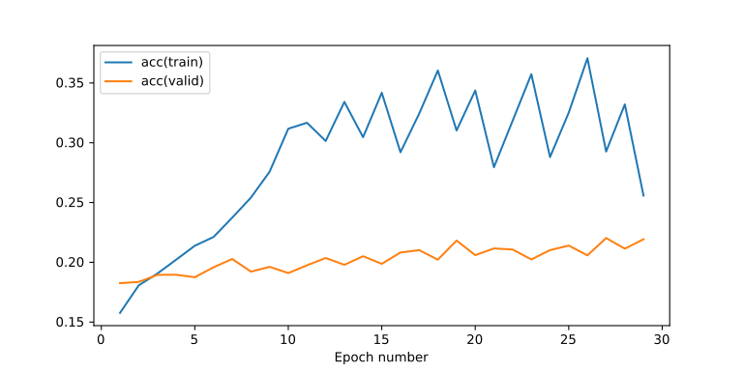
Plot 45: Training & Validation Accuracy - Deep Neural Network – 8 layers – Hidden dimensionalities [1000, 860, 721, 582, 442, 303, 164] – Tanh nonlinearity – Pretraining with Stacked Autoencoder – Batch Normalization at all layers – Dynamic Dropout with min input keep prob. 50% and min input keep prob 10% - Gamma hyperparameter 0.6 – Resolution hyperparameter 10

Conclusions
We see that the classification of the 25 genres is a much more difficult task for an even deeper neural network. More computational power is required and the learning rate is slower.
More resources are needed timewise as well because we should let the algorithm run for longer periods to get satisfactory results.
Thankfully our protocol has performed well in terms of regularization since we see that the validation error has remained stable.
The maximum validation accuracy recorded is ~22% which is less than the half for the validation accuracy of the simpler MSD-10 classification task.

Research Question: Will pretraining with the parameters of a model optimized for a similar classification task yield better results?
We are exploring another kind of pretraining based on neural networks we have trained before.

Method: Pretraining using the model parameters of the MSD-10 classifier
Here we are going to use the same neural network as above and the same protocol but we are pretraining it by asking it to solve the MSD-10 classification task first.
All the variables from all the layers of the weights, biases, along with the trainable parameters of batch normalization (beta offset and scale gamma) are used to pretrain/initialize the layers of the MSD-25 classifier.
Note that the current experiment is not in a direct comparison with the above experiment because we are using a different architecture of 6 layers, as opposed with the 8 layers used above. This is because we had optimize the msd-10 classification task for six layers.
So layer dimensionalities are these: 3000 → 1000 → 805 → 610 → 415 → 220 → 25

The tensorflow graph is as follows:
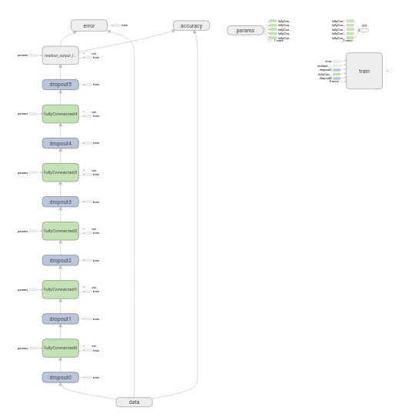
Graph 13: Deep Neural Network – 6 layers – Hidden dimensionalities [1000, 805, 610, 415, 220, 25] – Tanh nonlinearity – Batch Normalization at all layers – Dropout at all layers with keep probabilities as placeholders - Pretraining with model params of MSD-10 classification task

Results
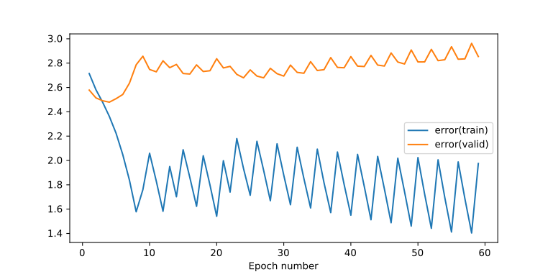
Plot 46: Training & Validation Error - Deep Neural Network – 6 layers – Hidden dimensionalities [1000, 805, 610, 415, 220, 25] – Tanh nonlinearity – Batch Normalization at all layers – Dynamic Dropout with min input keep prob. 50% and min input keep prob 10% - Gamma hyperparameter 0.6 – Resolution hyperparameter 10 – Pretraining with model params of MSD-10 classification task
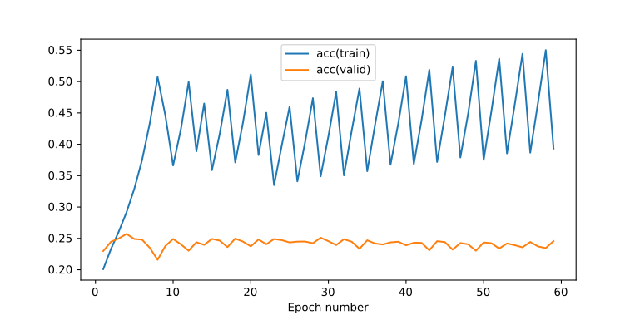
Plot 47: Training & Validation Accuracy - Deep Neural Network – 6 layers – Hidden dimensionalities [1000, 805, 610, 415, 220, 25] – Tanh nonlinearity – Batch Normalization at all layers – Dynamic Dropout with min input keep prob. 50% and min input keep prob 10% - Gamma hyperparameter 0.6 – Resolution hyperparameter 10 – Pretraining with model params of MSD-10 classification task

Conclusions
Pretraining by model parameters of MSD-10 classifier worked better than expected. We started with a very good validation accuracy and we peaked over 25% which is the best we have seen so far for MSD-25 classification task.
However our dynamic dropout algorithm did a poor job on converging and we can see an overall increasing trend of the validation error, meaning that it did not work as an optimal regularizer.

Further Work
- Even though our simple algorithm for dynamic dropout yield some promising results, it includes a lot of resources both timewise and computationally to make it converge. So for final coursework 4 we will not continue using it. Instead we will try and combine L2 regularization with dropout of static keep-probability and use that as our baseline.
- We are going to build our own custom Data Provider in order to exploit the song data with segments of variable length. We will utilize Recursive Neural Networks to build a classifier for the variable length segments.
- We will try and use Curriculum Learning in order to train first the most easier to be classified samples and then to train the more “difficult” ones.
- Given that the MSD-25 classes are a specialization of the more generic classes of the MSD-10, we will train a network for the MSD-25 classification task and then use the learned classes to derive the simpler classes of the MSD-10 classification task and see how well our classifier performs then.
- More experiments to drive the classification accuracy of unseen data/songs as high as possible

Tensorflow & Python Technical Details Appendix
- Pretrained model variables are saved in .npz files with the np.savez method whenever necessarry and then loaded with the np.load method
- We are not using the tensorflow default graph, rather we are creating our own graph and use that on each experiment via the graph = tf.Graph() command
- batch_norm.py file contains functionality useful for batch normalization
  - batchNormWrapper_byExponentialMovingAvg is a wrapper function which sets four variables. Two trainable variables will be our beta offset and the scale gamma which are added and multiplied respectively. We use two more variables for the population mean and variance and exponential moving average is used to approximate it from the mean and variance of the batches.
Note that the with tf.control_dependencies is used to force tensorflow to calculate the mean and variance before proceeding with calculating the actual batch normalization step
  - fully_connected_layer_with_batch_norm is a function that created a fully connected affine and a nonlinearity putting a batch normalization layer in between
- jupyter_notebook_helper.py file contains functionality for plotting graphs and plots embedded in jupyter and in tensorbard
  - show_graph is the function provided to show a tensorflow graph inside jupyter notebook
  - getRunTime is a function to calculate the duration of the execution of a callback function passed as a parameter
  - getWriter, getTrainWriter and getValidWriter are three functions that work with the convention that the log directory for summaries for tensorboard will be the concatenation of an arbitrary path folder, the timestamp with second precision and a key value
  - initStats is a function to initialize the statistics we collect on every epoch
  - gatherStats is a helper function to set each passed parameter to the right index at the two dimensional stats array
  - plotStats is a function to render the statistics as a line plot inside jupyter notebook
- py_helper.py file contains a collection of functions usually generically useful for any python program
  - merge_dicts is a helper function to easily merge an arbitrary number dictionaries. Key conflicts are solved by giving precedence to the dictionaries that are of lower order in the stack. For example the dictionary at the tail has higher precedence than the dictionary before that etc.
- tf_helper.py file contains methods generally useful across tensorflow applications
  - tfRMSE calculates the Root Mean Sum of Square Residuals
  - tfMSE calculates the Mean Sum of Square Residuals
  - fully_connected_layer adds to a tensorflow graph a combinations of an affine layer along with a nonlinearity
  - trainEpoch and validateEpoch are helping to reduce the boilerplate code for training and validating a neural network for an entire epoch. Both functions take into account the keep probabilities of dropout layers that could be used as placeholders and an extra feed dictionary for passing extra parameters.
- stacked_autoencoder_pretrainer.py file contains useful functionality for stacked autoencoder pretraining. This module is mainly the same functionality that was used for coursework2 but refactored to work for tensorflow framework.
  - executeNonLinearAutoencoder is a function that builds a graph where there is one hidden layer and the error function is provided as parameter but it is typically the Mean Sum of Square Residuals, since we are trying to make the output match the input
  - buildGraphOfStackedAutoencoder is a function that creates a graph with all the layers that are already pretrained and put onto the stack. This is necessary to get inputs that have passed through the pretrained network.
  - constructModelFromPretrainedByAutoEncoderStack is a function which makes the stacked autoencoder as a black box. You only need to provide a set of dimensionalities for all hidden layers and a data provider class capable of processing a batch before returning the inputs/outputs set (which in the case of autoencoding are the same).
- In data_provider.py file in mlp folder you will find the MSD10Genre_StackedAutoEncoderDataProvider and MSD25Genre_StackedAutoEncoderDataProvider classes.
Their implementations are identical and they are mainly extending the corresponding class to provide a way to process an input batch.

