**LAZY TAG**

## An alternative solution to JSF “dataTable” session overload

Install Guide.

The Lazy Tag solution uses the following technologies

* JSF 2.0 (MVC framework for building J2EE based web applications)
* AJAX4JSF
* TOMAHAWK
* JPA
* EJB 3.0

In addition to run the application you would require a database server and an application server.

The steps to install are as follows:

### Step 1

Database server: Install one of the free RDBMS servers like PostgresSQL or MySql.

### Step 2

Create a database schema and populate the table with data using the script in github under:

<https://github.com/plimaye/LazyTag/tree/master/Scripts>

If you are using PostgreSQL the script is named:

[PostgreSQL_DBScript.txt](https://github.com/plimaye/LazyTag/blob/master/Scripts/PostgreSQL_DBScript.txt)

If you are using MySQL, the script is named:

[MySQL_DBScript.txt](https://github.com/plimaye/LazyTag/blob/master/Scripts/MySQL_DBScript.txt)

### Step 3

Application server and IDE:

We advice you install NetBeans IDE as it comes pre-configured GlassFish Application Server. You are free to install any other IDE and any other application servers as long as you can follow the instructions for configuring the application relevant to the server of your choice.

### Step 4

Download the source code from the github source link:

<https://github.com/plimaye/LazyTag>

### Step 5

Import the source code folder into the IDE of your choice.

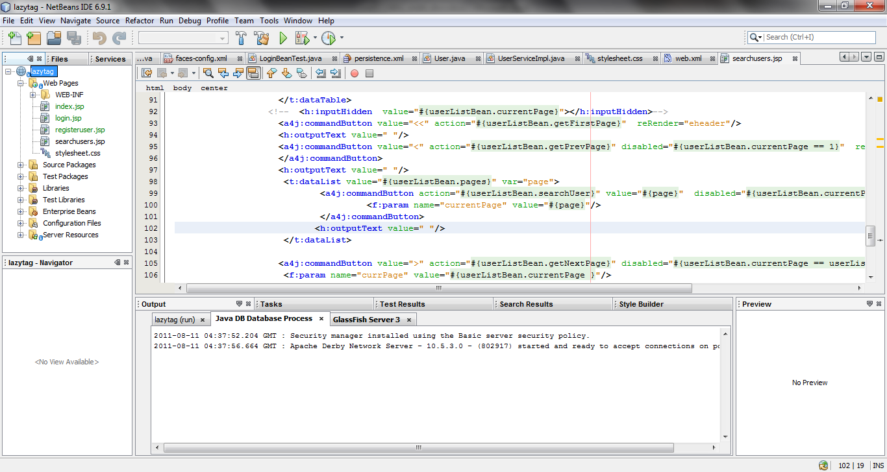

### Step 6

We assume you have the pre-requisites to compile a Java Enterprise Project like JDK6 (JAVA_HOME, environment variable setup).

### Step 7

The following jars which are required for the project.

* Database driver jar (specific to the database you choose to connect to) eg: postgresql-9.0-801.jdbc4 (for postgres DB)
* ajax4jsf-1.1.1
* tomahawk-1.1.10-bin

You can find all the jars in this location in our github repository

<https://github.com/plimaye/LazyTag/tree/master/Libs>

The location of all the above jars needs to be configured in the build path of your project.

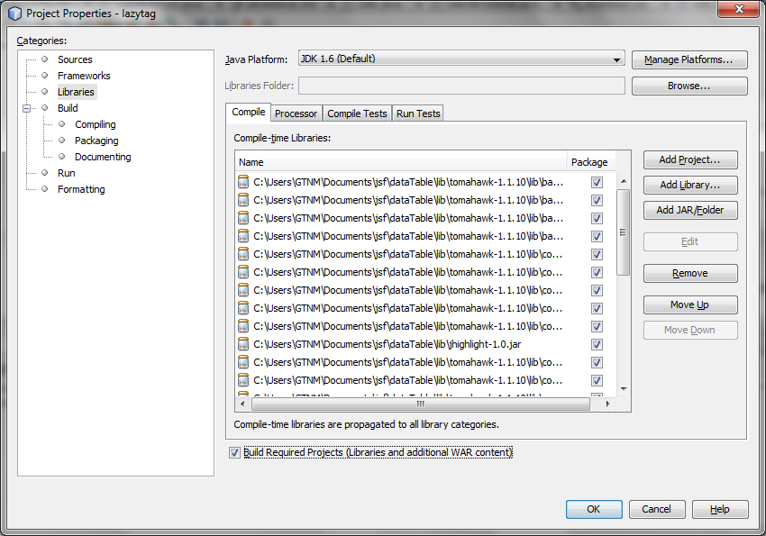

### Step 8

Configure the datasource connection details to match the database connection settings.

This can be found under the sun-resources.xml file as shown below:

<?xml version="1.0" encoding="UTF-8"?>

<!DOCTYPE resources PUBLIC "-//Sun Microsystems, Inc.//DTD Application Server 9.0 Resource Definitions //EN" "http://www.sun.com/software/appserver/dtds/sun-resources_1_3.dtd">

<resources>

<jdbc-resource enabled="true" jndi-name="jdbc/newDataSource" object-type="user" pool-name="connectionPool">

<description/>

</jdbc-resource>

<jdbc-connection-pool allow-non-component-callers="false" associate-with-thread="false" connection-creation-retry-attempts="0" connection-creation-retry-interval-in-seconds="10" connection-leak-reclaim="false" connection-leak-timeout-in-seconds="0" connection-validation-method="auto-commit" datasource-classname="org.postgresql.ds.PGSimpleDataSource" fail-all-connections="false" idle-timeout-in-seconds="300" is-connection-validation-required="false" is-isolation-level-guaranteed="true" lazy-connection-association="false" lazy-connection-enlistment="false" match-connections="false" max-connection-usage-count="0" max-pool-size="32" max-wait-time-in-millis="60000" name="connectionPool" non-transactional-connections="false" pool-resize-quantity="2" res-type="javax.sql.DataSource" statement-timeout-in-seconds="-1" steady-pool-size="8" validate-atmost-once-period-in-seconds="0" wrap-jdbc-objects="false">

<property name="databaseName" value="sampledb" />

<property name="URL" value="jdbc:postgresql://localhost:5432/sampledb"/>

<property name="User" value="postgresuser"/>

<property name="Password" value=" postgrespassword "/>

</jdbc-connection-pool>

</resources>

The above file can be generated by using the : New 🡪 File🡪 Glassfish🡪JDBC Resource

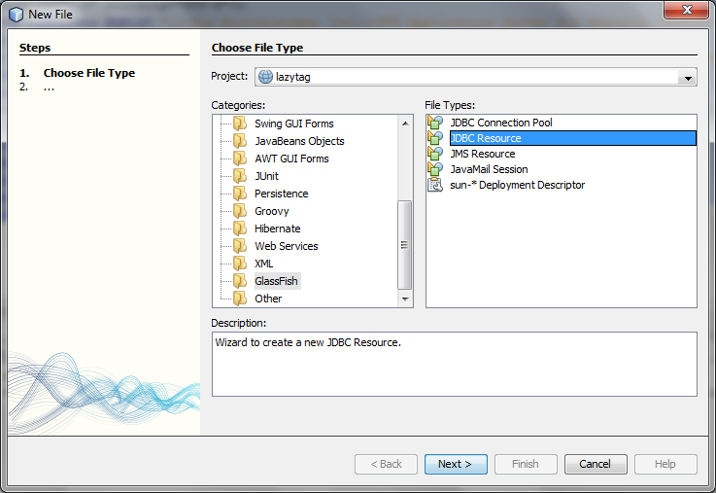

Fill in the required details of the required DB server, driver class, DB connection details.

### Step 8

Now that the IDE has been setup, choose to clean and build the project using the IDE.

### Step 9

Run the project , which will invoke the login url.

