Turing Machine Application Design

Christopher Wilkins
CptS 322 Spring 2014
Professor Corrigan
5/5/2014

Table of Contents
List of figures 1
Revision History 2
1.0 Introduction 3
2.0 Architecture 4
3.0 Data Dictionary 8
4.0 User Interface 32
5.0 Files 45

List of Figures

Figure 1 Page 4
Figure 2 Page 4
Figure 3 Page 4
Figure 4 Page 4
Figure 5 Page 5
Figure 6 Page 5
Figure 7 Page 5
Figure 8 Page 5
Figure 9 Page 5
Figure 10 Page 6
Figure 11 Page 6
Figure 12 Page 6
Figure 13 Page 6
Figure 14 Page 7
Figure 15 Page 7
Figure 16 Page 32
Figure 17 Page 32
Figure 18 Page 33
Figure 19 Page 34
Figure 20 Page 35
Figure 21 Page 35
Figure 22 Page 36
Figure 23 Page 36
Figure 24 Page 37
Figure 25 Page 38
Figure 26 Page 38
Figure 27 Page 39

Revision History
2.0 5/5/2014 Revised Final Submission
1.0: 4/11/2014 Initial Submission

1.0 Introduction
The design document contains the full design for the Turing Machine application. It describes a design that fulfills the requirements denoted in the Turing Machine Requirements specification. It is intended to be a blueprint that shows everything that is necessary to fully implement the Turing Machine application. The intended audience for this document are developers who are planning on implementing this design for a Turing Machine application. This design described in this document is ideally intended to be used with an object oriented programming language, such as C++. However, the design is not language-dependent, so it can be used with other languages, including non-object oriented languages.
This document is organized into four parts: Architecture, data dictionary, user interface examples, and file list. The architecture section is a visual representation of the design of this software using the Unified Modeling Language (UML). It shows the layout of each class in this application as well as the relationships between all classes. The UMLs provide a literal description of the classes in this application, and are intended to be used to directly implement the application. The architecture contains a figure showing a high-level view of all of the classes in the application and their relationships. It also shows a more microscopic view of each class, its attributes, and its methods.
The data dictionary explains the purpose of each class in detail. It describes what each attribute stores and describes the function and purpose of every method. It describes the relationships that each class has with the other classes in the application, including its lifetime. It also explains how each class fulfills requirement(s) of the Turing machine application.
The user interface section provides examples of the Turing Machine Application user interface, demonstrating how the application is intended to be used. The application is a command line program, so to use the application, one must type commands into the command prompt provided with the application. The user interface section gives an overview of each command, its purpose, and what it will cause the Turing Machine application to do.
The file list section shows an example of the two types of files used by this application: the turing machine definition file and the input string file. These files are shown exactly how they are intended to be used in the application as specified by the requirements specification, although formatting is subject to variation.

2.0 Architecture
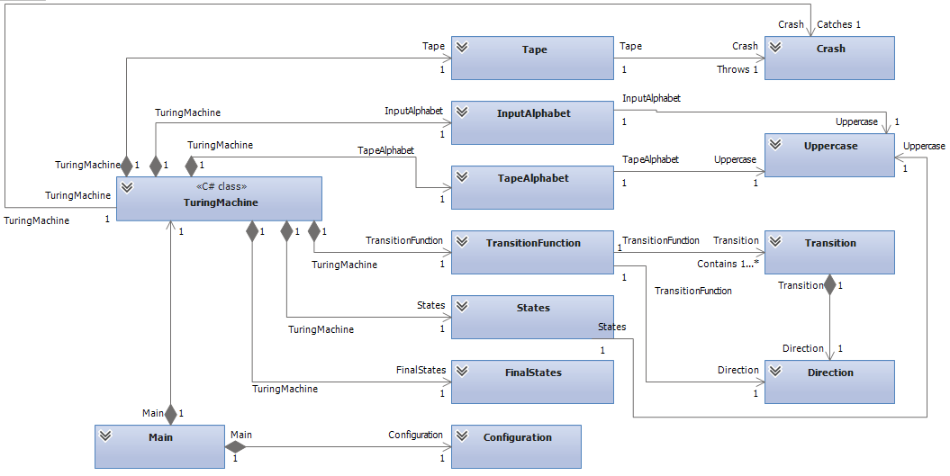
Figure 1 The TuringMachine class UML and the overview of the relationships of the TM application classes.

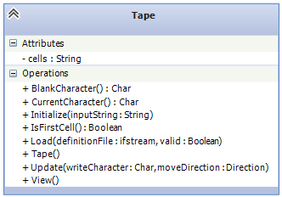
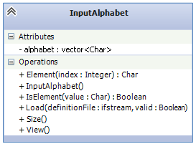

Figure 2 Tape UML class diagram Figure 3 Input Alphabet UML class diagram
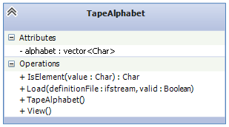
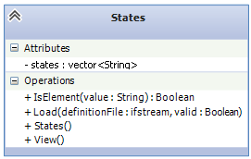

Figure 4 TapeAlphabet UML class diagram Figure 5 States UML class diagram
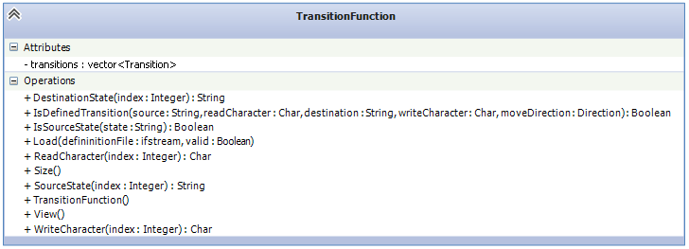
Figure 6 TransitionFunction UML class diagram
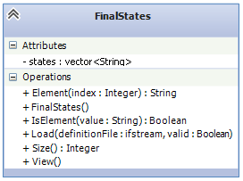
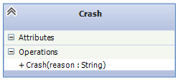

Figure 7 FinalStates UML class diagram Figure 8 Crash UML class diagram

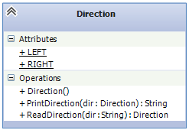
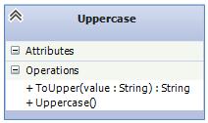

Figure 9 Direction UML class diagram Figure 10 Uppercase UML class diagram

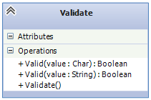
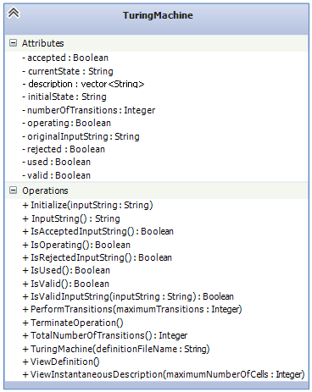

Figure 11 Validate UML class diagram

Figure 12 The TuringMachine UML class diagram
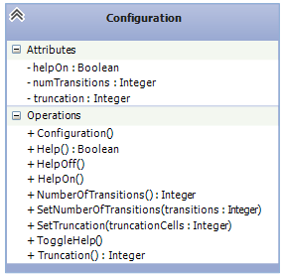

Figure 13 Configuration UML class diagram

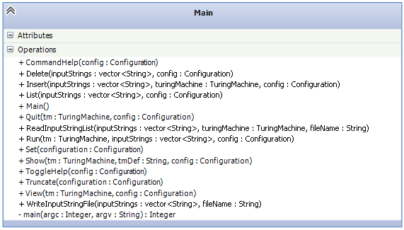

Figure 14 Main UML class diagram

3.0 Data Dictionary

Class:
TuringMachine

Description:
The TuringMachine class manages the operation of the Turing Machine in the turing machine application. It keeps track of whether or not the turing machine has operated on an input string, the number of transitions performed by the turing machine, the current state that the turing machine is in, the initial state that the turing machine starts in, and whether or not the current input string has been accepted or rejected. It is responsible for creating the definition file object that is passed to each part of the application. It also keeps track of whether or not the turing machine specified by the definition is valid. This class contains all of the methods that are necessary to view the turing machine, show its status, and run transitions on an input string.

Associations:
The TuringMachine class is composed of a Tape, InputAlphabet, TapeAlphabet, States, FinalStates, and TransitionFunction. The TuringMachine creates all of those objects throughout its lifetime. They do not exist outside of the TuringMachine class.

Attributes:
description:StringVector
The description attribute is a string vector consisting of the full description as specified in the Turing Machine definition file. Each element of the description string vector is a line of the description.

initialSate:String
The initialState attribute stores the name of the starting state of the turing machine as a string. This value is read from the Turing Machine definition file and does not change after it is initialized throughout the lifetime of the TuringMachine class.

currentState:String
The currentState attribute stores the name of the current state that the turing machine is in as a string.

originalInputString:String
The original input string attribute stores the original input string as it was before any transitions have taken place. This exists for the purposes of the view command, which shows the original input string. It is set by the user the first time the run command is used.

numberOfTransitions:Integer
The numberOfTransitions attribute stores the total number of transitions that have been run by all runs of the Run command on an input string. It is an integer value.

valid:Boolean
The valid attribute stores whether or not the turing machine definition file is valid as a boolean. This attribute is initially set to true, but it is changed by either the TuringMachine class or its subordinates if the file is found to be invalid.

used:Boolean
The used attribute stores whether or not the turing machine has ever been run on an input string as a boolean. This is initially set to false, but it is set to true by the PerformTransitions method.

operating:Boolean
The operating attribute stores whether or not the turing machine is currently operating on an input string as a boolean. This is initially set to false, but it is set to true by the PerformTransitions method. When it is determined that that input string has been accepted or rejected, or if the user uses the “Quit” command, this attribute is set to false.

accepted:Boolean
The accepted attribute stores whether or not the turing machine has been accepted as a boolean. This attribute is initially set to false, but is changed to true when the turing machine successfully completes operation on an input string and reaches a final state.

rejected:Boolean
The rejected attribute stores whether or not the turing machine has been rejected as a boolean. This attribute is initially set to false, but it is changed to true when the turing machine reaches a non-final state where there are no valid transitions given the current state and tape head character. It also is set to true if the tape head is moved left when it is position at the first cell of the tape.

Methods:
TuringMachine(in definitionFileName:String)
The TuringMachine is the constructor for the TuringMachine class. It sets all attributes with their initial values as described in the attributes section. It accepts the name of the Turing Machine definition file as a string. The constructor creates the Turing Machine definition file object. It creates instances of Tape, TapeAlphabet, InputAlphabet, States, FinalStates, and TransitionFunction. It passes the turing machine definition file object to each of the classes.

ViewDefinition()
The ViewDefinition method displays the turing machine definition. This prints the definition onscreen. The definition consists of the description, states, final states, initial state, transition functions, input alphabet, tape alphabet, and blank character.

ViewInstaneousDescription(in maximumNumberOfCells:Integer)
The ViewInstantaniousDescription method prints the instantaneous description onscreen. The instantaneous description consists of the truncated tape, containing the current state that the turing machine is in in flat brackets (“[]”) at the location of the tape head. It accepts an integer as a parameter that represents the maximum number of cells to show on either side of the tape head. If the number of cells to the left is greater than maximumNumberOfCells, “<” will be displayed on the left of the instantaneous description. Likewise, if the number of cells to the right of the tape head is greater than maximumNumberofCells, a “>” will be displayed on the right of the instantaneous description.

Initialize(in inputString:String)
The initialize method will prepare the turing machine to run on an input string. This includes reseting all attributes to their original values. It accepts a string parameter called inputString, the value of which the Initialize method will set the initialInputString attribute to.

PerformTransitions(maximumTransitions:Integer)
The PerformTransitions method will perform transitions on the input string. It accepts the maximum number of transitions to be performed as an integer as a parameter.

TerminateOperation()
The TerminateOperation will stop operation on an input string if the turing machine is currently running on one. It will set the operating attribute to false.

InputString():String
The InputString method will return the original input string as a string. This method is a getter for the originalInputString parameter.

TotalNumberOfTransitions():Integer
The TotalNumberOfTransitions method will return the total number of transitions that have run on the current input string as an integer. This is a getter for the numberOfTransitions attribute. If the turing machine has never run on an input string then it will return 0.

IsValidInputString(in inputString:String):Boolean
The IsValidInputString method will check to see if a given input string is valid. It accepts an input string as a string. It will check each character of the given input string to see if it is in the InputAlphabet class by calling the InputAlphabet class's IsElement() method on each character. If every character is an element of the InputAlphabet then it will return true. Otherwise, it will return false.

IsUsed():Boolean
The IsUsed method will return whether or not that turing machine has been used as a boolean. This method is a getter for the used attribute.

IsOperating():Boolean
The IsUsed method will return whether or not that turing machine is currently operating on an input string. This method is a getter for the operating attribute.

IsAcceptedInputString():Boolean
The IsAcceptedInputString method will return whether or not that turing machine has accepted the current input string. This method is a getter for the accepted attribute.

IsRejectedInputString():Boolean
The IsRejectedInputString method will return whether or not that turing machine has rejected the current input string. This method is a getter for the rejected attribute.

IsValid():Boolean
The IsValid method will return as a boolean whether or not the turing machine has evaluated the turing machine definition file as being valid. This method acts a getter for the “valid” boolean attribute.

Class:
Tape

Description:
The tape of a Turing machine consists of an ordered sequence of cells, indexed starting at 0, which may grow to any size needed up to the limit of storage during operation of the machine on an input string. Each cell contains a character in the tape alphabet. An input string is stored in the lowest numbered tape cells at the beginning of operation, and all other tape cells initially contain the blank character. The current cell starts at the first cell on the tape. In performing a transition of the Turing machine, the character contained in the current cell may be read and written, and the current cell may be moved one cell to the left or right. The tape exists only as part of a Turing machine.

Associations:
The class Tape is a component of the class TuringMachine, receiving messages delegated to it by the Turing machine.

Attributes:
cells:String = “”
The attribute cells is a dynamically growing character string containing the Turing machine tape. Whenever necessary, it my be extended by appending the blank character.

current_cell:Integer = 0
The index of the current cell on the Turing machine tape is stored in the attribute current_cell.

blank:character = “”
The blank character of the Turing machine is contained in the attribute blank.

Methods:
load(inout definition:File,
inout valid:Boolean)
The method load reads the blank character from the Turing machine definition file. If the blank character is reserved or not printable, or the next keyword does not follow in the file, an error message is displayed and valid is set to false.

View()
The method view displays the blank character of the Turing machine.

initialize(in inputString:String)
The method initialize sets the Turing machine tape to the input string followed by a blank character, replacing the previous contents of the tape. The current cell is set to the first cell on the tape, indicated by the index 0.

update(in writeCharacter:Character, in move_direction:Direction);
The method update first determines if the update of the Turing machine tape is possible. The method returns if a left move is specified from the first cell. If a right move is specified from the last cell, a blank character is appended to the tape. If no storage is available for this character, the character to write on the tap is stored in the current cell, replacing the previous character in that cell. To move the current cell one cell to the left, the index is decremented, or to move the current cell one cell to the right, the index is incremented.

method update(in writeCharacter:Character, in moveDirection:Direction) is
begin
if move_direction = L and current_cell = 0 then
return;
end if
if move_direction = R and current_cell = cells.length() -1 then
cells.append(blank);
end if;
cells[current_cell] := writeCharacter
if move_direction = L then
current_cell := current_cell – 1
else
current_cell := current_cell +1
end if
end update

left(in maximumNumberOfCells:Integer):String
The method left returns the character string up to the maximum number of cells from the Turing machine tape to the left of the current cell, excluding that cell. The length of the string will be less than the maximum if there are fewer cells to the left of the current cell. If the string is truncated from the tape, the reserved character '<' will be added to the beginning of the string.

right(in maximumNumberOfCells:Integer):String
The method right returns a character string up to the maximum number of cells from the Turing machine tape to the right of the current cell, including that cell. The length of the string will be less than the maximum if there are fewer cells to the right of the current cell up to the rightmost nonblank character. If the string is truncated from the tape, the reserved character '>' will be added to the end of the string.

current_character():Character
The method current_character returns the character contained in the current cell on the Turing machine tape.

BlankCharacter():Character
The method blankCharacter return the blank character of the Turing machine tape.

IsFirstCell():Boolean
The method IsFirstCell returns a value of true if the current cell on the Turing machine tape is the first cell, indicated by the index 0. Otherwise it returns a value of false.

Class:
TapeAlphabet

Description:
The tape alphabet of a turing machine consists of the characters that can appear on the tape in the Turing machine. The tape alphabet consists of all possible characters regardless of whether or not they can appear in the input string. It consists of all character which can appear on the tape. This includes the input alphabet, the blank character, and any output character that can be put onto the tape by a transition. It is responsible for reading the TAPE_ALPHABET section of the Turing Machine definition file and checking to see if it is valid.

Associations:
The class TapeAlphabet is a component of the class TuringMachine, receiving messages delegated to it by the Turing machine.

Attributes:
alphabet:CharacterVector = {}
The alphabet is a vector consisting of all of the characters that make up the Turing machine's tape alphabet. Each character of the Turing machine's tape alphabet is an element of the alphabet character vector. It is initialized with all of its characters by the Load() method, and cannot be changed any other way.

Methods:
Load(inout definitionFile:File, inout valid:Boolean)
The method load reads a series of characters from the Turing machine definition file. Each character is separated by any number of white space characters. Each character becomes an element of the alphabet character vector. If any of the characters are reserved or not printable, or the next keyword does not follow in the file, an error message is displayed and valid is set to false. If the file consists of characters that are not separated by any white space, an error message is displayed and valid is set to false.

View()
The View method prints the tape alphabet to the screen. It prints out each element of the alphabet character vector with each character separated by a comma and a space.

IsElement(int value:Character):Boolean
The IsElement method accepts a character value and looks to see if the character is an element of the alphabet character vector. If the character is in the alphabet character vector, the method returns true. Otherwise, the method returns false.

Class:
InputAlphabet

Description:
The tape alphabet of a turing machine consists of the characters that can be used as input to the turing machine. It is responsible for reading the INPUT_ALPHABET section of the Turing Machine definition file and checking to see if it is valid.

Associations:
The class InputAlphabet is a component of the class TuringMachine, receiving messages delegated to it by the Turing machine.

Attributes:
alphabet:CharacterVector = {}
The alphabet is a vector consisting of all of the characters that make up the Turing machine's input alphabet. Each character of the Turing machine's input alphabet is an element of the alphabet character vector. It is initialized with all of its characters by the Load() method, and cannot be changed any other way.

Methods:
Load(inout definitionFile:File, inout valid:Boolean)
The method load reads a series of characters from the Turing machine definition file. Each character is separated by any number of white space characters. Each character becomes an element of the alphabet character vector. If any of the characters are reserved or not printable, or the next keyword does not follow in the file, an error message is displayed and valid is set to false. If the file consists of characters that are not separated by any white space, an error message is displayed and valid is set to false.

View()
The View method prints the input alphabet to the screen. It prints out each element of the alphabet character vector with each character separated by a comma and a space.

Size()
The Size method returns the number of characters that are in the alphabet character vector.

Element(in index:Integer):Character
The Element method returns the input character at a given index in the alphabet character vector. If the index is less than zero or greater than the size of the alphabet character vector, it throws an exception and exits. Otherwise, it returns the character at the given index in the alphabet character vector.

IsElement(int value:Character):Boolean
The IsElement method accepts a character value and looks to see if the character is an element of the alphabet character vector. If the character is in the alphabet character vector, the method returns true. Otherwise, the method returns false.

Class:
States

Description:
The states of a turing machine consists of all possible states that the Turing machine can be in. The states are represented by a string that is the state's name. The States class stores all of the states as strings and allows a specific state to be referenced by an integer index.

Associations:
The class States is a component of the class TuringMachine, receiving messages delegated to it by the Turing machine. The TuringMachine class uses the States class to get information about the possible states of the turing machine.

Attributes:
states:StringVector = {}
States is a string vector that consists of all of the name of the states that can the Turing machine can enter or leave. Each state name is an element of the states string vector.

Methods:
Load(inout definitionFile:File, inout valid:Boolean)
The method load reads a series of strings from the Turing machine definition file. Each string is separated by any number of white space characters. Each string becomes an element of the states string vector. If any of the strings consist of a single character that is reserved or not printable, or the next keyword does not follow in the file, an error message is displayed and valid is set to false.

View()
The View method prints the state names to the screen. It prints out each element of the states character vector with each string separated by a comma and a space.

IsElement(int value:String):Boolean
The IsElement method accepts a string value and looks to see if the string is an element of the states string vector. If the value is in the states string vector, the method returns true. Otherwise, the method returns false.

Class:
FinalStates

Description:
The final states of a turing machine consists of all possible halt states of the Turing machine. These are states that the Turing machine can enter but not leave. The states are represented by a string that is the state's name. The States class stores all of the states as strings and allows a specific state to be referenced by an integer index.

Associations:
The class FinalStates is a component of the class TuringMachine, receiving messages delegated to it by the Turing machine. The TuringMachine class uses the FinalStates class to get information about the possible halt states of the turing machine.

Attributes:
states:StringVector = {}
States is a string vector that consists of all of the name of the halt states that the Turing machine can enter. Each state name is an element of the states string vector.

Methods:
Load(inout definitionFile:File, inout valid:Boolean)
The method load reads a series of strings from the Turing machine definition file. Each string is separated by any number of white space characters. Each string becomes an element of the states string vector. If any of the strings consist of a single character that is reserved or not printable, or the next keyword does not follow in the file, an error message is displayed and valid is set to false.

View()
The View method prints the final state names to the screen. It prints out each element of the states character vector with each string separated by a comma and a space.

Size()
The Size method returns the number of state names that are in the states string vector as an integer. The number indicates the total number of final states that are part of the Turing machine definition.

Element(in index:Integer):String
The Element method returns the final state name at a given index as a string in the alphabet character vector. If the index is less than zero or greater than the size of the states string vector, it throws an exception and exits. Otherwise, it returns the character at the given index in the states string vector.

IsElement(int value:String):Boolean
The IsElement method accepts a string value and looks to see if the string is an element of the states string vector. If the value is in the states string vector, the method returns true. Otherwise, the method returns false.

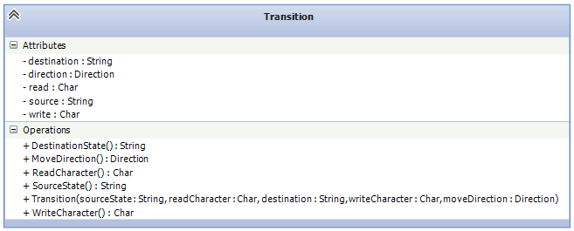

Class:
Transition

Description:
A transition defines one possible transition that the turing machine can perform. A transition consists of a source state that the Turing machine must be in the perform the transition, a read character that must be on the tape at the position of the tape head for the transition to be performed, a write character that is written to the tape at the position of the tape head when the transition is performed, direction (either left or right) to move the tape head, and a destination state that the Turing machine will enter once the transition has been performed.

Associations:
The class Transition is a component of the class TransitionFunction, receiving messages delegated to it by the TransitionFunction. A Transition object is created by the TransitionFunction class does not exist without the TransitionFunction object.

Attributes:
source:String
The source attribute is a string consisting of the name of the source state of the transition.

read:Character
The read attribute is the character that must appear on the Tape at the position of the tape head for the transition to occur. This character must be part of the input alphabet of the Turing machine.

write:Character
The write attribute is the character that will be written to the tape at the position of the tape head when the transition occurs. This character must be part of the tape alphabet of the Turing machine.

destination:String
The destination attribute is a string consisting of the name of the destination state of the transition.

move:Direction
The move attribute consists of a value from the Direction enumeration. It can have the possible values of LEFT and RIGHT. This attribute is the direction that the tape head will be moved when the transition is performed.

Methods:
Transition(in sourceState:String,
in readCharacter:Character,
in destinationState:String,
in writeCharacter:Character,
in moveDirection:Direction)
The Transition method is the constructor of the Transition class. It initializes all of the values of the attributes of the class. The sourceState parameter is the value that is assigned to the source attribute. The readCharacter parameter is the value that is assigned to the read attribute. The destinationState parameter is the value that is assigned to the destinationState attribute. The writeCharacter parameter is the value that is assigned to the write attribute. The destinationState parameter is the value that is assigned to the destination attribute.

SourceState():String
The SourceState method is a getter method that returns the source state of the transition as a string. It returns the value of the source attribute.
DestinationState():String
The DestinationState method is a getter method that returns the destination state of the transition as a string. It returns the value of the destination attribute.

ReadCharacter():Character
The ReadCharacter method is a getter method that returns the read character of the transition as a character. It returns the value of the read attribute.

WriteCharacter():Character
The WriteCharacter method is a getter method that returns the write character of the transition as a character It returns the value of the write attribute.

MoveDirection():String
The MoveDirection method is a getter method that returns the direction to move the tape head in as a Direction enumeration value. It returns a value of either LEFT or RIGHT. It returns the value of the source attribute.

Class:
TransitionFunction

Description:
The transition function describes all possible transitions of the Turing machine. It is used by the Turing Machine to get information about a particular transition, as well as to check to see if a transition is valid. The TransitionFunction manages the transitions in the program and reads the TRANSITION_FUNCTION section of the Turing Machine definition file. It verifies that this portion of the file is valid.

Associations:
The class TransitionFunction is a component of the class TuringMachine, receiving messages delegated to it by the TuringMachine. The TuringMachine class uses TransitionFunction to determine if a transition is valid, and to get information about a particular transition. A transition does not exist without the TuringMachine. The TransitionFunction has an aggregation of Transition objects. It contains one to many Transition objects. The Transition object is created by the TransitionFunction object, so Transition never exists without a TransitionFunction object.

Attributes:
transitions:TransitionVector
The transitions attribute is a vector of all possible transitions in the turing machine's definition.

Methods:
Load(inout definitionFile:File, inout valid:Boolean)
The method load reads a series of strings from the Turing machine definition file. Each string represents the definition for one entire transition of the Turing machine. The format of the each transition is:
source_state read_character destination_state write_character tape_direction
Each part of the transition is separated by white space. If the transition is not in this format, then valid will be set to false and the method will exit. If the transition is in a valid format, then a new Transition object will be created using the transition data as its parameters, and it will be added to the transitions transition vector.

View()
The View method displays the transition function in its entirety. It displays the transtition function as close to the theoretical formal definition of a turing machine as possible.

Size():Integer
The size method returns as an integer the number of transitions in the transition functions transtitions Transition vector.

SourceState(index:Integer):String
The SourceState method is a getter method that returns the source state as a string of a transition at a given index in the transitions transition vector.

DestinationState(index:Integer):String
The DestinationState method is a getter method that returns the destination state as a string of a transition at a given index in the transitions transition vector.

ReadCharacter(index:Integer):Character
The ReadCharacter method is a getter method that returns the read character as a character of a transition at a given index in the transitions transition vector.

WriteCharacter(indexInteger):Character
The WriteCharacter method is a getter method that returns the write character as a character of a transition at a given index in the transitions transition vector.

MoveDirection(index:Integer):String
The MoveDirection method is a getter method that returns the move direction as a Direction enumeration value of a transition at a given index in the transitions transition vector. It returns a value of either LEFT or RIGHT.

IsValidTransition(in source:String, in read:Char, inout destination:String, inout write:Char, inout move:Direction):Boolean
The IsValidTransition checks a source state given by the source parameter and a read character given the read character and checkds to see if there is a valid transition corresponding to the state and character. If there is, the method fills in the write character, destination state, and move direction with the correct values from the transition function. It also returns true. Otherwise, it does not fill in these values and returns false as a boolean.

IsSourceSate(in state:String):Boolean
The IsSourceState method checks to see if a state name given by the state parameter is in the transition function as a sourceState value in one of the transitions. If it is, the method returns true as a boolean. Otherwise, the method returns false.

Class:
Validate

Description:
The Validate class contains methods that are used by the Turing Machine Application to verify whether or not input strings are valid.

Attributes:
None

Methods:
Validate(in value:Character):Boolean
The Validate method is an overloaded method that checks to see whether a given character called value contains a value that is a reserved character. This method returns true as a boolean if the character is not a reserved character. It returns false as a boolean if it is a reserved character.
Validate(in value:String):Boolean
The Validate method is an overloaded method that checks to see whether a given string called value contains any characters that are reserved characters. This method returns true as a boolean if the string does not contain any reserved characters. It returns false as a boolean if it contains any reserved characters.

Class:
Uppercase

Description:
The Uppercase class contains a method that is used by the Turing Machine application to convert strings to uppercase. The purpose of this is to get strings to the same case so they can be compared without being restricted by case sensitivity.

Associations:
The Uppercase class is used by the InputAlphabet class, TapeAlphabet class, TransitionFunction class, TuringMachine class, and States class to convert text to uppercase to determine if the next header is in the turing machine definition file.

Attributes:
None

Methods:
ToUpper(in value:String):String
The ToUpper method accepts a string called value and converts each character in the string to uppercase. The method returns the same string with every character uppercase as a string.

Class:
Direction

Description:
The Direction class provides methods to convert a Direction enumerated value to a string and convert a string to a Direction enumerated value.

Associations:
The Direction class is used by the TransitionFunction class, and TuringMachine class, and class to convert text directions to and from strings to determine determine if the direction given in the turing machine definition file is valid.

Attributes:
None

Methods:
ReadDirection(in dir:String):Direction
The ReadDirection reads a value of a direction given as a string called dir. This string can contain either “R” or “L” in uppercase. This method determines the correct value of the Direction enumerated value.

PrintDirection(in direction:Direction):String
The PrintDirection method accepts a value of the Direction enumeration as a parameter. It converts this direction to a string. If the enumerated value is “RIGHT”, a string is return with the value of “R”. If the enumerated value is “LEFT” a string is returned with the value of “L”.

Class:
Crash

Description:
The Crash class is an exception class that carries information about a crash of the turing machine.

Associations:
The Crash class inherits from the C++ standard library's runtime_error exception class. It is used by the Tape class to communicate to the Turing Machine class that the turing machine has crashed.

Attributes:
None

Methods:
Crash(reason:String)
The Crash method is a constructor for the exception class. It accepts a string which provides the reason for the crash. It initializes it's parent class, runtime_error, with this reason. This reason is shown when the inherited method what() is called on a Crash object.

Class:
Configuration

Description:
The Configuration class stores the configuration settings for the Turing Machine Application. These settings are: Help on/off, maximum number of transitions to perform, and maximum truncation width.

Associations:
An object of the Configuration class is created by the Main class. The Main class sends signals to the Configuration class to read and change the configuration settings for the Turing Machine Application.

Attributes
truncation:Integer
The truncation attribute is an integer that stores the maximum number of cells to be shown to the left and the right of the tape head when the Turing Machine Application displays an instantaneous description.

HelpOn:Boolean
The HelpOn attribute is a boolean that stores whether or not the help messages in the Turing Machine Application are turned on.

NumTransitions:Integer
The NumTransitions attribute is an integer that stores the maximum number of transitions that the Turing Machine Application performs each time a run command is executed.

Methods
Configuration()
The Configuration method is the constructor for the Configuration class. It initializes the configuration settings to their default values. These values are truncation: 3, HelpOn: false, NumTransitions: 1.

Truncation():Integer
The Truncation method is a getter method for the truncation attribute. It returns the maximum number of cells to be shown to the left and right of the tape head when the Turing Machine Application displays and instantaneous description as an integer.

Help():Boolean
The Help method is a getter method for the HelpOn attribute. It returns whether or not help messages are turned on within the Turing Machine Application as a boolean. If it returns true if help messages are currently turned on, and returns false if help messages are currently turned off.

NumberOfTransitions():Integer
The NumberOfTransitions method is a getter for the NumTransitions attribute. It returns the maximum number of transitions that the Turing Machine Application performs each time a run command is executed as an integer.

SetTruncation(truncationCells:Integer)
The SetTruncation method is a setter method for the truncation attribute. It accepts an integer parameter called truncatinCells and sets the truncation attribute with this value.

HelpOn()
The HelpOn method sets the HelpOn boolean attribute to true. This means that it turns on help messages in the Turing Machine Application.

HelpOff()
The HelpOff method sets the HelpOn boolean attribute to false. This means that it turns off help messages in the Turing Machine Application.

ToggleHelp()
The ToggleHelp method toggles the HelpOn boolean attribute. If the HelpOn attribute is currently set to true, it sets it to false, turning off help messages in the application. If the HelpOn attribute is currently set to false, it sets it to true, turning on help messages in the application.

SetNumberOfTransitions(transitions:Integer)
The SetNumberOfTransitions method is a setter method for the NumTransitions integer attribute. It accepts an integer parameter called transitions and sets the NumTransitions attribute to this value.

Class:
Main

Description:
The Main class contains the methods that the user interacts with to use the Turing Machine Application.

Associations:
The Main class interacts with the Turing Machine class. The Main class creates an instance of the Turing machine class. It sends and recieves messages from the Turing Machine class. The Main class interacts with the Configuration class. It sends and receives messages from the Configuration class to set configuration settings and to retrieve the values of the configuration settings.

Attributes:
None. The Main class does not contain any attributes.

Methods:
CommandHelp(in config:Configuration)
The HelpCommand method uses the Configuration object to check whether or not the help configuration setting of the application is enabled. If it is, it displays a list of commands available in the application and help text regarding each one.

Show(in tm:TuringMachine, in tmDef:String, in config:Configuration)
The show method displays detailed information about the Turing Machine application and the currently loaded turing machine definition. It displays the applications author, version number, class name, instructor, and date of creation. It also shows the name of the current turing machine definition, the status of the turing machine (whether or not it is or has run on an input string), the number of transitions performed (if any), and finally the configuration settings of the Turing Machine. It uses the tm parameter to get information about the turing machine. The tmDef string is the name of the current turing machine. The config parameter stores the information about the configuration settings.

List(in inputStrings:StringVector, in config:Configuration)
The list method shows the list of input strings that are currently loaded into the Turing Machine application. It displays an enumerated list (beginning at 1) of all input strings is displayed. This list consists of all input strings that have either been read from the input string file or added by the user by using the “insert” command. This list is read from the inputStrings stringVector parameter. The number of each input string represents the number that the input string is accessed by when using the “run” and “delete” commands. The method retrieves the value of the help command from the config paramter. It uses this to determine whether or not help is displayed.

Insert(inout inputStrings:stringVector, in tm:TuringMachine, in config:Configuration)
The insert method allows the user to enter a new input string. The method will prompt for an input string, which reads “Enter input string: ”. The user must then type the input string that he or she wishes to enter. After typing the input string, the user will press enter on their keyboard to submit the input string for validation.
The Insert method validates the input string by checking to see if each character in the input string is present in the input alphabet of the Turing Machine, as defined in the Turing Machine definition file. The input string is validated to ensure that it does not contain reserved characters or characters that are not in the turing machine's input alphabet. This method uses the tm parameter to check whether or not the input string entered by the user is valid. If an empty input string is entered (ie pressing “enter” at the input string prompt without typing anything else), the method will return instantly.
If the input string passes validation, it will be inserted into the Turing Machine and a positive message affirming that it has been added will appear onscreen. This message is: “Input string has successfully been inserted.” and the input string will be inserted into the inputStrings stringVector. If the input string does not pass validation, the user will be given a negative message notifying them that it is an invalid input string, and the input string will not be inserted into the input string list. This message is “Input string was not valid and has not been inserted.”
The Insert method uses the config parameter to determine whether or not it should display help information before prompting the user for an input string.

Delete(inout inputStrings:stringVector, in config:Configuration)
The delete method allows the user to delete an input string from the application. The user will be prompted for the index of the input string to delete. This prompt is “Delete input string index: ”. If the user types nothing and presses enter at this prompt, the method will immediately exit. The index is the number of the input string as shown in the List command. Once the user enters an integer for the input string, the application will then validate the index to check to see if it is correct. If the index entered is greater than the maximum number of strings in the input string list, or if it is less than 0, or the index entered is not an integer, then a message will be displayed notifying the user that he or she entered an invalid index number. The message displayed will be “Invalid input string index.” If the index entered passes validation, the input string will be removed from the inputStrings stringVector. The inputStrings stringVector contains all of the input string of stored in the application. A message will appear on the screen informing the user that the input string has been deleted. This message will be “Input string [input string] has been removed from the input string list.” The config parameter is used to check whether or not help messages should be displayed before prompting the user for an input string index.
Set(inout config:Configuration)
The set method allows the user to set the maximum transitions to run configuration setting of the Turing Machine application. This setting is stored in the config parameter. This command allows the user to change the maximum number of transitions configuration setting. On entering this command, the user will be prompted for the maximum transitions to perform. If the user presses enter at this prompt without entering anything, he or she will be taken immediately back to the command prompt without further input. It will also show the current value that this configuration setting is set to. This prompt is “Maximum number of transitions to be performed (currently: [current maximum transitions]: ”. At this prompt, the user will enter a number which is the maximum number of transitions to perform. The input from the user will then be checked to ensure that it is a valid number of transitions that can be performed. The input to this prompt form the user consists of an integer greater than 1. If the user entered a number less than 1, or anything that is not an integer, the setting will not be changed and the user will receive a message informing he or she of this. The message displayed will be: “That is an invalid number of transitions.” If the user enters a value that is equal to the current number value of the configuration setting, no message will be displayed and the user will be taken immediately back to the command prompt without requiring any further input. If the input passes validation, the maximumtransitions setting will be changed in the config parameter and a message will be displayed notifying the user of this. The message displayed is: “Maximum number of transitions to perform has been changed to [user input]”. The set method also uses the config parameter to determine whether or not it should display a help message before the maximum number of transitions prompt.

Truncate(inout config:Configuration)
The truncate method allows the user to change the configuration setting for the maximum number of tape characters to be displayed to the left and the right of the tape head when an instantaneous description is displayed. This configuration setting is stored in the config parameter. The user will be prompted for the maximum number of transitions to perform. It will also show the current value that this configuration setting is set to. The prompt displayed is: “Number of characters in instantaneous description (current=[current number]): ” The input from the user to this prompt consists of an integer representing the number of characters that should be shown to the left and the right of the tape head on the instantaneous description. After the user enters this value, it will be validated to ensure it is a valid number of characters to be displayed. If the user enters a number less than 0 or enters non-numeric characters, the setting will not be changed and the user will be notified that their input is invalid. This message is: “Invalid truncation value.” If the user enters a value that is equal to the current number value of the configuration setting, no message will be displayed and the user will be taken immediately back to the command prompt without requiring any further input. If the input from the user passes validation, the truncation setting in the config parameter will be changed and the user will be informed that is was changed. This message is: “Truncation value has been changed to [user input].” The Truncate command also uses the config parameter to determine whether or not it should display a help message before the truncate prompt.

View(int tm:TuringMachine, config:Configuration)
The View method displays the current turing machine definition. Once the command is entered at the command prompt, no further information is requested from the user. This is the definition of the Turing Machine as given by the Turing Machine Definition file. The method using the tm parameter to display the definition. It displays the description of the turing machine, a list of all states, the input alphabet (sigma), the tape alphabet (gamma), and a list of final states, the blank character, and a starting state. The View method uses the config parameter to determine whether or not it should display a help message before the definition.

Run(inout tm:TuringMachine, inputStrings:StringVector, config:Configutarion)
The run method will cause the turing machine to begin running on an input string. The tm parameter is the turing machine to run transitions on. The inputString stringVector parameter contains the list of the input string in the application. The config parameter is used to determine whether or not help messages should be displayed by the run method. It is also used to determine how many transitions the turing machine should run at a time, and how many characters should be shown to the left and the right of the tape head in the instantaneous description. If the turing machine is not currently running on an input string, the user will be prompted for additional information. The user is prompted for the index of the input string to run transitions on. The input string is given by the user as the index of the input string as shown on the listing of the List command. This index must be less than or equal to the number of input strings in the input string list and greater than zero. The input string index provided by the user is validated to ensure that it is a valid index. Once the user enters an integer for the input string, the application will then validate the index to check to see if it is correct. If the index entered is greater than the maximum number of strings in the input string list, or if it is less than 0, or the index entered is not an integer, then a message will be displayed notifying the user that he or she entered an invalid index number. The message displayed will be “Invalid input string index.” If the index entered passes validation, the input turing machine will begin running transitions on the input string. If the user has already began operation on the input string on a previous execution of the run method, the user will not be prompted for any information. The turing proceed will attempt to perform the maximum number of transitions as specified by the maximum number of transitions configuration setting.
When the Turing Machine Application operates on a new input string, it must perform several states to begin operation. The turing machine loads the input string onto the tape. The turing machine then sets its current state to the initial state as defined in the turing machine definition file. The turing machine tracks the total number of transitions performed, so this value is reset to zero. The turing machine then begins to perform transitions. It attempts to perform as many transitions as are specified by the maximum number of transitions configuration setting.
The turing machine performs transitions by reading the character on the tape at the tape head, looking for a transition from the current state for this tape character. If there is one, the turing machine writes the write character defined in the transition, switches to the transition's destination state, and moves the tape head in the direction specified by the transition. If there is not valid transition from the current state given the current character on the tape at the tape head, the turing machine will crash and the input string will be rejected. If the input string is rejected, a message will be displayed to the user: “Input string rejected in [transitions performed]” where “[transitions performed]” is the total number of transitions performed on the turing machine so far. If the turing machine reaches a halt state before the maximum number of transitions have occurred, a message will be displayed information the user that the input string has been accepted. This message should be “Input string accepted in [transitions performed]”. If the input string is not accepted or rejected by the time it has run the maximum number of transitions, nothing will be displayed to the user.

Quit(inout tm:TuringMachine, config:Configuration)
The quit method is used to stop the turing machine from running on an input string. When this command is entered, the turing machine will cease to run on the turing machine. This method calls the HaltOperation command on the tm parameter to halt operation on the turing machine. The total number of transitions that were performed will be displayed on the screen. If the Turing Machine is not currently running on an input string, a message will be displayed telling the user that nothing was quit. This message is: “The Turing Machine is not currently running on an input string.” The config parameter is used by the Quit method to determine whether or not it should display a help message before showing the halt operation text.

ReadInputStringList(inout inputStrings:stringVector, tm:TuringMachine, fileName:String)
The ReadInputStringList method reads a list of input strings from a file. The name of the file to read the input strings from is specified by the fileName string parameter. The ReadInputStringList uses the tm TuringMachine parameter to determine whether or not each string in the list is valid. If an inputstring is valid, the string is added to the end of the inputStrings stringVector. The inputStrings stringVector parameter contains the list of all the input strings in the input string list.

WriteInputStringFile(in inputStrings:StringVector, in fileName:String)
The WriteInputStringFile accepts a list of input strings as a stringVector. It writes this list to a file, the name of which is given by the fileName string parameter. Each element of the inputStrings StringVector becomes a line in the input string file. This method attempts to write the file. If it can write the file, it prints a message stating that it successfully wrote it. Otherwise, it prints out a message stating that it was not able to write the file.

ToggleHelp(inout config:Configuration)
The ToggleHelp method toggles the state of the help configuration setting in the config parameter. It modifies the help setting in the config parameter. If help is currently off, it turns it on and displays a message stating that is was turned on. Otherwise, it turns it off and displays a message stating that it was turned off.

Main(argc:Integer, argv:String):Integer
The Main method is the entry point for the Turing Machine Application. It initializes an object of the TuringMachine class and passes into it a turing machine definition file as specified by the string argv. The argc parameter is checked to make sure that the user entered a name of a turing machine on the command line. The Main method reads the input string file and maintains a list of input strings. The Main method sets up the command prompt and accepts all the commands in the application. It calls the correct method for each command. It returns 0 or 1 as an integer. It returns 0 if the application exits successfully and returns 1 if the application does not exit successfully.

4.0 User Interface

Command Line Invocation
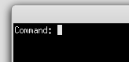
The Turing Machine application features a command prompt with the label “command:” where a command can be entered. The user enters a command by typing the command letter and then pressing the “enter” key on their keyboard. The application then either displays the information associated with that command, or prompts the user again for additional information.

Figure 15 The command prompt

Show Command
The Turing Machine's Show command can be accessed by entering “w” at the command prompt. It shows detailed information about the Turing Machine application and the currently loaded turing machine definition. It displays the applications author, version number, class name, instructor, and date of creation. It also shows the name of the current turing machine definition, the status of the turing machine (whether or not it is or has run on an input string), the number of transitions performed (if any), and finally the configuration settings of the Turing Machine.
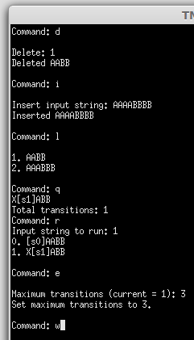

Figure 16 Type “w” for Show command

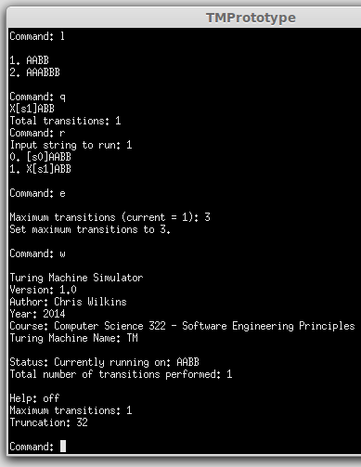

Figure 17 The command shows information about the application, configuration settings, and current running input string

View Command
The View command displays the current turing machine definition. It can be accessed by typing “v” at the command prompt. It displays the description of the turing machine, a list of all states, the input alphabet (sigma), the tape alphabet (gamma), and a list of final states, the blank character, and a starting state.
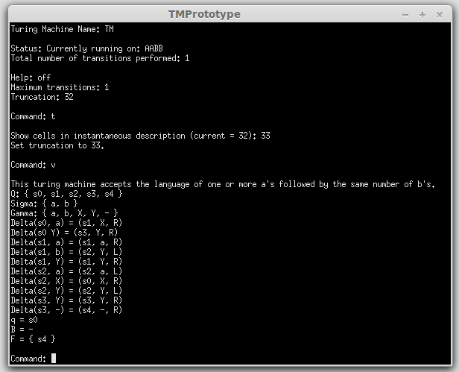

Figure 18 The View Command displays the turing machine definition

List Command
The list command shows the list of input strings that are currently loaded into the Turing Machine application. It can be accessed by typing “l” at the command prompt. When “l” is entered, an enumerated list (beginning at 1) of all input strings is displayed.
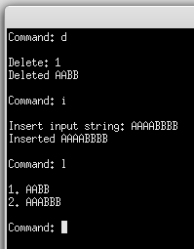

Figure 19 The List command displays list of possible input strings

Insert Command
The insert command allows the user to enter a new input string. It can be accessed by entering “i” at the command prompt. Once the user has initiated the insert command, the application will then prompt for an input string. The user must then type the input string that he or she wishes to enter.
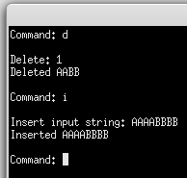

Figure 13 The Insert Command prompts for an input string. If it is valid, it tells the user that the string has been inserted.

Delete Command
The delete command allows the user to delete an input string from the application. It can be accessed by entering “d” at the command prompt. The user will then be prompted for the index of the input string to delete. The index is the number of the input string as shown in the List command.

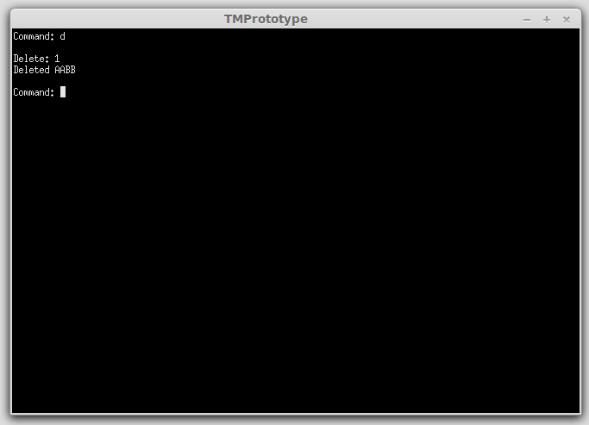

Figure 20 When the delete command is entered the user is prompted for the index of the input string. If it is a valid index, the user is told that the input string has been deleted.

Set Command
The set command allows the user to set the maximum transitions to run configuration setting of the Turing Machine application. It can be accessed by typing “e” at the command prompt. On entering this command, the user will be prompted for the maximum transitions to perform. It will also show the current value that this configuration setting is set to.
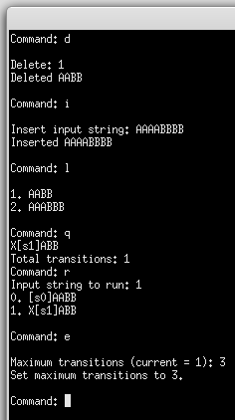

Figure 21 The set command prompts for the maximum number of transitions. It tells the user the current number of transitions currently set.

Truncate Command
The truncate command allows the user to change the configuration setting for the maximum number of tape characters to be displayed to the left and the right of the tape head when an instantaneous description is displayed. This command can be accessed by typing “t” at the command prompt. Upon activating this command, the user will be prompted for the maximum number of transitions to perform. It will also show the current value that this configuration setting is set to.
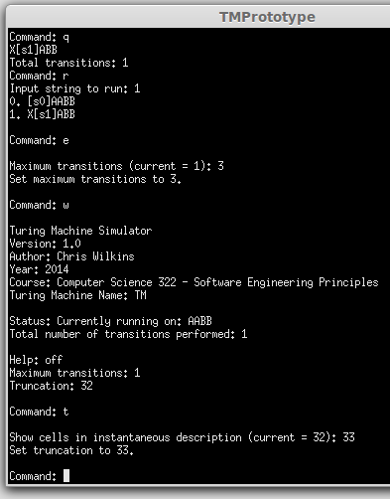

Figure 22 The truncate command prompts for the maximum number of cells to show in instantaneous description. It tells the user the current number of maximum cells currently set.

Run Command
The run command will cause the turing machine to begin running on an input string. The run command is triggered by typing “r” at the command prompt. The user is then prompted for the input string to run transitions on. The input string is the index of the input string as shown on the listing of the List command.

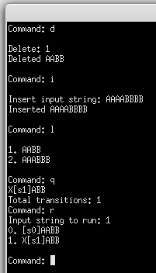

Figure 23 When the run command is execute the user is prompted for the index of the input string to run. The transitions are then silently ran on the input string.

Quit Command
The quit command is used to stop the turing machine from running on an input string. This command can be accessed by typing “q” at the command prompt. When this command is entered, the turing machine will cease to run on the turing machine. The total number of transitions that were performed will be displayed onscreen.
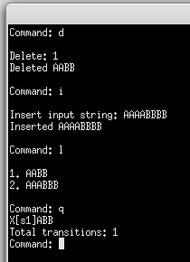

Figure 24 When the Quit command is run the user is told the total number of transitions that have run.

Exit Command
The exit command is used to exit the Turing Machine application. This command can be accessed by typing “x” at the command prompt. Upon entering this command, the Turing Machine will display whether or not the input string file was successfully written, and then the application will exit and the user will be taken back to their operating system.

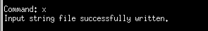

Figure 25 When the exit command is run, the user is told whether or not the input string file was successfully written and the program exits back to the user's operating system.

5.0 Files
This section shows examples of both the Turing Machine definition file and the input string files. These are both valid examples that could be used by the turing machine application.

Turing Machine Definition File
tm.def
This Turing machine accepts the language of one or more a's followed by the same number of b's.
STATES: s0 s1 s2 s3 s4
INPUT_ALPHABET: a b
TAPE_ALPHABET: a b X Y -
TRANSITION_FUNCTION:
s0 a s1 X R
s0 Y s3 Y R
s1 a s1 a R
s1 b s2 Y L
s1 Y s1 Y R
s2 a s2 a L
s2 X s2 a L
s2 Y s2 Y L
s3 Y s3 Y R
s3 - s4 – R
INITIAL_STATE: s0
BLANK_CHARACTER: -
FINAL_STATES: s4

Input String File
tm.str
a
ab
\
aaabb
aaaaaaaaabbbbbbbbb
aabb
aaaaaabbbbbb

