

Technical Safety Concept Lane Assistance

**Document Version: [Version]**

**Template Version 1.0, Released on 2017-06-21**



# Document history

|  |  |  |  |
| --- | --- | --- | --- |
| Date | Version | Editor | Description |
| 11/10/2017 | 1.0 | Pedro Lizana | First version of the document. |
|  |  |  |  |
|  |  |  |  |
|  |  |  |  |
|  |  |  |  |

# 

# Table of Contents

Document history

Table of Contents

Purpose of the Technical Safety Concept

Inputs to the Technical Safety Concept

Functional Safety Requirements

Refined System Architecture from Functional Safety Concept

Functional overview of architecture elements

Technical Safety Concept

Technical Safety Requirements

Refinement of the System Architecture

Allocation of Technical Safety Requirements to Architecture Elements

Warning and Degradation Concept

# 

# Purpose of the Technical Safety Concept

The Technical Safety Concept defines how the subsystems interact at the message level and describes how the ECUs communicate with each other.

# Inputs to the Technical Safety Concept

## Functional Safety Requirements

|  |  |  |  |  |
| --- | --- | --- | --- | --- |
| **ID** | **Functional Safety Requirement** | **ASIL** | **Fault Tolerant Time Interval** | **Safe State** |
| Functional  Safety  Requirement  01-01 | The lane keeping item shall ensure that the lane departure oscillating torque amplitude is below Max_Torque_Amplitude. | C | 50ms | The Safe State is achieved when the LDW function is turned off (Lane Assistance Output = 0). |
| Functional  Safety  Requirement  01-02 | The lane keeping item shall ensure that the lane departure oscillating torque amplitude is below Max_Torque_Frequency. | C | 50ms | The Safe State is achieved when the LDW function is turned off (Lane Assistance Output = 0). |
| Functional  Safety  Requirement  02-01 | The electronic power steering ECU shall ensure that the lane keeping assistance torque is applied for only Max_Duration. | B | 500ms | The Safe State is achieved when the LKA function is turned off (Lane Assistance Output = 0). |

## Refined System Architecture from Functional Safety Concept

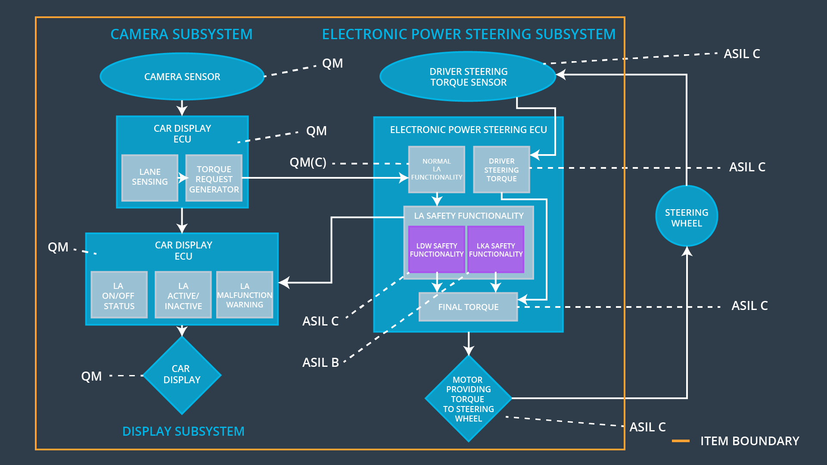

### 

### Functional overview of architecture elements

|  |  |
| --- | --- |
| **Element** | **Description** |
| Camera Sensor | The Camera Sensor reads in images from the road. |
| Camera Sensor ECU - Lane Sensing | The Camera Sensor ECU – Lane Sensing identifies when the vehicle has accidentally departed its ego lane and sends this output to the Camera Sensor ECU - Torque request generator. |
| Camera Sensor ECU - Torque request generator | The Camera Sensor ECU – Torque Request Generator uses the output of the The Camera Sensor ECU – Lane Sensing functionality to calculate the torque to keep the vehicle in the same lane and the torque to warn the driver that is has departed its ego lane. It then sends this messages (torque requests) to the Car Display ECU and to Normal Lane Assistance functionality in the Electronic Power Steering ECU. |
| Car Display | The Car Display shows information related to the Lane Assistance item and other items as well. |
| Car Display ECU - Lane Assistance On/Off Status | Controls the light that tells the driver if the Lane Assistance feature is On or Off. |
| Car Display ECU - Lane Assistant Active/Inactive | Controls the light that tells the driver if the Lane Assistance feature is Active or Inactive. |
| Car Display ECU - Lane Assistance malfunction warning | Controls the light that tells the driver if there is a malfunction with the Lane Assistance feature. |
| Driver Steering Torque Sensor | The Driver Steering Torque Sensor measures the current torque in the steering wheel, information passed to the Driver Steering Torque functionality in the Electronic Power Steering ECU. |
| Electronic Power Steering (EPS) ECU - Driver Steering Torque | Receives the information from the Driver Steering Torque Sensor and sends it to the Final Torque Generator functionality. |
| EPS ECU - Normal Lane Assistance Functionality | Will receive the raw torque request by the Camera Sensor ECU - Torque request generator functionality and limit the torque frequency and amplitude. It send the torque output to the EPS ECU LA Safety Functionalities. |
| EPS ECU - Lane Departure Warning Safety Functionality | Will check that the torque request from the EPS ECU - Normal Lane Assistance Functionality is below the Max_Torque_Amplitude and Max_Torque_Frequency. If it is higher, then it transmits a error status to the Car Display. If it is lower, then |
| EPS ECU - Lane Keeping Assistant Safety Functionality | Will check that the LKA normal functionality has not sent LKA torque requests for more than Max_Duration. |
| EPS ECU - Final Torque | It outputs the final torque to send to the motor. It receives as an input the torque from the Driver Steering Torque and the torque requests from the Safety Lane Assistance Functionality. |
| Motor | The Motor applies the torque request generated by the EPS ECU – Final Torque functionality. |

# 

# Technical Safety Concept

## Technical Safety Requirements

**Lane Departure Warning (LDW) Requirements:**

Functional Safety Requirement 01-01 with its associated system elements

(derived in the functional safety concept)

|  |  |  |  |  |
| --- | --- | --- | --- | --- |
| **ID** | **Functional Safety Requirement** | **Electronic Power Steering ECU** | **Camera ECU** | **Car Display ECU** |
| Functional  Safety  Requirement  01-01 | The lane keeping item shall ensure that the lane departure oscillating torque amplitude is below Max_Torque_Amplitude | X |  |  |

Technical Safety Requirements related to Functional Safety Requirement 01-01 are:

|  |  |  |  |  |  |
| --- | --- | --- | --- | --- | --- |
| **ID** | **Technical Safety Requirement** | **ASIL** | **Fault Tolerant Time Interval** | **Architecture Allocation** | **Safe State** |
| Technical  Safety  Requirement  01 | The LDW safety component shall ensure that the amplitude of the 'LDW_Torque_Request' sent to the 'Final electronic power steering Torque' component is below 'Max_Torque_Amplitude’. | C | 50ms | LDW Safety Block | Lane Departure Warning Torque Request Amplitude Shall be set to zero. |
| Technical  Safety  Requirement  02 | As soon as the LDW function deactivates the LDW feature, the 'LDW Safety' software block shall send a signal to the car display ECU to turn on a warning light. | C | 50ms | LDW Safety Block | Lane Departure Warning Torque Request Amplitude Shall be set to zero. |
| Technical  Safety  Requirement  03 | As soon as a failure is detected by the LDW function, it shall deactivate the LDW feature and the 'LDW_Torque_Request' shall be set to zero. | C | 50ms | LDW Safety Block | Lane Departure Warning Torque Request Amplitude Shall be set to zero. |
| Technical  Safety  Requirement  04 | The validity and integrity of the data transmission for 'LDW_Torque_Request' signal shall be ensured. | C | 50ms | Data Transmission Integrity Check Block | Lane Departure Warning Torque Request Amplitude Shall be set to zero. |
| Technical  Safety  Requirement  05 | Memory test shall be conducted at start up of the EPS ECU to check for any faults in memory. | A | Ignition cycle | Safety Startup Block | Lane Departure Warning Torque Request Amplitude Shall be set to zero. |

Functional Safety Requirement 01-2 with its associated system elements

(derived in the functional safety concept)

|  |  |  |  |  |
| --- | --- | --- | --- | --- |
| **ID** | **Functional Safety Requirement** | **Electronic Power Steering ECU** | **Camera ECU** | **Car Display ECU** |
| Functional  Safety  Requirement  01-02 | The lane keeping item shall ensure that the lane departure oscillating torque frequency is below Max_Torque_Frequency | X |  |  |

Technical Safety Requirements related to Functional Safety Requirement 01-02 are:

|  |  |  |  |  |  |
| --- | --- | --- | --- | --- | --- |
| **ID** | **Technical Safety Requirement** | **ASIL** | **Fault Tolerant Time Interval** | **Architecture Allocation** | **Safe State** |
| Technical  Safety  Requirement  01 | The LDW safety component shall ensure that the frequency of the 'LDW_Torque_Request' sent to the 'Final electronic power steering Torque' component is below 'Max_Torque_Frequency’. | C | 50ms | LDW Safety Block | Lane Departure Warning Torque Request Frequency Shall be set to zero. |
| Technical  Safety  Requirement  02 | As soon as the safety LDW function deactivates the LDW feature, the 'LDW Safety' software block shall send a signal to the car display ECU to turn on a warning light. | C | 50ms | LDW Safety Block | Lane Departure Warning Torque Request Frequency Shall be set to zero. |
| Technical  Safety  Requirement  03 | As soon as a failure is detected by the safety LDW function, it shall deactivate the LDW feature and the 'LDW_Torque_Request' shall be set to zero. | C | 50ms | LDW Safety Block | Lane Departure Warning Torque Request Frequency Shall be set to zero. |
| Technical  Safety  Requirement  04 | The validity and integrity of the data transmission for 'LDW_Torque_Request' signal shall be ensured. | C | 50ms | Data Transmission Integrity Check Block | Lane Departure Warning Torque Request Frequency Shall be set to zero. |
| Technical  Safety  Requirement  05 | Memory test shall be conducted at start up of the EPS ECU to check for any faults in memory. | A | Ignition cycle | Safety Startup Block | Lane Departure Warning Torque Request Frequency Shall be set to zero. |

**Lane Departure Warning (LDW) Verification and Validation Acceptance Criteria:**

**Lane Keeping Assistance (LKA) Requirements:**

Functional Safety Requirement 02-1 with its associated system elements

(derived in the functional safety concept)

|  |  |  |  |  |
| --- | --- | --- | --- | --- |
| **ID** | **Functional Safety Requirement** | **Electronic Power Steering ECU** | **Camera ECU** | **Car Display ECU** |
| Functional  Safety  Requirement  02-01 | The lane keeping item shall ensure that the lane keeping assistance torque is applied for only Max_Duration | X |  |  |

Technical Safety Requirements related to Functional Safety Requirement 02-01 are:

|  |  |  |  |  |  |
| --- | --- | --- | --- | --- | --- |
| **ID** | **Technical Safety Requirement** | **ASIL** | **Fault Tolerant Time Interval** | **Allocation to Architecture** | **Safe State** |
| Technical  Safety  Requirement  01 | The LKA safety component shall ensure that the 'LKA_Torque_Request' sent to the 'Final electronic power steering Torque' component is applied for only ‘Max_Duration’. | B | 500ms | LKA Safety Block | Lane Keeping Assistance Torque Request Shall be set to zero. |
| Technical  Safety  Requirement  02 | As soon as the safety LKA function deactivates the LKA feature, the 'LKA Safety' software block shall send a signal to the car display ECU to turn on a warning light. | B | 500ms | LKA Safety Block | Lane Keeping Assistance Torque Request Shall be set to zero. |
| Technical  Safety  Requirement  03 | As soon as a failure is detected by the safety LKA function, it shall deactivate the LKA feature and the 'LKA_Torque_Request' shall be set to zero. | B | 500ms | LKA Safety Block | Lane Keeping Assistance Torque Request Shall be set to zero. |
| Technical  Safety  Requirement  04 | The validity and integrity of the data transmission for 'LKA_Torque_Request' signal shall be ensured. | B | 500ms | Data Transmission Integrity Check Block | Lane Keeping Assistance Torque Request Shall be set to zero. |
| Technical  Safety  Requirement  05 | Memory test shall be conducted at start up of the EPS ECU to check for any faults in memory. | A | Ignition cycle | Safety Startup Block | Lane Keeping Assistance Torque Request Shall be set to zero. |

**Lane Keeping Assistance (LKA) Verification and Validation Acceptance Criteria:**

## Refinement of the System Architecture

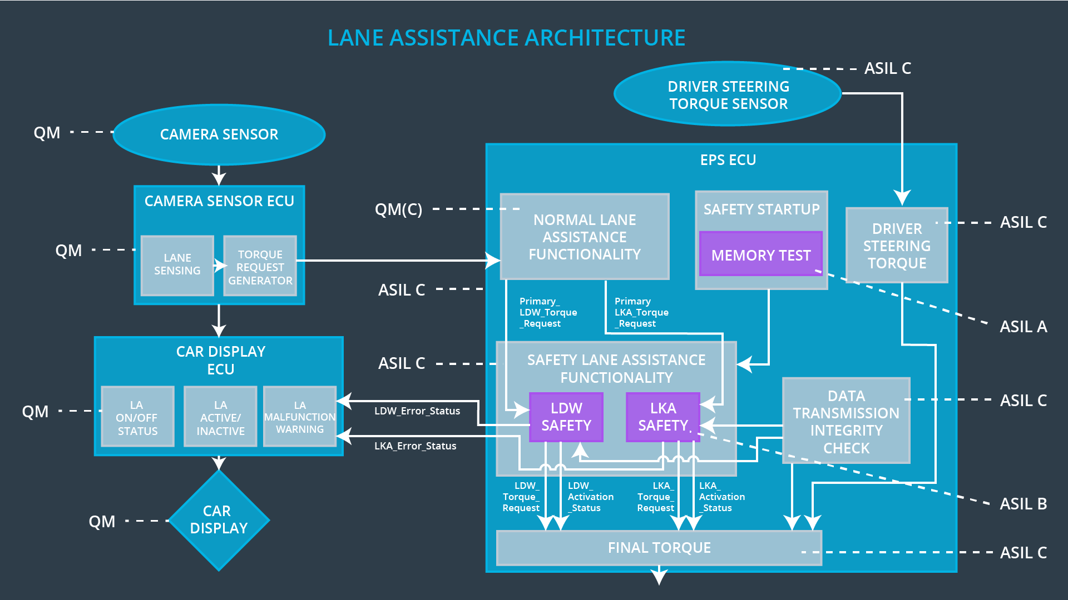

## Allocation of Technical Safety Requirements to Architecture Elements

For this particular item, all technical safety requirements are allocated to functionalities within the Electronic Power Steering ECU.

## Warning and Degradation Concept

|  |  |  |  |  |
| --- | --- | --- | --- | --- |
| **ID** | **Degradation Mode** | **Trigger for Degradation Mode** | **Safe State invoked?** | **Driver Warning** |
| WDC-01 | Turn off LDW (LA) functionality. | Torque amplitude and frequency exceeds Max_Torque_Ampltiude or Max_Torque_Frequency. | Yes. | Lane Assistance lights in Car Display will turn to Off/Inactive. The LA Malfunction Warning light will also turn on. |
| WDC-02 | Turn off LKA (LA) functionality. | Duration of LKA exceeds Max_Duration. | Yes. | Lane Assistance lights in Car Display will turn to Off/Inactive. The LA Malfunction Warning light will also turn on. |