PhotoGrapher’s Screenflow:

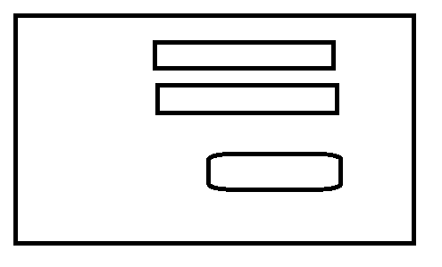

After login PhotoGrapher will see below screen.

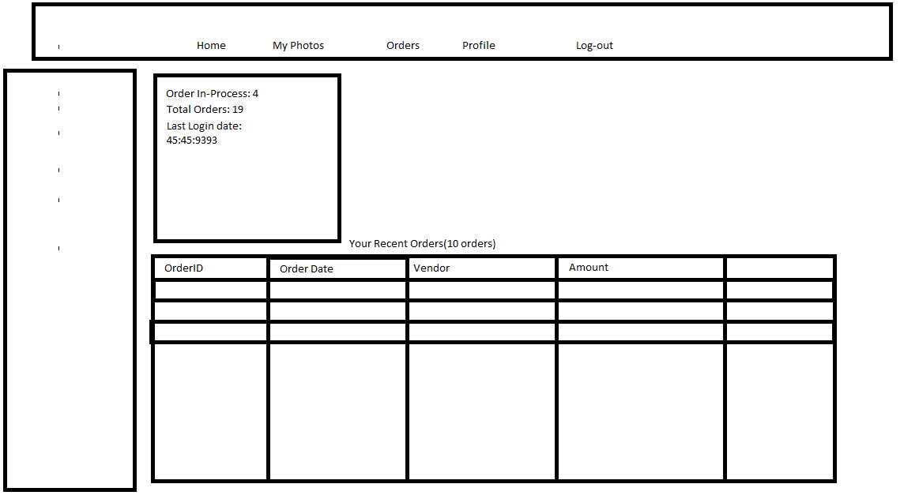

Home > My Photos