**Project Proposal - BlackJack**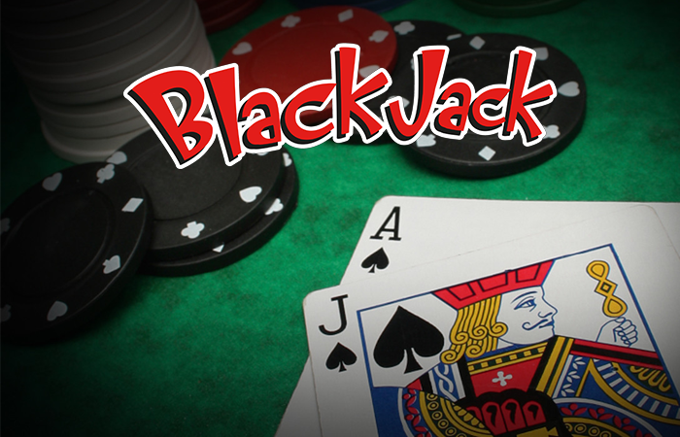

**Team:** [GitHub: FinalProjectTeam3](https://github.com/plmcgriff21/FinalProjectTeam3)

|  |  |  |
| --- | --- | --- |
| Patrick Beltran  Bandana Deo | Seidi Mohammad  Caitlin Smith | Portia McGriff  Stephanie Hucks |

**Topic:**

BlackJack is a card game often found in casinos and occasionally played for leisure time fun. While winning is great, it is always better when it comes with cold hard cash. This project will analyze the hands (cards received) and strategy across 6 players in 150K rounds of BlackJack (900K rows of data). Ultimately we’re looking for the best strategy and a forecast of future wins. We’ll dig in by attempting to answer the questions below.

**Questions:**

* Which player is the luckiest?
* Which player has the most wins (non-BlackJack)?
* Which player has the most BlackJack wins?
* Which player is likely to win with each additional round?
* How many times would you need to play to break-even?

**Planned Activities**

|  |  |  |  |  |
| --- | --- | --- | --- | --- |
| **#** | **Task** | **Description** | **App(s)** | **Team Member** |
| 1 | Create GitHub | * GitHub |  | Portia McGriff |
| 2 | Upload & Clean CSV | * Upload [Kaggle](https://www.kaggle.com/mojocolors/900000-hands-of-blackjack-results) file to GitHub * Remove column A | PostGres  SQL | Patrick Beltran |
| 3 | Quantitative Analysis |  | Tableau | Stephanie Hucks |
| 4 | Web Dev | * Create site to host on Heroku | HTML/CSS Bootstrap | Catlin Smith |
| 5 | Setup ML | * Investigate ML * Set up test scenarios and predictions | ML App-TBD | Portia McGriff  Seidi Mohammad |
| 6 | Host on Heroku | * Investigate Heroku * Setup hosting and embedded Tableau Story |  | Patrick Beltran  Bandana Deo |